Fforwm Rhanbarthol Rhanddeiliaid South East Wales Regional Stakeholder Forum
07/03/2023
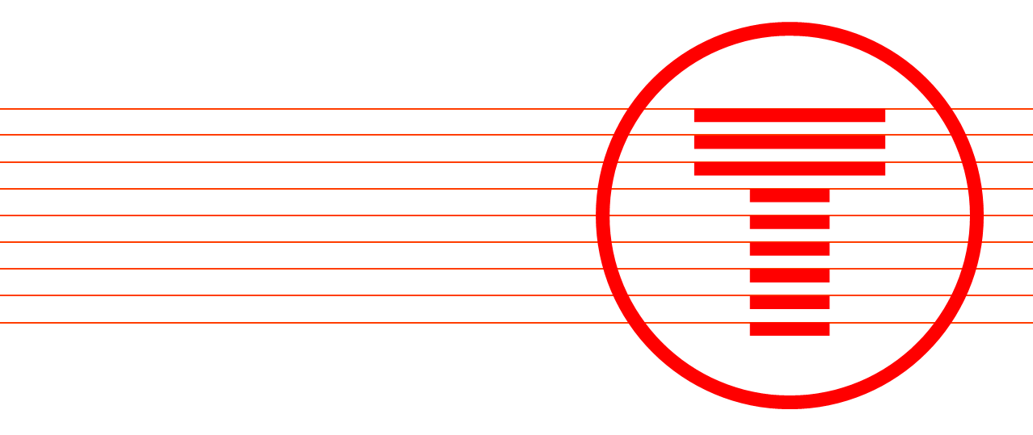
=

Adroddiad o’r cyfarfod
Meeting report

Wales and Borders Regional Stakeholder Forum
The forum met on the 7th March 2023, 15:00 – 15:30
Attendees
Forum Members
Andy Johns | Coleg Y Cymoedd | Vice Principal
Rhys Roberts | Coleg Y Cymoedd | TBC
Alun Evans | Blaenau Gwent Council | TBC
Gemma Hayne | Bridgend Council | Employability Team
Kevin Mulcahy | Bridgend Council | Group Manager - Highways
Kyle Phillips (Enfys Griffiths) | Vale of Glamorgan Council | Group Manager - Transport Services
Natalie Curtis | Bridgend Council | SEW Regional Engagement Team
Nicola Somerville | Valleys Taskforce | Taskforce Member
Daniel Bowden | Stagecoach | Assistant Operations Manager
Nigel Winter | Stagecoach | Managing Director, South Wales
Paul Dyer | Cardiff Bus CEO | Managing Director
Jonathan Parson | Bridgend County Borough Council | Vice Principal

Transport for Wales
Jessica Clement | Stakeholder Manager
Kelsey Barcinilla | Stakeholder Manager
Eleanor Crowley | Community Engagement Officer

Note from the Chair, {Jessica Clement }
(Jess to write)

Agenda

- South Wales Metro

JC began the meeting by discussing the aims of the South Wales Metro which include providing quicker journeys, better connections, more capacity, smarter ticketing options and more reliable services.
JC discussed the requirements to deliver this service, which includes a big transformational project of electrifying 170km track, upgrading stations and building new stations in and around the Cardiff area.
The aim of Metro will increase these services from the valley lines into Cardiff. Overall, there should be an increase of 70% of AM and PM services.

- Introduction of 231’s on Rhymney line

The 231’s were introduced into service in January of this year, and this is our first Metro train which has been entered into service. There are 11 of these trains which include 4 car services. These are currently providing services from Rumney to Penarth. Once we have finished all the electrification works, these will be moved used on the Cardiff, Ebbw Vale, Maesteg and Cheltenham routes.

JC confirmed that these trains will then be replaced by the 756 tri mode vehicle which are battery powered, but also work on electric lines and diesel. JC discussed the benefits of the 756 models, which include ‘all boarding’ which allows wheelchair and cyclists to board easier with a capacity of 425 people including standing room.

- Infrastructure updates

JC discussed the 4 steps which are required to allow us to install the OLE equipment which will power the new trains which are due to go live in June 2023.

JC explained the current progress across the CVL lines relating to ;

1 : (Trial holes and foundations determines whether there are any utility diversions required and to check the ground conditions for piling work)

Between Queen Street – Llandaff - Radyr – : The majority of the OLE works has been completed, 50% has been completed in Merthyr and Aberdare, however there is a lot of work to do at Treherbert.

2. Installations for MPS and SPS :(steel gantries and smaller sections on the masts which hold the wires in place)

On the CVL we are using two different types depending on the amount of tracks (whether single or double lines). Radyr – Ponty – Llandaff : is 85% completed, 50% is completed in Aberdare and Merthyr but there are a number of utility diversions at the Treherbert line.

- Wiring –

To date, there has been approximately 3000miles of wires which have been installed. Unfortunately, there has been some wire thefts, and we are working closely with BTP to put more security in place.

- Going live

JC discussed the preperation work which is being done ahead of the line going live in June 2023. This includes our safety campaign which will make the public aware of the dangers of coming close to the OLE equipment. It will also be an opportunity for us to educate people to understand the dangers of the OLE, and taking those extra measures to prevent trespass. Works are being carried out to erect new fencing along the lines.

Installing new tracks , bridge improvements and building new stations

JC gave an overview of the current works which are being conducted across the CVL. These include;

Merthyr Tydfil : There is a lot of work in the area where repairs are required to listed bridges in order for us to be able to install OLE underneath.

Quakers Yard – We are installing a new ramped footbridge as the track is being doubled. There will be a track loop from Pentrebach to Merthyr. This will increase the frequency of the lines which will mean there will be 8 trains an hour

Aberdare – This is one of our infrastructure projects. We are currently in the process of building a new platform which will be an arrivals only platform which is located opposite the Sobell Leisure Centre.

Fernhill – The level crossing will be closed due to the frequency of trains on the line and the dangers of the OLE equipment. To replace the crossing, we will be installing a ramped footbridge.

Cwm Cynon – The bridge here is currently in bad condition, and therefore we will be replacing this with a new bridge.

Treherbert – Works include stripping out the current signalling and replacing with new and infrastructure work at Dinas Rhondda and Ynyswen. This includes lift bridge and improvements to Treherbert Station to bring it up to todays standards. Blockades will be required to carry out this work, although we do not currently have any dates for this.

Rumney – We are re doubling the track which is over a distance of 4km in total. By re doubling the track in sections, this will help reduce journey times by 20%.

Caerphilly – The works being carried out here focusses on the transport interchange. This will mean an improved link between train and bus services, and a better park and ride facilities.

Cardiff – There are no OLE in certain sections of the track (between Llandaff and Cathays), and therefore - trains on this line will be powered by battery.

JC discussed how the lines from Cardiff Central South are owned by Network Rail, and therefore it will currently be the tri-mode trains will run on these lines. Should these lines become electrified in future, we would still be able to use the fleet of trains we have.

Gelynis Farm - The current crossing is being/has been closed, and we are currently in the process of building a bridge which includes a road and pedestrian access which allows access to Gelynis Farm. This is due to be completed in June 2023.

Access For All Bridges – These will be erected at Treforest, Taffs Well and Cathays stations. The one at Treforest is currently being constructed. The AFA bridges will include both lift and step access which will enable people to cross safely and will also help our customers who have accessibility needs.

Cardiff Bay –
KB updated forum on the current and planned work in the area.
Penarth Station is currently in the early stages of design. It is planned that there will be a loop system which will help in conjunction with the tri mode trains and timetables. There will also be a slope which will come from the back of the station which will accommodate future tram trains in the area.
Work at Cardiff Bay started in January 2023 where we have installed 4 compounds (1 at Roath Dock area and 3 along Lloyd George Avenue. We have erected 800m of hoarding in the area, and are currently working with local community (which includes local artists and residents) on initiatives.
Preparation work for construction is due to commence at the end of March. This will be to install a railroad access point. Traffic management will be in place which is being supported by Cardiff Council.
Ground investigation works along Bute Street has began this week (week commencing 6 March 2023). Whilst this work is being carried out, there will be no road closures, however there will be pedestrian track side closures. This will not affect residents accessing their properties.
Improvements include – a new station which is currently known as Bute Street station, however this will be renamed at some point. There will also be steps and a lift to improve accessibility which will be located near Maria Street on Bute Street.
Double tracks will also be built to improve the trains in the area, and part of the track will have OLE installed, and the other parts will operate on batter.
Improvements to Cardiff Bay Station include widening the platform, and improving the access from both sides of Bute Street and Lloyd George Avenue. There will also be additions such as CCTV.
Consultation – (Cardiff Central to Newport Road). This closed on 30 January for 4 tram train and 1 bus route . written summary report which is due to be shared with key stake in next few weeks. This will inform our outline business case. This is separate to the Cardiff Cross Rail programme which has had the levelling up fund.

Taffs Well Depot
The maintenance depot is where the tram trains will be stored. The ICC is due to be opened in the next couple of weeks, and the site is to be fully operational by November 2023. JC discussed the workings of the depot and how the new entrance from the existing track will allow the trams to enter via an existing road through a tunnel.
ICC – our help point is due to open in the next couple of weeks which will be open 24/7.
There will be times where blockades will be needed so that works can be carried out in the day and the night.

Planned blockades :
JC gave an overview of the upcoming blockades which will be carried out over the next couple of months which will allow works to continue through the day and night.
These include routes between
- Radyr to Pontypridd
- Abercynon to Merthyr
- Pontypridd to Aberdare and Merthyr
- Ystrad Mynach to Rhymney
- Cardiff Queen Street to Radyr, Cardiff Central to Radyr via the City Line
- Cardiff Queen Street to Cardiff Bay

- AOB

KB asked for feedback from stakeholders as this will be beneficial for future meetings (especially content of regional forum).

Actions

No actions from the regional forum.

Forum digital chat highlights

Highlights of the conversation within the chat function of the Forum were:

For the+71% capacity - and set against the original business case, has there been a revision in the demand forecast?

For those interested in Cardiff's Bus Interchange, TfW will take ownership last this month. Upon taking ownership of the interchange, TfW will undertake the fit out of the interior of the building to deliver an operational bus interchange. TfW will be engaging with bus operators to ensure a smooth transition to operation – this engagement has and will continue to be undertaken by Station Manager, Gavin Hawkins and supported by myself, when required. TfW will share regular updates on progress throughout the coming phases of works.

Our latest update on Cardiff Central Enhancement Programme: We’re currently working with the Department for Transport, Cardiff Capital Region and the Welsh Government on the development of significant enhancement proposals at Cardiff Central station, with a joint investment of £113m. We have agreed on a core scope of works that is to be taken forward into outline design, planning and delivery of the full business case over the next 12 months. This core scope includes the extension of platform 0 to improve its connectivity to the rest of the station, as well as amendments and reconfiguration of the concourse ticket lines and improved integration of the east and west subways. Our aim is to provide a station that performs, can accommodate long-term growth and offers passengers the best travel experience. We hope to seek a final investment decision next year that will then help us to determine delivery dates.

Next Regional Stakeholder Forum

The next South East Wales Regional Stakeholder Forum is scheduled for June 2023. The meeting will be held virtually over the Microsoft Teams platform between 09:00 – 11:45.

