Date issued: 9 March 2022

Freedom of Information Request

We are writing in response to your Freedom of Information request. Your request has been considered in accordance with the requirements of the Freedom of Information Act and our Data and Information Management Policy.

Your Questions Answered

- The organisational structure and a full breakdown of your HR department by title i.e. The number of directors, managers, HRBP etc so 1 x director, 3 x manager, 4 x HRBP etc

Please find attached to our responding email a PDF copy of the organisational structure for the HR Department containing the information required.

- The gender and age group of each person occupying these i.e., HRBP, Female, 18-25

This information is exempt from disclosure under Section 40(2) of the Freedom of Information Act (2000) - 'personal information'. This exemption covers the personal data of third parties where complying with the request would breach any of the principles in the UK GDPR. In order to apply this exemption, we must refer to the UK GDPR as data protection principles are not outlined in the Freedom of Information Act.

The information requested here constitutes personal data as defined by UK GDPR. Personal data is information that relates to an individual who:

- can be identified or who are identifiable directly from the information in question; or
- who can be indirectly identified from that information in combination with other information.

UK GDPR provides a non-exhaustive list of identifiers that may constitute personal information. Notably, the ICO website states 'you don’t have to know someone’s name for them to be directly identifiable, a combination of other identifiers may be sufficient to identify the individual'. They continue: '…when considering whether information ‘relates to’ an individual, you need to take into account a range of factors, including the content of the information, the purpose for which you are processing it and the likely impact or effect of that processing on the individual… If you cannot directly identify an individual from [the] information, then you need to consider whether the individual is still identifiable. You should take into account the information you are processing together with all the means reasonably likely to be used by either you or any other person to identify that individual'.

As shown in the organisational chart provided, the TfW's HR department is a small team of twenty members of staff, whilst members of the department are publicly visible on social media platforms as part of their role to recruit new people into our organisation. When viewed alongside these public social media profiles of TfW staff, this data set could serve to identify members of the team. As such, this data set is likely to indirectly identify the individuals in question.

Further information about this exemption can be found here:

When can we refuse a request for information? | ICO
What is personal data? | ICO

- The salary band of each member of staff, i.e., HR Manager, salary band 35-45k

The salary band of each member of staff within the HR department is outlined in the organisation chart provided, with the exception of seconded staff members who do not fall into our banding structure. Our salary bandings are as follows:

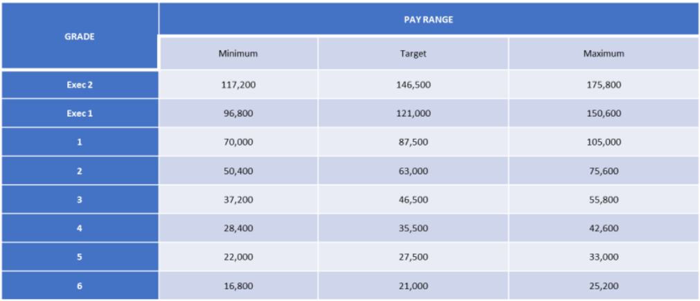

- The number of vacancies advertised both internally and externally within the department in the last 3 years

Please refer to the spreadsheet entitled ‘Applicants, Interviews and Attrition’ attached to our responding email, where you will find this information for April 2021-present. Our data retention guidelines only require us to retain this information for a twelve month period, therefore we do not have information to share for 2020 - April 2021. From 2018 – 2020, recruitment was outsourced to an external provider, and information relating to recruitment for this period was also subject to a retention period twelve months after the contract ended. As such, information for this period is also unavailable.

- The number of vacancies filled both internally and externally within the department in the last 3 years

As per Q4, please refer to the spreadsheet entitled ‘Applicants, Interviews and Attrition’ attached to our responding email.

- The number of applicants per vacancy broken down into gender, age.

As per Q4, please refer to the spreadsheet entitled ‘Applicants, Interviews and Attrition’ attached to our responding email. TfW does not collect data relating to the age and gender of our applicants to ensure a fair selection process. Whilst we do have the names of these applicants on record for the timeframe outlined in Q4, it is also not appropriate for us to review them and make an assumption of gender.

- The number of applicants per vacancy shortlisted for interview broken down into gender and age

As per Q4, please refer to the spreadsheet entitled ‘Applicants, Interviews and Attrition’ attached to our responding email. TfW does not collect data relating to the age and gender of our applicants to ensure a fair selection process. Whilst we do have on record the names of these applicants, it is not appropriate for us to review them and make an assumption of gender.

- The number of ex armed forces veterans who have applied for vacancies and the number who have been successful at shortlisting and the number appointed

TfW does not hold this information. Our guaranteed interview scheme for veterans is a recent incentive and our in-house systems are in the process of being updated to include a searchable field or term to provide this information in the future. We cannot provide a timescale in which this will be achieved.

- The number of candidates interviewed for positions broken down by gender, age.

As per Q4, please refer to the spreadsheet entitled ‘Applicants, Interviews and Attrition’ attached to our responding email. TfW does not collect data relating to the age and gender of our applicants to ensure a fair selection process. Whilst we do have on record the names of these applicants, it is not appropriate for us to review them and make an assumption of gender. We note that this question is a duplicate of Q7.

- The number of successful candidates appointed to a position within the department broken down by gender and age.

Please refer to the spreadsheet entitled ‘Applicants, Interviews and Attrition’, where the number of successful applicants appointed is outlined for the timeframe outlined in our answer to Q4. For the reasons outlined in Q1, we have not outlined the age and gender of the successful candidates as this is likely to indirectly identify members of the HR Department.

- The gender and age of the interview panels for all the vacancies

As per Q1.

- The attrition numbers of the HR department in the last 3 years broken down by gender and age

As per Q4, please refer to the spreadsheet entitled ‘Applicants, Interviews and Attrition’ attached to our responding email.

[cont’d]

We hope this information is of use to you.

Yours sincerely,

Transport for Wales

Appeal Rights
If you are unhappy with the way your request has been handled and wish to make a complaint or request a review of our decision, please write to the Head of Freedom of Information at either Transport for Wales, 3 Llys Cdwyn, Pontypridd, CF37 4TH or freedomofinformation@tfw.wales. Your request must be submitted within 40 working days of receipt of this letter. If you are not content with the outcome of the internal review, you have the right to apply directly to the Information Commissioner for a decision.
The Information Commissioner (ICO) can be contacted at Information Commissioner's Office, Wycliffe House, Water Lane, Wilmslow, Cheshire, SK9 5AF or you can contact the ICO through the 'Make a Complaint' section of their website on this link: https://ico.org.uk/make-a-complaint/
The relevant section to select will be "Official or Public Information".

