Foundations
Please see below screenshot of foundation locations as identified in Helix. Majority of locations have foundations already installed (Green).
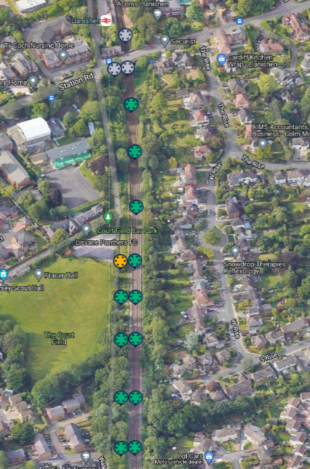
All piles installed and remaining to install are Steel CHS with typically 40-60m between structures. This is subject to change depending on ground conditions experienced on site.

Mast design
Spacing can be seen in the screen shot above for foundations.
The majority of the structures are STCs (Single Track Cantilever) in this area, as per images:
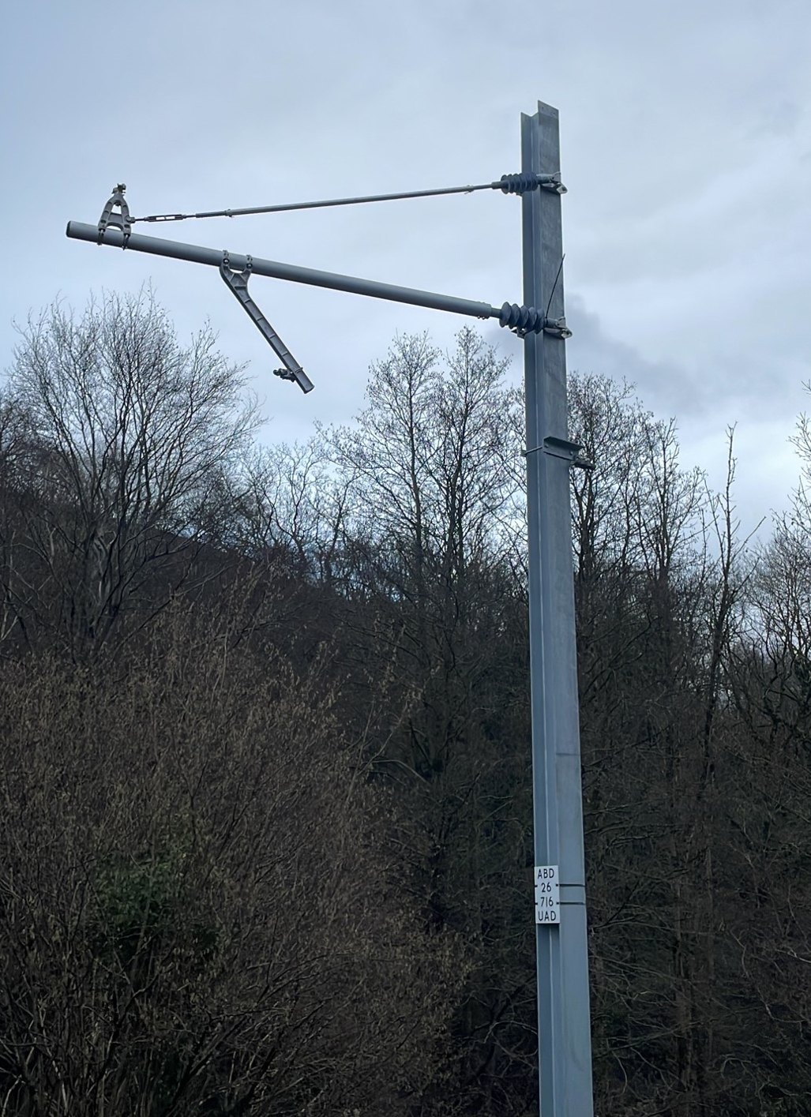
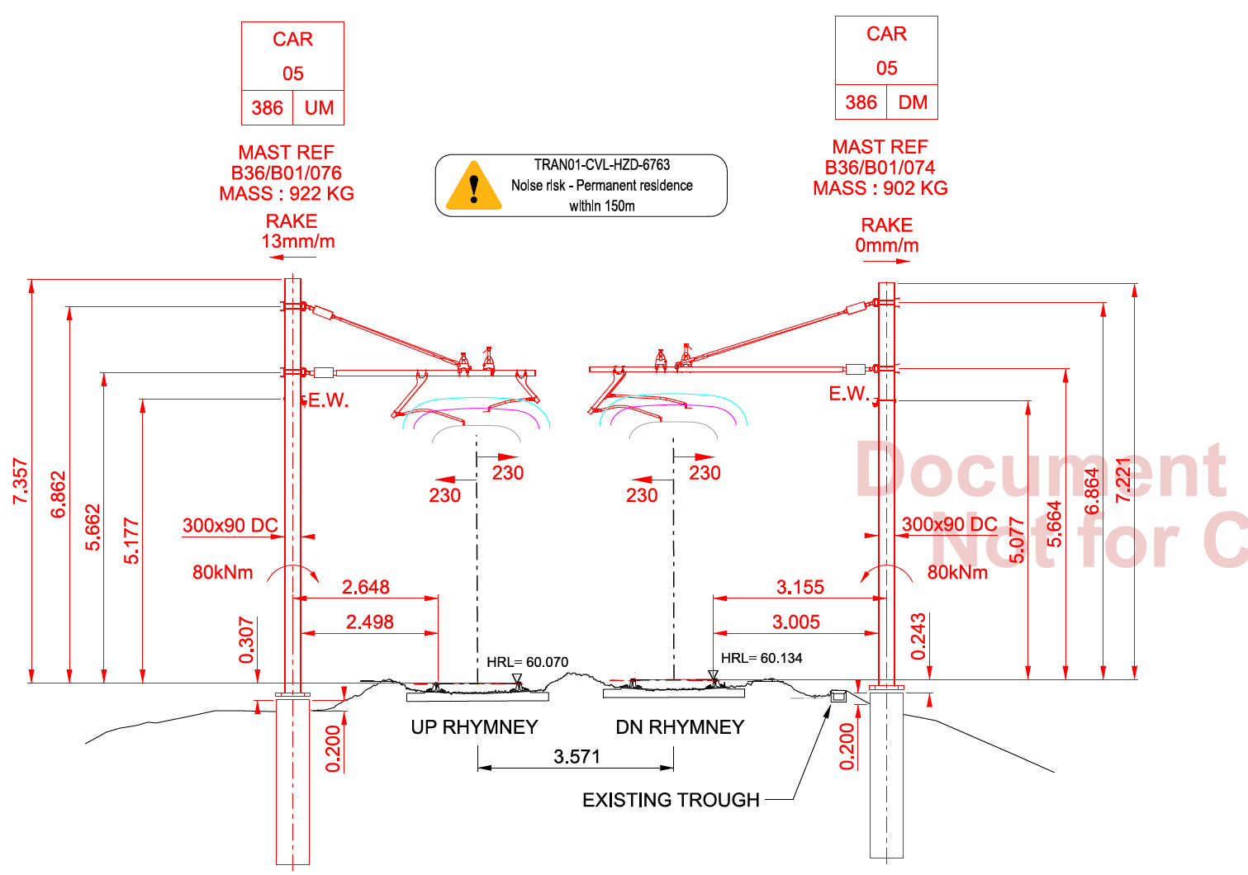

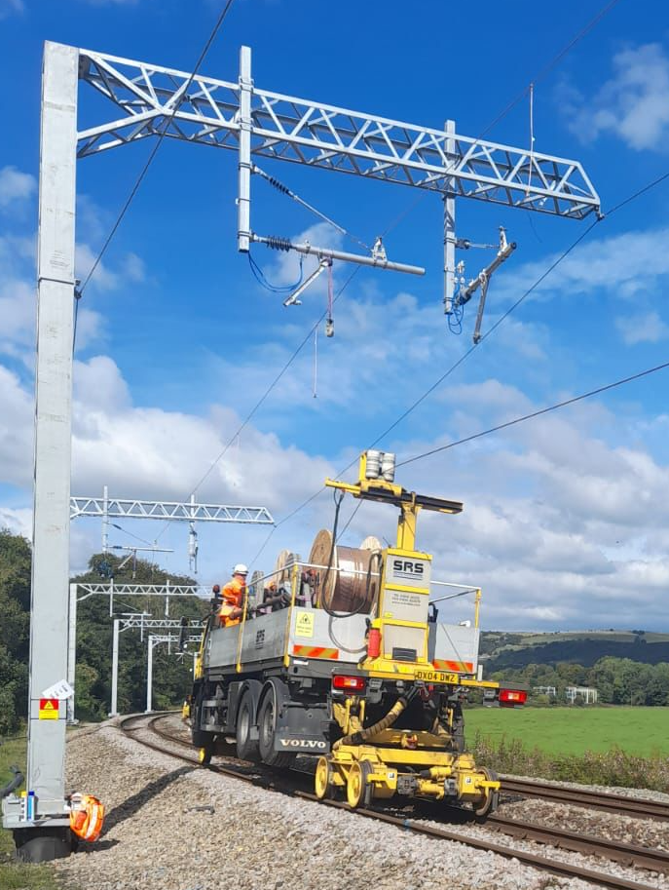
There are also a few TTC (Twin Track Cantilever structures, as per images:
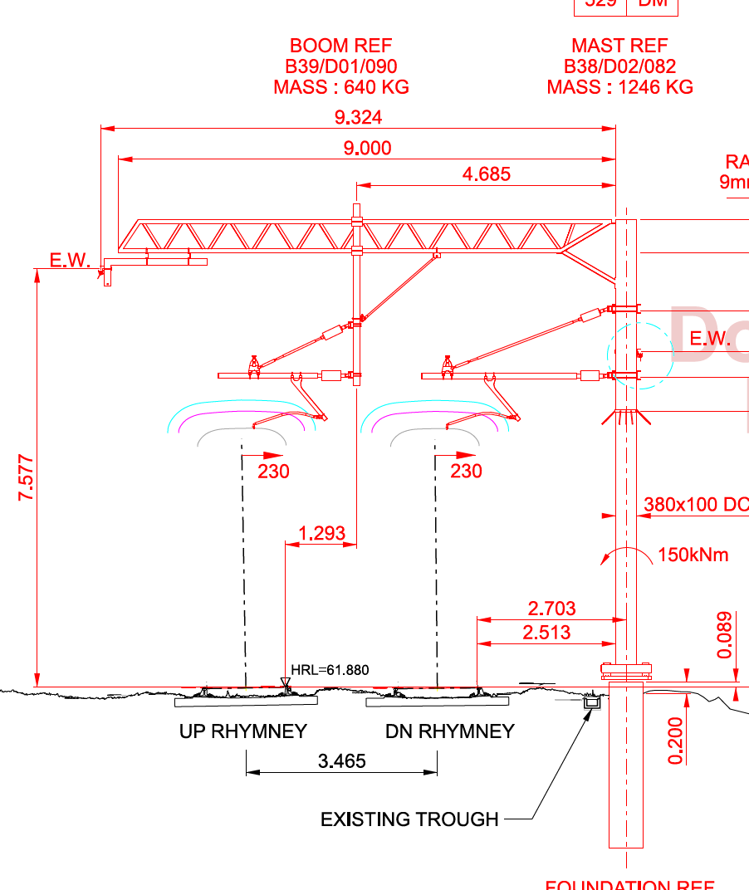

Fencing
There are plans to upgrade any non-compliant boundary measures to a green powder-coated palisade fence with a minimum height of 1.8m.

