The purpose of these kits is to help identify a person who may have spat at you, by analysing any of the spittle still on you. This can be achieved by obtaining DNA from the saliva.  If the spittle is on clothing, please retain the clothing.  Each swab kit contains the following items:  2 sterile swabs in containers (one for sample purposes)  1 self sealing evidence bag  1 pair of sterile latex gloves | 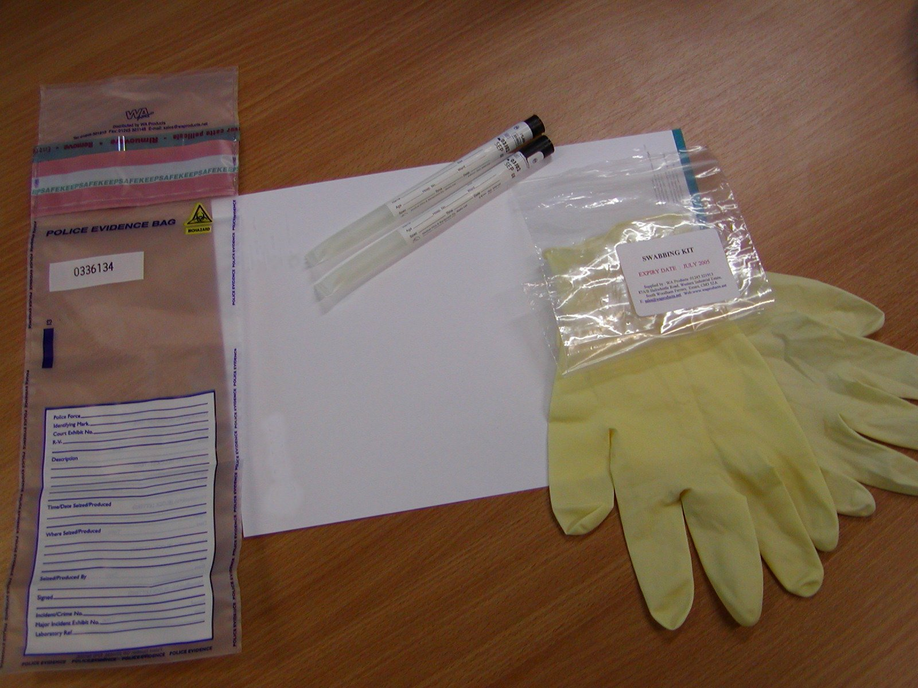
Procedure  - Open kit and check that the container seals are intact. If ANY seal is broken or damaged, then the kit must not be used.  - Wearing the sterile gloves provided, remove one swab from its protective tube.  - Roll the end of the swab in the spittle and replace it in its container.  The other swab must remain untouched within its plastic container as a reference. | 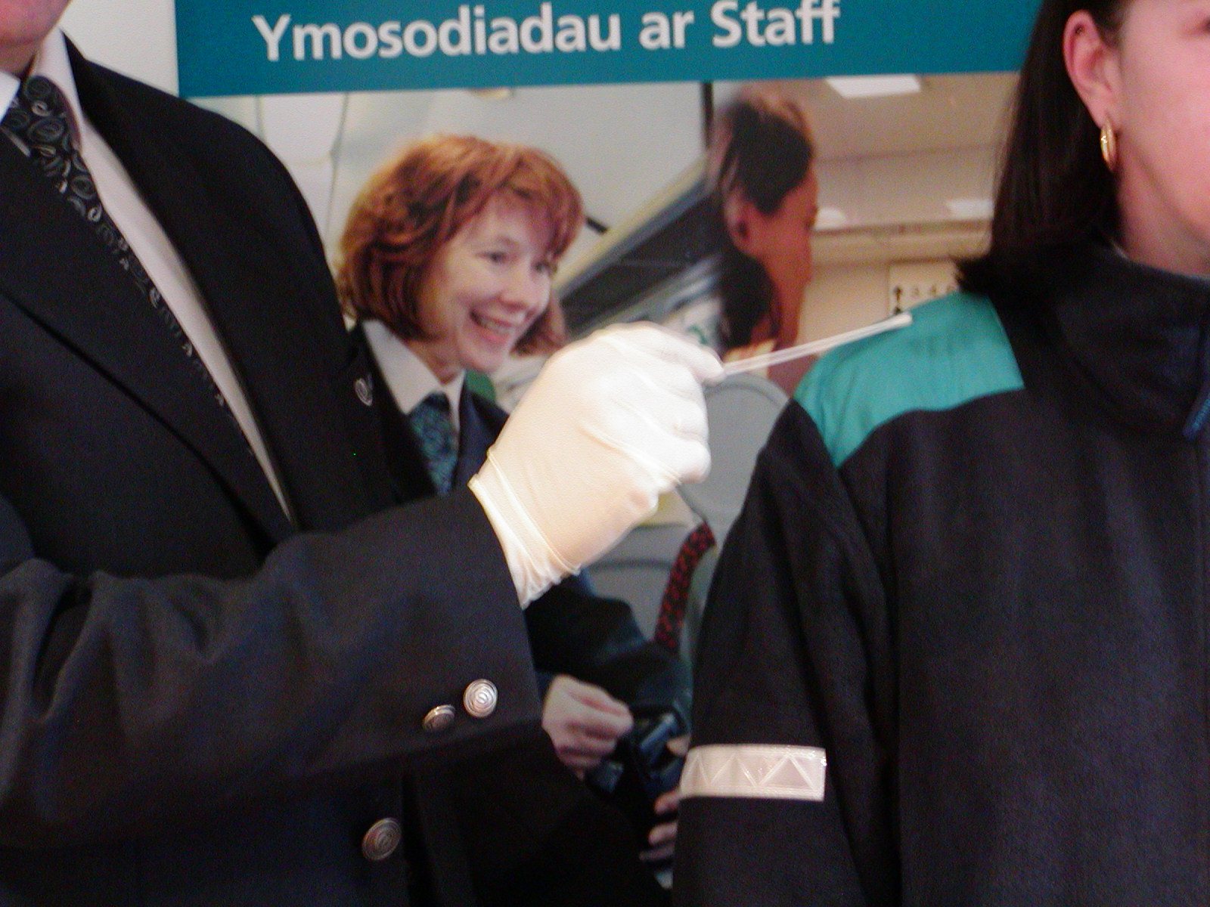
- Place both the used swab and the sealed swab in the evidence bag.  Whenever possible, the swabs should always be used. However in circumstances when a member of staff wipes spit from their skin onto a handkerchief or tissue, that item must be placed in the sealed bag. It may be possible to obtain a DNA sample from that recovered item.  - Seal the evidence bag, by removing the blue protective layer and press together. | 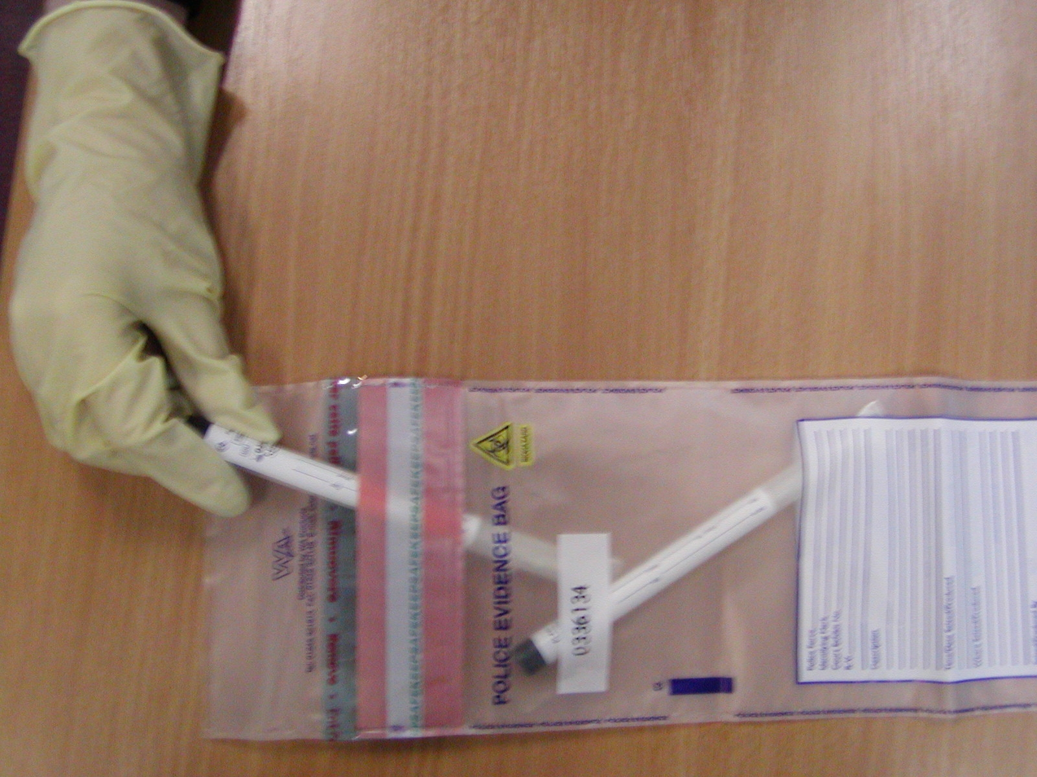
- Remove gloves and dispose of into bin.  - On the evidence bag fill in the designated boxes labelled: description, time/date seized/where seized and sign.  - Wherever possible obtain witness details (i.e. name and signature of an other member of staff who either witness the assault or witnessed the taking of the sample) and ask them to complete under the description section on the evidence bag. | 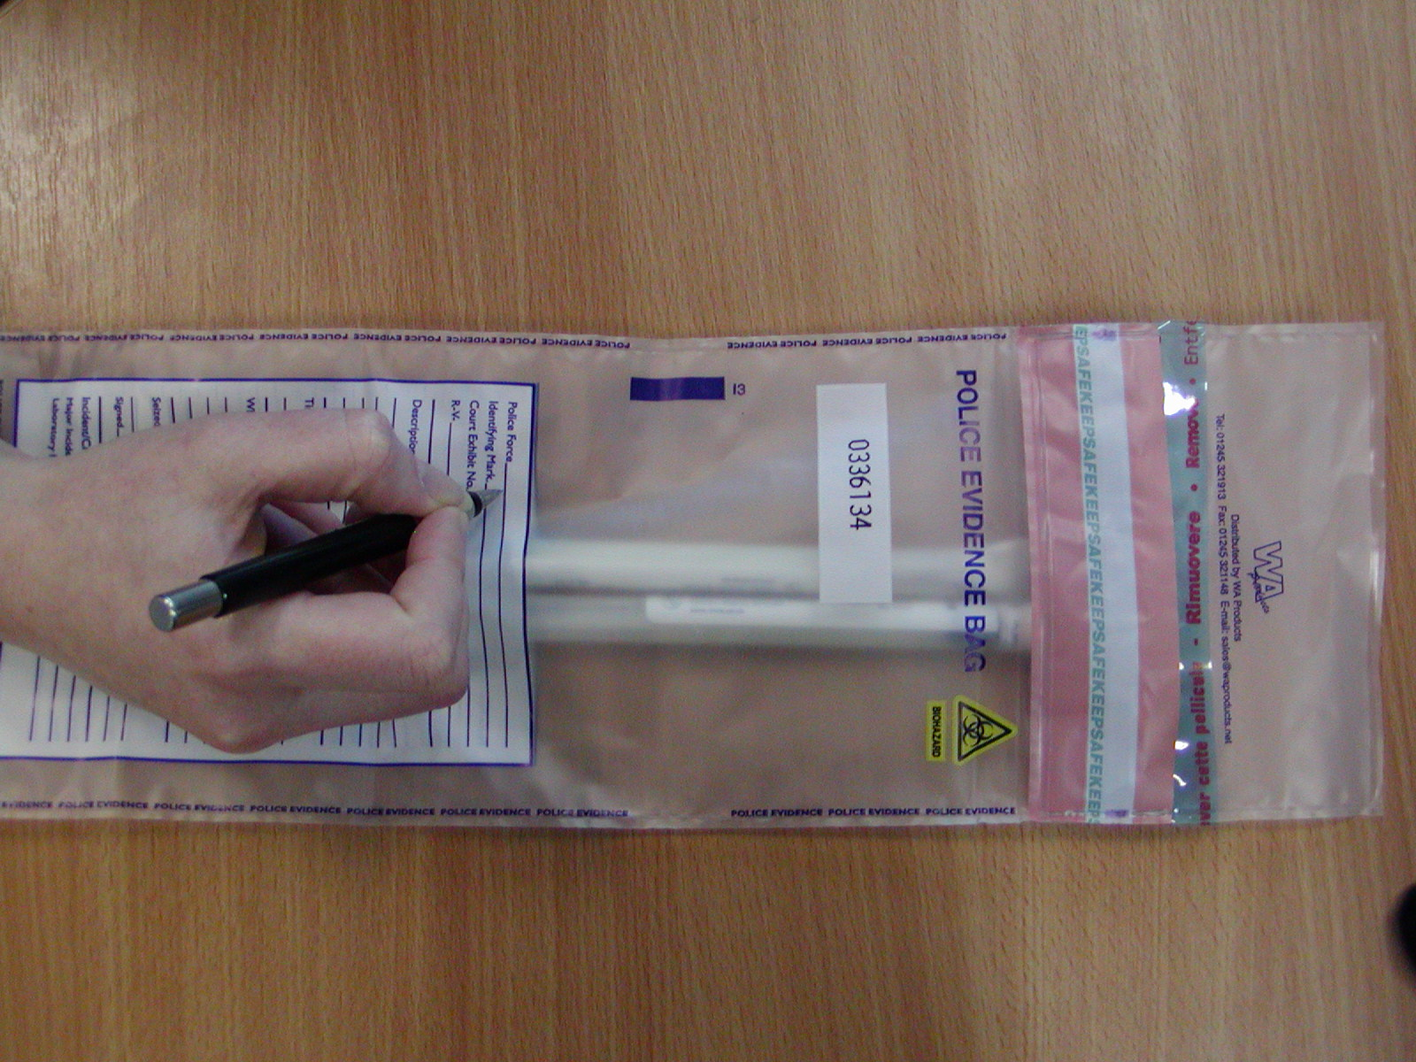
- Make a separate note of as many details as possible including the time and date and a description of the assailant.  Please use the STAFF REPORT FORM FOR VERBAL THREATS & PHYSICAL ASSAULTS. Include details such as: age, height and build, hair colour, hairstyle, distinguishing features, clothing description etc.  - Report the assault to your Supervisor or Manager in the usual manner.  You may need to provide a sample of your own DNA for elimination purposes. This will be taken by a Police Officer using a kit supplied by BTP. NOTE: YOUR SAMPLE IS NOT SUBJECT OF A SPECULATIVE SEARCH AND WILL NOT BE RETAINED FOLLOWING THE ELIMINATION TEST. | 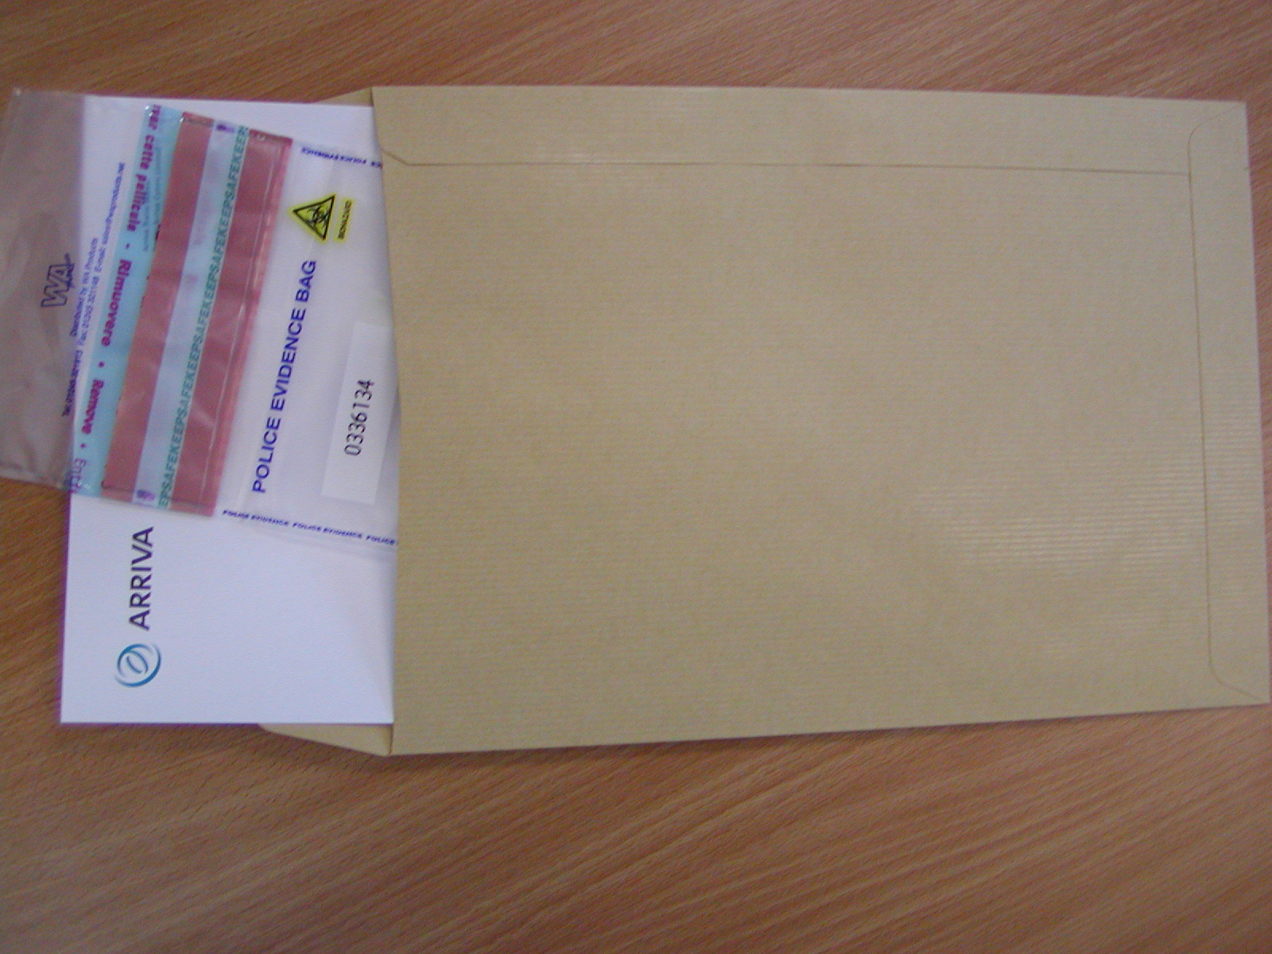
Supervisors / Local Managers:
Ensure that the sealed bag is either delivered to a British Transport Police (BTP) office or collected by a member of BTP as soon as is practicable. Please supply details if any intermediary is used, for continuity purposes. Please note that BTP officers may ask for affected clothing as evidence.

