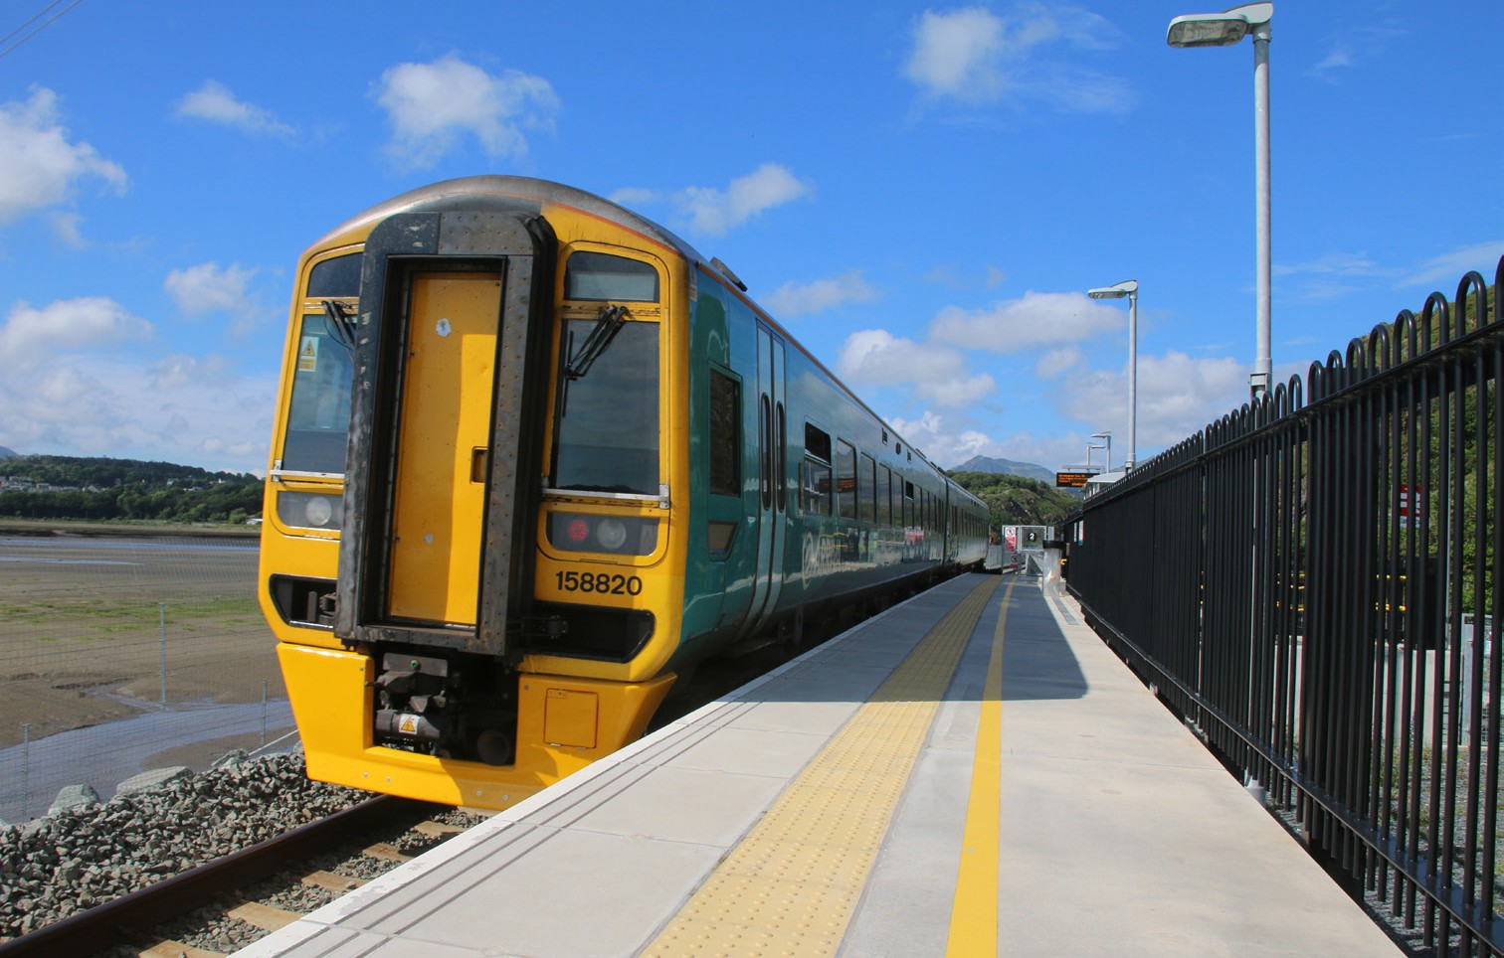

Class 158
Type of train Two carriage diesel train
Year built 1989 to 1992
Number in fleet 24
Seating capacity 138
Toilets 2
Wheelchair accessible toilet 1
(Accessible toilet door is 780mm wide Standard toilet door is 460mm wide.)
Wheelchair users’ space 2
Bicycle space 2
Priority Seating Yes
On board facilities Public address, visual information screens,
assistance button, access ramp, push button doors, baby changing, Wifi, assistance button, baby changing, power points and at seat catering on selected services.
Routes operated Long distance services between West Wales, Swansea, Cardiff, Shrewsbury, Manchester and Holyhead.
Aberystwyth and Pwllheli to Shrewsbury and Birmingham International.
Maesteg to Cardiff, Ebbw Vale and Cheltenham.

