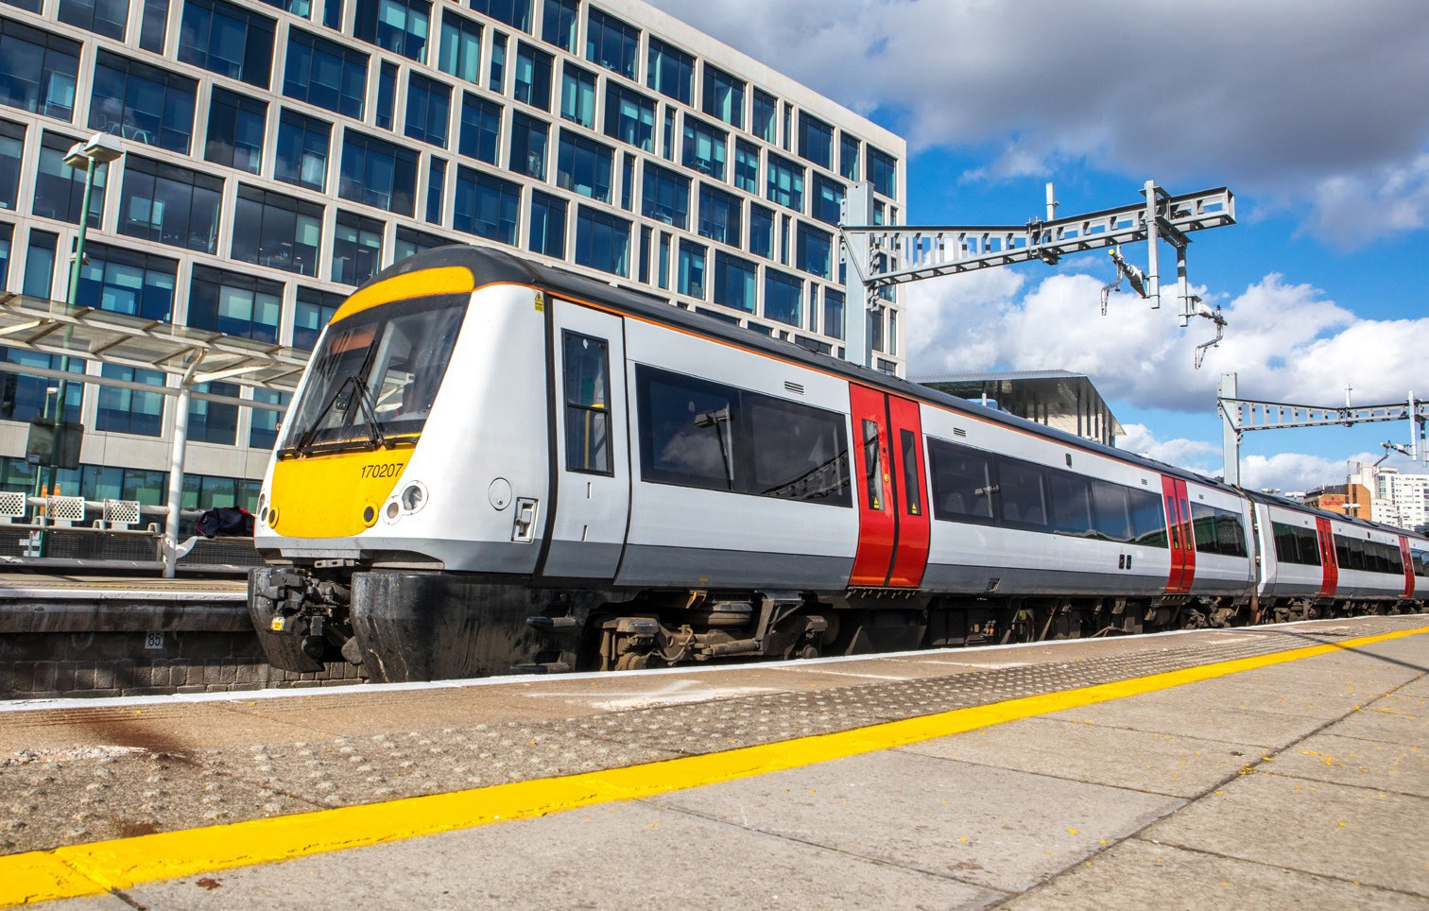

Class 170
Type of train Year built Number in fleet Seating capacity Toilets
Wheelchair accessible toilet Wheelchair users’ space Priority Seating
Bicycle space
On board facilities

Routes operated

Two and three carriage diesel train 1998 to 2005
4 two car and 8 three car units
126 in the two car and 187 in the three car 2
1
2
Yes 2
Public address, visual information screens,
access ramp, and push button doors. Wifi due to be fitted in September 2020.
Services between Maesteg, Cardiff, Ebbw Vale and Cheltenham.

