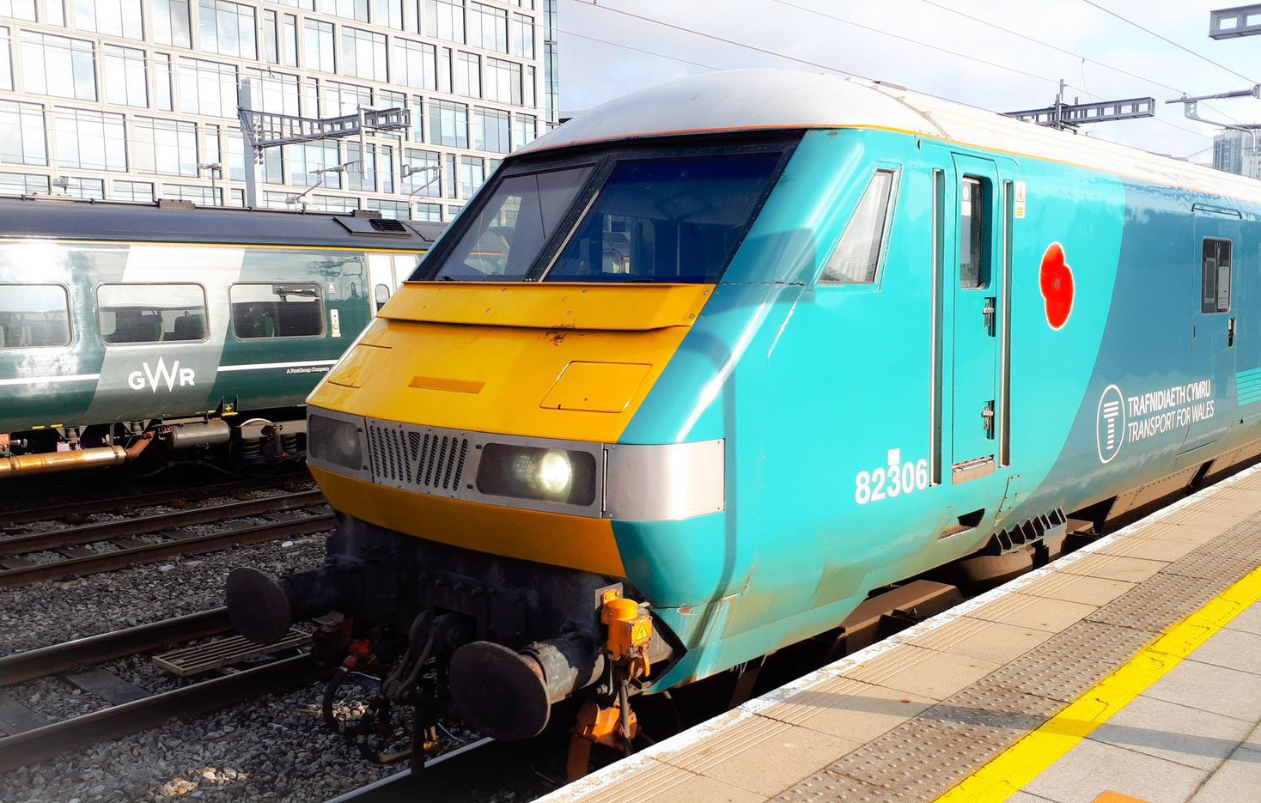

Long distance locomotive hauled services
Type of train Diesel locomotive and four carriages
Year built 1989 to 1992
Number in fleet 3
Seating capacity 46 First Class, 202 Standard Class
Toilets 4
Wheelchair accessible toilet No
Wheelchair users’ space 2
Priority Seating Yes
Bicycle space 5
On board facilities Public address, access ramp, assistance button, Wifi
and Restaurant car on the Holyhead to Cardiff service in both directions.
Routes operated Holyhead to Cardiff in both directions.
Holyhead to Chester and Manchester in both directions.

