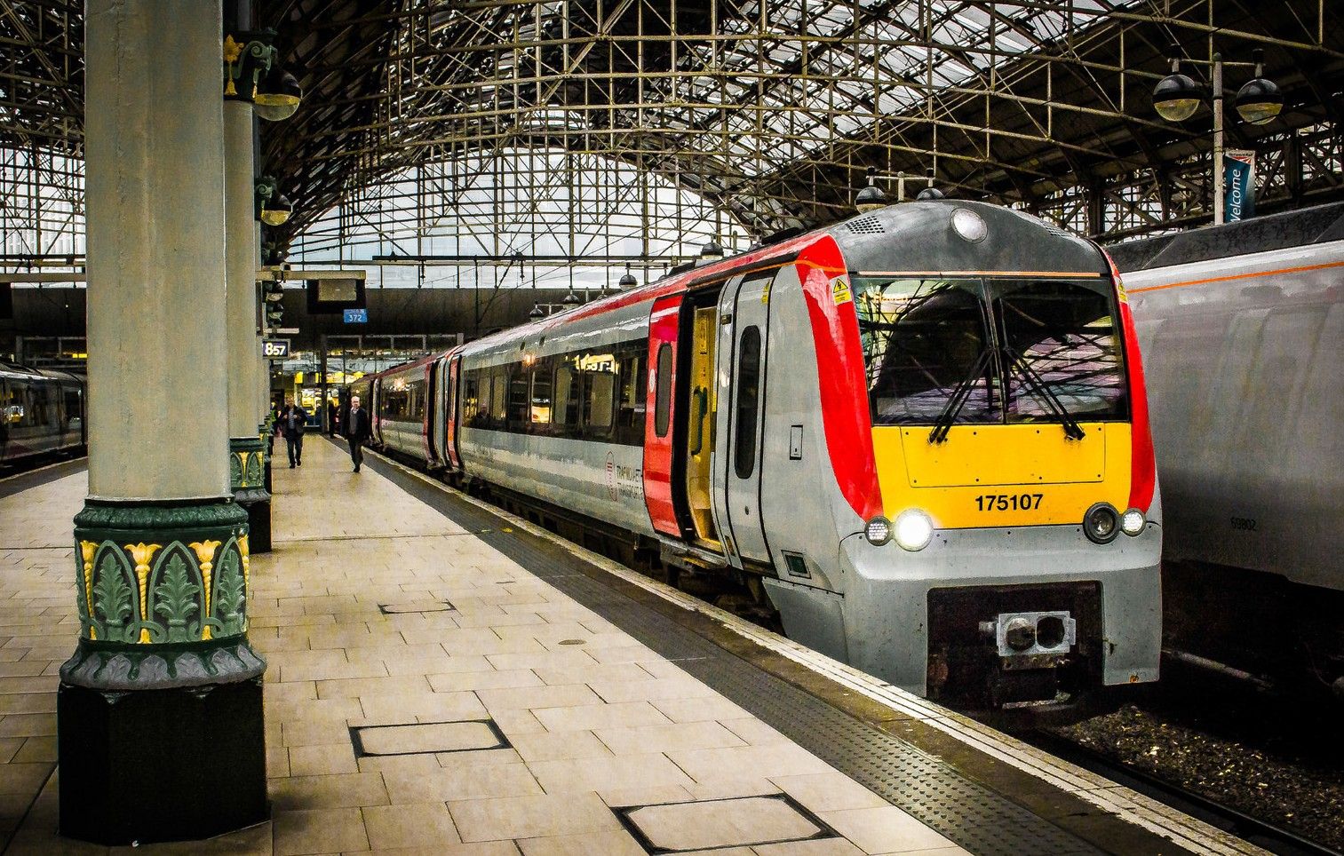

Class 175
Type of train Two and three carriage diesel train
Year built 1999 to 2001
Number in fleet 11 two car and 16 three car trains
Seating capacity 122 in the two car and 190 in the three car
Toilets 2
Wheelchair accessible toilet 1
Wheelchair users’ space 2
Priority Seating Yes
Bicycle space 2
On board facilities Public address, visual information screens,
assistance button, access ramp, push button doors, baby changing, Wifi, assistance button, baby changing, power points and at seat catering on selected services.
Routes operated Long distance services between West Wales, Swansea, Cardiff, Shrewsbury, Manchester and Holyhead.
Maesteg to Cardiff and Ebbw Vale.

