Making Rail Accessible
A guide to our fleet of trains

Last updated 1st August 2020

Welcome on board

This document provides an overview of Transport for Wales’ current fleet of trains, detailing the facilities available on board for persons with reduced mobility.

A new fleet of trains will gradually be introduced between now and December
2022. Details will be included within this document as and when each type of train is refurbished or withdrawn and replaced.

Assisted Travel Team
Our Assisted Travel Team can provide advice, book assistance and arrange tickets for your journey, regardless of train operator. They can be contacted on 033 300 50 501 between 8am and 8pm every day except Christmas Day. The Next Generation Text service number for people with hearing and speech difficulties is
18001 033 300 50 501.

Assistance during your journey
Should you require assistance with boarding and alighting the train, this will be provided by the conductor on the train or by station staff where staff are present. Details of which stations have staff and the times they are available to assist can be found on page xx of our booklet ‘Making Rail Accessible - helping older and disabled passengers.’

Wheelchairs and powered mobility scooters on trains
We can accommodate wheelchairs and powered mobility scooters with dimensions of up to 700mm x 1200mm (including footplates), with a turning radius of 900mm, and a maximum combined weight (wheelchair and passenger) of 300kg. Please check the dimensions of your wheelchair and powered mobility scooter before travel to avoid disappointment if they cannot be carried on the train.

Services between Holyhead, Manchester and Cardiff in both directions
Please note that some services on these routes are operated by traditional engine and coaches and do not have wheelchair-accessible toilets. They also have doors that have to be opened manually. The Assisted Travel team can tell you which services are operated by these trains. If the train you want does not have an accessible toilet, the Assisted Travel team will tell you this when you book and can suggest alternative services for you.

Services between Rhymney and Cardiff in both directions
Please note that some services on this route are operated by traditional engine and coaches and do not have dedicated spaces for wheelchair users. They also have doors that have to be opened manually. The Assisted Travel team can tell you which services are operated by these trains. If the train you want is not accessible to you, the Assisted Travel team can suggest alternative services for you.

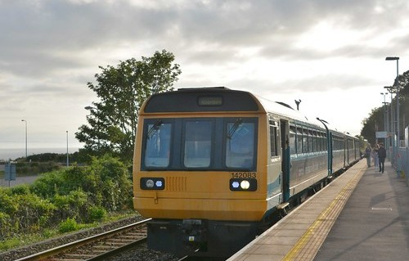

Class 142

Type of train Two carriage diesel train
Year built 1985 to 1987
Number in fleet 15
Seating capacity 102 + 6 tip up seats
Toilets 1
Wheelchair accessible toilet No
Wheelchair users’ space 2
Priority seating No
Bicycle space 2
On board facilities Public address, access ramp, Wifi and push button
doors. These trains do not have visual information screens.
Routes operated Cardiff Valleys network.
Cardiff to Swansea and West Wales. Cardiff to Ebbw Vale and Cheltenham.

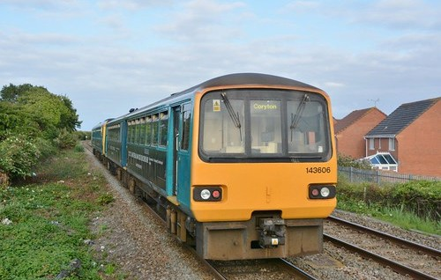

Class 143

Type of train Two carriage diesel train
Year built 1985 to 1986
Number in fleet 15
Seating capacity 104 + 6 tip up seats
Toilets 1
Wheelchair accessible toilet No
Wheelchair users’ space 2
Priority seating No
Bicycle space 2
On board facilities Public address, access ramp, Wifi and push button
doors. These trains do not have visual information screens.
Routes operated Cardiff Valleys network.
Cardiff to Swansea and West Wales. Cardiff to Ebbw Vale and Cheltenham.

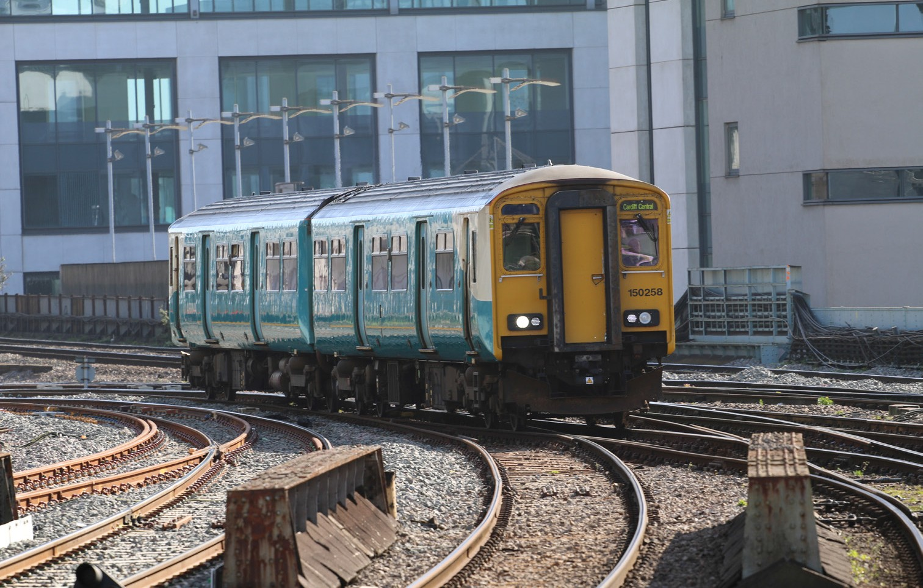

Class 150

Type of train Two carriage diesel train
Year built 1987
Number in fleet 36
Seating capacity 108 + 6 tip up seats on refurbished fleet. A refurbishment programme is currently in progress and due to be completed in August 2020.
Toilets 2
Wheelchair accessible toilet None on the non refurbished fleet.
1 on refurbished fleet.
Wheelchair users’ space 2
Priority seating Yes - on refurbished trains only
Bicycle space 2
On board facilities Public address, visual information screens*, access
ramp, Wifi, power points* and push button doors.
*Available on the refurbished fleet.
Routes operated Swansea to Shrewsbury via Llandovery.
Cardiff to Swansea and West Wales. Llandudno Junction to Blaenau Ffestiniog. Wrexham to Bidston Line.
Cardiff Valleys network and Maesteg. Cardiff to Ebbw Vale and Cheltenham.

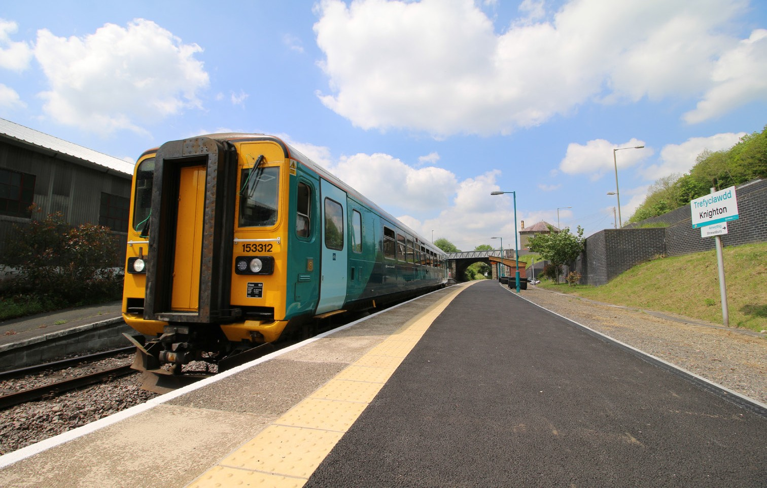

Class 153

Type of train Single carriage diesel train
Year built 1987 / 1988
Number in fleet 22
Seating capacity 59 on refurbished fleet.
72 on non refurbished fleet.
Fleet refurbishment is currently in progress and due to be completed in August 2020 for 1 units.
Toilets 1
Wheelchair accessible toilet None on the non refurbished fleet.
1 on the refurbished fleet.
Wheelchair users’ space 1 space on the non refurbished fleet
- spaces on the refurbished fleet.
Priority Seating 6
Bicycle space 2
On board facilities Public address, visual information screens*, access
ramp, Wifi, power points* and push button doors.
*Available on the refurbished fleet.
Routes operated Swansea to Shrewsbury via Llandovery.
Cardiff to Swansea and West Wales. Llandudno Junction to Blaenau Ffestiniog. Coryton to Radyr.
Cardiff Queen Street to Cardiff Bay.

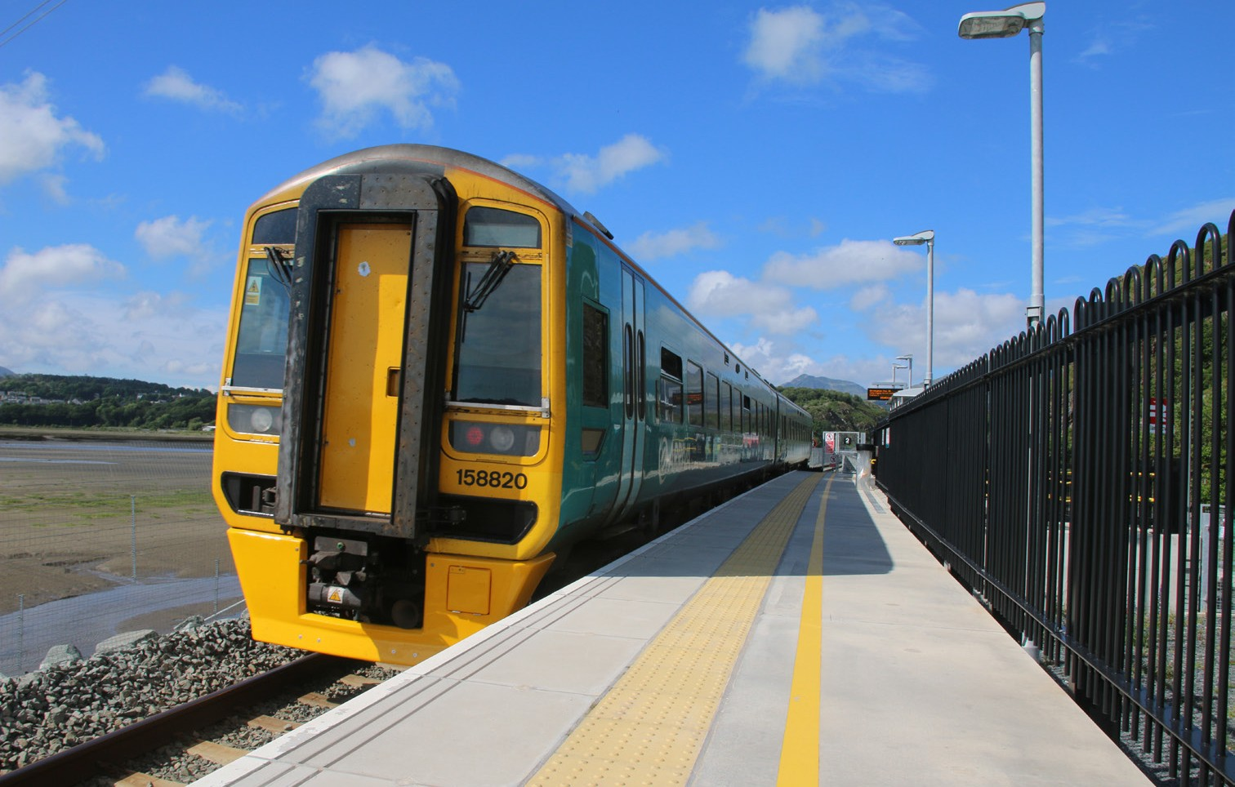

Class 158
Type of train Two carriage diesel train
Year built 1989 to 1992
Number in fleet 24
Seating capacity 138
Toilets 2
Wheelchair accessible toilet 1
(Accessible toilet door is 780mm wide Standard toilet door is 460mm wide.)
Wheelchair users’ space 2
Bicycle space 2
Priority Seating Yes
On board facilities Public address, visual information screens,
assistance button, access ramp, push button doors, baby changing, Wifi, assistance button, baby changing, power points and at seat catering on selected services.
Routes operated Long distance services between West Wales, Swansea, Cardiff, Shrewsbury, Manchester and Holyhead.
Aberystwyth and Pwllheli to Shrewsbury and Birmingham International.
Maesteg to Cardiff, Ebbw Vale and Cheltenham.

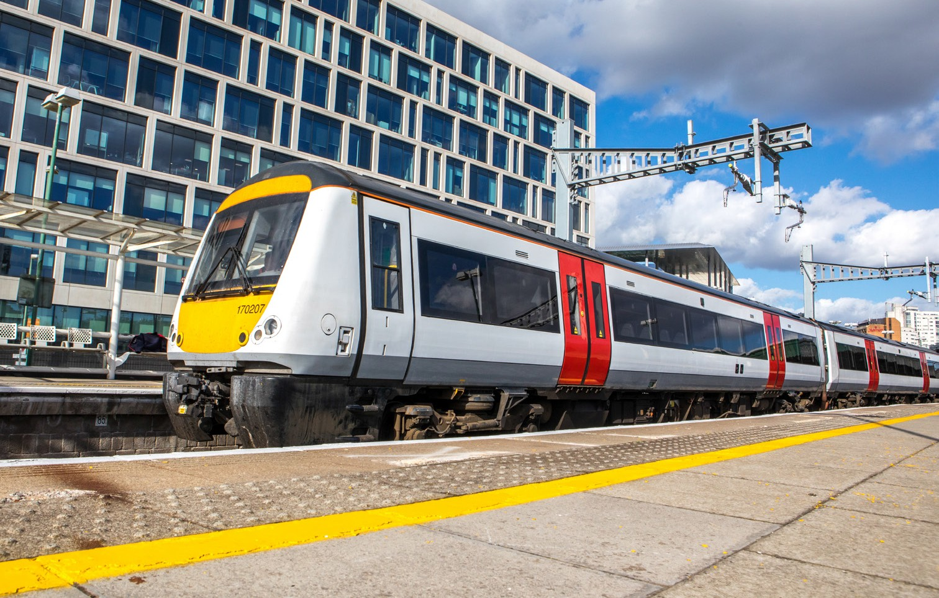

Class 170
Type of train Two and three carriage diesel train
Year built 1998 to 2005
Number in fleet 4 two car and 8 three car units
Seating capacity 126 in the two car and 187 in the three car
Toilets 2
Wheelchair accessible toilet 1
Wheelchair users’ space 2
Priority Seating Yes
Bicycle space 2
On board facilities Public address, visual information screens,
access ramp, and push button doors. Wifi due to be fitted in September 2020.
Routes operated Services between Maesteg, Cardiff, Ebbw Vale and
Cheltenham.

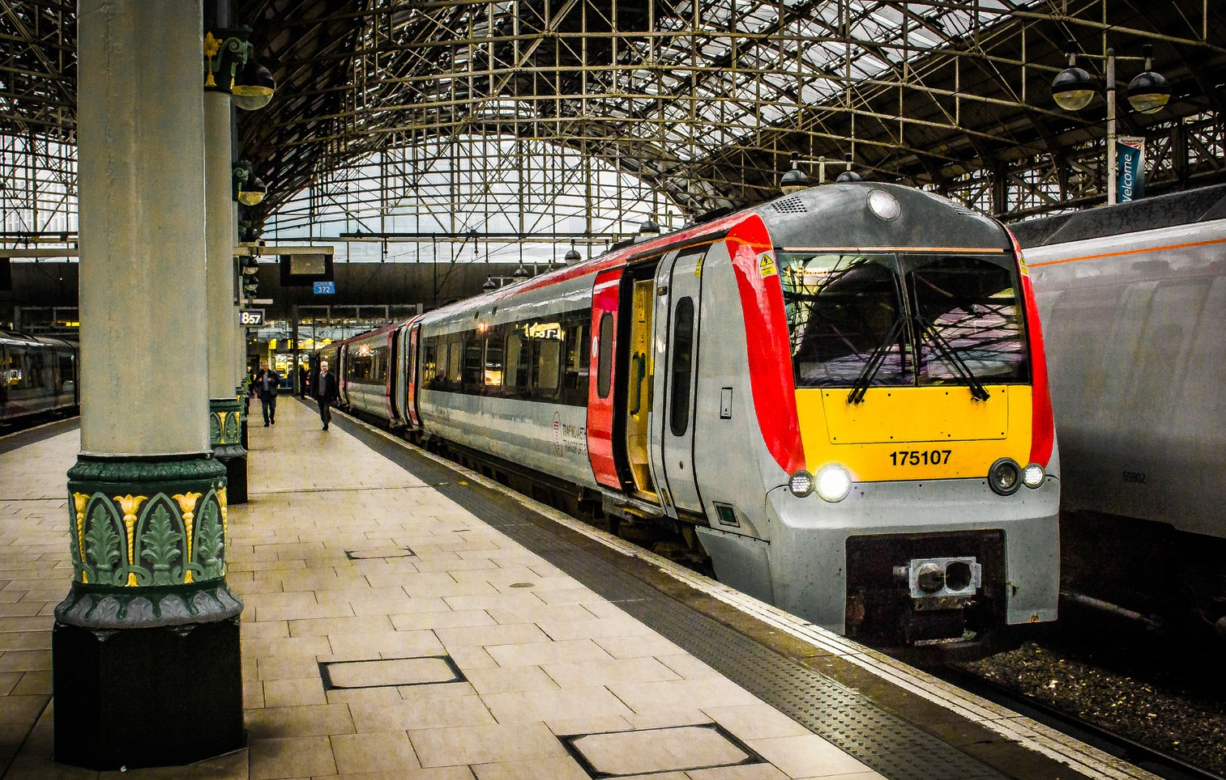

Class 175
Type of train Two and three carriage diesel train
Year built 1999 to 2001
Number in fleet 11 two car and 16 three car trains
Seating capacity 122 in the two car and 190 in the three car
Toilets 2
Wheelchair accessible toilet 1
Wheelchair users’ space 2
Priority Seating Yes
Bicycle space 2
On board facilities Public address, visual information screens,
assistance button, access ramp, push button doors, baby changing, Wifi, assistance button, baby changing, power points and at seat catering on selected services.
Routes operated Long distance services between West Wales, Swansea, Cardiff, Shrewsbury, Manchester and Holyhead.
Maesteg to Cardiff and Ebbw Vale.

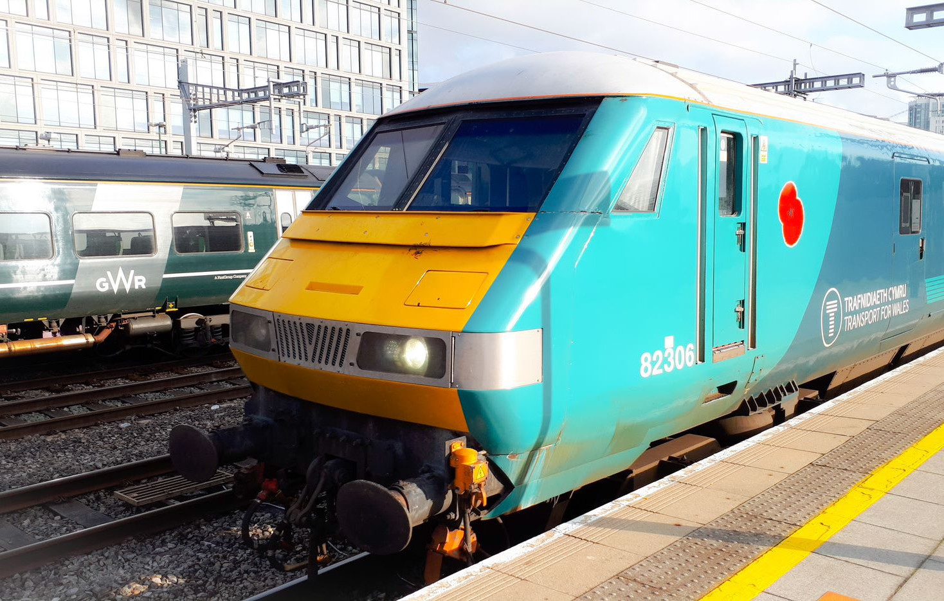

Long distance locomotive hauled services
Type of train Diesel locomotive and four carriages
Year built 1989 to 1992
Number in fleet 3
Seating capacity 46 First Class, 202 Standard Class
Toilets 4
Wheelchair accessible toilet No
Wheelchair users’ space 2
Priority Seating Yes
Bicycle space 5
On board facilities Public address, access ramp, assistance button, Wifi
and Restaurant car on the Holyhead to Cardiff service in both directions.
Routes operated Holyhead to Cardiff in both directions.
Holyhead to Chester and Manchester in both directions.

