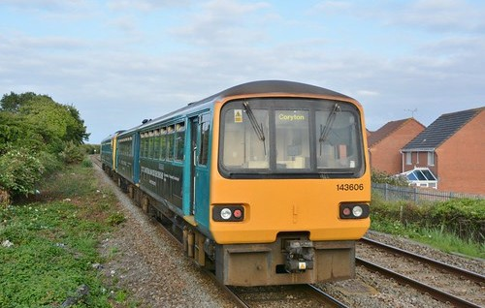

Class 143

Type of train Two carriage diesel train
Year built 1985 to 1986
Number in fleet 15
Seating capacity 104 + 6 tip up seats
Toilets 1
Wheelchair accessible toilet No
Wheelchair users’ space 2
Priority seating No
Bicycle space 2
On board facilities Public address, access ramp, Wifi and push button
doors. These trains do not have visual information screens.
Routes operated Cardiff Valleys network.
Cardiff to Swansea and West Wales. Cardiff to Ebbw Vale and Cheltenham.

