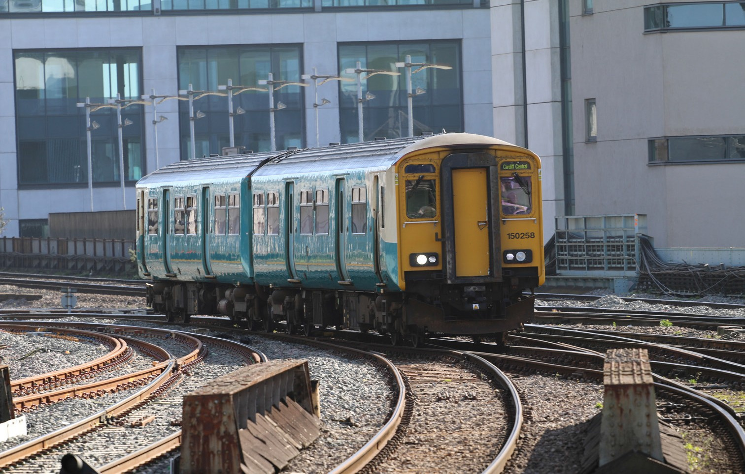

Class 150
Type of train Two carriage diesel train
Year built 1987
Number in fleet 36
Seating capacity 108 + 6 tip up seats on refurbished fleet. A refurbishment programme is currently in progress and due to be completed in August 2020.
Toilets 2
Wheelchair accessible toilet None on the non refurbished fleet.
1 on refurbished fleet.
Wheelchair users’ space 2
Priority seating Yes - on refurbished trains only
Bicycle space 2
On board facilities Public address, visual information screens*, access
ramp, Wifi, power points* and push button doors.
*Available on the refurbished fleet.
Routes operated Swansea to Shrewsbury via Llandovery.
Cardiff to Swansea and West Wales. Llandudno Junction to Blaenau Ffestiniog. Wrexham to Bidston Line.
Cardiff Valleys network and Maesteg. Cardiff to Ebbw Vale and Cheltenham.

