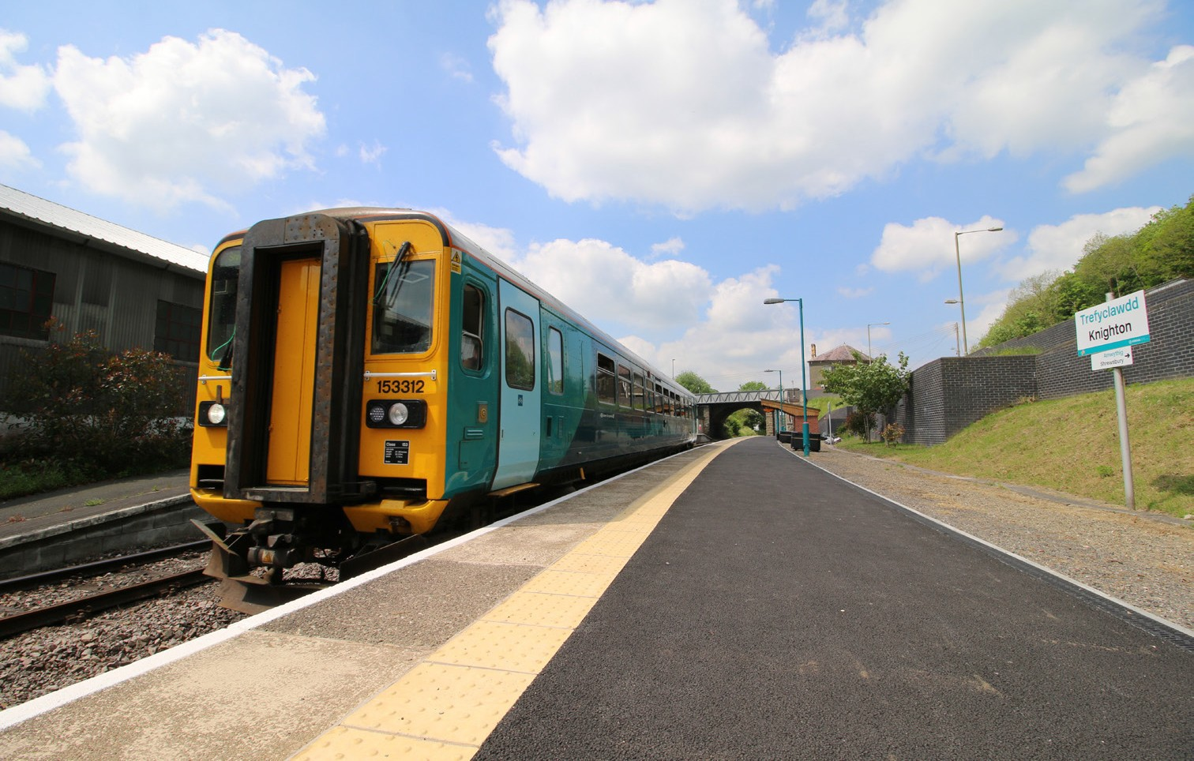

Class 153
Type of train Single carriage diesel train
Year built 1987 / 1988
Number in fleet 22
Seating capacity 59 on refurbished fleet.
72 on non refurbished fleet.
Fleet refurbishment is currently in progress and due to be completed in August 2020 for 1 units.
Toilets 1
Wheelchair accessible toilet None on the non refurbished fleet.
1 on the refurbished fleet.
Wheelchair users’ space 1 space on the non refurbished fleet
1 spaces on the refurbished fleet.
Priority Seating 6
Bicycle space 2
On board facilities Public address, visual information screens*, access
ramp, Wifi, power points* and push button doors.
*Available on the refurbished fleet.
Routes operated Swansea to Shrewsbury via Llandovery.
Cardiff to Swansea and West Wales. Llandudno Junction to Blaenau Ffestiniog. Coryton to Radyr.
Cardiff Queen Street to Cardiff Bay.

