Fforwm Rhanddeiliaid Rhanbarthol Cymru a'r Gororau Wales & Borders Regional Stakeholder Forum
07/03/2023
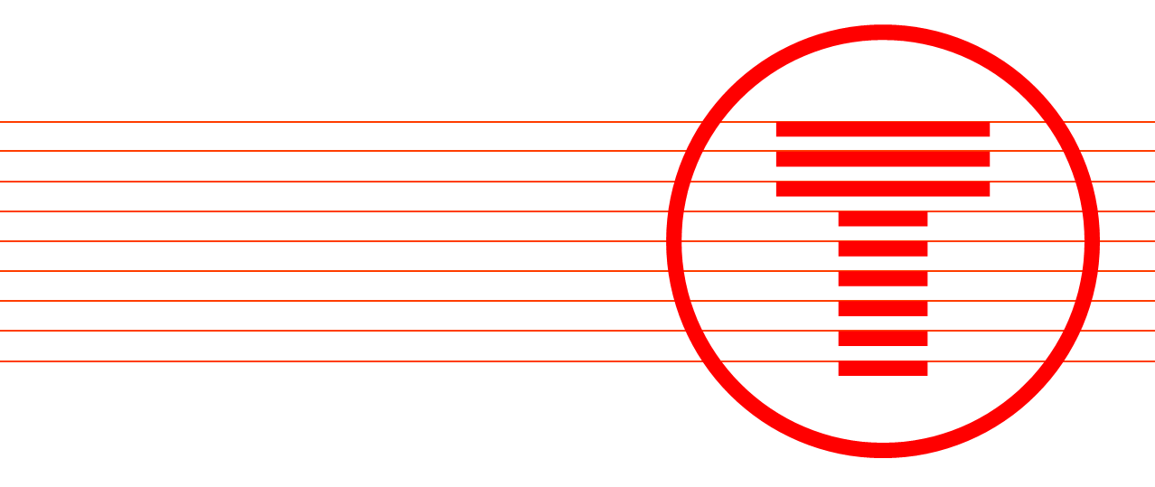

Adroddiad o’r cyfarfod
Meeting report

Wales & Borders Regional Stakeholder Forum
The forum met on the 7th March 2023, 13:00 – 15:00
Attendees
Forum Members
Christian Schmidt | Monmouthshire County Council
Gemma Lelliott
Lindsey McDonald
Michelle Roles | Transport Focus Wales
Rich Middleton | Great Western Railways
Richard Gibson | Newport City Council
Toby Rackliff

Transport for Wales
(Chair) Nichole Sarra | Stakeholder Manager
Alex Chung | Community Engagement Officer
Gareth Potter | Senior Project Manager
Emily Staples | Project Manager
Louise Price-David | Comms Business Partner

Note from the Chair, {Nichole Sarra }
“I am very pleased that the Forum session went very well. Can I thank members who were able to attend for your time and contributions and also the presenters who engaged us across a range of topics. We had useful discussions of opportunities and key challenges for the future including the changed model for rail operations and rebuilding confidence in public transport. Please can I encourage your continuing contributions to these topics – time in the session is quite short and also to include those not able to join us; to benefit from the panel’s wide experience and advice to support Transport for Wales to plan during this important time.”

Agenda
- Wales and the Borders Regional Stakeholder Forum Introduction – Nichole Sarra (TfW Stakeholder Manager & Chair Regional Forum)
Introduction was made by Nichole Sarra, Stakeholder Manager for borders area of the Wales and Borders Network. This was the first regional forum of 2023, in which the only item on the agenda was Newport Central Travel improvement consultation.
- Newport Central Transport Improvement Consultation – Gareth Potter (TfW Senior Project Manager)

Chair introduced Gareth Potter, Senior Project Manager at Transport for Wales to provided presentation overview on the Newport Central Travel Improvement consultation, which is live from 24th February 2023 to 6th April 2023.

Gareth informed attendees that the project originated from Southeast Wales Transport Commission, which was chaired by Lord Burns. In which, 58 final recommendations were created to improve public transport and active travel links within South East Wales area. Timeline was shown detailing, how the project had got to today date –

- Final Report of recommendations from South East Wales Transport Commission – Nov 2020
- Accepted in principle by Welsh Government of Final Report – Jan 2021
- Burns Delivery Board Established to take recommendations forward – Mar 2021
- Burns Delivery Board first annual report, in which a free bus pilot was launch for Newport – Jan 2022
- Burn Delivery Board second annual report – Jan 2023

Delivery unit board is chaired independently by Professor Simon Gibson & Dr Lynn Sloman working collaboratively with Cardiff, Newport and Monmouthshire councils respectively. The task of the delivery unit is to start to build the network of alternative recommendations set out in the SEWTC final report in Nov 2020.
Gareth went onto explain three of the current projects that his team is assigned too, which are:
- Cardiff to Newport Corridor Project, which went out to public consultation in 2022.

- Newport Central Infrastructure Project and Behaviour Change Pilots (Newport Central Travel Improvement project), this being the project that currently out for consultation between Feb and April 2023 and presentation being delivered on.

- Severn Tunnel Junction Access Park & Ride, provide new bus access and potential connection to motorway. Public Consultation was held for this project in 2022.

Current development timeline was shown that was updated from the Burns Delivery Board second annual report. In which stated the desire to secure funding and delivery of these three projects by 2026 at current forecast. Gareth explained that the rail improvement recommendations, including five new stations and enhanced passengers services were being taken forward by a separate team within Transport for Wales as part of the South Wales Mainline Programme.
Gareth moved on to provide the current timeline for the Newport Central Travel Improvement project:
- 2021-2022 – WelTAG Stages 1-2a
- 2022-2023 – WelTAG Stages 2b + Public Consultation
- 2023-2024 – Final Business case submitted to Welsh Government

The project proposal aims are to make it easier to travel to Newport Railway Station, the city centre and Riverfront through old green junction roundabout. The changes will make it easier for people to travel by Bus, Walking and Cycling.

The five aims that are to be achieved for this project are:

- Make it more convenient and quicker to change between rail and bus at the railway station.

- Make it easier to travel by walking, cycling, bus and rail to and from the railway station and the city centre.

- Improve the passenger experience and welcome at the railway station.

- Provide good-quality walking and cycling routes to the railway station and city centre which are safe and attractive.

- Create a green and healthy people-focussed environment around the railway station, old green and the riverfront.

Before and after images were then shown of part 1 and 2 of the project and how the intended changes and improvements would look and work for the area.
- Part 1 – Newport Railway Station and Queensway
- Part 2 – Old Green Junction and the Riverfront

Part 1 proposals to Newport Railway Station to Queensway changes would include:
- Current existing Taxi rank being relocated closer to the entrance of the station, where the current pick up and drop up facility is.
- Creation of six bus bays where the current taxi rank is to improve connectivity between bus and rail.
- Potential for bike storage facility or bike hire scheme
- Placemaking improvements along Queensway

These proposals are being shown live to the public as part of the consultation to feedback on within an online survey on the opinions of how people think the proposals put forward would improve and encourage the use of, walking, cycling, bus and rail connectivity.
Gareth explains reasons for part 2 proposals, were due to a number of reasons some being:
- Connection for residents that live on east side of the city, trying to access the city centre as there are currently several subways and footbridges that needed to be crossed.
- Safety of those subways at night for residents of the city
- The current layout of the junction goes against the Wales Transport Strategy Priority.

Note at this point Gareth played a video rendering flythrough of how all changes would look.
Part 2 proposals from Old Green Junction and the Riverfront changes would include:
- New compact junction which would prioritise walking, cycling and bus in the directions that are needed.
- Purpose built bus gate to exit market square bus station (Friers Walk) to return Southbound.
- Separated cycle and walking routes for safety.
- Removal of subways, which would result in more direct surface level walking and cycling.

It was explained that part 2 of this project being Old Green to the Riverfront, is being put forward as a three option approached compared to part 1, which as Gareth explained is a single concept option.
These three options of part 2 are:
- Option A – Balance of Benefits, this would mean balance approach between, cycling, walking, bus and public green spaces.
- Option B – Public space focus, Riverfront would be maximized in the creation of green public space. However, would cause more delays to traffic and buses compared to option A.
- Option C – Bus Station Focus, current Market Square Bus station space would be increased to encourage more bus activity. However, again would cause the same delays as option B, that option A mitigates.

Gareth lastly showed the finals things that were to be considered by the public in the consultation, which were the old green murals, located on the roundabout itself and in the subways. Consultation is asking residents what they would like us to do with the murals as we understand at TfW and Newport City Council the importance and heritage these murals bring and are to the people of Newport.
Final slides in the presentation touched on next steps after the consultation. As demonstrates by Gareth in the presentation, currently project is at WelTAG stage 3 being public consultation. Then leading into stage 4 & 5, of preferred option design identification and construction of option scheme and post-opening monitoring.
Gareth then invited Nicole in to help explain TfW and Newport City Council communication strategy for the consultation that focused on inclusive, bilingual and accessible forms of communication and material. Through various platforms and tools such as:
- Engagement HQ
- Public drop-in events
- Online social media ad campaigns
- Press releases.
- Bulletins and newsletters
- Stakeholder letters
- Paper copies for resident’s request

Nicole that went onto explain TfW recently procured new engagement platform that is being used for the consultation and has been used for other TfW consultations called Engagement HQ. The platform allows for information to be displayed and engaged with in a more user friendly and accessible format. Those interested in the consultation can access the page and be provided with links to supporting documentation, video rendering and answering the public survey.
So far the survey responses have been over a 1000 people within first couple weeks of the consultation going live.
Presentation was then concluded, and room was open to questions. No such questions were put to Gareth, other than points raised by Christian Schmidt that Richard Gibson from Newport City Council has answered on behalf of Gareth.
Richard Gibson invited to talk by Gareth, Richard welcomed the work being done on the consultation and the collaboration between TfW and Newport City Council. He recognised that the consultation proposals, were challenges that they have been trying to solve for years and pleased to see proposals put to the public and welcome those on the forum to participate in the survey and feedback information.

Actions

The actions below were raised during the forum and will be addressed prior to the next Regional Forum where possible.

Action | What will be done?

Next Regional Stakeholder Forum

The next Wales & Borders Regional Stakeholder Forum is scheduled for late June 2023. The meeting will be held virtually over the Microsoft Teams platform between xx:xx – xx:xx.

