**Date issued:** 11th of July 2021

**Freedom of Information Request** 104/23

We are writing in response to your Freedom of Information request. Your request has been considered in accordance with the requirements of the Freedom of Information Act and our Data and Information Management Policy.

**YOU ASKED US…**

**I'm trying to find information regarding the punctuality of scheduled trains on the Wrexham - Bidston line for the period of January to March. Excluding strike days.**

**RESPONSE**

Please find below the requested data below P11 = 56.5%, P12 = 46.0% and P13 = Service suspended with RRS.

Please note: These are 28 days periods that Transport for Wales use when measuring performance dates are as below:

P11: Sunday 08 January 2023 - Saturday 04 February 2023

P12: Sunday 05 February 2023 - Saturday 04 March 2023

P13: Sunday 05 March 2023 - Friday 31 March 2023 *(shorter as period 13 always finishes on 31st March)*

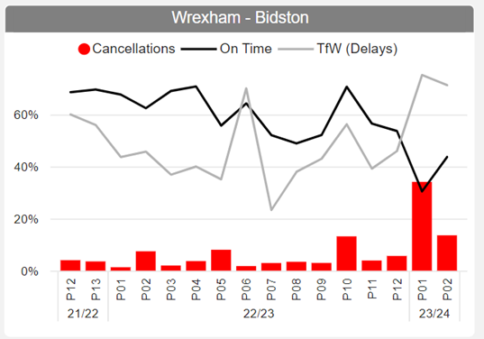

We hope this information is of use to you.

Yours sincerely,

**Transport for Wales**

**Appeal Rights**

If you are unhappy with the way your request has been handled and wish to make a complaint or request a review of our decision, please write to the Head of Freedom of Information at either Transport for Wales, 3 Llys Cdwyn, Pontypridd, CF37 4TH or [freedomofinformation@tfw.wales](mailto:freedomofinformation@tfw.wales). Your request must be submitted within 40 working days of receipt of this letter. If you are not content with the outcome of the internal review, you have the right to apply directly to the Information Commissioner for a decision.

The Information Commissioner (ICO) can be contacted at Information Commissioner's Office, Wycliffe House, Water Lane, Wilmslow, Cheshire, SK9 5AF or you can contact the ICO through the 'Make a Complaint' section of their website on this link: <https://ico.org.uk/make-a-complaint/>

The relevant section to select will be "Official or Public Information".