**Date issued:** 12th of January 2024

**Freedom of Information Request** 04/24

We are writing in response to your Freedom of Information request. Your request has been considered in accordance with the requirements of the Freedom of Information Act and our Data and Information Management Policy.

**YOU ASKED US…**

**Since the closure of the Rhondda line how many complaints has TFW received to date.**

**I how many complaints has TFW received since the closure of the Rhondda line due to replacement bus services not turning up on time or at all.**

**RESPONSE**

Question 1

The Rhondda line closed in April 2023 (23/24 P1) Since then we have received 29,715 complaints in total. (Source: ORR Periodic)

Question 2

Since the Rhondda line closed in April 2023 (23/24 P1), TfW has received 166 complaints about CVL Bus Replacement services. (Source: CRM Rail)

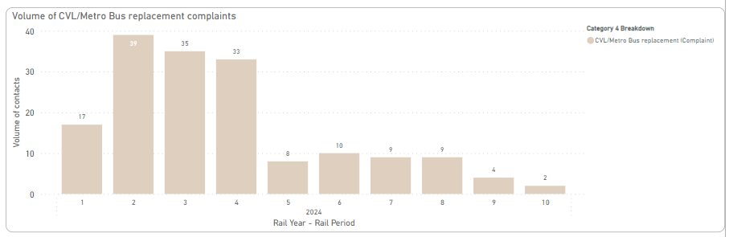

Of those 166 complaints about CVL Bus replacement services, 57 specifically mention delays, lateness or not turning up. (Source: CRM Rail)

We hope this information is of use to you.

Yours sincerely,

**Transport for Wales**

**Appeal Rights**

If you are unhappy with the way your request has been handled and wish to make a complaint or request a review of our decision, please write to the Head of Freedom of Information at either Transport for Wales, 3 Llys Cadwyn, Pontypridd, CF37 4TH or [freedomofinformation@tfw.wales](mailto:freedomofinformation@tfw.wales). Your request must be submitted within 40 working days of receipt of this letter. If you are not content with the outcome of the internal review, you have the right to apply directly to the Information Commissioner for a decision.

The Information Commissioner (ICO) can be contacted at Information Commissioner's Office, Wycliffe House, Water Lane, Wilmslow, Cheshire, SK9 5AF or you can contact the ICO through the 'Make a Complaint' section of their website on this link: <https://ico.org.uk/make-a-complaint/>

The relevant section to select will be "Official or Public Information".