20 mph Phase 1 - Air Quality Monitoring Report
Document no: B2437100/REP/001
Transport for Wales

9 May 2024
Jacobs U.K. Limited
2nd Floor, Cottons Centre  Cottons Lane  London SE1 2QG  United Kingdom | www.jacobs.com
© Copyright 2024 Jacobs U.K. Limited. All rights reserved. The content and information contained in this document are the property of the Jacobs group of companies (“Jacobs Group”). Publication, distribution, or reproduction of this document in whole or in part without the written permission of Jacobs Group constitutes an infringement of copyright. Jacobs, the Jacobs logo, and all other Jacobs Group trademarks are the property of Jacobs Group.
NOTICE: This document has been prepared exclusively for the use and benefit of Jacobs Group client. Jacobs Group accepts no liability or responsibility for any use or reliance upon this document by any third party.

Executive summary
The 20 mph Task Force Group report, published in 2020, set out the key performance indicators which should be monitored as part of 20 mph Phase 1, including “Air quality remaining [the] same (at the least)”. In 2021, TfW commissioned Jacobs to develop an air quality assessment methodology to assess changes in air pollution (if any) resulting from the implementation of the 20 mph default speed limit. The methodology proposed the use of air quality sensors to measure the impact in three separate Phase 1 areas.
Air quality sensors were deployed at locations in Cardiff, Severnside (Magor) and Abergavenny, to monitor differences in concentrations of nitrogen dioxide (NO₂), particulate matter less than 10 µm in diameter (PM₁₀) and particulate matter less than 2.5 µm in diameter (PM_{2.5}). Pairs of sensors were located on the same stretch of road, one ‘inside’ and one ‘outside’ of the introduced 20 mph speed limit, in an attempt to measure its influence on air quality.
In order to improve the accuracy of the results obtained, prior to installation and periodically over the duration of the monitoring, the sensors used were calibrated against a more accurate reference station forming part of the Air Quality Wales Network at Bridgend.
Data was obtained and analysed from May 2022 through to April 2024. Whilst concentrations of PM₁₀ and PM_{2.5} were measured, it was found that road traffic emissions on adjacent roads contributed very little to the measured PM₁₀ and PM_{2.5} concentrations at each pair of sensors. As such, the assessment has focussed on the pollutant NO₂, which, as shown by the monitoring undertaken, is strongly influenced by road traffic exhaust emissions, especially at the roadside.
In addition to the air quality monitoring, traffic volume and speed was also monitored at a nearby location within the 20 mph speed limit area in Cardiff and Magor and at nearby locations both inside and outside the 20mph speed limit area in Abergavenny. Where possible, the traffic data were compared to the air quality data to assess whether any observed differences in measured NO₂ concentrations could reasonably be attributed to differences in vehicle speed following the introduction of the 20 mph limit.
Additional supplementary analysis has also been undertaken to consider:
- Wider trends in air quality within Wales over similar timescales.
- The impact of regional air pollution episodes on concentrations measured by the air quality sensors.
- The impact of a period of nearby construction and traffic management on measured NO₂ concentrations adjacent to one of the sensors in Cardiff.
- The impact of a new raised pedestrian crossing on measured NO₂ concentrations adjacent to one of the sensors in Cardiff.
- The impact of partial temporary closures of the M48 (and resulting increased traffic congestion on local roads) on measured NO₂ concentrations at one of the sensors in Magor.
- The impact of speed enforcement activities within the 20 mph speed limit area in Magor on measured NO₂ concentrations.

Summary of Results
A summary of average measured NO₂ concentrations at the sensors inside and outside each of the 20 mph speed limit areas (and the resulting difference) is presented in Table ES-1, along with the estimated average measurement error of the sensors. The results obtained in each area are discussed further in the sub-sections below and in the full technical report. In summary:
- All measured concentrations of NO₂ were within the level of the relevant annual mean Air Quality Objective / Limit Value. Furthermore, these measurements were made at the roadside, meaning NO₂ concentrations at the nearest residential properties, which are set further back, would likely be much lower. This is because NO₂ concentrations typically decrease rapidly with increasing distance from a road due to the increased dispersion and dilution of road traffic emissions.
- The differences in measured NO₂ concentrations between the sensors inside the 20 mph speed limit area relative to those outside the area were mainly small relative to the annual mean NO₂ Air Quality Objective / Limit Value. The differences were also within the range of average measurement error, apart from in Magor.
- At Cardiff Outside Location 2 and Magor, measured NO₂ concentrations inside the 20 mph speed limit were lower than those outside the 20 mph speed limit, with the largest difference being at Magor. Potential reasons for these differences are discussed in the relevant sub-sections below.
- At Cardiff Outside Location 1 and Abergavenny, measured NO₂ concentrations inside the 20 mph speed limit were slightly higher than those outside the 20mph speed limit, but well within the range of measurement error. Again, potential reasons for these differences are discussed in the relevant sub-sections below.
Table ES-1. Summary NO₂ concentration data within each area
Area | Average Measured NO₂ Concentration Inside 20mph Speed limit  (µg/m³) | Average Measured NO₂ Concentration Outside 20mph Speed limit  (µg/m³) | Difference Between Inside and Outside 20mph Speed limit  (µg/m³) | Average NO₂ Concentration Measurement Error  (µg/m³)
Cardiff (using Outside Location 1) | 21.0 | 20.6 | +0.4 | 3.6 – 3.8
Cardiff (using Outside Location 2) | 21.7 | 23.3 | -1.6 | 1.4 – 4.3
Magor (Severnside) | 20.2 | 25.8 | -5.6 | 2.6 - 5.1
Abergavenny | 15.0 | 14.5 | +0.5 | 1.6 - 2.7

Cardiff
Monitoring was undertaken in Cardiff between May 2022 and March 2024. However, the sensor outside the 20 mph speed limit had to be moved (from Outside Location 1 to Outside Location 2) following the construction of a raised pedestrian crossing adjacent to the sensor. This crossing was thought likely to cause frequent deceleration and acceleration events and hence increased road traffic emissions. Construction activities and related traffic management were present in this area from late November 2022 to early January 2023, the impact of which can clearly be seen in the measurement data. The measurement data obtained during this ‘construction’ period were therefore excluded from the analysis. The remainder of the monitoring data obtained indicates:
- Outside Location 1 (before the construction of the crossing) - There was a small difference between the NO₂ concentrations monitored inside and outside the 20 mph speed limit with an average difference of 0.4 µg/m³ higher inside the 20 mph speed limit area. As well as being small in comparison to the annual mean NO₂ Air Quality Objective / Limit Value (40 µg/m³), this difference is well within the average measurement error of the sensors.
- Outside Location 2 (post construction of the crossing) - The sensor outside the 20 mph speed limit recorded an average NO₂ concentration 1.6 µg/m³ higher than the sensor inside the 20 mph speed limit, a small difference in comparison to the annual mean NO₂ Air Quality Objective / Limit Value (40 µg/m³), and within the average measurement error of the sensors for the majority of the time. Outside Location 2 is much closer to the 20 mph speed limit than Outside Location 1 and it is thought that the acceleration of vehicles leaving the 20 mph speed limit as they pass the sensor is potentially a reason for the higher concentrations measured at Outside Location 2.
The construction of the raised pedestrian crossing and associated footway works adjacent to Outside Location 1 resulted in a considerable increase in measured NO₂ concentrations at this location as a result of emissions from construction plant and equipment and associated traffic management (including temporary traffic lights which resulted in increased congestion and acceleration). This inadvertent finding provides additional confidence that the assessment approach used was able to detect changes in exhaust emissions as and when they occurred.

Magor (Severnside)
Monitoring was undertaken inside and outside the 20 mph speed limit in Magor between July 2022 and April 2024. The outside location at Magor has consistently monitored higher concentrations of NO₂ compared to the sensor inside the 20 mph speed limit. This difference is greater than the average measurement error of the sensors for the majority of the time.
As traffic volumes adjacent to each sensor are the same, it is thought likely that the higher NO₂ concentrations outside of the 20 mph speed limit can be explained by a combination of:
- Vehicles potentially still accelerating away from a roundabout to the west as they pass the sensor outside of the 20 mph speed limit, resulting in increased engine load and exhaust emissions.
- The proximity of trees and vegetation to the sensor outside the 20 mph speed limit resulting in a more enclosed environment, meaning pollutants cannot disperse as readily compared to the area adjacent to the sensor within the 20 mph speed limit.
Observed mean speeds (of approximately 30 mph) near to the sensor within the 20 mph speed limit indicate that the measured difference in NO₂ concentrations between the sensors is not as a result of vehicles within the 20 mph speed limit area travelling at 20mph, although it may be that vehicles adjacent to the sensor outside the 20 mph speed limit area are travelling faster than those adjacent to the sensor inside the 20 mph speed limit.
A number of short periods of speed enforcement were undertaken in this area during the monitoring period. Information from the speed enforcement period has been used in an attempt to understand potential impacts on NO₂ concentrations should vehicles travel at mean speeds closer to 20 mph. However, it is considered that the overall duration of speed enforcement (and resulting quantity of monitoring data collected during periods of enforcement) is insufficient to draw firm conclusions as to the potential impact of lower average vehicle speeds on NO₂ concentrations.
Large differences in NO₂ concentrations between the sensors were recorded when there were traffic issues as a result of temporary closures of the M48 Severn Bridge. During this time, over late December 2022 to early January 2023, the sensor outside the 20 mph speed limit area recorded much higher NO₂ concentrations compared to the sensor inside the 20 mph speed limit area which is potentially associated with greater levels of congestion at the roundabout to the west and along approaches to the roundabout. Meteorological conditions during this period were also potentially favourable for the grounding of nearby industrial stack emissions, however without activity data and more detailed analysis beyond the scope of this study, this cannot be confirmed. The monitoring results obtained during this period were removed from the analysis, but again demonstrate that the monitoring approach employed was able to detect changes in road traffic emissions as and when they occurred.

Abergavenny
Air quality monitoring has not been undertaken for as long in Abergavenny (March 2023 – April 2024) due to difficulties installing the sensors in this area. Since monitoring began, the sensors both inside and outside the 20 mph speed limit area have recorded similar NO₂ concentrations, albeit with the sensor inside the 20 mph speed limit recording slightly higher concentrations. This difference is well within the average measurement error of the sensors. It is possible that the difference between the sensors is a result of the location of Nevill Hall Hospital which is between the two sensors. Traffic passing the sensor inside the 20 mph speed limit will not always continue to pass the sensor outside of the 20 mph speed limit, if it is travelling to and from the hospital. There is evidence within the traffic flow data to suggest this is the case. This finding again shows that the monitoring approach employed was able to detect differences in road traffic emissions between the sensors, but in this case because of differences in traffic volumes.

Conclusions
There is good evidence in all three study areas that measured NO₂ concentrations are strongly influenced by traffic conditions on the adjacent road (as expected). It is also clear that the assessment approach is able to identify differences in NO₂ concentrations and therefore road traffic exhaust emissions. This was particularly evident in Cardiff during traffic management to facilitate construction works, in Magor during periods when there were closures on the M48 and in Abergavenny due to differences in traffic volumes.
Measured concentrations of PM₁₀ and PM_{2.5} were shown to be much less heavily influenced by road traffic emissions as sources of these pollutants are more regional in nature, including emissions from industrial sources, domestic wood burning or sea salt over the wider region. The focus of this assessment has therefore been on measured concentrations of NO₂.
At all monitoring locations there were differences in measured NO₂ concentrations inside the 20 mph speed limit area compared to outside the 20 mph speed limit area, however these differences:
- Were typically small relative to the annual mean NO₂ Air Quality Objective / Limit Value (and typically within the average measurement error of the sensors).
- Indicate that NO₂ concentrations inside the 20 mph speed limit were similar to (or in the case of Magor, lower than) those outside the 20 mph speed limit.
- Are not simply a result of vehicles travelling at 20 mph within the 20 mph speed limit areas, as vehicles are travelling in excess of 20 mph within all three of the monitoring areas.
- Can potentially be explained by other factors which influence road traffic emissions more than slight changes in vehicle speed (such as increased acceleration or differences in traffic volume).

Contents
Executive summary ii
Summary of Results ii
Cardiff iii
Magor (Severnside) iv
Abergavenny v
Conclusions v
Glossary x
1. Introduction 1
1.1 Project Description 1
1.2 Study Areas 1
2. Methodology 6
2.1 Air Quality Sensors 6
2.2 Survey Programme 6
2.3 Improving Sensor Performance 6
2.4 Analysis of Data 7
2.5 Assumptions and Limitations 7
3. Monitoring Results 9
3.1 Time Series 9
3.1.1 Cardiff 9
3.1.2 Magor 11
3.1.3 Abergavenny 12
3.1.4 Summary 12
3.2 Time variations 13
3.2.1 Cardiff 13
3.2.2 Magor 16
3.2.3 Abergavenny 17
3.3 Differences Inside vs Outside 18
3.4 Supplementary Analyses 20
3.4.1 Impact of construction and traffic management 20
3.4.2 Impact of differences in road traffic contributions 21
3.4.3 Impact of regional pollution episodes 22
3.4.4 Impact of vegetation on pollutant dispersion 23
3.4.5 Impact of speed enforcement activities 23
4. Conclusions & Recommendations 24

Appendices
Appendix A. Methodology 25
Appendix B. Calibrations 30
Appendix C. Traffic Data 47
Appendix D. Source Apportionment 53
Appendix E. PM₁₀ and PM_{2.5} 59
Appendix F. Detailed Cardiff Analysis 72
Appendix G. Detailed Magor Analysis 75
Appendix H. Potential Impact of Speed Enforcement 80

Tables
Table ES-1. Summary NO₂ concentration data within each area iii
Table 3-1. Summary NO₂ concentration (µg/m³) data within each area 19
Table 3-2. Summary traffic data for each area (and subset) 20
Table B-1. Calibration period 1 for monitoring pair 878245 and 881245 33
Table B-2. Calibration period 2 for monitoring pair 878245 and 881245 34
Table B-3. Calibration period 3 for monitoring pair 878245 and 881245 35
Table B-4. Calibration period 4 for monitoring pair 878245 and 881245 36
Table B-5. Calibration period 1 for monitoring pair 879245 and 885245 37
Table B-6. Calibration period 2 for monitoring pair 879245 and 885245 38
Table B-7. Calibration period 3 for monitoring pair 879245 and 885245 39
Table B-8. Calibration period 1 for monitoring pair 882245 and 883245 40
Table B-9. Calibration period 2 for monitoring pair 882245 and 883245 41
Table B-10. Calibration period 3 for monitoring pair 882245 and 883245 42
Table B-11. Calibration period 1 for monitoring pair 884245 and 880245 43
Table B-12. Calibration period 2 for monitoring pair 884245 and 880245 44
Table B-13. Calibration period 3 for monitoring pair 884245 and 880245 45
Table B-14. Calibration period 4 for monitoring pair 884245 and 880245 46
Table C-1. Average daily traffic variables at the traffic monitoring sites for the study period 48
Table C-2. Average daily traffic speeds for each location pre/post national roll-out 50
Table E-1. Summary PM₁₀ concentration data within each area 60
Table E-2. Summary PM_{2.5} concentration data within each area 60
Table F-1. Comparison of measured NO₂ concentrations during construction of the pedestrian crossing 72

Figures
Figure 1-1. Monitoring Locations on Thornhill Road, Cardiff 3
Figure 1-2. Monitoring Locations on B4245, Magor 4
Figure 1-3. Monitoring Locations on A40, Abergavenny 5
Figure 2-1. Schematic of Monitoring Assessment 7
Figure 3-1. Time Series of Daily NO₂ Concentrations (µg/m³) for Cardiff 10
Figure 3-2. Time Series of Daily NO₂ Concentrations (µg/m³) for Magor 11
Figure 3-3. Time Series of Daily NO₂ Concentrations (µg/m³) for Abergavenny 12
Figure 3-4. Average hourly NO₂ Concentrations (µg/m³) for Cardiff (Site 1) (Pre-Construction) 14
Figure 3-5. Average hourly NO₂ Concentrations (µg/m³) for Cardiff (Site 2) 15
Figure 3-6. Average hourly NO₂ Concentrations (µg/m³) for Magor 16
Figure 3-7. Average hourly NO₂ Concentrations (µg/m³) for Abergavenny 17
Figure 3-8. Difference in NO₂ Concentrations (µg/m³) between the sensor pairs in each location 18
Figure A-1. De-seasoned NO₂ TheilSen trend analysis at long-term Welsh Air Quality Network sites 26
Figure B-1. Calibration set-up at Bridgend continuous monitoring station 31
Figure C-1. Daily average traffic volume data across the air quality study area 48
Figure C-2. Daily flow-weighted speed (mph) across the air quality study area 49
Figure C-3. Time variation of traffic volume across the study area 50
Figure C-4. Time variation of flow weighted average speed (mph) across the study area 51
Figure C-5. Time variation of flow weighted average speed (mph) split by pre / post national rollout 52
Figure D-1. Wind roses of modelled meteorology obtained from WRF for each location (2022-24) 54
Figure D-2. Polar Plot of adjusted NO₂ (µg/m³) for Cardiff Site 1 sensors (26/05/22 to 26/09/2022) 55
Figure D-3. Polar Plot of adjusted NO₂ (µg/m³) for Cardiff Site 2 sensors (17/05/23 to 05/03/24) 56
Figure D-4. Polar Plot of adjusted NO₂ (µg/m³) for Magor sensors (27/06/22 to 05/04/24) 57
Figure D-5. Polar Plot of adjusted NO₂ concentration for Abergavenny sensors (18/03/23 to 10/04/24) 58
Figure E-1. Diurnal profile for adjusted PM₁₀ concentrations for each monitoring location 62
Figure E-2. Diurnal profile for adjusted PM_{2.5} concentrations for each monitoring location 63
Figure E-3. Polar Plot of adjusted PM₁₀ (µg/m³) for Cardiff Site 1 sensors (26/05/22 to 26/09/2022) 65
Figure E-4. Polar Plot of adjusted PM_{2.5} (µg/m³) for Cardiff Site 1 sensors (26/05/22 to 26/09/2022) 65
Figure E-5. Polar Plot of adjusted PM₁₀ (µg/m³) for Cardiff Site 2 sensors (17/05/23 to 05/03/24) 66
Figure E-6. Polar Plot of adjusted PM_{2.5} (µg/m³) for Cardiff Site 2 sensors (17/05/23 to 05/03/24) 67
Figure E-7. Polar Plot of adjusted PM₁₀ (µg/m³) for Magor sensors (27/06/22 to 05/04/24) 68
Figure E-8. Polar Plot of adjusted PM_{2.5} (µg/m³) for Magor sensors (27/06/22 to 05/04/24) 68
Figure E-9. Polar Plot of adjusted PM₁₀ concentration for Abergavenny sensors (18/03/23 to 10/04/24) 69
Figure E-10. Polar Plot of adjusted PM_{2.5} concentration for Abergavenny sensors (18/03/23 to 10/04/24) 70
Figure E-11. Polar Plot of PM₁₀ concentration for nearby Welsh AQ Network sites (2022 – 2024) 70
Figure E-12. Polar Plot of PM_{2.5} concentration for nearby Welsh AQ Network sites (2022 – 2024) 71
Figure F-1. Average hourly NO₂ Concentrations (µg/m³) for Cardiff (Site 1) (Post-Construction of crossing) 74
Figure G-1. Polar Plot of adjusted NO₂ (µg/m³) for Magor sensors with conditioned subset marked out 77
Figure G-2. Average monthly NO₂ concentration at both Magor sensors 79

Glossary
Average measurement error - refers to the average deviation of the outcome of a measurement from the true value.
Background sources - The total concentration of a pollutant comprises those from explicit local emission sources such as local roads, industrial stacks, etc., and those that are transported into an area by the wind from further away. If all the local sources were removed, all that would remain is that which comes in from further away; and it is this component that is called ‘background’.
Nitrogen Dioxide (NO₂) - NO₂ is a gas that is produced along with nitric oxide (NO) by combustion processes (i.e. burning of fossil fuels). Together they are often referred to as oxides of nitrogen (NOx). The Department for Environment, Food & Rural Affairs (Defra) estimates that 80% of NOx emissions in areas where the UK is exceeding NO₂ air quality standards are due to emissions from road transport. Other sources include power generation, industrial processes, and domestic heating.
Particulate Matter (PM) - PM is a generic term used to describe a complex mixture of solid and liquid particles of varying size, shape, and composition (i.e. everything in the air that isn’t a gas). Some particles are emitted directly (primary PM), while others are formed in the atmosphere through complex chemical reactions (secondary PM).
The main sources of man-made PM are the burning of fuels (in vehicles, industry and homes) and other physical processes, such as tyre and brake wear. Natural sources include wind-blown soil and dust, sea spray particles, and fires. PM is often classified according to its size and referred to as:
- Coarse particles (PM₁₀; particles that are less than 10 microns (µm) in diameter).
- Fine particles (PM_{2.5}; particles that are less than 2.5 µm in diameter).
- Ultrafine particles (PM_{0.1}; particles that are less than 0.1 µm in diameter).
polarPlot – A bivariate plot of concentrations by wind speed and direction which can be useful for quickly gaining a graphical representation of the influence of pollution sources in different directions at a particular location. For this plot, air quality data in each hour is aggregated with meteorological data.
Root Mean Square Error (RMSE) - Used to define the average error or uncertainty between two sets of measurements. The units are the same as the values compared e.g. µg/m³. The ideal value is 0.0.
Stable atmospheric conditions - occur when the vertical profile of temperature (or lapse rate) results in a situation where air parcels tend to remain in place or return to their original position. In a stable atmosphere, clouds tend to be flat and layered, with limited vertical extent.
TheilSen – Used to determine trends in pollutant concentrations over several years. Monthly mean concentrations are calculated, and a trend assigned with a degree of statistical significance. Because seasonal effects can be important for monthly data, there is an option to deseasonalise the data before calculating the trend in concentrations. The trend is given with upper and lower confidence intervals and provided in µg/m³ per year.
timePlot / timeSeries – A simple timeseries to plot multiple pollutants / locations for a period of interest across different time resolutions.
timeVariation – Similar to timePlot, however concentrations are averaged over different time periods to identify the variation of pollutant concentrations over hour of day, day of week or month of year.

Introduction

Project Description
In 2019, the 20 mph Task Force Group was established by Welsh Government (WG) to identify the outcomes which would be expected from changing the default speed limit for restricted roads in Wales to 20 mph, and the practical actions needed to implement this change in the law. The potential speed limit reduction received cross-party support in the Senedd and Transport for Wales (TfW) was asked to assist with implementing the key recommendations within the report, including the 20 mph Phase 1 (previously known as the Pilot Settlements) project. The aim of the project was for eight Local Authorities to make an early start on the development and refinement of the various processes needed to implement wide-area 20 mph limits, and to capture and collate a comprehensive dataset to evaluate the impacts of the 20 mph nationwide programme.
The 20 mph Task Force Group report, published in 2020, set out the key performance indicators including “Air quality remaining [the] same (at the least)” which should be monitored as part of the 20 mph Phase 1 project. TfW commissioned Jacobs to develop an air quality assessment methodology for the 20 mph Phase 1 project. The methodology proposed the use of air quality sensors to measure the impact in three separate Phase 1 areas.
Pairs of column-mounted air quality sensors were therefore strategically placed in each area along the same road stretch, close together, and in comparable locations (to minimise the influence of other factors). One sensor was positioned adjacent to a road section within the 20 mph limit area (and therefore expected to experience a reduction in speed), while another was positioned adjacent to a section of the same road outside of the 20 mph limit area (and therefore assumed to be unaffected by the introduction of the 20 mph limit).
It should be noted that prior to, upon and following the implementation of the 20 mph speed limit and installation of associated signage in each of the areas considered, there was no accompanying publicity campaign of the scale undertaken for the national roll-out of the scheme. Therefore, any resulting impact on average speeds within the Phase 1 20 mph speed limit areas was solely due to the influence of signage and low-key local publicity, until much later in the survey period when there was greater publicity in the national news and 20 mph speed limits were rolled out nationally on 17th September 2023.
This report presents the result of analysis performed to compare the measurements made at each ‘pair’ of sensors in each area, with the assumption being that any differences between them (in excess of inherent measurement error between the sensors) would be attributable to differences in speed (and therefore road traffic emissions) inside and outside the 20 mph limit area.

Study Areas
Three urban areas forming part of the 20 mph Phase 1 project were identified as being suitable for deploying air quality sensors, namely:
- Cardiff;
- Severnside (Magor); and
- Abergavenny.
Pairs of locations were chosen within close proximity along the same stretch of road. One location within the 20 mph area (expected to experience speed changes) and the other outside the 20 mph area (not affected by the speed limit change). This approach ensured comparable traffic flow, vehicle composition (e.g. proportion of HGVs), and other contributions from other pollutant sources between the two locations. The locations of each pair of sensors in relation to traffic monitors and 20 mph signposts are shown in Figure 1-1 to Figure 1-3.
To optimise the ability to identify and attribute changes in air pollutant concentrations as a result of the 20 mph speed limit, additional siting criteria were also considered, namely:
- Roadside locations (i.e. within 5m of a road), which are more likely to provide a strong and consistent road traffic pollution signal;
- Sections of road representing typically free flowing conditions whereby any differences in speed could be attributed to the 20 mph speed limit, and not other factors such as parked cars;
- Avoidance of complex road layouts where congested conditions could occur such as bus stops and traffic lights where deceleration/acceleration events (and associated excess emissions) may occur. As discussed in Appendix F, the introduction of a raised pedestrian crossing adjacent to Outside Location 1 in Cardiff introduced such deceleration/acceleration events, therefore this sensor was moved to a second alternative location during the study;
- Downwind placement (with regard to prevailing winds), so emissions are dispersed toward the monitoring site;
- Well away from other emission sources which may impact measurement results (e.g. industrial emission sources); and
- In as open setting as possible to allow for free dispersion of road traffic emissions. Objects such as buildings, signposts and trees may impact dispersion.
Three study areas were chosen to increase the chances of monitoring changes in air quality where a sizable change in speed was possible (which in itself was not certain). Any differences observed between the pairs of sensors within each area could then also be compared to those in other areas. Consistent differences at two or more Phase 1 areas would therefore provide additional confidence that any observed differences were as a result of changes in speed, and not as a result of other confounding factors or measurement uncertainty.
Additional constraints also needed to be considered with regard to the siting of the air quality sensors themselves, such as the availability of power supplies, structural integrity of lighting columns and available sunlight for solar power.
As part of the monitoring the 20 mph Phase 1 project, TfW collected traffic flow, composition and speed data at various locations within each area. Traffic data collection sites have been located close to each of the air quality sensors within the 20 mph areas in order to understand changes in traffic conditions as a result of the speed restrictions.
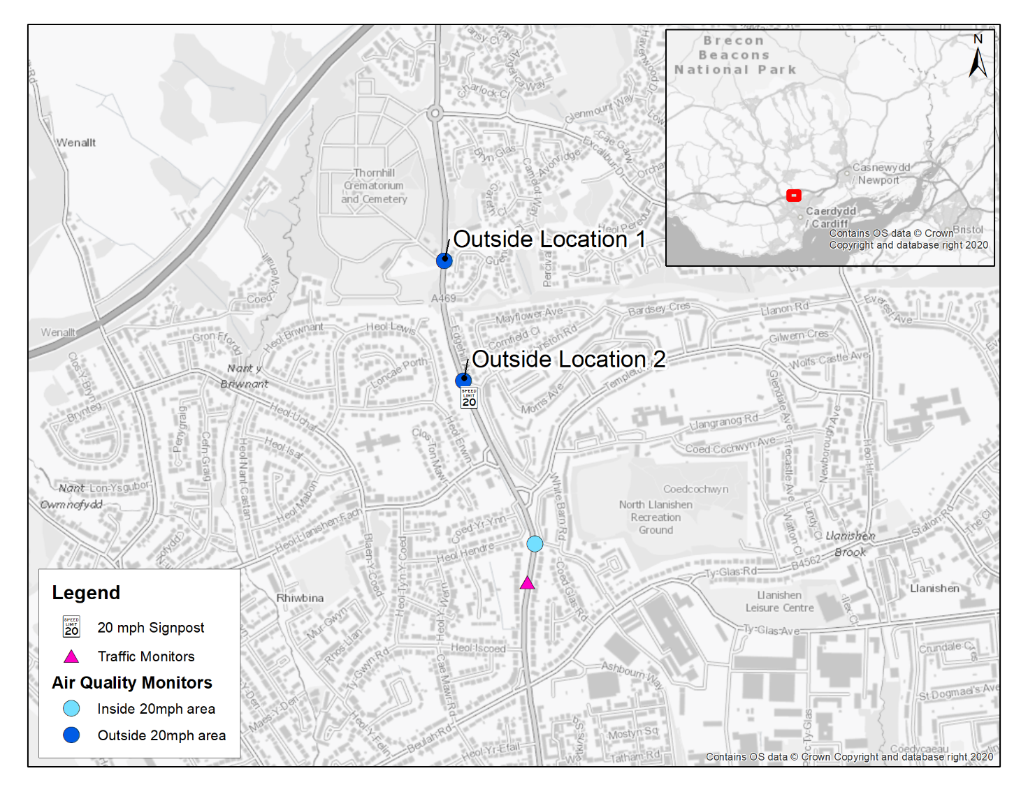
Figure 1-1. Monitoring Locations on Thornhill Road, Cardiff

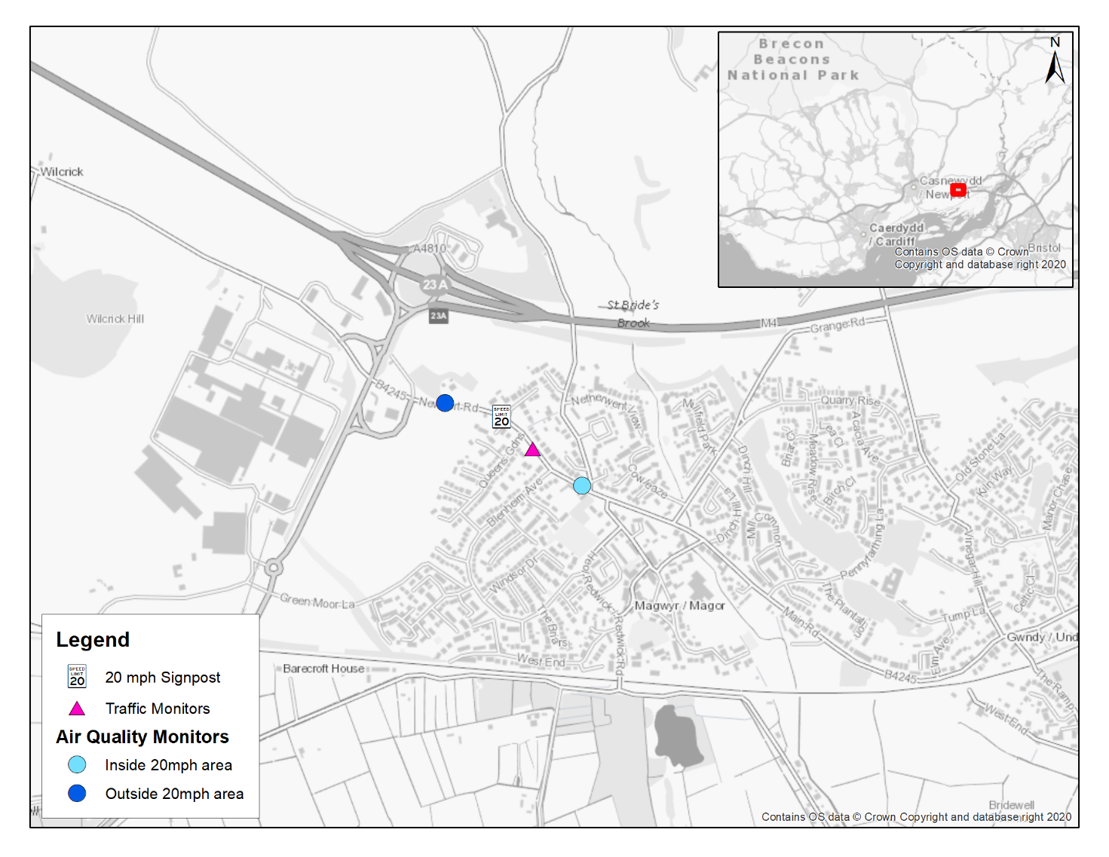
Figure 1-2. Monitoring Locations on B4245, Magor

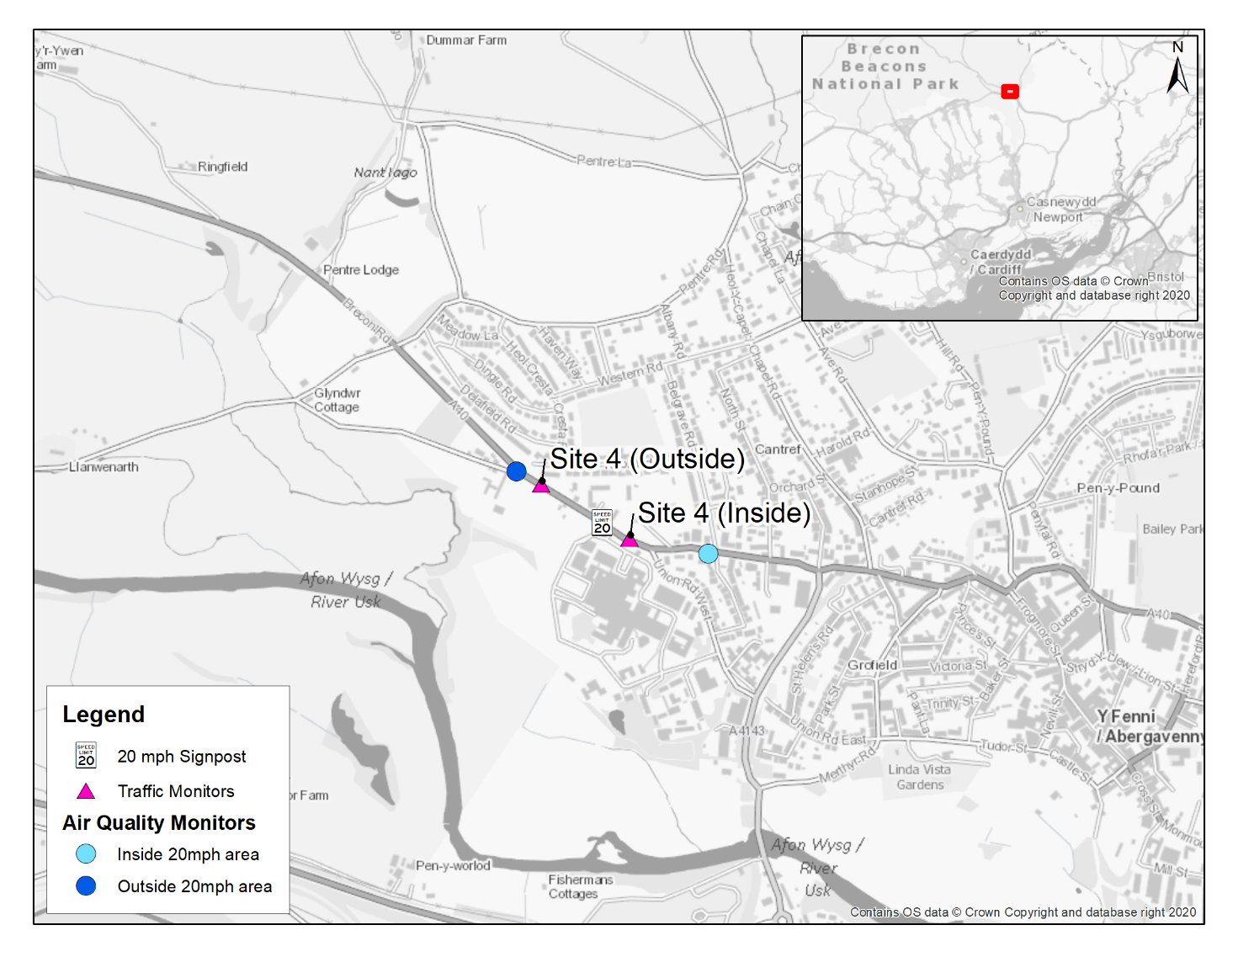
Figure 1-3. Monitoring Locations on A40, Abergavenny

Methodology

Air Quality Sensors
The AQMesh air quality sensors, were selected to record concentrations of nitrogen dioxide (NO₂), particulate matter less than 10 µm in diameter (PM₁₀), and particulate matter less than 2.5 µm in diameter (PM_{2.5}). They also measured meteorological variables such as temperature and humidity. A reading is made every minute for each variable within each sensor which is then communicated to a central server via GSM modem.
AQMesh units have been deployed in pairs across the three study areas on the same stretch of road (one inside and one outside the 20mph area), relatively close together to reduce potential confounding factors. These factors are discussed further in Appendix A. Monitoring was undertaken using a consistent approach in each area to increase the chances of monitoring air quality in locations where a sizeable change in speed occurred (which in itself is not certain). Any observed trends across the areas would therefore be comparable. Consistent trends in two or more areas would provide additional confidence around the observations.
A reliable estimate of measurement uncertainty is key to assessing the information content that an instrument is capable of providing, and its usefulness in a particular application. To improve the accuracy of the results and measure the level of consistency between each pair of sensors, all sensors were subject to co-location at a reference monitoring station at Bridgend. This monitoring site is part of the Air Quality in Wales Network. Once calibrated, each sensor was deployed to their respective study area locations. More information on this process is provided in Appendix B.
With confounding factors controlled for (as much as possible), and the level of measurement uncertainty quantified, the differential between the pair of sensors can be studied with confidence. This is so any differences or changes over time can be matched to specific events and be put into context.

Survey Programme
The survey period was from May 2022 to April 2024 . Monitoring began at different times for each area due to various deployment and calibration constraints. The monitoring periods in each area considered in this assessment are therefore as follows:
- Cardiff (Outside Location 1) – May 2022 to May 2023;
- Cardiff (Outside Location 2) – May 2023 to March 2024;
- Magor – June 2022 to April 2024; and
- Abergavenny – March 2023 to April 2024.

Improving Sensor Performance
It is known that AQMesh sensors (and other similar sensors) can perform differently under certain atmospheric conditions (e.g. low temperatures or high humidity). Covariance of many physical and chemical parameters of the atmosphere (e.g. changes in temperature are likely to occur at the same time as changes in humidity) makes accurately identifying particular sources of measurement interference or error difficult in the real world3. In most cases when using air quality sensors it is important to try and account for such differences so that any variances in measured concentrations due to changes in atmospheric conditions are not misinterpreted as resulting from changes in road traffic emissions.. This issue is far less important for this study, as atmospheric conditions would be almost identical at each pair of sensors, therefore it would not impact the differential between the two.
Periodic calibration is important to ensure both sensors are performing similarly when they are deployed. This process identifies the level of measurement uncertainty and quantifies (and corrects for if necessary) any differences in sensor performance relative to each other over time, compared to when they were first deployed.
The calibrations undertaken are detailed in Appendix B.

Analysis of Data
Data analysis has consisted mainly of comparisons of concentrations recorded between each pair of sensors within each study area. Air pollutant concentrations have been analysed and compared using techniques within the openair package. This package includes some bespoke analysis tools designed for air quality data to identify trends and impacts. A full description of analysis undertaken at each monitoring location is presented in Appendix A
Air quality data has been supplemented with traffic volume and speed data recorded within each 20 mph speed limit area. This is to understand how traffic variables influence measured pollutant concentrations, as well as to potentially link any measured changes in pollutant concentrations over time with any changes in traffic speeds observed over the same time period. A schematic of the monitoring process is presented in Figure 2-1, which demonstrates how the potential impact has been assessed at a high level.

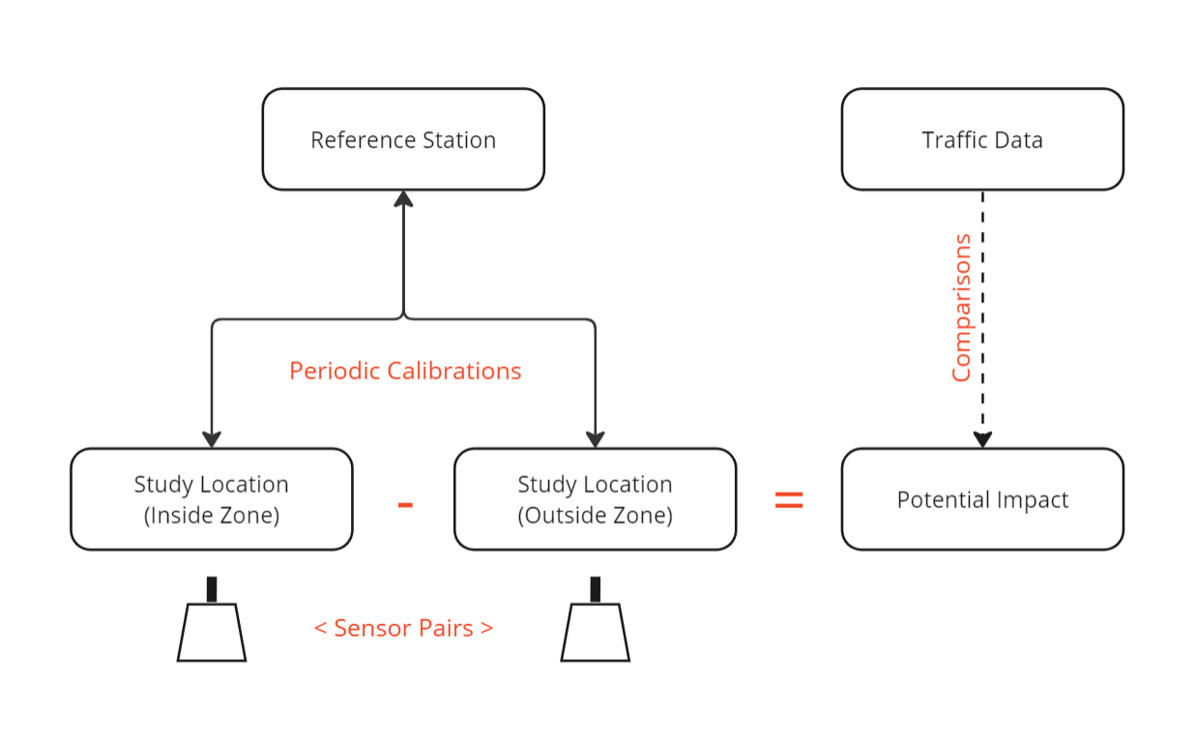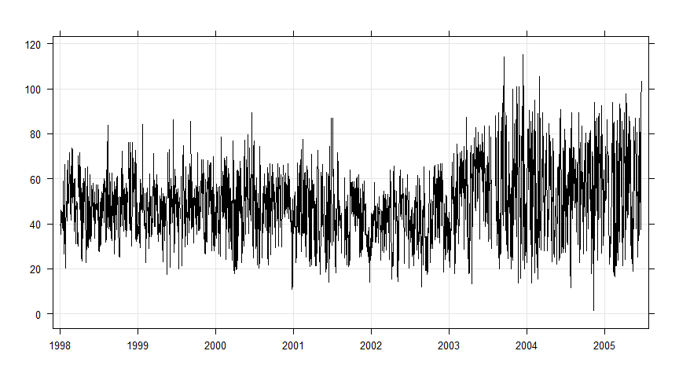
Figure 2-1. Schematic of Monitoring Assessment

Assumptions and Limitations
Whilst this project has been carefully planned, there are a number of assumptions and limitations to be aware of whilst interpreting results. These are discussed further in Appendix A, but are listed below:
- Unfortunately, due to time constraints, it was not possible to collect any baseline data prior to the implementation of the 20mph speed limits. The collection of such data would have allowed differences between the sensors prior to the implementation of the 20 mph speed limit to be compared with those after the implementation of the 20 mph speed limit. Given the introduction of the 20 mph speed limits has been shown to have had a relatively minor impact on average vehicle speeds at the specific air quality monitoring locations, it is considered that such a comparison would have been of limited use;
- The lower-cost air quality sensors used offer various advantages over other monitoring techniques, such as high time resolution data and relative ease of installation. However, such sensors are not certified as reference equivalent, meaning caution should be taken when comparing measured concentrations with national air quality objectives (AQOs), for example. However, absolute concentrations are not key to assessing the KPI for this study, as it is the performance of the sensors relative to each other to identify differences which is of greatest importance;
- Calibration periods were not always undertaken as originally scheduled due to sensor calibrations being undertaken by others at the Bridgend reference monitor. In some cases, this has resulted in longer or shorter periods between sensor calibrations than originally planned. It is considered, however, that this has not had a substantial impact on the results obtained.
- Interpolations between sensor calibrations are assumed to be linear i.e. there is a gradual change in the performance of each sensor over time.
- Power outages due to poor solar harvest during certain times of year which impacted data collection and the calibration programme. Whilst this resulted in some data losses and longer periods between calibrations than scheduled, again, it is considered that this has not had a substantial impact on the results obtained.
- Traffic monitoring sites were located within the 20 mph areas as close to the air quality sensor as possible. However, traffic speeds and flows could potentially differ slightly in some instances between the locations of the air quality sensors and traffic monitoring site in each area.
- The traffic data was collected and provided by third parties and was subject to a number of issues leading to data losses in some periods.
- There is no corresponding traffic monitoring site located outside the 20 mph speed limit area in Cardiff and Magor. It is therefore assumed that traffic adjacent to the air quality sensors outside of the 20 mph speed limit area is travelling at or close to the signposted speed, which may not always be the case.
- Construction and traffic management impacts affected the results obtained at some of the sensors, which impacted the comparisons for various reasons. This data has therefore been excluded from the assessment and is discussed further in Appendix F. For Cardiff in particular, new raised pedestrian crossings were introduced along Thornhill Road, which potentially impacted the measured air pollutant concentrations during some of the survey period. This includes the impact of both construction and operation of the raised crossings.
- Meteorological data used for the interpretation of some of the data was obtained from a modelled source as the nearest sources of observed data were deemed potentially unrepresentative due to their coastal location or other geographical issues. The meteorological data used may therefore not be representative of actual meteorological conditions in each area.
- Prior to, upon and following the implementation of the 20 mph speed limit and installation of associated signage in each of the Phase 1 areas, there was only limited local publicity to inform drivers of the change.

Monitoring Results

Time Series

Cardiff
The daily average concentrations measured by each sensor are presented in Figure 3-1. This consists of three locations:
- Cardiff Inside, which remained constant throughout the study period;
- Cardiff Outside (Site 1) and Cardiff Outside (Site 2) as the sensor location outside the 20 mph speed limit area had to be moved on 17th May 2023 due to the construction of a pedestrian crossing adjacent to Cardiff Outside (Site 1).
The vertical black dashed lines mark periods of calibration where sensors were changed over. Yellow periods mark longer periods of data loss associated with solar issues in the winter months due to dark and cold conditions impacting the power supplied to the units. Daily mean concentrations were calculated based on a 75% data capture rate i.e. where sensors did not capture >1,080 minutes of data in a day, the daily mean was not calculated. Grey shaded areas mark out known periods with roadworks or traffic management issues which are likely to have impacted the results and have therefore been excluded from the analysis. These periods consist of:
- Construction of pedestrian crossing (opposite Crematorium) and pavement widening consisting of traffic light controls and road closures between 26th September 2022 to 18th November 2022;
- Construction of pedestrian crossing (Templeton Avenue) consisting of traffic light controls and road closures between 27th March 2023 and 27th June 2023.
The works associated with the construction of the pedestrian crossing opposite the crematorium between 26th September 2022 and 18th November 2022 resulted in a considerable increase in NO₂ concentrations at the location outside the 20 mph area. This was due to a combination of traffic management (single lane traffic with temporary lights) and heavy machinery operating directly opposite the sensor.
Concentrations inside the 20 mph area do not show a similar trend over the same timeframe. However between 18th November 2022 and 2nd January 2023 (as highlighted in orange), there are marked increases at both the location inside and outside the 20 mph speed limit area of similar magnitude to that observed at the location outside of the 20 mph speed limit area during the construction of the crossing. Whilst the official dates provided by Cardiff Council indicate the works had finished at this point, the concentrations measured during this period are abnormally high, and likely associated with further road works along Thornhill Road. This data has therefore also been removed from further analysis in this report as these concentrations are not considered ‘normal’ and certainty has not been obtained around the activities in this area that may have impacted emissions.
The period of construction for the second raised pedestrian crossing at Templeton Avenue does not show a considerable change in concentrations at the sensor inside the 20 mph speed limit area compared to the sensor outside the 20 mph speed limit area. This is particularly true in comparison to the difference in measured concentrations observed during the construction works in late 2022. However, these works do not appear to have been paired with similar traffic management activities.
The remaining data for the Cardiff Outside (Site 1) pair of sensors has been subset into two further periods defined as “pre construction” highlighted in aqua, and “post construction” highlighted in blue. These mark periods of more typical conditions before and after the pedestrian crossing was introduced, respectively. This is in an attempt to demonstrate the impact (if any) the crossing had on concentrations after its installation. It should be noted that this “post construction” period was before the sensor outside the area was moved to a new location. A summary of this analysis is provided in Appendix F.
The average daily concentrations show the variation in NO₂ over the study period. When each pair of sensors are compared, there are similarities in when the peaks and troughs occur in the monitoring data. This suggests both sensors are being impacted by similar emission sources with the exception of known and potential construction periods. There is some evidence to suggest that some of the peaks are associated with regional pollution episodes as the pattern is observed more widely (e.g. Summer 2022 was influenced by heatwaves, as discussed in Appendix D).
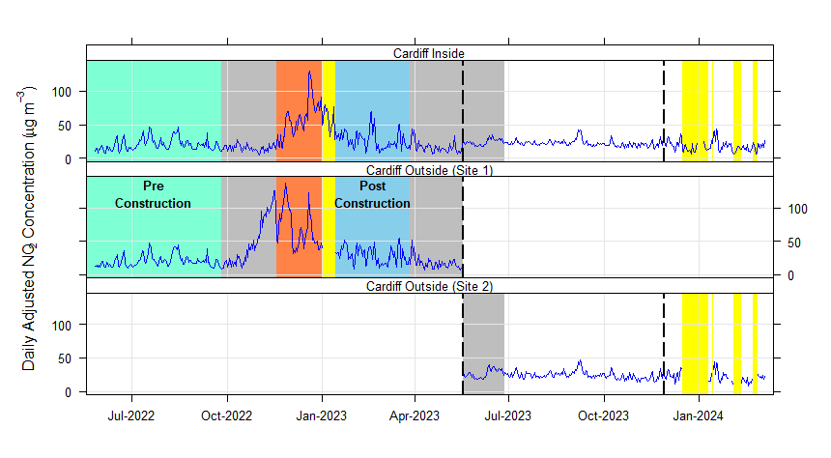
Figure 3-1. Time Series of Daily NO₂ Concentrations (µg/m³) for Cardiff

Magor
The daily average concentrations for each sensor are presented in Figure 3-2. The grey shaded areas for this location represent a period of traffic disruption on the M4/M48 whereby congestion occurred at the roundabout to the west of the sensors (20th December 2022 to 9th January 2023). During this period there is a large increase in concentrations at the sensor outside the 20 mph area relative to concentrations within the 20 mph area. Issues on the M4/M48 resulted in increased congestion and queuing on the B4245 adjacent to the sensor outside the 20 mph area causing elevated exhaust emissions. Meteorological conditions during this period could also have resulted in the grounding of nearby emission plumes such as those from the industrial site located to the west. However, this cannot be confirmed without activity data nor more detailed analysis outside the scope of this study. This is discussed further in Appendix G.
There are also short periods highlighted in yellow associated with equipment outages in December 2022 and January 2024 which have been removed from the dataset taken forward for further analysis.
When each pair of sensors are compared, as with Cardiff, there are similarities in when the peaks and troughs occur in the monitoring data, suggesting both sensors are being impacted by the same emission sources. There are also similarities in the timing of peaks in concentrations with other locations e.g. peaks in the Summer of 2022 also occurred in Cardiff. However, it is noticeable that concentrations outside the 20 mph area are typically higher compared to within the area.
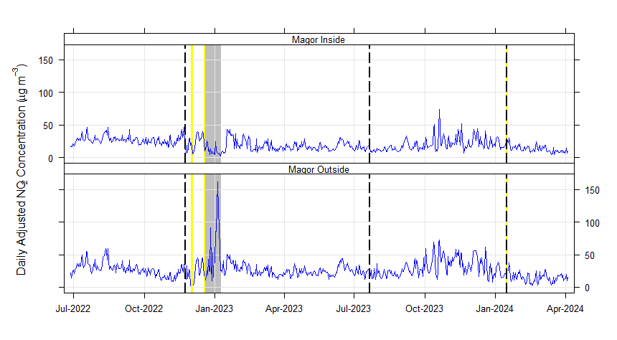
Figure 3-2. Time Series of Daily NO₂ Concentrations (µg/m³) for Magor

Abergavenny
The daily average concentrations for each sensor are presented in Figure 3-3. There were no known periods of traffic management or construction works during this period which could have potentially impacted measured concentrations. Similar to the other locations, both the sensor inside and outside the 20 mph area show very similar trends in concentrations, adding confidence that both sensors are recording concentrations resulting from the same emission sources.
A period of continuous data loss associated with poor solar harvest occurred in mid-January 2024, which was therefore removed from the dataset taken forwards for further analysis.
NO₂ concentrations are slightly greater inside the 20 mph area compared to outside the area. This was investigated and the difference in traffic volume between the two locations is considered likely to be the primary reason for this difference due to the location of Nevill Hall Hospital which is a sizable trip attractor. This is discussed further in Appendix C.
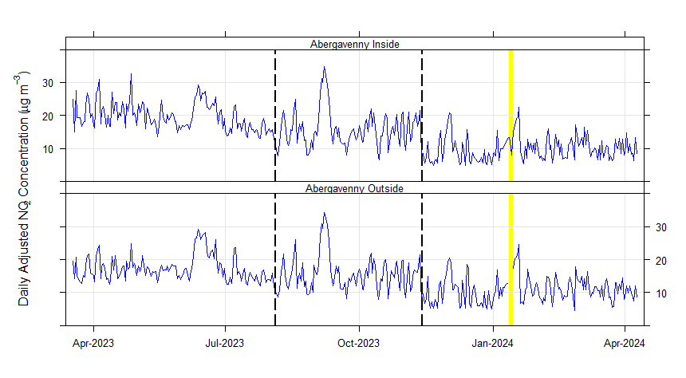
Figure 3-3. Time Series of Daily NO₂ Concentrations (µg/m³) for Abergavenny

Summary
The data presented in Figure 3-1 to Figure 3-3 shows that each pair of sensors provided a very similar response to road traffic emissions adjacent to each sensor. This is evident from the very similar trends between the sensor pairs over the survey period at all sites. The exceptions to this were when other emission sources or known changes in road traffic emissions occurred local to one sensor and not the other e.g. traffic management and construction works. This highlights the monitoring approach employed was able to detect changes in road traffic emissions as and when they occurred. It should be noted that where a known short-term local change in emissions was present adjacent to one sensor in a pair and not the other (such as construction works), the data from both sensors has been discounted for further analysis in this report so that results remain comparable. Details of local emission changes are discussed in Appendix G.2.

Time variations
Time variation plots are useful to see how concentrations change by hour of day, day of week and month of year. The plots can give insights into potential emission sources based on trends in concentrations over time e.g. road traffic emissions are typically strongly associated with an AM and PM peak in concentrations. Both sensors (inside and outside) are plotted on Figure 3-4 to Figure 3-7, helping to identify similarities and differences between the sensors over time, which could be a result of differences in their local environment (e.g. surrounding vegetation, nearby buildings) or road traffic conditions (e.g. differences in traffic volume).
Each plot consists of four separate plots. The top row shows the mean concentration by hour of day and day of the week. The bottom left plot shows the diurnal profile (concentration by hour of day) for all days of the week. The middle plot on the bottom row shows the average hourly concentration by month, which is useful for identifying seasonal changes in concentrations. The bottom right plot shows the average hourly concentration by day of the week.

Cardiff
As discussed in Section 3.1.1 the Cardiff study area has been subset for the following periods:
- Cardiff (Site 1)
  - Pre-Construction of raised pedestrian crossing; and
  - Post-Construction of raised pedestrian crossing.
- Cardiff (Site 2).

Cardiff Site 1 – Pre-Construction
The diurnal profile for Cardiff (Site 1) before the construction of the pedestrian crossing is shown in Figure 3-4. This shows little difference in concentrations between the two sensors on an average day of the week across the study period. There is a distinct difference in the profiles between weekdays and weekends, with weekdays being characterised by two distinct peaks in the AM and PM periods. This is characteristic of sites influenced by road traffic emissions, as higher traffic flows occur during these time periods. The AM peak is typically higher and more defined compared to the PM peak (e.g. the maximum average hourly concentrations is 28.1 µg/m³ in the AM peak and 25.8 µg/m³ in the PM peak for the sensor within the 20 mph area), but it should be noted much of the data over this period was collected within the school holidays, which would have resulted in more dispersed traffic throughout the day. The strong association with road traffic emissions is confirmed when comparing these concentrations to road traffic data for the same road and periods in Appendix C.
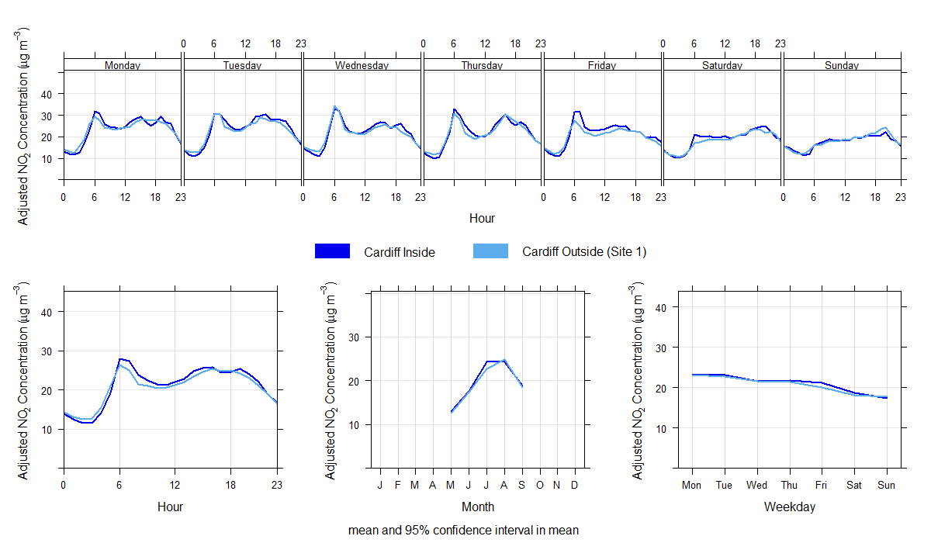
Figure 3-4. Average hourly NO₂ Concentrations (µg/m³) for Cardiff (Site 1) (Pre-Construction)
The concentrations of both sensors are almost identical during the off-peak period (19:00 – 07:00). This is a strong indication both sensors are recording similar background concentrations i.e. the contribution from local non-road traffic sources of pollutants such as domestic heating and regional emission sources. During this time, there is very little traffic on the road, therefore emissions from this source are almost non-existent. Given the locations of the two sensors, it is unlikely background sources of pollution would change considerably over this small distance, adding confidence that changes seen during the day are a result of differences in road traffic emissions.
The average daily profile suggests that daytime concentrations are typically slightly higher inside the 20 mph area compared to outside the area and nighttime concentrations are typically slightly lower inside the 20 mph area compared to outside the area. However, these differences are very small, with a maximum difference of 2.3 µg/m³ at 08:00 (which is around 6% of the AQO, and within the range of average measurement error).

Cardiff Site 2
The diurnal profile for Cardiff (Site 2) is presented in Figure 3-5. As with Site 1, both profiles demonstrate a strong diurnal profile across weekdays which reflect traffic flow data. The AM and PM peaks in concentrations are of similar magnitude (maximum average hourly concentrations of 28.4 µg/m³ and 29.1 µg/m³ at the sensor outside the 20 mph area). Compared to Site 1, there is a greater difference in concentrations between the two sensors between 06:00 and 20:00, when the sensor outside the 20 mph area measures average concentrations greater than inside the area (with a maximum difference of 4.6 µg/m³ at 16:00 which is around 12% of the AQO, and outside the range of average measurement error). The difference is smaller in the morning peak and gradually increases throughout the day before reducing from 17:00. The greater concentrations at the sensor outside the 20 mph area compared to inside the area is relatively consistent for each day of the week.
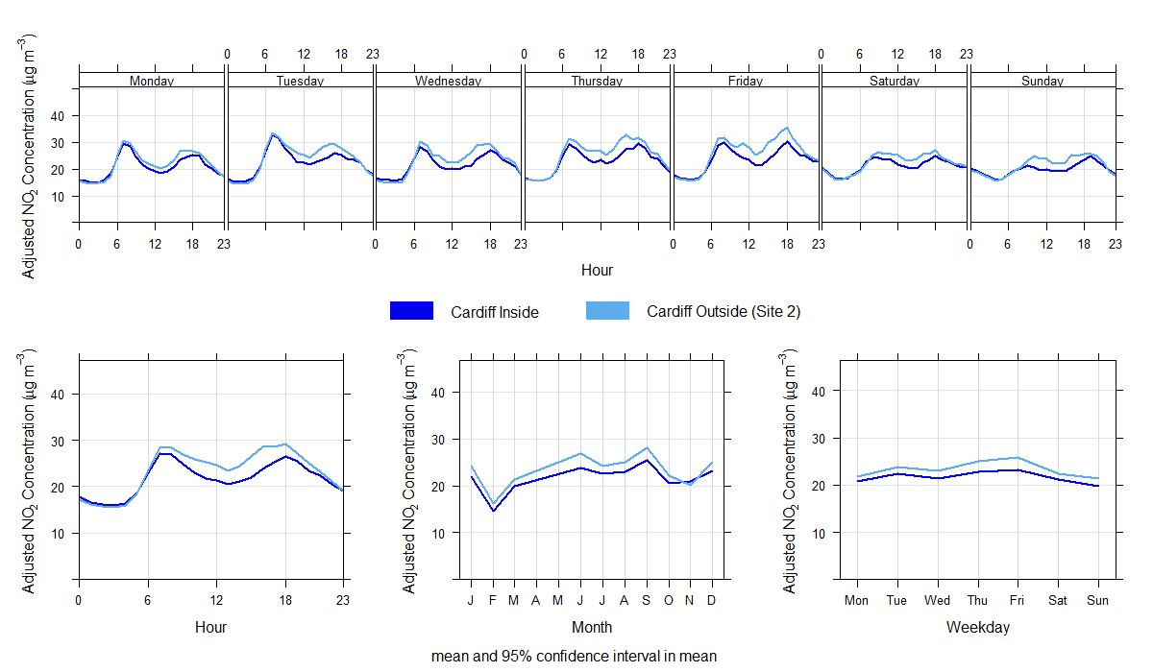
Figure 3-5. Average hourly NO₂ Concentrations (µg/m³) for Cardiff (Site 2)
As with Site 1, the concentrations recorded at each location are almost identical in the late evening and early morning, indicating that background concentrations are similar at both locations. Due to lower data capture during some months and a single year of monitoring data it is not possible to draw firm conclusions on seasonal trends at this location. Although concentrations are greatest in September relative to the other months during this period.
As the differences between the sensors occur during the daytime when road traffic emissions are highest, this suggests that the differences between the sensors are because of differences in road traffic emissions between the two locations.

Magor
The time variation plots for Magor are shown in Figure 3-6. This demonstrates a strong diurnal profile, which can be associated with traffic flows (which is matched by the traffic flow profile in Appendix C). The concentrations at both locations are greatest during the week compared to weekends, when the profile is not as defined. Compared with the Cardiff locations, the AM peak in concentrations is considerably greater compared to the PM peak (maximum average concentration of 34.4 µg/m³ in the AM period against 27.6 µg/m³ in the PM period for the sensor outside the 20 mph area).
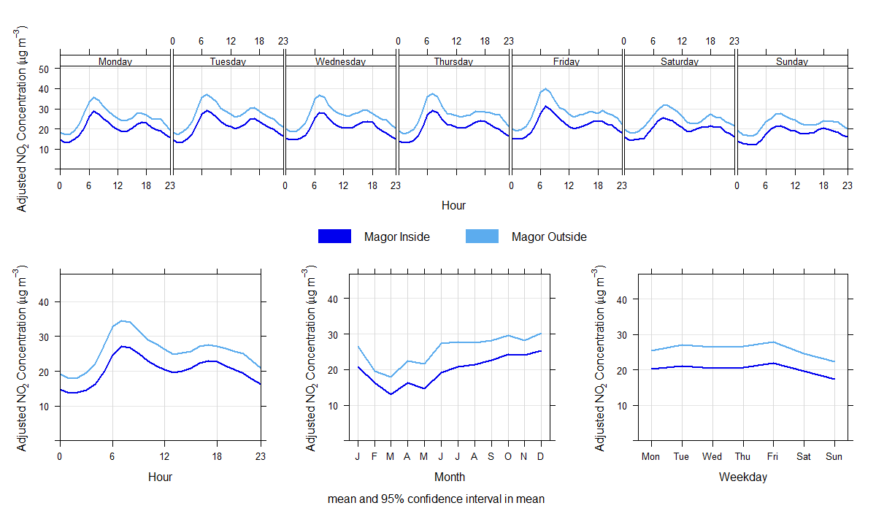
Figure 3-6. Average hourly NO₂ Concentrations (µg/m³) for Magor
The seasonal pattern in concentrations reflects what would be expected in NO₂ concentrations in the UK, with lower concentrations in the spring/summer months compared to the autumn/winter months. This is because lower wind speeds and more stable atmospheric conditions are more likely to occur in winter months.
In each of the plots, the sensors both inside and outside the 20 mph area follow the same trend, indicating both are influenced by similar emission sources, however the sensor outside the area is consistently higher compared to within the area (with a maximum difference of 8.2 µg/m³ at 06:00 which is around 20% of the AQO, and outside the range of average measurement error). This difference is unlikely to be solely down to differences in traffic flow conditions, as the difference is fairly consistent during each hour of the day. If it were entirely due to traffic flow conditions, it would be expected that off-peak concentrations would be similar as they were in Cardiff due to traffic flows being much lower during this period. Some of the potential reasons for the elevated concentrations at the sensor outside the 20 mph area include:
- Acceleration of vehicles away from the roundabout to the west of the sensor;
- Industrial sources to the west of the sensor; and / or
- Proximity of the sensor to vegetation.
Potential reasons for this difference are discussed further in Appendix G.

Abergavenny
The time variation plots for Abergavenny are shown in Figure 3-7. This demonstrates a strong diurnal profile, which can be associated with traffic flows (confirmed in Appendix C). The concentrations at both locations are greatest during the week compared to weekends, where the profile is not as defined. The typical diurnal profile shows that the AM peak is slightly greater compared to the PM peak (maximum average concentration of 21.4 µg/m³ in the AM at the sensor inside the 20 mph area and 19.0 µg/m³ in the PM at the sensor outside the 20 mph area). This difference between the periods is not as great when compared to Magor.
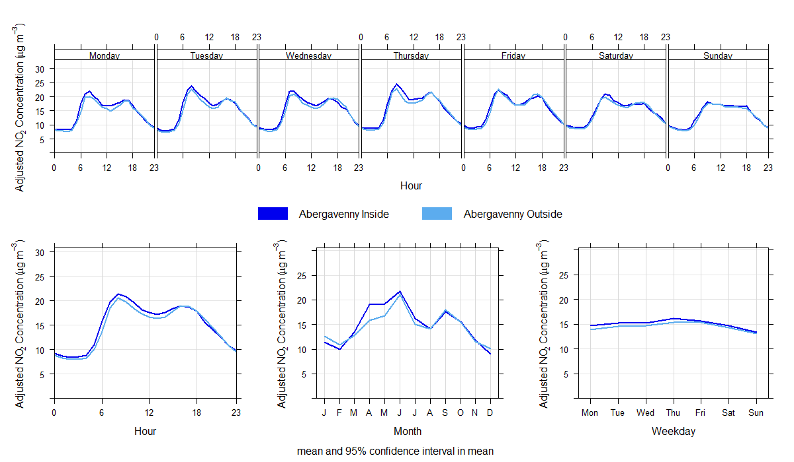
Figure 3-7. Average hourly NO₂ Concentrations (µg/m³) for Abergavenny
The seasonal pattern in concentrations differs from that of Magor or Cardiff, with concentrations typically higher in the spring/summer compared to the autumn/winter months. Abergavenny, however, is notably different in its geography, being sited at the foot of a valley which may influence typical dispersion characteristics by season. Equally, as Abergavenny experiences lower data capture compared to the other two locations, differences in traffic flows could also be the reason for this discrepancy. For example, Abergavenny is located just outside Bannau Brycheiniog (Brecon Beacons) national park, which may influence seasonal traffic flows.
When comparing concentrations inside and outside the 20 mph area, there is little difference between the two sensors (with a maximum average difference of 2.2 µg/m³ at 06:00 which is around 6% of the AQO, and within the range of average measurement error). The difference is much smaller during the off-peak period, which as discussed previously, suggests that both sensors are measuring similar background concentrations. The trends over the course of the day at both sensors are also similar, suggesting road traffic emissions are impacting measured concentrations at both sites in a similar way.
Unlike Cardiff Location 2 and Magor, the sensor inside the 20 mph area tends to record higher NO₂ concentrations compared to outside the area between the hours of 05:00 to 19:00. Due to the similarities in measured background concentrations during the nighttime, this difference is likely due to differences in road traffic emissions between the two locations. One of the most likely reasons for this difference in road traffic emissions is due to difference in traffic volumes between the two locations as a result of Nevill Hall Hospital. This is discussed further in Appendix C.

Differences Inside vs Outside
The overall comparisons between the NO₂ concentrations measured by the sensors inside and outside the 20 mph area for each of the locations are presented in Figure 3-8 and Table 3-1. The red lines on Figure 3-8 indicate:
- 17th September 2023, to mark the national rollout of the default 20 mph speed limit on restricted roads; and
- 8th January 2023, when the 20 mph areas became enforceable.
For reference, traffic variables for the corresponding periods are provided in Table 3-2.
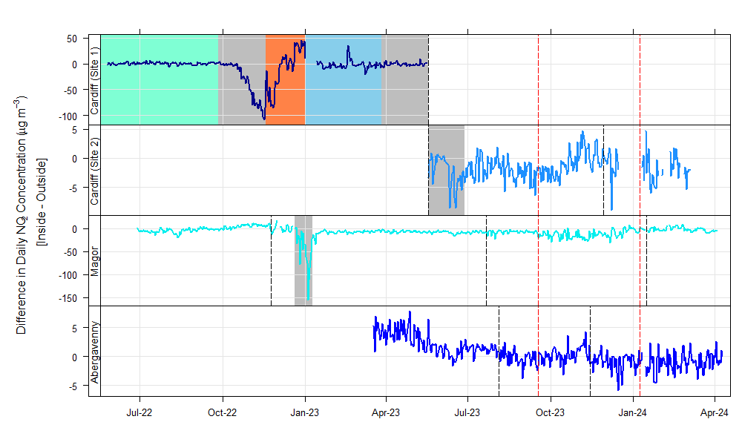
Figure 3-8. Difference in NO₂ Concentrations (µg/m³) between the sensor pairs in each location
The results in Table 3-1 show that measured NO₂ concentrations at each location are well within the level of the relevant annual mean AQO (40 µg/m³). Furthermore, these measurements were made at the roadside, meaning NO₂ concentrations at the nearest residential properties, which are set further back, would likely be much lower. This is because NO₂ concentrations typically decrease rapidly with increasing distance from a road due to the increased dispersion and dilution of emissions.
The differences in measured NO₂ concentrations between the sensors inside the 20 mph speed limit areas relative to those outside were mainly small relative to the annual mean NO₂ AQO (and typically within the range of average measurement error). The exception to this being the results obtained at Magor, which indicate that annual mean NO₂ concentrations outside the 20 mph limit area are substantially higher than those inside the 20 mph limit area.
As other confounding factors are largely controlled by selecting paired locations on the same stretch of road where traffic flows would not differ considerably, and at similar locations relative to the road i.e. distance and orientation, the assumption is that any differences between the sensors, outside the range of average measurement error, are attributable to differences in road traffic emissions as a result of differences in speed between the two locations. There are some potential exceptions to this including:
- Potential differences in traffic volumes in Abergavenny;
- Acceleration of vehicles away from the roundabout to the west of the sensor outside the 20 mph limit area in Magor;
- Industrial sources to the west of the sensor outside the 20 mph limit area in Magor; and
- Proximity of the sensor outside the 20 mph limit area in Magor to vegetation.
All of which are detailed and discussed in Appendix C and Appendix G.
Table 3-1. Summary NO₂ concentration (µg/m³) data within each area
Area | Average Measured NO₂ Concentration Inside 20mph Speed limit  (µg/m³) | Average Measured NO₂ Concentration Outside 20mph Speed limit  (µg/m³) | Difference Between Inside and Outside 20mph Speed limit  (µg/m³) | Average NO₂ Concentration Measurement Error  (µg/m³)
Cardiff (using Outside Location 1) | 21.0 | 20.6 | +0.4 | 3.6 – 3.8
Cardiff (using Outside Location 2) | 21.7 | 23.3 | -1.6 | 1.4 – 4.3
Magor (Severnside) | 20.2 | 25.8 | -5.6 | 2.6 - 5.1
Abergavenny | 15.0 | 14.5 | +0.5 | 1.6 - 2.7

As shown in Table 3-2, average speeds within each of the 20 mph speed limit areas remain higher than the signposted limit of 20 mph. So the differences in Table 3-1 cannot be attributed to vehicles travelling at the 20 mph speed limit within the 20 mph speed limit area. The differences in NO₂ concentrations could, however, potentially be attributed to vehicles travelling at lower speeds within the 20 mph speed limit areas compared to outside the 20 mph speed limit areas. For example, whilst speed data within Magor and Cardiff is only available within the 20 mph speed limit area, the average speeds in Abergavenny are 8.3 mph greater outside the area relative to inside the area. It would therefore be reasonable to assume speeds outside the 20 mph speed limit areas in Magor and Cardiff are higher than inside the 20 mph limit areas. It is likely speeds are at or in excess of the signposted limit of 30 mph based on observed conditions in Abergavenny.
As shown in Appendix C, traffic flows at the sensor location inside the 20 mph limit area in Abergavenny are more than 20% higher than those outside the 20 mph limit area, which is thought to be as a result of vehicles accessing the Nevill Hall hospital located between the two locations. This difference in traffic flows is thought to explain (and potentially even outweigh) the observed difference in measured NO₂ concentrations inside and outside of the 20 mph limit area in Abergavenny.
The results suggest the introduction of the 20 mph speed limit has had a negligible impact on NO₂ concentrations based on the overall comparisons of inside vs outside the 20 mph area (with further details relating to each location provided in the following sections).
The timeseries for speed data in Appendix C also suggests that there have been more recent reductions in speed at each location around the time of the national rollout of the default 20 mph speed limit on 17th September 2023 (albeit speeds remain higher than 20 mph). This appears to be accompanied by variations in the differences between the sensor pairs as shown in Figure 3-8. However, it is not entirely clear if these variations are a direct result of these changes in speed. Further data collection and analysis would be required to add further clarity as the differences are within the range of measurement error of the sensors and can be impacted by an array of other factors as described in Section 3.4.
Table 3-2. Summary traffic data for each area (and subset)
Location | Period Data Capture (%) | Average Daily Traffic Flow | Signposted Limit (mph) | Flow Weighted Speed (mph)
Abergavenny Inside | 59 | 9,753 | 20 | 30.4
Abergavenny Outside | 51 | 7,955 | 30 | 38.6
Cardiff Inside (Pre-Construction of pedestrian crossing) | 93 | 18,557 | 20 | 24.5
Cardiff Inside (Location 2) | 44 | 15,654 | 20 | 27.9
Magor Inside | 72 | 12,843 | 20 | 30.4

Supplementary Analyses
A number of additional potential impacts on measured pollutant concentrations during the project were observed outside of the main objective of assessing the potential impact of the introduction of 20 mph limits. Some of this analysis involved investigating potential confounding factors to help understand measured differences in NO₂ concentrations between the sensors, such as differences in traffic volumes at Abergavenny or the potential impact of vegetation at Magor. Other analysis considered the impact of interventions such as temporary traffic management or traffic calming in Cardiff, so that context could be given to observed differences in measured concentrations as a result of such interventions compared to differences between the sensor pairs during other periods. A summary of these supplementary findings is presented below, with further detail provided in the relevant appendices.

Impact of construction and traffic management
It has been shown that various construction activities, traffic management and temporary road closures have had an impact on monitored NO₂ concentrations in Cardiff and Magor. The potential impact of each of these is summarised in the sub-sections below.

Cardiff – pedestrian crossing construction
Construction of the raised pedestrian crossing and associated footpath works adjacent to the crematorium had a substantial impact on monitored NO₂ concentrations outside the 20 mph area. The works involved temporary traffic lights for contraflow traffic adjacent to the sensor. The measured increase in concentrations at the sensor outside the 20 mph area during this period is likely due to queuing, congestion and acceleration as vehicles passed through the traffic lights. In addition to road traffic emissions, it is likely further emissions were present from heavy machinery (such as idling HGVs and excavators).
Whilst the impact was large, it was relatively short lived, and concentrations dropped following the completion of the works.
During the construction of the second pedestrian crossing at Templeton Avenue, there was very little difference between the sensor inside and outside the 20 mph area. This is due to a number of factors, including smaller scale works not requiring traffic management, and proximity of the sensor in relation to the works (i.e. the sensor was further from the activity relative to the sensor near the crematorium works).
Further information is provided in Appendix F.

Cardiff – operational pedestrian crossing
Following the construction of the pedestrian crossing opposite the crematorium, there was a period of monitoring when the crossing was in full operation before the sensor was relocated. This shows a small but consistent increase in the difference between the sensor inside vs outside the 20 mph area throughout the day. The average concentrations for the period (12/01/2023 – 17/05/2023) show the sensor outside the 20 mph area measured NO₂ concentrations 2.1 µg/m³ greater compared to the sensor inside the area.
In comparison to the pre-construction period, the increased magnitude of the difference between the sensor outside the 20 mph area relative to inside the area suggests that the crossing has potentially resulted in a small increase in road traffic emissions at the location outside the 20 mph area.
Increases in road traffic emissions are possible where a breakdown in flow conditions (such as braking and subsequent acceleration) occurs, which could be the reason for the larger difference observed in this period. However, it should be noted the sample size for the pre and post construction periods are relatively small.
Further information is provided in Appendix F.

Magor – nearby road closures
As shown in Figure 3-8, a large difference was observed between the sensor outside the 20 mph area compared to inside the area in Magor during late December 2022 to early January 2023. This difference was of similar magnitude to that observed in Cardiff during construction of the pedestrian crossing. It is known that weather-related issues had closed the M48 Severn Bridge at this time, which impacted local roads in the vicinity of the sensor outside the 20 mph area.
Meteorological conditions (i.e. strong westerly winds) could potentially also have caused an increased contribution from an elevated emission source such as a stack, during the same period. For example, wind speeds from this direction correlate well with known industrial emission sources located at the industrial park located to the west of the sensors, beyond the A4810. However, without emission source activity data and further, more detailed analysis outside the scope of this study, this is very difficult to confirm.
Although much higher concentrations were monitored during this time, the episode was relatively short-lived and therefore specific to particular weather conditions, road closures or a combination of the two.
Further information is provided in Appendix G.

Impact of differences in road traffic contributions

Differences in road traffic volumes in Abergavenny
The presence of Nevill Hall Hospital between the sensor inside and outside the 20 mph area in Abergavenny is a complicating factor due to the trip attracting nature of the hospital itself. This means that vehicles passing one sensor may not go on to pass the second sensor. Therefore observed differences between the sensors may be a result of differences in road traffic volumes rather than traffic speed.
Traffic data indicates that on average around 1,800 vehicle movements per day passed the sensor inside the 20 mph area, but then did not go on to pass the sensor outside the area. The most likely explanation for this is the presence of Nevill Hall Hospital, which explains why concentrations outside the 20 mph area were consistently lower than inside the area in Abergavenny, which was not the case for Cardiff and Magor.
Differences in the diurnal profiles of traffic flows between the sensors inside and outside the 20 mph area adds further evidence to the influence of the hospital on monitored concentrations. The difference in traffic volume on weekdays is much greater in the AM period, which suggests likely work related trips (i.e. hospital workers attending during the morning period). The difference reduces throughout the day which could represent visitors or outpatient appointments.
Further information is provided in Appendix C.

Magor Road / B4245 roundabout
In Magor, the sensor outside the 20 mph area consistently measured higher NO₂ concentrations compared to the sensor within the area. It was thought the proximity of the roundabout to the west of the sensor could be contributing as an additional emission source, given that not all vehicles using the roundabout would be travelling past both sensors, reducing the influence of the controls introduced by the methodology.
Conditional analysis was used to reduce the impact of potential excess emissions at the sensor outside the 20 mph area by removing measured NO₂ concentrations from both datasets when winds were from the west and at higher wind speeds, to strengthen the signal from the target source of emissions (i.e. the B4245).
The analysis showed little difference between the sensors when the potential roundabout emissions were removed versus when they were included. This suggests the additional emissions from the roundabout are sufficiently far from the sensor, and conditions dispersing emissions toward the sensor are infrequent enough to have little impact on average measured concentrations. This gives greater confidence the large difference between the sensors can be explained by a combination of greater emissions associated with acceleration away from the roundabout and/or vegetation reducing emission dispersion around the sensor outside the 20 mph speed limit area.
Further information is provided in Appendix G.

Impact of fleet turnover
Long-term trend analysis of air quality monitors on the Welsh Air Quality Network show that there has been a consistent downward trend in NO₂ concentrations over the last 10 years. The average annual reduction in concentrations across the sites is 1.7 µg/m³. This is most likely due to improving emission control technologies and the increasing uptake of electric vehicles.
The observed differences between the monitoring locations considered are therefore of similar magnitude to those which are likely to occur annually via general vehicle fleet upgrades over time.
Further information is provided in Appendix A.

Impact of regional pollution episodes
Air pollutants in the UK are influenced by regional pollution episodes to differing extents depending on the pollutant. There is evidence of these episodes influencing the concentrations monitored inside and outside the areas in each of the monitored locations, for both NO₂ and PM₁₀.
There were two heatwaves present in 2022 which resulted in elevated concentrations of NO₂ in Cardiff and Magor during these events. As a result of still meteorological conditions and prolonged sunlight and high temperatures, elevated concentrations of ozone were present nationwide in 2022 (with Defra raising alerts for ozone on 18th – 19th July and 11th – 15th August 2022). The impact of these episodes on NO₂ concentrations are demonstrated in Figure 3-1 and Figure 3-2 (and source apportionment analysis further shows the impact of this in Appendix D). This showed that concentrations during these episodes were around 25 µg/m³ greater compared to other similar periods.
Concentrations of PM₁₀ and PM_{2.5} are not strongly influenced by road traffic emissions in the study locations. Source apportionment analysis shows that the highest concentrations occur under conditions consistent with regional emission episodes e.g. wind-blown sea spray particles or long-range transport from continental Europe or Saharan dust. This is consistent across each location and collates with other monitors in the Welsh Air Quality Network.
Further information is provided in Appendix E.

Impact of vegetation on pollutant dispersion
The sensor outside the 20 mph area in Magor is the only sensor that is surrounded by fairly dense vegetation (to the north and south). Magor is also the location where the difference between the two sensors is greatest, with the sensor outside the 20 mph area consistently monitoring greater concentrations compared to inside the area. Dense vegetation at the location of the sensor outside the 20 mph area may be causing higher concentrations in this location due to lack of dispersion of emissions as a result of vegetation inhibiting wind flows.
It was thought that this impact would be greatest when vegetation was fullest i.e. in Summer months relative to Winter months. Monthly concentrations presented in Appendix G provides some evidence to support this given the difference between the two sensors is lower during the winter months compared to the summer, however this is not conclusive. As mentioned above, it is likely the large difference between the sensors is a result of a combination of both increased acceleration emissions and the presence of the vegetation.

Impact of speed enforcement activities
Short periods of speed enforcement activity were undertaken during the study period. Comparisons of NO₂ concentrations during the periods of enforcement against those where enforcement was not undertaken have been made. This found a small impact of enforcement on traffic speeds and NO₂ concentrations across the three areas. However, very limited enforcement was undertaken, greatly reducing the sample size of this dataset, so no firm conclusions can be drawn from the analysis.
Further information is provided in Appendix H.

Conclusions & Recommendations
In summary, there is good evidence in each of the Phase 1 areas that measured NO₂ concentrations are strongly associated with traffic conditions on the adjacent road (as is expected). It is also clear that the assessment approach is able to identify differences in NO₂ concentrations and therefore road traffic exhaust emissions between each pair of the sensors. This was particularly evident in Cardiff during traffic management to facilitate construction works, in Magor during periods when there were closures on the M48 Severn Bridge and in Abergavenny due to differences in traffic volumes. Whilst the methodology could not control for all confounding factors, the approach of focussing on the differential between pairs of sensors is considered suitable, given the factors that could not be controlled between each pair remained fairly constant and were well understood.
Measured concentrations of PM₁₀ and PM_{2.5} were shown to be much less heavily linked to road traffic emissions as sources of these pollutants are more regional in nature (e.g. emissions from industrial sources, domestic wood burning or sea salt over the wider region). The focus of this assessment has therefore been on measured concentrations of NO₂ due to the stronger signal associated with the adjacent road.
At all monitoring locations there were differences in measured NO₂ concentrations inside the 20 mph speed limit area compared to outside the area, however these differences:
- Were typically small relative to the annual mean NO₂ Air Quality Objective / Limit Value (and within the average measurement error of the sensors):
- Indicate that NO₂ concentrations inside the 20 mph speed limit area were very similar to or lower than those outside the 20 mph speed limit area;
- Are not simply a result of vehicles travelling at 20 mph within the 20 mph speed limit, as traffic monitoring data suggests vehicles are travelling in excess of 20 mph within all of the areas considered.
- Can generally be explained by other factors which influence road traffic emissions other than vehicle speed (e.g. increased acceleration or differences in traffic volume). Although short-lived, other events appeared to have had a bigger influence on the variation of concentrations monitored during the study area compared to any changes in vehicle speed e.g. regional pollution episodes or traffic management.
- Are small in the context of the longer-term impact of vehicle fleet upgrades as emission control technologies improve and the prevalence of electric vehicles increases within the national fleet.
Following the conclusion of the monitoring, it is recommended that alternative areas are assessed where traffic speed data has been obtained and shows higher levels of compliance with the 20 mph speed limit. At the project planning stage of this study, it was unknown how drivers would react to the speed limit signage in each area and as such, the project has not been able to monitor the impact of a more sizeable change in traffic speeds (e.g. from 30 mph to 20 mph) on air quality. The study has, however, shown a negligible impact of the observed changes in traffic speeds in the Phase 1 areas, even if the observed reductions in average speed were relatively minor.
Furthermore, alternative uses could be sought for the air quality sensors based on the supplementary findings of this study, for example the potential impact of traffic calming measures on road traffic emissions within urban areas, particularly adjacent to sensitive receptors such as schools. It is possible that these schemes may be introducing inadvertent localised impacts that detriment air quality in the vicinity.

Methodology
  - Approach and Rationale
AQMesh units have been deployed in pairs across the three study areas on the same stretch of road (one inside and one outside the 20mph area), relatively close together to reduce potential confounding factors. These potential confounding factors include:
- Changes in road traffic emissions over time – The Air Quality Expert Group (AQEG) have noted that road traffic emissions may change as a result of changes in speed, but that any such change could be outweighed by other factors such as an increase in vehicle flow or changes in composition. To reduce this impact, sensor pairs have been placed on the same stretch of road with limited access points for road traffic between them, so the traffic flow and composition on the section of road next to each sensor would be very similar;
- Meteorology – The influence of meteorology (e.g. wind speed and direction) can easily mask or in itself result in changes in ambient air pollutant concentrations. Due to the sensor pairs being located in close proximity, meteorology should impact both sensors in the same way, with the exception of microclimates produced by obstructions in the immediate vicinity of the sensors e.g. buildings or trees, which have been avoided where possible; and
- Other sources of pollution – Whilst roadside NO₂ concentrations are heavily influenced by road traffic NOx emissions, they are also influenced by emissions from other sources (e.g. industrial or residential combustion), both local and distant from the location of interest. This is particularly true of particulate matter, which is less heavily influenced by road traffic emissions. Instead this pollutant is more influenced by other combustion sources, both locally and regionally, as well as more distant sources (e.g. in the UK more widely and Europe) and natural sources (e.g. sea salt and windblown dust). Similar to for meteorology, as the sensors are located relatively close to each other, there should be little difference in the contribution made by non-road traffic sources to the pollutant concentrations observed at each pair of monitoring sites. Whilst it is possible to ‘remove’ regional contributions from measured concentrations (e.g. by subtracting measurements from a nearby background monitoring site) to derive a ‘road traffic contribution’, there is uncertainty in this approach. In any case, as the regional contribution that would be removed would be the same for each pair of monitoring sites, the resulting difference between the two sensors would be the same.
Whilst AQEG state that measurements might be made before and after an intervention, there are a number of potential issues that mean this approach may not be valid, and so the approach of using a control (outside the area) in this instance is considered the best approach.
For example, by monitoring a before and after period, the impact of confounding factors has the potential to increase e.g. changes in emissions associated with differing traffic flows, seasons or fleet turn over. Either period could be skewed by unusual conditions which could result in concentrations being wrongly attributed to an intervention if it occurred at the same time as a confounding factor. For example, as shown in this analysis, summer heatwaves led to elevated concentrations of NO₂ across the monitoring locations. If this had occurred in the ‘before’ period, and was compared to the ‘after’ period, when similar heatwaves did not occur, concentrations would have been lower, but not as a result of the intervention.
For longer term studies, the impact of changes in fleet is an important factor to understand, because as emission control technologies improve, there are generally widespread improvements to air quality as newer vehicles enter the fleet. Comparing a ‘before’ period with an ‘after’ period would therefore also account for some of the improvements brought about by newer vehicles.
To demonstrate this impact, long-term trend analysis presented in Figure A-1 for a selection of urban traffic monitoring sites on the Welsh Air Quality Network shows how concentrations of NO₂ have changed between 2015 to 2024. For all sites, there is a highly statistically significant (p < 0.001) downward trend over this period of time. The data has had the influence of seasonal trends removed. Whilst the influence of Covid-19 restrictions is present during 2020 in the plots, it should be noted that the downward trend was present both before and after the pandemic, so this does not have a big influence on the long-term trend.
The average of the trend across all sites is a reduction of around 1.7 µg/m³ per year between 2015 and 2024. The location with the greatest reduction is Rhondda Mountain Ash with an annual reduction of 3.4 µg/m³, whereas the location with the smallest reduction is Wexham with an annual reduction of 0.8 µg/m³. It should be noted that those sites with the greatest absolute change per year are those with the highest concentrations.
Whilst there will be localised reasons for a fall in emissions such as local schemes to reduce traffic, the main reason for a such a widespread reduction over time is due to the improvement in emission control technologies, particularly the introduction of Euro 6 and VI vehicles.
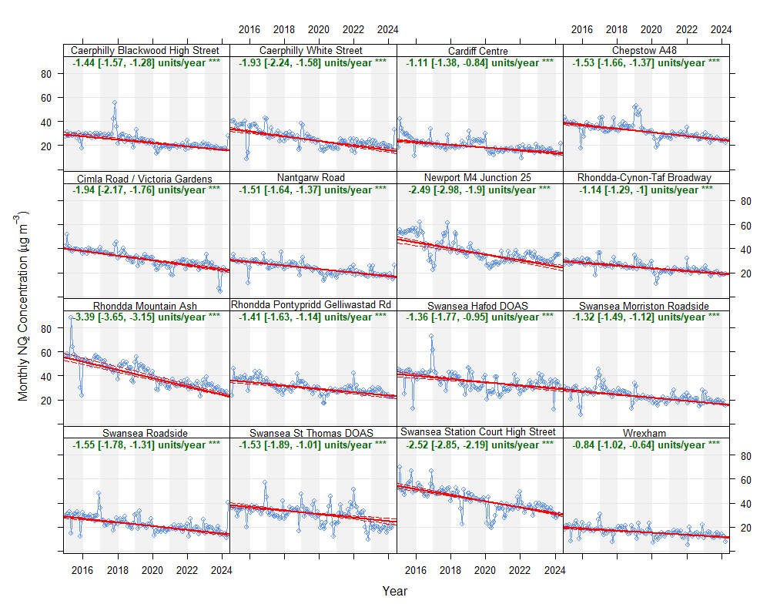
Figure A-1. De-seasoned NO₂ TheilSen trend analysis at long-term Welsh Air Quality Network sites
Therefore, the approach of using an intervention sensor (inside the area) and control sensor (outside the area) is considered the most appropriate approach to account for confounding factors, such as those discussed above, as these should impact each site in the same way. It is however noted that it was subsequently found that not all influencing factors could be controlled for (as discussed in the main document).
  - Analysis
As discussed in the main document, the openair package was used for the bulk of the analysis. A brief description of the main functions used are provided below:
- timePlot – a simple timeseries to plot multiple pollutants / locations for a period of interest across different time resolutions;
- timeVariation – similar to timePlot, however concentrations are averaged over different time periods to identify the variation of pollutant concentrations over hour of day, day of week or month of year;
- polarPlot – a bivariate plot of concentrations by wind speed and direction which can be useful for quickly gaining a graphical representation of the influence of pollution sources in different directions at a particular location. For this plot, air quality data in each hour is aggregated with meteorological data; and
- TheilSen – used to determine trends in pollutant concentrations over several years. Monthly mean concentrations are calculated, and a trend assigned with a degree of statistical significance. Because seasonal effects can be important for monthly data, there is an option to deseasonalise the data before calculating the trend in concentrations. The trend is given with upper and lower confidence intervals and provided in µg/m³ per year.
  - Equipment Used
The monitoring equipment used for this project were AQMesh. AQMesh is a versatile and compact air quality monitoring system designed for a wide range of applications. It is capable of monitoring multiple gases, particulate matter, and other atmospheric variables. The system is renowned for its ease of installation, allowing for precise placement exactly where monitoring is needed. With a relatively low cost of ownership and a robust design, AQMesh is engineered to last in the field, providing maximum uptime across the network.
Key features of AQMesh include:
- Multi-sensor capabilities: Monitors up to six gases, as well as particulate matter and meteorological factors.
- Data management flexibility: Offers secure and accessible cloud-based data storage, with real-time pollution alerts and repeatable, traceable results.
- Proven performance: Independently verified, with rigorous sensor characterisation and quality control processes to ensure out-of-the-box accuracy.
This technology has been applied across hundreds of air quality data projects including ‘Breathe London’. Further information on data specifications of the units is provided in the manufacture’s brochure.
For this project, the units have been attached to existing street furniture (lighting columns) using the standard mounting brackets. The existing power supply within the lighting column was utilised for Magor, whereas the units in Cardiff and Abergavenny were accompanied with individual solar panels to power the units. The units monitored NO₂, particulate matter of varying size proportions (PM₁, PM_{2.5}, PM₄, PM₁₀ and PM_{total}), along with temperature, pressure and humidity.
  - Limitations
    - Equipment
As stated previously, the sensors in Cardiff and Magor were powered by solar, as were the Bridgend co-location units for calibration. This provided some issues in the winter months when solar energy is limited, which is particularly problematic when other factors limit the ideal conditions for solar harvest e.g. the panel at the co-location site was not positioned at the optimal angle due to needing to be placed within a cage for security reasons. In addition, the position of nearby houses at this location limited solar harvest during parts of the day, which was amplified in the winter due to the sun being lower in the sky.
AQMesh sensors are susceptible to interference from multiple conditions found in the ambient environment, including temperature, humidity and cross-gas effects. Therefore, the manufacturers have developed algorithms designed to compensate for these environmental variables to provide the best possible precision and accuracy of measurement. This limitation is not such a factor for this study as the absolute concentrations are not the key metric in informing the KPI, and both sensors within each pair should be impacted by environmental conditions in the same way.
Accuracy of the sensors is improved by way of a colocation study to correct slope and offset values. This is discussed further in Appendix B.
    - Monitoring Locations
Monitoring locations were limited in some places to where lighting columns were available for mounting. However, the columns used had to be assessed for structural integrity prior to deployment for safety, and this survey found some of the preferred locations were not suitable, which limited options still further.
This impacted Magor, which had the lowest number of options outside the area, so a column was selected knowing the potential limitations of the proximity to vegetation and the roundabout to the west.
In Cardiff, the sensor outside the area had to be re-located following the construction of a raised pedestrian crossing adjacent to the sensor. However, alternative locations were limited, as moving further north would potentially be too close to roundabout emissions and further south could potentially be too close to the 20 mph area. In the end a site closer to the 20 mph area was chosen.
Similar placement issues occurred in Abergavenny where it became difficult to site any sensors on the existing street furniture. As such there were substantial delays in deploying the sensors in Abergavenny as new columns had to be installed prior to deployment.
    - Retrospective survey design
Upon completion of the project, some retrospective methodology limitations were identified including:
- Lack of baseline data due to unavoidable project delays – it would have been helpful to have obtained a period of baseline to understand what conditions were like prior to the 20 mph signs being installed. However as mentioned previously, comparing ‘before’ and ‘after’ periods comes with its own inherent issues. Due to the design of this survey, the lack of baseline data is not considered detrimental to the outcomes of the study;
- Survey locations were selected before any speed limits were put in place. Therefore, it was not certain how drivers would react to the new speed limit and if consistent compliance would be achieved. Following the completion of the study, it is evident that limited changes in speed were achieved for the majority of the survey period at the specific locations chosen. It would have been useful to have undertaken exploratory data collection of traffic variables prior to air quality monitoring deployment.
- Whilst not detrimental to the outcomes of the study, it would have been useful to have an understanding of background concentrations in each location by the positioning of a third sensor away from any emission sources. This would have assisted in improving the signal to noise ratio by removing background concentrations from the sensors adjacent to the road. In theory this would leave just the road component to provide a better and more confident understanding of how road traffic emissions were changing.
- The sensors were not directly co-located with traffic monitoring equipment, however the sites are considered to be representative of general trends recorded at the traffic locations. As shown for Abergavenny (where data capture allows), it would have been useful to have traffic variables monitored both inside and outside the 20 mph area in all locations.

Calibrations
  - Calibration approach
When using low-cost sensors such as those used in this study, there is an inherent trade-off between price, size, power consumption and the accuracy and precision of the measurement being made. This trade-off may occur due to low-cost manufacturing or the greater uncertainty in the analytical chemistry method itself.
For example, many low-cost sensors are sensitive to changes in atmospheric conditions (temperature and humidity) or can give false signals if other air pollutants (e.g. ozone) are present at high concentrations. Low-cost sensors therefore cannot be used as direct replacements for reference monitors used by Defra and the Welsh Government under current conditions. This is because highly accurate measurements are required by Defra and the Welsh Government for comparison to legally binding air quality Limit Values.
At project inception the key performance indicator for evaluating the air quality impact of the 20 mph Phase 1 was “Air Quality remaining the same (at the least)”. This has been evaluated using low-cost sensor data by assessing the difference between two sensors (one within the 20 mph limit area and one outside). Comparing the results of two identical low-cost sensors under the same environmental conditions has negated many of the limitations of these devices (i.e. changes in measured concentrations which may arise due to the influence of temperature, humidity and / or ozone concentrations).
Consistency is, however, required in the monitoring over time and between sensors i.e. sensor performance should ideally not vary substantially over time, or between the sensors. This study has been designed to mitigate the potential uncertainties in measured concentrations as much as possible. This includes calibration of the sensor pairs at a reference method monitor at Bridgend (Figure B-1) at the same time to understand:
- How each low-cost sensor performed relative to the reference method monitor and the level of adjustment needed to improve concentrations measured by the low-cost sensor; and
- How each low-cost sensor performed against the other sensor (post-adjustment to the reference method monitor).
This assisted in understanding and reducing the level of uncertainty with the monitored concentrations once deployed to the study area. As each pair of sensors performed similarly to each other (post calibration), it is reasonable to assume the sensors should perform similarly once deployed in the field. The monitored concentrations are also adjusted based on the comparison with the reference method monitor so that concentrations recorded on site are scaled to the reference monitor. This is done by comparing the measurements from each of the sensors and the reference monitor over the calibration period and applying an offset and slope using the following equation:
Reference Concentration = (AQMesh Concentration X Gradient) + Y Intercept
Where:
Gradient = Slope
Y-Intercept = Offset
AQMesh Adjusted Concentration = (AQMesh Concentration X Slope) + Offset
As meteorological conditions change with the seasons, several calibration periods coinciding with changing conditions were undertaken to account for potential differences in sensor performance over time. A calibration factor was then applied to representative periods to reflect the meteorological conditions in which the sensor was deployed in the field.
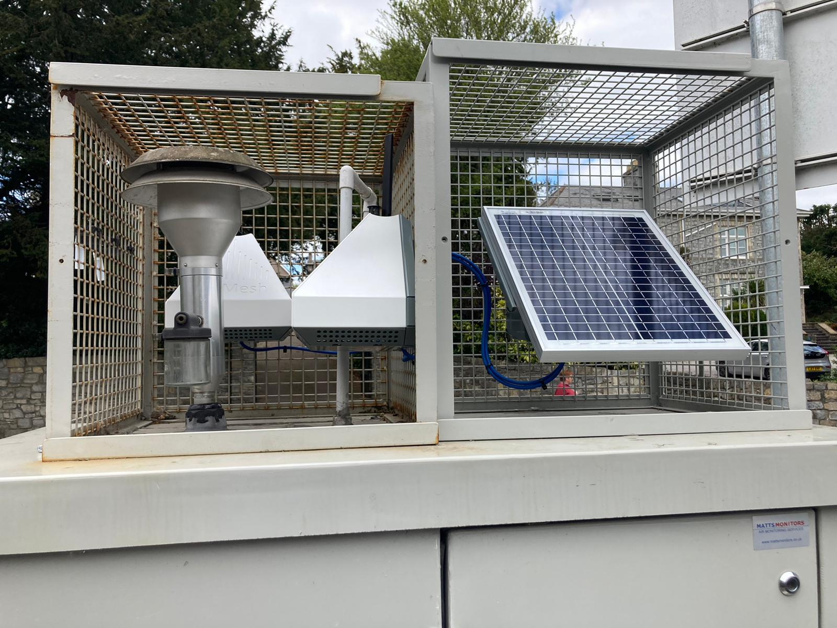
Figure B-1. Calibration set-up at Bridgend continuous monitoring station
  - Calibration Results
The AQMesh were always calibrated and deployed in pairs which did not change over the duration of the study period. To be resilient to project challenges, four pairs of sensors were placed into rotation, with a new pair replacing another in each location to avoid data loss at the monitoring locations. Whilst each pair of sensors may perform slightly differently to one another, the absolute difference between the sensors within the pairs is consistent and is maintained by the periodic calibrations. The data for each of the periodic calibrations for each pair of sensors are provided in Table B-1 to Table B-14. Each table shows how the relative performance of each AQMesh is improved compared to the reference monitor post calibration, and how each performs relative to the other sensor within the pair.
The performance metrics are as follows:
- Correlation Coefficient (R²) – Used to measure the linear relationship between the two measurements. A value of zero means no relationship and a value of 1 means an absolute relationship. The ideal value is 1.
- Root Mean Square Error (RMSE) – Used to define the average error or uncertainty between two sets of measurements. The units are the same as the values compared i.e. µg/m³. The ideal value is 0.0, however this is very difficult to achieve, so a value should be considered in the context of the annual mean air quality objective (e.g. 40 µg/m³ for NO₂).
- Fractional Bias – used to identify if a set of values systematically over or under predict relative to the other values. Values range between +2 and -2, and have an ideal value of 0. Negative values suggest an underprediction, and positive values suggest an overprediction.
In general, the calibrations across all pairs of sensors made an improvement to RMSE i.e. how well the measured values match the reference equipment and match each other. Typically, concentrations of NO₂ perform better in both instances relative to PM₁₀. This is mainly due to the greater uncertainty associated with the PM concentrations monitored by AQMesh.
Calibration periods are recommended for a period of at least 7 to 10 days and at least every 6 months. There are varying lengths of calibration periods and frequencies of calibration due to various factors outside of the project’s control. However, the minimum calibration period was met in all but one calibration where there were significant power issues as a result of poor solar harvest.

Table B-1. Calibration period 1 for monitoring pair 878245 and 881245
Statistics | NO₂ Pre-Adjustment | NO₂ Pre-Adjustment | NO₂ Post Adjustment | NO₂ Post Adjustment | PM₁₀ Pre-Adjustment | PM₁₀ Pre-Adjustment | PM₁₀ Post Adjustment | PM₁₀ Post Adjustment | Post Adjustment Pair Comparison | Post Adjustment Pair Comparison
 | 878245 | 881245 | 878245 | 881245 | 878245 | 881245 | 878245 | 881245 | NO₂ | PM₁₀
No. of hours | 1,112 |  |  |  | 1,015 |  |  |  | 1,114 | 1,114
AQMesh Mean | 13.6 | 17.3 | 25.3 | 25.3 | 15.2 | 15.6 | 17.7 | 17.9 | 25.3  (878245) | 17.7  (878245)
Reference Mean | 25.3 |  |  |  | 18.4 |  |  |  | 25.3  (881245) | 17.9  (881425)
Difference | 11.7 | 7.9 | 0.0 | 0.0 | 3.2 | 2.7 | 0.7 | 0.5 | 0.0 | 0.2
Slope | 1.1 | 1.1 | 1.0 | 1.0 | 0.8 | 0.4 | 1.0 | 1.0 | 0.9 | 1.1
Intercept | 10.2 | 6.6 | 0.0 | 0.0 | 5.4 | 11.0 | 0.0 | 0.0 | 3.4 | -2.1
R² | 0.7 | 0.8 | 0.7 | 0.8 | 0.5 | 0.4 | 0.5 | 0.4 | 0.9 | 0.8
RMSE | 14.1 | 10.2 | 7.8 | 6.3 | 6.6 | 9.7 | 6.0 | 6.9 | 5.1 | 2.6
Fractional Bias | 0.6 | 0.4 | 0.0 | 0.0 | 0.2 | 0.2 | 0.0 | 0.0 | 0.0 | 0.0
Calibrations were undertaken between 01/09/2022 00:00 to 17/10/2022 09:00
AQMesh 878245 was calibrated from the box and deployed to Magor Outside
AQMesh 881245 was calibrated from the box and deployed to Magor Inside

Table B-2. Calibration period 2 for monitoring pair 878245 and 881245
Statistics | NO₂ Pre-Adjustment | NO₂ Pre-Adjustment | NO₂ Post Adjustment | NO₂ Post Adjustment | PM₁₀ Pre-Adjustment | PM₁₀ Pre-Adjustment | PM₁₀ Post Adjustment | PM₁₀ Post Adjustment | Post Adjustment Pair Comparison | Post Adjustment Pair Comparison
 | 878245 | 881245 | 878245 | 881245 | 878245* | 881245 | 878245 | 881245 | NO₂ | PM₁₀
No. of hours | 332 |  |  |  | 304 |  |  |  | 332 | 304
AQMesh Mean | 19.2 | 20.6 | 18.8 | 18.8 | - | 6.2 | - | 18.0 | 18.8  (878245) | -  (878245)
Reference Mean | 18.8 |  |  |  | 17.9 |  |  |  | 18.8  (881245) | 18.0  (881425)
Difference | -0.4 | -1.8 | 0.0 | 0.0 | - | 11.7 | - | 0.0 | 0.0 | -
Slope | 1.0 | 0.9 | 1.0 | 1.0 | - | 1.3 | - | 1.0 | 0.9 | -
Intercept | 0.3 | -0.4 | 0.0 | 0.0 | - | 10.1 | - | 0.0 | 1.1 | -
R² | 0.8 | 0.8 | 0.8 | 0.8 | - | 0.8 | - | 0.8 | 0.9 | -
RMSE | 5.8 | 5.4 | 5.7 | 5.1 | - | 12.4 | - | 3.6 | 2.7 | -
Fractional Bias | 0.0 | -0.1 | 0.0 | 0.0 | - | 1.0 | - | 0.0 | 0.0 | -
Calibrations were undertaken between 21/07/2023 14:00 to 04/08/2023 09:00
AQMesh 878245 was calibrated from the Magor Outside and deployed to Abergavenny Outside
AQMesh 881245 was calibrated from the Magor Inside and deployed to Abergavenny Inside
* Note the PM sensor within sensor 878245 became faulty and was not replaced
Table B-3. Calibration period 3 for monitoring pair 878245 and 881245
Statistics | NO₂ Pre-Adjustment | NO₂ Pre-Adjustment | NO₂ Post Adjustment | NO₂ Post Adjustment | PM₁₀ Pre-Adjustment | PM₁₀ Pre-Adjustment | PM₁₀ Post Adjustment | PM₁₀ Post Adjustment | Post Adjustment Pair Comparison | Post Adjustment Pair Comparison
 | 878245 | 881245 | 878245 | 881245 | 878245* | 881245 | 878245 | 881245 | NO₂ | PM₁₀
No. of hours | 227 |  |  |  | 211 |  |  |  | 229 | 211
AQMesh Mean | 25.8 | 25.7 | 28.4 | 28.4 | - | 12.4 | - | 20.8 | 28.4  (878245) | -  (878245)
Reference Mean | 29.5 |  |  |  | 20.4 |  |  |  | 28.4  (881245) | 20.8  (881425)
Difference | 3.8 | 3.9 | 1.1 | 1.1 | - | 8.0 | - | -0.4 | 0.0 | -
Slope | 0.9 | 0.8 | 1.0 | 1.0 | - | 1.2 | - | 1.0 | 1.0 | -
Intercept | 6.0 | 6.8 | 0.0 | 0.0 | - | 5.7 | - | 0.0 | 0.0 | -
R² | 0.8 | 0.8 | 0.8 | 0.8 | - | 0.9 | - | 0.9 | 1.0 | -
RMSE | 8.2 | 8.6 | 7.3 | 7.6 | - | 11.8 | - | 7.3 | 1.9 | -
Fractional Bias | 0.1 | 0.1 | 0.0 | 0.0 | - | 0.5 | - | 0.0 | 0.0 | -
Calibrations were undertaken between 17/11/2023 10:00 to 28/11/2023 09:00
AQMesh 878245 was calibrated from the Abergavenny Outside and deployed to Cardiff Inside
AQMesh 881245 was calibrated from the Abergavenny Inside and deployed to Cardiff Outside (Location 2)
* Note the PM sensor within sensor 878245 became faulty and was not replaced
Table B-4. Calibration period 4 for monitoring pair 878245 and 881245
Statistics | NO₂ Pre-Adjustment | NO₂ Pre-Adjustment | NO₂ Post Adjustment | NO₂ Post Adjustment | PM₁₀ Pre-Adjustment | PM₁₀ Pre-Adjustment | PM₁₀ Post Adjustment | PM₁₀ Post Adjustment | Post Adjustment Pair Comparison | Post Adjustment Pair Comparison
 | 878245 | 881245 | 878245 | 881245 | 878245* | 881245 | 878245 | 881245 | NO₂ | PM₁₀
No. of hours | 714 |  |  |  | 714 |  |  |  | 718 | 714
AQMesh Mean | 26.1 | 23.7 | 16.6 | 16.6 | - | 9.9 | - | 15.8 | 16.6  (878245) | -  (878245)
Reference Mean | 16.6 |  |  |  | 15.8 |  |  |  | 16.6  (881245) | 15.8  (881425)
Difference | -9.5 | -7.1 | 0.0 | 0.0 | - | 5.9 | - | 0.0 | 0.0 | -
Slope | 0.6 | 0.7 | 1.0 | 1.0 | - | 0.7 | - | 1.0 | 1.0 | -
Intercept | 1.2 | 1.1 | 0.0 | 0.0 | - | 9.3 | - | 0.0 | 0.0 | -
R² | 0.9 | 0.9 | 0.9 | 0.9 | - | 0.6 | - | 0.6 | 1.0 | -
RMSE | 12.2 | 9.6 | 3.6 | 3.9 | - | 8.9 | - | 5.5 | 1.4 | -
Fractional Bias | -0.4 | -0.4 | 0.0 | 0.0 | - | 0.5 | - | 0.0 | 0.0 | -
Calibrations were undertaken between 05/03/2024 14:00 to 04/04/2024 13:00
AQMesh 878245 was calibrated from Cardiff Inside
AQMesh 881245 was calibrated from Cardiff Outside (Location 2)
* Note the PM sensor within sensor 878245 became faulty and was not replaced
Table B-5. Calibration period 1 for monitoring pair 879245 and 885245
Statistics | NO₂ Pre-Adjustment | NO₂ Pre-Adjustment | NO₂ Post Adjustment | NO₂ Post Adjustment | PM₁₀ Pre-Adjustment | PM₁₀ Pre-Adjustment | PM₁₀ Post Adjustment | PM₁₀ Post Adjustment | Post Adjustment Pair Comparison | Post Adjustment Pair Comparison
 | 879245 | 885245 | 879245 | 885245 | 879245 | 885245 | 879245 | 885245 | NO₂ | PM₁₀
No. of hours | 241 |  |  |  | 335 |  |  |  | 241 | 330
AQMesh Mean | 14.9 | 20.1 | 24.4 | 24.4 | 18.0 | 24.3 | 19.3 | 19.1 | 25.0  (879245) | 19.3  (879245)
Reference Mean | 23.4 |  |  |  | 19.3 |  |  |  | 25.0  (885245) | 19.1  (885245)
Difference | 8.5 | 3.3 | -1.6 | -1.6 | 1.3 | -5.0 | 0.0 | 0.2 | 0.0 | -0.2
Slope | 1.2 | 1.1 | 1.0 | 1.0 | 0.7 | 0.7 | 1.0 | 1.0 | 1.0 | 0.7
Intercept | 6.5 | 3.7 | 0.0 | 0.0 | 6.5 | 1.9 | 0.0 | 0.0 | 1.2 | 6.0
R² | 0.8 | 0.9 | 0.8 | 0.9 | 0.5 | 0.7 | 0.5 | 0.7 | 0.9 | 0.7
RMSE | 11.8 | 7.2 | 5.6 | 5.3 | 7.3 | 7.9 | 6.7 | 5.1 | 3.6 | 3.9
Fractional Bias | 0.4 | 0.2 | -0.1 | -0.1 | 0.1 | -0.2 | 0.0 | 0.0 | 0.0 | 0.0
Calibrations were undertaken between 12/05/2022 10:00 to 26/05/2022 09:00
AQMesh 879245 was calibrated from the box and deployed to Cardiff Outside (Location 1)
AQMesh 885245 was calibrated from the box and deployed to Cardiff Inside

Table B-6. Calibration period 2 for monitoring pair 879245 and 885245
Statistics | NO₂ Pre-Adjustment | NO₂ Pre-Adjustment | NO₂ Post Adjustment | NO₂ Post Adjustment | PM₁₀ Pre-Adjustment | PM₁₀ Pre-Adjustment | PM₁₀ Post Adjustment | PM₁₀ Post Adjustment | Post Adjustment Pair Comparison | Post Adjustment Pair Comparison
 | 879245 | 885245 | 879245 | 885245 | 879245 | 885245 | 879245 | 885245 | NO₂ | PM₁₀
No. of hours | 1,038 |  |  |  | 1,473 |  |  |  | 1,554 | 1,553
AQMesh Mean | 20.5 | 26.5 | 17.8 | 18.2 | 13.8 | 7.4 | 18.2 | 18.1 | 17.8  (879245) | 18.2  (879245)
Reference Mean | 19.8 |  |  |  | 18.3 |  |  |  | 18.2  (885245) | 18.1  (885245)
Difference | -0.7 | -6.7 | 2.0 | 1.6 | 4.5 | 10.9 | 0.1 | 0.2 | 0.4 | -0.1
Slope | 0.8 | 0.7 | 1.0 | 1.0 | 1.2 | 1.4 | 1.0 | 1.0 | 0.9 | 0.9
Intercept | 1.8 | 1.0 | 0.0 | 0.0 | 1.2 | 7.6 | 0.0 | 0.0 | 1.6 | 2.2
R² | 0.7 | 0.7 | 0.7 | 0.7 | 0.6 | 0.5 | 0.6 | 0.5 | 0.9 | 0.7
RMSE | 8.5 | 12.5 | 7.3 | 6.5 | 7.0 | 12.4 | 5.3 | 5.8 | 3.8 | 3.9
Fractional Bias | 0.0 | -0.3 | 0.1 | 0.1 | 0.3 | 0.8 | 0.0 | 0.0 | 0.0 | 0.0
Calibrations were undertaken between 17/05/2023 15:00 to 21/07/2023 09:00
AQMesh 879245 was calibrated from Cardiff Outside (Location 1) and deployed to Magor Outside
AQMesh 885245 was calibrated from Cardiff Inside and deployed to Magor Inside
Note the continuous monitoring station had a faulty NO_{x} filter for a period of time and was replaced hence why the period of comparison for the pairs is greater than the comparison with the continuous monitor
Table B-7. Calibration period 3 for monitoring pair 879245 and 885245
Statistics | NO₂ Pre-Adjustment | NO₂ Pre-Adjustment | NO₂ Post Adjustment | NO₂ Post Adjustment | PM₁₀ Pre-Adjustment | PM₁₀ Pre-Adjustment | PM₁₀ Post Adjustment | PM₁₀ Post Adjustment | Post Adjustment Pair Comparison | Post Adjustment Pair Comparison
 | 879245 | 885245 | 879245 | 885245 | 879245 | 885245 | 879245 | 885245 | NO₂ | PM₁₀
No. of hours | 341 |  |  |  | 340 |  |  |  | 341 | 340
AQMesh Mean | 33.4 | 43.3 | 27.7 | 27.7 | 22.0 | 13.3 | 25.1 | 25.3 | 27.7  (879245) | 25.1  (879245)
Reference Mean | 27.7 |  |  |  | 25.3 |  |  |  | 27.7  (885245) | 25.3  (885245)
Difference | -5.7 | -15.6 | 0.0 | 0.0 | 3.3 | 11.9 | 0.1 | 0.0 | 0.0 | 0.1
Slope | 0.7 | 0.6 | 1.0 | 1.0 | 0.7 | 0.8 | 1.0 | 1.0 | 1.0 | 1.0
Intercept | 4.9 | 0.1 | 0.0 | 0.0 | 8.8 | 14.2 | 0.0 | 0.0 | 0.6 | 0.8
R² | 0.6 | 0.6 | 0.6 | 0.6 | 0.3 | 0.3 | 0.3 | 0.3 | 0.9 | 1.0
RMSE | 14.3 | 21.0 | 11.1 | 11.2 | 14.5 | 18.3 | 13.8 | 13.8 | 3.5 | 1.9
Fractional Bias | -0.2 | -0.4 | 0.0 | 0.0 | 0.1 | 0.6 | 0.0 | 0.0 | 0.0 | 0.0
Calibrations were undertaken between 15/01/2024 14:00 to 29/01/2024 18:00
AQMesh 879245 was calibrated from Magor Outside
AQMesh 885245 was calibrated from Magor Inside

Table B-8. Calibration period 1 for monitoring pair 882245 and 883245
Statistics | NO₂ Pre-Adjustment | NO₂ Pre-Adjustment | NO₂ Post Adjustment | NO₂ Post Adjustment | PM₁₀ Pre-Adjustment | PM₁₀ Pre-Adjustment | PM₁₀ Post Adjustment | PM₁₀ Post Adjustment | Post Adjustment Pair Comparison | Post Adjustment Pair Comparison
 | 882245 | 883245 | 882245 | 883245 | 882245 | 883245 | 882245 | 883245 | NO₂ | PM₁₀
No. of hours | 356 |  |  |  | 367 |  |  |  | 356 | 368
AQMesh Mean | 25.3 | 27.1 | 39.7 | 39.7 | 15.6 | 15.9 | 18.2 | 18.2 | 39.7  (882245) | 18.2  (882245)
Reference Mean | 36.7 |  |  |  | 17.9 |  |  |  | 39.7  (883245) | 18.2  (883245)
Difference | 11.4 | 9.6 | -3.0 | -3.0 | 2.3 | 2.0 | -0.3 | -0.3 | 0.0 | 0.0
Slope | 0.9 | 1.0 | 1.0 | 1.0 | 0.9 | 0.9 | 1.0 | 1.0 | 1.0 | 0.8
Intercept | 15.8 | 13.9 | 0.0 | 0.0 | 3.3 | 3.9 | 0.0 | 0.0 | 0.5 | 3.0
R² | 0.9 | 0.9 | 0.9 | 0.9 | 0.2 | 0.3 | 0.2 | 0.3 | 1.0 | 0.9
RMSE | 15.7 | 14.1 | 6.3 | 6.2 | 11.9 | 11.4 | 11.6 | 11.1 | 2.3 | 2.3
Fractional Bias | 0.4 | 0.3 | -0.1 | -0.1 | 0.1 | 0.1 | 0.0 | 0.0 | 0.0 | 0.0
Calibrations were undertaken between 22/02/2023 13:00 to 18/03/2023 00:00
AQMesh 882245 was calibrated from the box and deployed to Abergavenny Inside
AQMesh 883245 was calibrated from the box and deployed to Abergavenny Outside

Table B-9. Calibration period 2 for monitoring pair 882245 and 883245
Statistics | NO₂ Pre-Adjustment | NO₂ Pre-Adjustment | NO₂ Post Adjustment | NO₂ Post Adjustment | PM₁₀ Pre-Adjustment | PM₁₀ Pre-Adjustment | PM₁₀ Post Adjustment | PM₁₀ Post Adjustment | Post Adjustment Pair Comparison | Post Adjustment Pair Comparison
 | 882245 | 883245 | 882245 | 883245 | 882245 | 883245 | 882245 | 883245 | NO₂ | PM₁₀
No. of hours | 953 |  |  |  | 842 |  |  |  | 982 | 982
AQMesh Mean | 27.3 | 27.6 | 25.2 | 25.2 | 14.4 | 7.2 | 17.4 | 16.5 | 25.2  (882245) | 17.4  (882245)
Reference Mean | 25.2 |  |  |  | 15.5 |  |  |  | 25.2  (883245) | 16.5  (883245)
Difference | -2.1 | -2.4 | 0.0 | 0.0 | 1.0 | 8.3 | -1.9 | -1.0 | 0.0 | -0.9
Slope | 0.7 | 0.7 | 1.0 | 1.0 | 1.2 | 0.6 | 1.0 | 1.0 | 1.0 | 1.9
Intercept | 6.2 | 7.2 | 0.0 | 0.0 | 0.5 | 12.1 | 0.0 | 0.0 | 0.6 | -13.7
R² | 0.7 | 0.7 | 0.7 | 0.7 | 0.6 | 0.1 | 0.6 | 0.1 | 1.0 | 0.6
RMSE | 9.4 | 9.9 | 7.8 | 7.6 | 6.0 | 12.6 | 5.3 | 7.7 | 1.6 | 6.0
Fractional Bias | -0.1 | -0.1 | 0.0 | 0.0 | 0.1 | 0.7 | -0.1 | -0.1 | 0.0 | -0.1
Calibrations were undertaken between 04/08/2023 13:00 to 04/09/2023 10:00
AQMesh 882245 was calibrated from Abergavenny Inside and deployed to Abergavenny Outside
AQMesh 883245 was calibrated from Abergavenny Outside and deployed to Abergavenny Inside

Table B-10. Calibration period 3 for monitoring pair 882245 and 883245
Statistics | NO₂ Pre-Adjustment | NO₂ Pre-Adjustment | NO₂ Post Adjustment | NO₂ Post Adjustment | PM₁₀ Pre-Adjustment | PM₁₀ Pre-Adjustment | PM₁₀ Post Adjustment | PM₁₀ Post Adjustment | Post Adjustment Pair Comparison | Post Adjustment Pair Comparison
 | 882245 | 883245 | 882245 | 883245 | 882245 | 883245 | 882245 | 883245 | NO₂ | PM₁₀
No. of hours | 297 |  |  |  | 322 |  |  |  | 322 | 322
AQMesh Mean | 27.1 | 25.7 | 20.0 | 19.9 | 13.4 | 2.3 | 14.1 | 14.1 | 20.0  (882245) | 14.1  (882245)
Reference Mean | 20.3 |  |  |  | 14.0 |  |  |  | 19.9  (883245) | 14.1  (883245)
Difference | -6.8 | -5.4 | 0.3 | 0.3 | 0.6 | 11.8 | 0.0 | 0.0 | 0.0 | 0.0
Slope | 0.7 | 0.7 | 1.0 | 1.0 | 0.9 | 1.1 | 1.0 | 1.0 | 1.0 | 1.1
Intercept | 1.9 | 2.5 | 0.0 | 0.0 | 1.5 | 11.5 | 0.0 | 0.0 | 0.1 | -2.1
R² | 0.8 | 0.8 | 0.8 | 0.8 | 0.5 | 0.2 | 0.5 | 0.2 | 1.0 | 0.5
RMSE | 10.8 | 9.8 | 5.2 | 5.2 | 4.7 | 13.2 | 4.7 | 5.9 | 1.6 | 3.2
Fractional Bias | -0.3 | -0.2 | 0.0 | 0.0 | 0.0 | 1.4 | 0.0 | 0.0 | 0.0 | 0.0
Calibrations were undertaken between 09/04/2024 14:00 to 23/04/2024 10:00
AQMesh 882245 was calibrated from Abergavenny Outside
AQMesh 883245 was calibrated from Abergavenny Inside

Table B-11. Calibration period 1 for monitoring pair 884245 and 880245
Statistics | NO₂ Pre-Adjustment | NO₂ Pre-Adjustment | NO₂ Post Adjustment | NO₂ Post Adjustment | PM₁₀ Pre-Adjustment | PM₁₀ Pre-Adjustment | PM₁₀ Post Adjustment | PM₁₀ Post Adjustment | Post Adjustment Pair Comparison | Post Adjustment Pair Comparison
 | 884245 | 880245 | 884245 | 880245 | 884245 | 880245 | 884245 | 880245 | NO₂ | PM₁₀
No. of hours | 240 |  |  |  | 335 |  |  |  | 241 | 337
AQMesh Mean | 11.3 | 7.1 | 21.5 | 21.5 | 19.6 | 14.8 | 14.0 | 14.0 | 21.5  (884245) | 14.0  (884245)
Reference Mean | 21.6 |  |  |  | 14.0 |  |  |  | 21.5  (880245) | 14.0  (880245)
Difference | 10.3 | 14.5 | 0.1 | 0.1 | -5.6 | -0.8 | 0.0 | 0.0 | 0.0 | 0.0
Slope | 1.2 | 2.0 | 1.0 | 1.0 | 0.4 | 0.6 | 1.0 | 1.0 | 1.0 | 1.1
Intercept | 7.4 | 7.5 | 0.0 | 0.0 | 5.3 | 4.6 | 0.0 | 0.0 | -0.6 | -1.0
R² | 0.7 | 0.7 | 0.7 | 0.7 | 0.6 | 0.4 | 0.6 | 0.4 | 0.9 | 0.9
RMSE | 12.2 | 16.8 | 6.2 | 7.1 | 10.6 | 6.6 | 5.1 | 5.8 | 2.7 | 2.0
Fractional Bias | 0.6 | 1.0 | 0.0 | 0.0 | -0.3 | -0.1 | 0.0 | 0.0 | 0.0 | 0.0
Calibrations were undertaken between 26/05/2022 09:00 to 09/06/2022 09:00
AQMesh 884245 was calibrated from the box and deployed to Magor Outside
AQMesh 880245 was calibrated from the box and deployed to Magor Inside

Table B-12. Calibration period 2 for monitoring pair 884245 and 880245
Statistics | NO₂ Pre-Adjustment | NO₂ Pre-Adjustment | NO₂ Post Adjustment | NO₂ Post Adjustment | PM₁₀ Pre-Adjustment | PM₁₀ Pre-Adjustment | PM₁₀ Post Adjustment | PM₁₀ Post Adjustment | Post Adjustment Pair Comparison | Post Adjustment Pair Comparison
 | 884245 | 880245 | 884245 | 880245 | 884245 | 880245 | 884245 | 880245 | NO₂ | PM₁₀
No. of hours | 595 |  |  |  | 595 |  |  |  | 596 | 596
AQMesh Mean | 17.0 | 12.6 | 27.2 | 27.2 | 18.7 | 12.1 | 15.8 | 15.8 | 27.2  (884245) | 15.8  (884245)
Reference Mean | 27.2 |  |  |  | 15.8 |  |  |  | 27.2  (880245) | 15.8  (880245)
Difference | 10.2 | 14.5 | 0.0 | 0.0 | -2.9 | 3.6 | 0.0 | 0.0 | 0.0 | 0.0
Slope | 0.7 | 1.0 | 1.0 | 1.0 | 0.4 | 0.7 | 1.0 | 1.0 | 1.0 | 0.8
Intercept | 14.7 | 14.5 | 0.0 | 0.0 | 8.3 | 7.0 | 0.0 | 0.0 | -0.2 | 3.4
R² | 0.7 | 0.6 | 0.7 | 0.6 | 0.4 | 0.4 | 0.4 | 0.4 | 0.9 | 0.6
RMSE | 12.5 | 16.2 | 6.5 | 7.1 | 9.6 | 6.9 | 5.5 | 5.5 | 2.6 | 3.2
Fractional Bias | 0.5 | 0.7 | 0.0 | 0.0 | -0.2 | 0.3 | 0.0 | 0.0 | 0.0 | 0.0
Calibrations were undertaken between 22/04/2023 12:00 to 17/05/2023 09:00
AQMesh 884245 was calibrated from Magor Outside and deployed to Cardiff Outside (Location 2)
AQMesh 880245 was calibrated from Magor Inside and deployed to Cardiff Inside

Table B-13. Calibration period 3 for monitoring pair 884245 and 880245
Statistics | NO₂ Pre-Adjustment | NO₂ Pre-Adjustment | NO₂ Post Adjustment | NO₂ Post Adjustment | PM₁₀ Pre-Adjustment | PM₁₀ Pre-Adjustment | PM₁₀ Post Adjustment | PM₁₀ Post Adjustment | Post Adjustment Pair Comparison | Post Adjustment Pair Comparison
 | 884245 | 880245 | 884245 | 880245 | 884245 | 880245 | 884245 | 880245 | NO₂ | PM₁₀
No. of hours | 27 |  |  |  | 26 |  |  |  | 27 | 27
AQMesh Mean | 33.6 | 38.6 | 32.0 | 32.0 | 7.4 | 14.2 | 15.4 | 15.4 | 32.0  (884245) | 15.4  (884245)
Reference Mean | 29.0 |  |  |  | 13.4 |  |  |  | 32.0  (880245) | 15.4  (880245)
Difference | -4.6 | -9.6 | -3.0 | -3.0 | 6.0 | -0.8 | -2.0 | -2.0 | 0.0 | 0.0
Slope | 0.5 | 0.5 | 1.0 | 1.0 | 0.5 | 0.1 | 1.0 | 1.0 | 1.0 | 2.0
Intercept | 15.1 | 12.9 | 0.0 | 0.0 | 11.8 | 13.6 | 0.0 | 0.0 | -0.1 | -15.1
R² | 0.8 | 0.8 | 0.8 | 0.8 | 0.0 | 0.0 | 0.0 | 0.0 | 1.0 | 1.0
RMSE | 10.4 | 12.4 | 4.3 | 4.4 | 10.7 | 8.7 | 7.0 | 7.1 | 1.0 | 0.8
Fractional Bias | -0.1 | -0.3 | -0.1 | -0.1 | 0.6 | -0.1 | -0.1 | -0.1 | 0.0 | 0.0
Calibrations were undertaken between 28/11/2023 14:00 to 30/11/2023 00:00
AQMesh 884245 was calibrated from Magor Outside and deployed to Cardiff Outside (Location 2)
AQMesh 880245 was calibrated from Magor Inside and deployed to Cardiff Inside
Note that the calibration period for this calibration was short due to poor solar harvest and associated power issues.

Table B-14. Calibration period 4 for monitoring pair 884245 and 880245
Statistics | NO₂ Pre-Adjustment | NO₂ Pre-Adjustment | NO₂ Post Adjustment | NO₂ Post Adjustment | PM₁₀ Pre-Adjustment | PM₁₀ Pre-Adjustment | PM₁₀ Post Adjustment | PM₁₀ Post Adjustment | Post Adjustment Pair Comparison | Post Adjustment Pair Comparison
 | 884245 | 880245 | 884245 | 880245 | 884245 | 880245 | 884245 | 880245 | NO₂ | PM₁₀
No. of hours | 118 |  |  |  | 119 |  |  |  | 119 | 119
AQMesh Mean | 12.6 | 17.6 | 13.2 | 13.3 | 8.6 | 16.8 | 19.3 | 19.3 | 13.2  (884245) | 19.3  (884245)
Reference Mean | 13.3 |  |  |  | 19.2 |  |  |  | 13.3  (880245) | 19.3  (880245)
Difference | 0.8 | -4.2 | 0.1 | 0.1 | 10.7 | 2.5 | 0.0 | 0.0 | 0.0 | 0.0
Slope | 0.9 | 0.7 | 1.0 | 1.0 | 2.2 | 1.2 | 1.0 | 1.0 | 0.9 | 1.0
Intercept | 1.9 | 0.1 | 0.0 | 0.0 | 0.4 | -0.7 | 0.0 | 0.0 | 1.4 | 0.2
R² | 0.8 | 0.9 | 0.8 | 0.9 | 0.7 | 0.7 | 0.7 | 0.7 | 0.9 | 0.9
RMSE | 5.2 | 6.8 | 5.1 | 4.0 | 12.2 | 5.5 | 4.6 | 4.8 | 3.6 | 1.7
Fractional Bias | 0.1 | -0.3 | 0.0 | 0.0 | 0.8 | 0.1 | 0.0 | 0.0 | 0.0 | 0.0
Calibrations were undertaken between 04/04/2024 13:00 to 09/04/2024 13:00
AQMesh 884245 was calibrated from Cardiff Outside (Location 2)
AQMesh 880245 was calibrated from Cardiff Inside

Traffic Data
Traffic flow and speed data has been collected at the various study area locations. The locations of the traffic flow monitors in relation to the air quality monitoring locations are shown in Figure 1-1 to Figure 1-3. For Cardiff and Magor, there is one traffic monitor located within the 20 mph area, not directly co-located with the air quality sensor, but close enough to be considered representative. At Abergavenny, there are two traffic monitors (one within and one outside the 20 mph area), which are not directly co-located with the air quality sensors but considered close enough to be representative.
The data was provided to Jacobs by Transport for Wales, collated from local authorities on a monthly basis. However there are a number of data gaps across the timeseries relating to equipment failure. The most recent data received from Cardiff Council is from October 2023, so recent trends cannot be fully assessed.
The average daily traffic flow and flow-weighted average speeds are presented in Table C-1 for the duration of the air quality study period (26th May 2022 to 29th February 2024). This is supplemented with timeseries data to show how these variables changed over time in Figure C-1 and Figure C-2.
As noted previously, this air quality monitoring work did not begin until after the 20 mph areas were introduced. The period averages for the traffic data show:
- Daily traffic flows are greatest at Cardiff, followed by Magor and Abergavenny;
  - The difference in traffic flows between the traffic monitor inside the 20 mph area and outside at Abergavenny is thought to be due to the location of Nevill Hall Hospital between the sensors. On average, it is thought around 1,800 vehicle movements per day passed the sensor within the 20 mph area but did not go on to travel to the sensor outside the area. It is thought these vehicles were accessing the hospital. This is supported by Figure C-3, explained below, whereby traffic profiles differ between the two sites.
- The flow weighted average speed exceeds the signposted limit for each monitoring location;
  - Both Abergavenny inside, and Magor have the same average speed of 30.4 mph which is 10.4 mph greater than the signposted speed;
  - Cardiff has the lowest average speed of the four locations with 26.6 mph (for the full period), but is still 6.6 mph above the signposted limit;
    - average speeds for the Cardiff subsets are 24.5 mph, 28.8 mph and 27.9 mph for the Location 1 pre-construction of the pedestrian crossing, post- construction of the pedestrian crossing and Location 2 periods, respectively.
  - The Abergavenny site outside the 20 mph area records the greatest average speed of 38.6 mph and is 8.6 mph above the signposted speed limit of 30 mph.
- Traffic data capture across the monitoring locations was limited by periods of missing data partly due to equipment failure.
Table C-1. Average daily traffic variables at the traffic monitoring sites for the study period
Location | Period Data Capture (%) | Average Daily Traffic Flow | Signposted Limit (mph) | Flow Weighted Speed (mph)
Abergavenny Inside | 59 | 9,753 | 20 | 30.4
Abergavenny Outside | 51 | 7,955 | 30 | 38.6
Cardiff Inside (Full period) | 67 | 17,239 | 20 | 26.6
Cardiff Inside (Pre-Construction of pedestrian crossing) | 93 | 18,557 | 20 | 24.5
Cardiff Inside (Post-Construction of pedestrian crossing) | 86 | 16,977 | 20 | 28.8
Cardiff Inside (Location 2) | 44 | 15,654 | 20 | 27.9
Magor Inside | 72 | 12,843 | 20 | 30.4

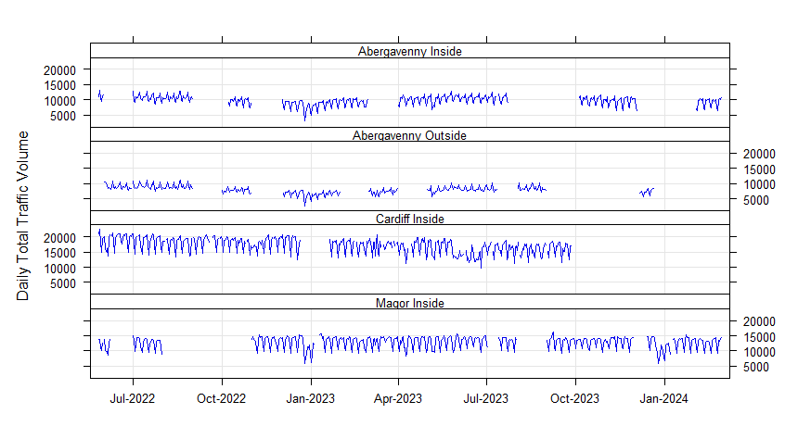
Figure C-1. Daily average traffic volume data across the air quality study area
The daily average traffic volumes in Figure C-3 over the duration of the study show a typical 7-day profile, whereby flows are greater at weekdays versus weekends. This trend is consistent at each of the locations. Other notable trends include a reduction in traffic flows across all sites in late December, which is in relation to the Chirstmas period. In addition there is some evidence to suggest lower traffic volumes in the summer, associated with less routine traffic associated with the summer holidays.

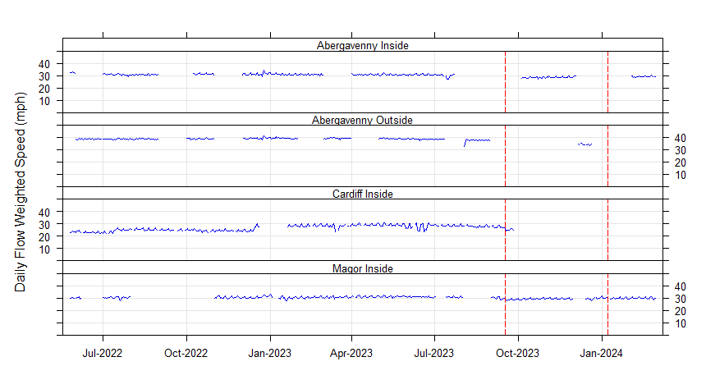
Figure C-2. Daily flow-weighted speed (mph) across the air quality study area
The daily flow weighted average speeds for each location are presented in Figure C-2 with red dashed lines marking:
- 17/09/2023 – national roll-out of the default 20 mph speed limit on restricted roads; and
- 08/01/2024 – when the 20 mph area became enforceable.
The speeds appear fairly consistent across the majority of the study period, with the exception of Cardiff which shows an increase in speeds in July 2022, and then again in December 2022. It is thought this is due to the removal of traffic management associated with the Thornhill Road pedestrian crossing and pavement improvements. More recently, average speeds have dropped slightly at all locations for which there are data, which appears to be associated with the national 20 mph roll-out in September 2023. This reduction is most evident in Cardiff, however, traffic data is only available for nine days post-national roll-out at this location. A comparison of the difference in traffic flows and speeds pre and post-national roll-out are presented in Table C-2.
This shows that the daily average speed at each of the locations within the area has reduced since the national roll-out of the 20 mph scheme. However, these speed changes are small, and total speeds are still in excess of the speed limit of 20 mph. The largest reduction is at the Abergavenny site with a reduction from 30.8 mph to 28.7 mph, whereas the lowest total speed is recorded at Cardiff after the roll-out (a reduction of 1.4 mph).
It should be noted that whilst consistent reductions have been achieved in each area, the data before 17th September 2023 consisted of 479 days, compared to the 165 days post. Therefore, caution should be taken with regard to the interpretation of the results post 17th September, particularly for Cardiff where there is only 5% data capture for that period. In addition, seasonal trends in traffic conditions may impact each period differently e.g. during the post period, factors such as returning to school and the Christmas period will have a greater impact compared to the longer period pre 17th September.
A mitigating measure for the comparison could be to isolate and compare the same days of the year from 2022/23 compared with the post period in 2023/24, however due to limited data capture across the sites, this comparison would suffer from the same issues.
Table C-2. Average daily traffic speeds for each location pre/post national roll-out
Location | Before 17/09/23 | Before 17/09/23 | Before 17/09/23 | After 17/09/23 | After 17/09/23 | After 17/09/23 | Percentage Difference (%) | Percentage Difference (%)
 | Period Data Capture (%) | Average Daily Traffic Flow | Flow Weighted Speed (mph) | Period Data Capture (%) | Average Daily Traffic Flow | Flow Weighted Speed (mph) | Average Daily Traffic Flow | Flow Weighted Speed
Abergavenny Inside | 61 | 9,837 | 30.8 | 52 | 9,467 | 28.7 | -4 | -7
Abergavenny Outside | 66 | 7,989 | 38.8 | 10 | 7,300 | 34.4 | -9 | -13
Cardiff Inside | 89 | 17,280 | 26.7 | 5 | 15,905 | 25.3 | -9 | -5
Magor Inside | 66 | 12,917 | 30.7 | 90 | 12,712 | 29.6 | -2 | -4

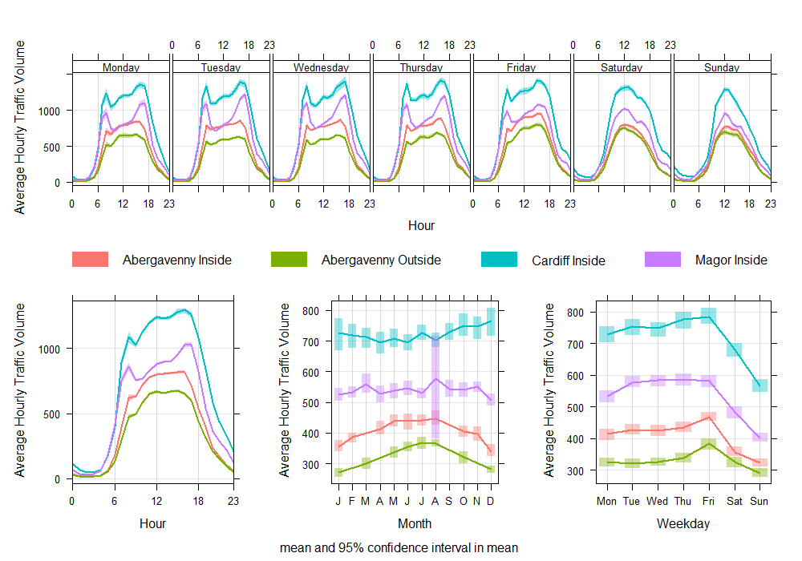
Figure C-3. Time variation of traffic volume across the study area
The time variation plot of average hourly traffic for all the monitoring locations is presented in Figure C-3. This shows that each location demonstrates a fairly distinct AM and PM peak profile on weekdays, particularly at Cardiff and Magor. As discussed above, Cardiff records the greatest average flows, followed by Magor, then Abergavenny inside and outside. There is a small difference between the two Abergavenny locations whereby flows during 06:00 and 19:00 are much greater inside the 20 mph area compared with outside. The difference is greatest between the hours of 06:00 and 10:00, whereby flows within the 20 mph area are approximately 30% greater compared to outside the area. The difference between these hours suggests a workplace is a likely cause, the largest and closest being Nevill Hall Hospital. The difference between the flows inside and outside reduces throughout the day, with a slight increase in the PM. This suggests that not all trips are associated with workers at the hospital, however, it is likely the difference is a result of visitors and outpatient appointments. Further evidence of this is presented in the profiles for Saturday and Sunday, whereby the difference between the flows inside and outside the 20 mph area is much lower. It is possible hospital appointment activity (outpatient appointments) and deliveries are reduced at the weekend which could explain the lower differences, however this is not known for certain.
The PM peak is on average greater than AM peak for all locations. Similarly, trends in traffic flows during the week are consistent for all locations, whereby average hourly flows increase throughout the week from Monday to Thursday, peaking on Friday, before lowering on Saturday and Sunday. Seasonal trends are also fairly similar across the sites with an increase in the summer months, and a decrease in winter months, with the exception of Cardiff, where October to December averages are elevated. This highlights the differences in the locations, whereby Cardiff is a city location, compared to the relatively rural settings of Magor and Abergavenny.
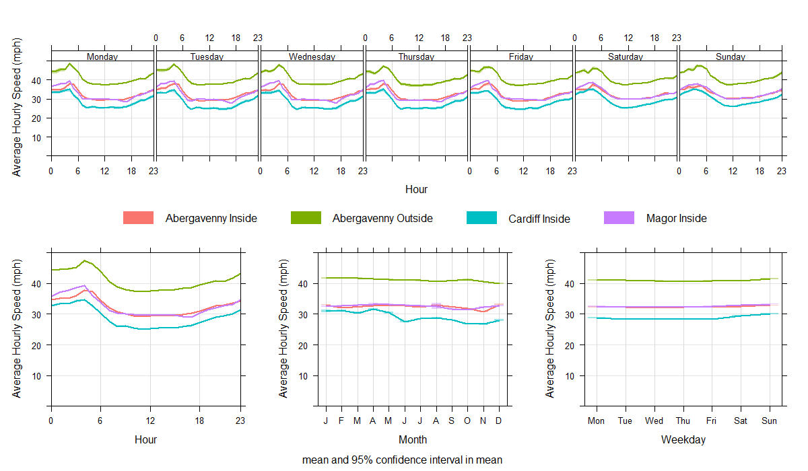
Figure C-4. Time variation of flow weighted average speed (mph) across the study area
The time variations of average speeds are shown for each monitoring location in Figure C-4. Each site shows a very similar trend in traffic speeds across the different temporal categories. This includes:
- Average speeds are in excess of the sign posted speed limit during all hours of the day;
- Speeds are greatest between the hours of 03:00 and 05:00, where there is little traffic on the road as shown in Figure C-3;
- Speeds are fairly consistent across each of the locations during the hours of 08:00 and 17:00, with variation of between 1.2 mph and 1.5 mph.
- Speeds do not vary considerably by day of the week, however there is a slight increase at the weekend.
The daytime (06:00 to 19:00) average speeds at each of the locations are much greater than the signposted speeds (by around 10 mph at Abergavenny inside and outside, and Magor). The difference is smaller at Cardiff, with average daytime speeds 6.4 mph greater than the signposted limit. As shown in Figure C-2, there has been a recent reduction in average speeds potentially linked to the national rollout of the scheme, which has potentially influenced public behaviour, as no changes to speed limits occurred at this time within the study areas, just increased media attention.
Figure C-5 shows the diurnal profiles at each of the locations pre and post 17th September 2023, which demonstrates a consistent reduction in average speeds in all hours of the day. However, the sites within the 20 mph areas do not record an average speed close to the sign posted speed limit in either period, across any hour of the day.

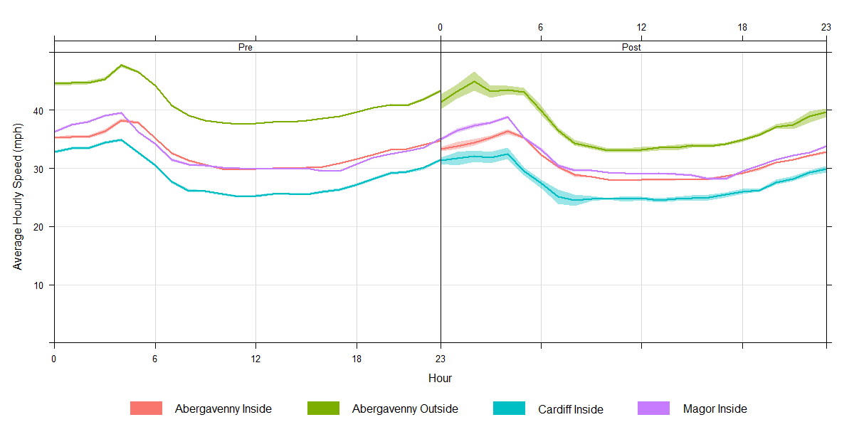
Figure C-5. Time variation of flow weighted average speed (mph) split by pre / post national rollout

Source Apportionment
The use of bivariate plots of concentrations by wind speed and wind direction can be useful for gaining graphical representation of the influence of pollution sources in different directions at a particular location. Average hourly concentrations are aggregated with meteorological data. Ordinarily, this data would be sourced from the closest and most representative airport from the National Oceanic and Atmospheric Administration’s (NOAA) Integrated Surface Database. However, for each location none of the closest meteorological sites on NOAA are considered representative for the following reasons:
- Cardiff – closest NOAA location Cardiff Airport (approximately 18 km to the southwest) is a very coastal location where wind speeds are typically higher and more influenced by temperature changes between land and sea;
- Magor - closest NOAA location Bristol Airport (approximately 23 km to the south southeast) is the other side of the Severn Estuary and more inland compared to Magor, so is likely to record fairly different wind speeds and directions.
- Abergavenny – closest NOAA location is Hereford (approximately 30 km to the northeast) is in a fairly open, inland location. However due to Abergavenny’s unique geographic location at the foot of a valley with hills approximately 400m tall to the north and south of the town, the terrain is likely to impact the meteorological conditions at Abergavenny compared to Hereford.
Due to the reasons listed above, an alternative source of meteorological data has been used for the analysis. Modelled meteorological data has been obtained from the nearest Wales Air Quality Network sites, for which modelled 10 km x 10 km grid resolution meteorological data is provided for air quality forecasting. The data is provided by the Weather Research and Forecasting (WRF) model developed by Ricardo. The data are considered representative of regional synoptic conditions at the location of each UK air quality monitoring site. A wind rose for the meteorological data obtained for each area is presented in Figure D-1, which demonstrates conditions at each location are potentially quite different due to their physical location. Data was taken from the following sites:
- Cardiff was paired with Caerphilly White Street monitor located approximately 4.3 km to the north;
- Magor was paired with Newport M4 Junction 25 monitor located approximately 10.0 km to the west;
- Abergavenny was paired with Cwmbran Crownbridge monitor located approximately 20.0 km to the south. Whilst this site was not the closest, the position of Cwmbran in relation to elevated terrain to the west is similar to Abergavenny.
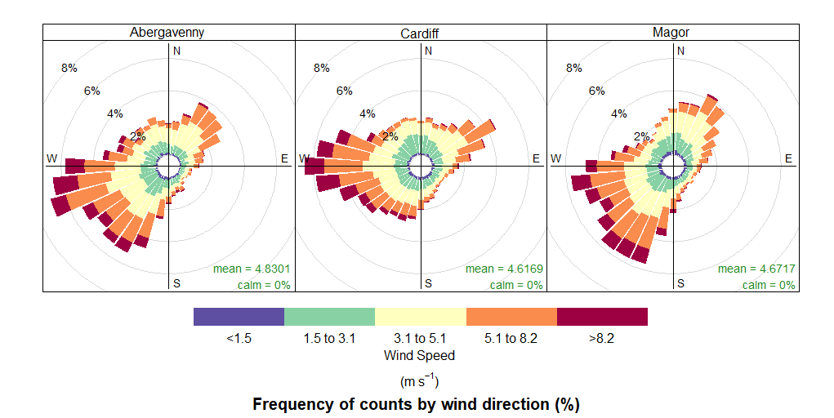
Figure D-1. Wind roses of modelled meteorology obtained from WRF for each location (2022-24)
The wind roses in Figure D-1 show the most frequent wind directions during 2022-24 were from the west and southwest for Abergavenny and Magor, and west for Cardiff. There is also a secondary prevailing wind consistent from the northeast at each location. The average speeds are similar at each of the three locations with the most common wind speed between 3.1 m/s to 5.1 m/s; however, this varies by direction, with winds from the west and southwest being typically stronger, with the most frequent speeds from this direction being between 5.1 m/s to 8.2 m/s. These patterns are important to understand how meteorology could be impacting air pollutant concentrations at the sensors.
Polar plots combine air quality concentration data (colours) with wind speed (concentric rings) and wind direction (grid), to provide an indication of the potential distance and direction of sources influencing measured pollutant concentrations. The polar plots for each pollutant at each site location are presented in the sections below.

  - NO₂
    - Cardiff
The polar plot showing NO₂ concentrations at each of the Cardiff locations are shown in Figure D-2 and Figure D-3. For Cardiff Site 1 (pre-construction) i.e. all data prior to the construction of the Thornhill Road pedestrian crossing, the polar plots show:
- The pattern in the plots is very similar at both monitoring locations, indicating both sensors are being impacted by comparable pollution sources in the same way;
- The highest concentrations are present at lower wind speeds (i.e. less than 4 m/s), indicating a local emission source, and when winds are from the northeast or south. Concentrations typically decrease with increasing wind speed, which is primarily due to increased dilution through advection and increased mechanical turbulence;
- The patterns in the plots where concentrations are elevated when winds are from the south correlate well with the orientation of Thornhill Road relative to both sensors;
- Elevated concentrations when winds are from the northeast do not correlate with an obvious emission source as the road is located to the west of the sensors. However, as this monitoring period is relatively short (three months), the plot can be influenced by atypical pollution events. There were two heatwaves present in this period whereby there were elevated concentrations of ozone (Defra issued pollution episodes for ozone on 18th-19th July, and 11th-15th August). This resulted in elevated concentrations in NO₂ as shown in Figure 3-1 (there is a signal present at both Cardiff and Magor over this period, as well as elevated concentrations nationwide). The winds during the heatwaves were fairly low speed and from the north east, which explains why the high concentrations do not directly correlate with the orientation of the road as would be expected from such a plot.
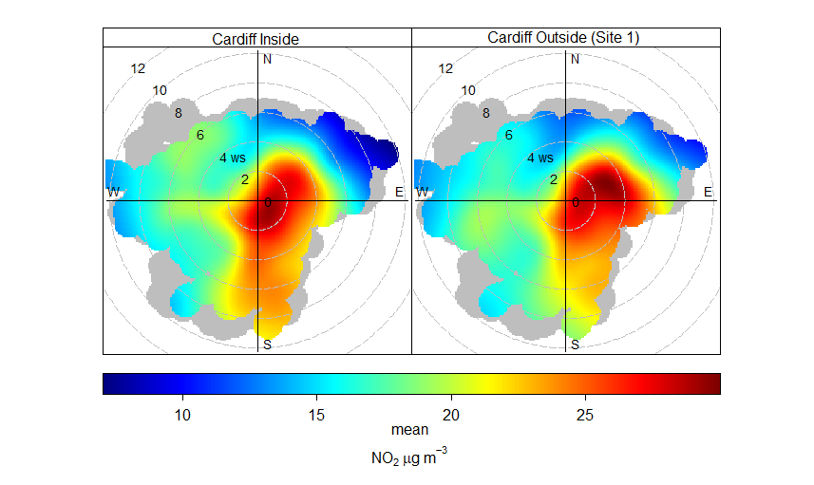
Figure D-2. Polar Plot of adjusted NO₂ (µg/m³) for Cardiff Site 1 sensors (26/05/22 to 26/09/2022)

For Cardiff Site 2, the polar plot is presented in Figure D-3 which shows:
- The pattern in the plots is very similar at both monitoring locations which indicates both sensors are being impacted by comparable pollution sources in the same way;
- The highest concentrations are present at lower wind speeds from most directions, but mostly in the direction which matches Thornhill Road i.e. northwest/southeast. These patterns are indicative of a low-level emission source in close proximity such as a nearby road;
- The lowest concentrations occur from higher wind speeds, which is expected as pollutants typically have greater dispersion under these conditions.
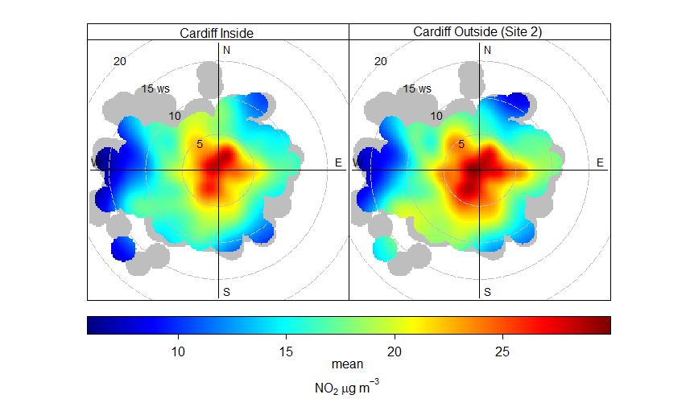
Figure D-3. Polar Plot of adjusted NO₂ (µg/m³) for Cardiff Site 2 sensors (17/05/23 to 05/03/24)

    - Magor
The Magor polar plots presented in Figure D-4 show a greater difference between the sensors inside and outside the 20 mph area. However there are still similarities in the relationship between meteorological conditions and the range of concentrations between the two locations, with the key difference being the magnitude of measured concentrations. This indicates a potentially similar emissions source The plots show:
- Higher concentrations at the site outside the 20 mph area relative to inside, however the highest concentrations at both locations typically occur under the same conditions i.e. low wind speeds when winds are from the northwest and southeast.
- There is evidence of pollution sources in an orientation east to west on both plots, which is typically the orientation of the adjacent road. The elevated concentrations that occur from the west at high wind speeds correlate well with the orientation of the roundabout, which are not present on the plot inside the 20 mph area.
- There is evidence of a pollution source located to the north of the sensor outside the 20 mph area, which is not shown to the same extent on the plot for within the 20 mph area. This could suggest a motorway component which is located in that direction, however this is unlikely given the distance (250m) from the sensor is sufficient not to be contributing concentrations this high. There is an area of dense vegetation immediately to the north of the sensor, which may be impacting the winds from this direction. However as the meteorological data is not monitored at the location, it may be artificially plotting elevated concentrations which may be influenced by lower wind speeds as a result of the vegetation. This is a limitation of using meteorological data from an alternative source instead of local data co-located with the sensors, however patterns will generally be reflective of broader conditions at the monitoring sites.
- The conditions for the lowest concentrations are consistent at both sites (from the southwest and northeast), with vast amounts of greenspace and very limited emission sources relative to the position of the sensors.
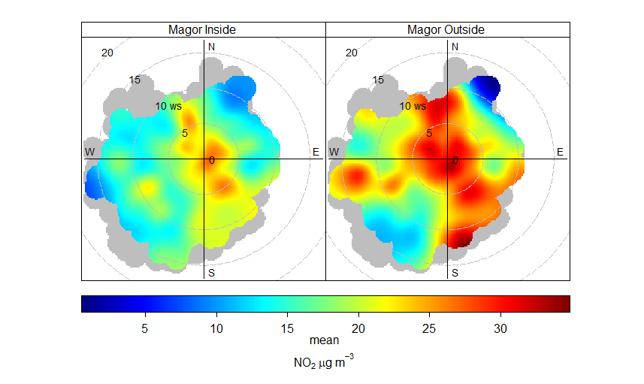
Figure D-4. Polar Plot of adjusted NO₂ (µg/m³) for Magor sensors (27/06/22 to 05/04/24)
    - Abergavenny
The Abergavenny polar plots presented in Figure D-5 show:
- Almost identical patterns in concentrations for inside and outside sensors indicating both sites are impacted by the same emission sources;
- Highest concentrations are present from when winds are from the east, southeast and south at low wind speeds, which is indicative of a low lying emission source such as a road;
- The lowest concentrations occur at higher wind speeds from the north, southwest, west and northwest, in which there are no notable emission sources as it consists of vast open green space.
In summary, there is strong evidence at all three locations that each monitoring site within the pairs are impacted by similar emission sources. The evidence suggests that these are low lying emission sources such as roads, as the greatest concentrations typically occur at low wind speeds. There is also evidence that concentrations are highest when winds are from the direction in which the road is orientated i.e. dispersing emissions toward the sensor. However, it should be noted the limitations of using meteorological data obtained from sources not from the monitoring location themselves, as it will not represent the specific micro-environment in some locations e.g. vegetation having a blocking effect on winds from a certain direction as shown in Magor.
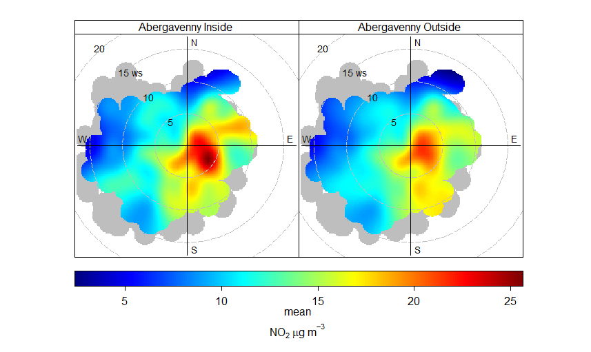
Figure D-5. Polar Plot of adjusted NO₂ concentration for Abergavenny sensors (18/03/23 to 10/04/24)

PM₁₀ and PM_{2.5}
Particulate matter (PM) is a generic term used to describe a complex mixture of solid and liquid particles of varying size, shape, and composition (i.e. everything in the air that isn’t a gas). Some particles are emitted directly (primary PM), while others are formed in the atmosphere through complex chemical reactions (secondary PM).
The main sources of man-made PM are the burning of fuels (in vehicles, industry and homes) and other physical processes, such as tyre and brake wear. Natural sources include wind-blown soil and dust, sea spray particles, and fires. PM is often classified according to its size and referred to as:
- Coarse particles (PM₁₀; particles that are less than 10 microns in diameter);
- Fine particles (PM_{2.5}; particles that are less than 2.5 microns in diameter).
Unlike NO₂ concentrations, PM₁₀ and PM_{2.5} concentrations are less influenced by road traffic emissions. This is demonstrated by the monitoring undertaken in Cardiff, Magor and Abergavenny.
  - Study Period Summary
The study period averages for the four monitoring locations for PM₁₀ and PM_{2.5} concentrations are presented in Table E-1 and Table E-2. This shows:
- The sensors for each location record concentrations well within the annual mean and short term air quality objectives for PM₁₀ and PM_{2.5}
- For Cardiff;
  - The sensor inside the 20 mph area monitors 0.3 µg/m³ lower compared to outside the area for PM₁₀ at Outside Location 1. This small difference is well within the average measurement error of the sensors. Neither sensor recorded an exceedance of the short term daily average standard of 50 µg/m³;
  - The sensor inside the 20 mph area monitors 0.1 µg/m³ greater compared to outside the area for PM₁₀ at Outside Location 2. This small difference is well within the average measurement error of the sensors. Neither sensor recorded an exceedance of the short term daily average standard of 50 µg/m³;
  - The sensor inside the 20 mph area monitors 0.5 µg/m³ lower compared to outside the area Location 1 (pre construction of pedestrian crossing) for PM_{2.5}. This is well within the average measurement error of the sensors;
  - The sensor inside the 20 mph area monitors 0.2 µg/m³ greater compared to outside the area for PM_{2.5} at Outside Location 2. This small difference is well within the average measurement error of the sensors;
- For Magor;
  - The sensor inside the 20 mph area monitors 1.0 µg/m³ greater compared to outside the area for PM₁₀. This small difference is within the average measurement error of the sensors. The sensor inside recorded four exceedances of the short term daily average standard of 50 µg/m³, compared to one at the sensor outside the area;
  - The sensor inside the area monitors 1.6 µg/m³ greater compared to outside the area for PM_{2.5}. This difference is well within the average measurement error of the sensors;
- For Abergavenny;
  - The sensor inside the 20 mph area monitors 0.8 µg/m³ lower compared to outside the area for PM₁₀. This small difference is well within the average measurement error of the sensors. Neither sensor recorded an exceedance of the short term daily average standard of 50 µg/m³;
  - The sensor inside the area monitors 1.5 µg/m³ greater compared to outside the area for PM_{2.5}. This difference is well within the average measurement error of the sensors;

Table E-1. Summary PM₁₀ concentration data within each area
Area | Average Measured PM₁₀ Concentration Inside 20mph Speed Limit  (µg/m³) | Average Measured PM₁₀ Concentration Outside 20mph Speed Limit  (µg/m³) | Difference Between Inside and Outside 20mph Speed Limit  (µg/m³) | Average PM₁₀ Concentration Measurement Error  (µg/m³)
Cardiff (using Outside Location 1) | 13.3 [0] | 13.6 [0] | -0.3 | 3.9
Cardiff (using Outside Location 2) | 14.7 [0] | 14.6 [0] | +0.1 | 1.7 - 3.2
Magor (Severnside) | 17.6 [4] | 16.6 [1] | +1.0 | 1.7 - 3.9
Abergavenny | 15.6 [0] | 16.4 [0] | -0.8 | 2.3 – 6.0
Numbers in square brackets represent the number of times the short term daily average concentration of 50 µg/m³ was exceeded. Note that the annual objective for the short term target allows for 35 daily exceedances of this threshold.

Table E-2. Summary PM_{2.5} concentration data within each area
Area | Average Measured PM_{2.5} Concentration Inside 20mph Speed Limit  (µg/m³) | Average Measured PM_{2.5} Concentration Outside 20mph Speed Limit  (µg/m³) | Difference Between Inside and Outside 20mph Speed Limit  (µg/m³) | Average PM_{2.5} Concentration Measurement Error  (µg/m³)
Cardiff (using Outside Location 1) | 10.0 | 10.5 | -0.5 | 3.9
Cardiff (using Outside Location 2) | 13.3 | 13.1 | +0.2 | 1.7 - 3.2
Magor (Severnside) | 13.5 | 11.9 | +1.6 | 1.7 - 3.9
Abergavenny | 13.7 | 12.2 | +1.5 | 2.3 – 6.0
  - Temporal Variations
The average temporal variations for each location for PM₁₀ and PM_{2.5} concentrations are presented in Figure E-1and Figure E-2 respectively. This shows that relationships between each monitoring pair and hour of day is similar for both PM₁₀ and PM_{2.5}. This is expected given that a fraction of PM₁₀ is made up of PM_{2.5}.
At all sites, the diurnal profile of both pollutants is more consistent over the course of the day, unlike NO₂, which shows a distinct AM and PM peak in concentrations. Whilst there is evidence of a slight rise in average concentrations of PM₁₀ and PM_{2.5} in the morning and evening, the peak is more spread out and not of the magnitude seen for NO₂. This could be indicative of more general anthropogenic activity such as domestic heating, wood burning, industrial emissions etc, rather than a direct relationship to road traffic activity. This is particularly evident at Cardiff Site 1 within the 20 mph area, whereby the profiles are the most different between the sensor pairs. It suggests a gradual build up of concentrations over the day before decreasing in the evening, noting very little influence of peak traffic conditions. Likewise, at the other locations, concentrations in the off-peak are fairly high relative to the peak periods and consistent in magnitude across each of the locations. Given that traffic activity dramatically falls in the off-peak, if concentrations were influenced to the same extent as NO₂, it would be expected off-peak concentrations would be much lower relative to the peak periods.
The diurnal profiles at each of the locations are evidence that concentrations of PM₁₀ and PM_{2.5} are not heavily influenced by road traffic emissions. Other sources can be indicated by assessing when elevated concentrations occur under certain meteorological conditions discussed below.

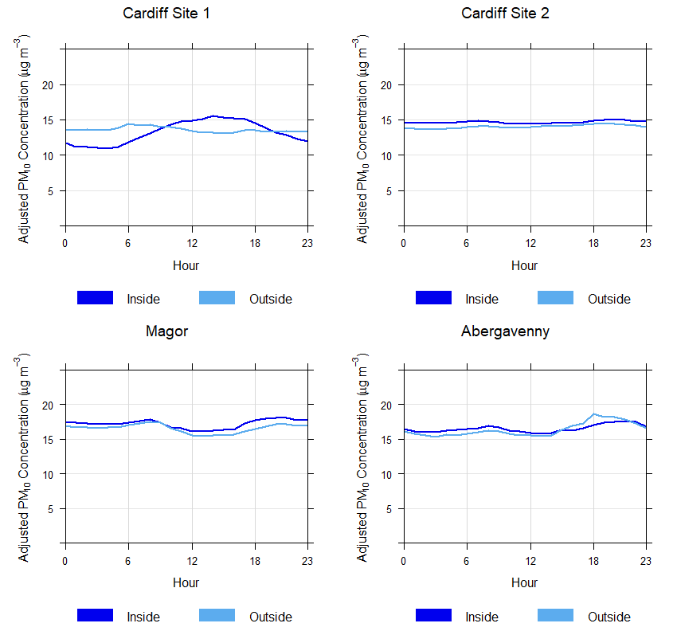
Figure E-1. Diurnal profile for adjusted PM₁₀ concentrations for each monitoring location

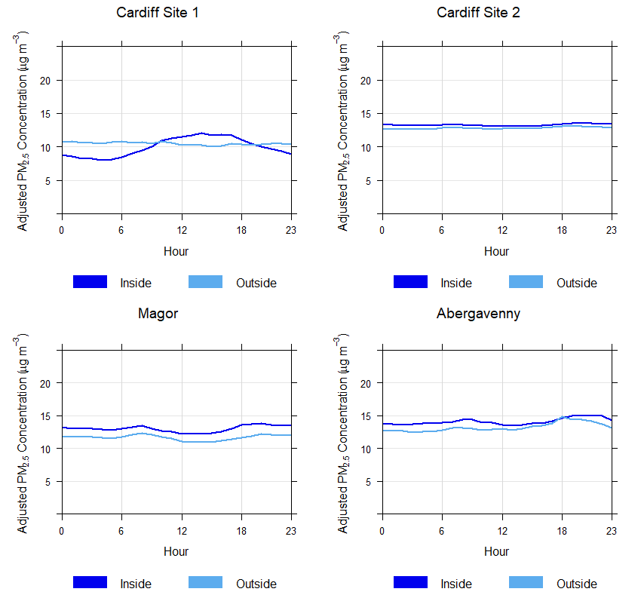
Figure E-2. Diurnal profile for adjusted PM_{2.5} concentrations for each monitoring location

  - Source Apportionment
Plotting concentrations by wind speed and direction can provide further confidence on the potential sources of emissions. Some useful known relationships with particle pollution and wind speed which differ compared to gaseous pollutants include:
- Increasing concentrations with increasing wind speeds as a result of particle resuspension;
  - This suspension can be important near to coastal areas where high wind speeds generate more sea spray
- Elevated concentrations from easterly directions in the UK is linked to emissions and precursors of secondary particulate pollution from Europe and natural contributions during continental episodes such as Saharan dust.
The polar plot showing PM₁₀ and PM_{2.5} concentrations at Cardiff Site 1 (pre-pedestrian crossing construction) are shown Figure E-3 to Figure E-4. The polar plots show similarities for both PM₁₀ and PM_{2.5} contributions indicating similar sources for both pollutants. There are also differences between the sensor inside and the sensor outside the 20 mph area which likely indicate differences in local pollution sources.
- For both locations, elevated concentrations of PM₁₀ occur at high wind speeds from the south and the west. The westerly contribution is less pronounced for PM_{2.5} on both plots. The orientation of the Bristol Channel matches well with the elevated concentrations from the southwest and west. In addition, spray particles are typically coarser compared to other sources which provides further evidence that wind blown particles have a large influence on monitored concentrations in Cardiff as the elevated concentrations from this direction are not as prominent for PM_{2.5} (finer particles);
- Elevated contributions occur from easterly winds between 2 to 6 m/s at the sensor within the 20 mph area. Given that this pattern does not occur for the sensor outside the area, it is likely this is from a nearby local emission source, not associated with road traffic emissions (the road is located to the west of the sensor).
In comparison to the NO₂ polar plot presented in Figure D-2, the plots are very different, particularly when wind speeds are lower (indicative of low-lying local sources of emissions i.e. road traffic emissions). Elevated concentrations do not occur at low wind speeds to the same extent for PM₁₀ and PM_{2.5}. This suggests that PM₁₀ and PM_{2.5} are not influenced by similar emission sources of NO₂ i.e. road traffic emissions.
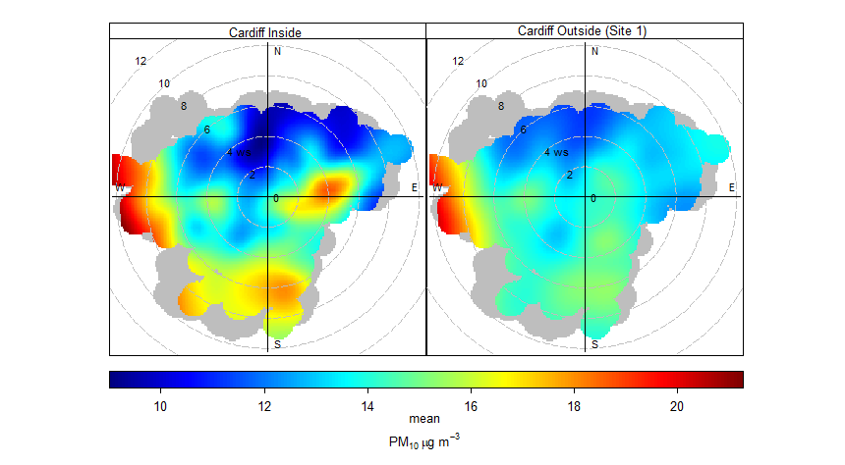
Figure E-3. Polar Plot of adjusted PM₁₀ (µg/m³) for Cardiff Site 1 sensors (26/05/22 to 26/09/2022)

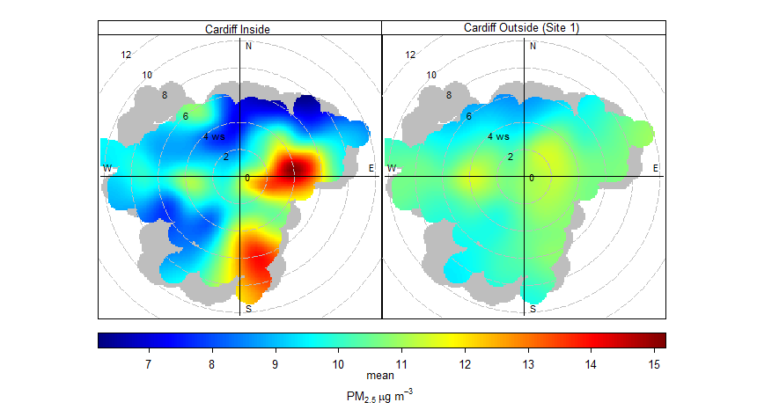
Figure E-4. Polar Plot of adjusted PM_{2.5} (µg/m³) for Cardiff Site 1 sensors (26/05/22 to 26/09/2022)
The polar plot showing PM₁₀ and PM_{2.5} concentrations at Cardiff Site 2 (post-pedestrian crossing construction) are shown in Figure E-5 to Figure E-6. The polar plots show similarities for both PM₁₀ and PM_{2.5} contributions indicating similar sources for both pollutants. The key features of the plots show:
- For both locations, elevated concentrations for both PM₁₀ and PM_{2.5} occur at high wind speeds from the south and the west (as they did in during the pre-pedestrian crossing construction period). This adds further confidence that concentrations are influenced by wind-blown sea spray;
- There is a slight contribution of elevated contributions when winds are from the east at the location inside the 20 mph area. However this is not as pronounced compared to the pre-construction period. The elevated concentrations under the easterly conditions are still evident outside the area, so it is possible this contribution is more regional in nature.
In comparison to the NO₂ polar plot presented in Figure D-3, the plots are very different, whereby the highest concentrations of NO₂ for both sites occur under low wind speeds from multiple directions, whereas the highest concentrations for PM₁₀ and PM_{2.5} occur under high wind speeds primarily from the south and west. This suggests that PM₁₀ and PM_{2.5} are not influenced by similar emission sources of NO₂ i.e. road traffic emissions.
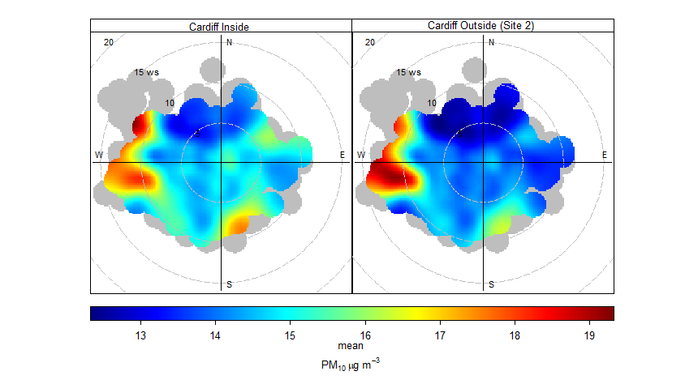
Figure E-5. Polar Plot of adjusted PM₁₀ (µg/m³) for Cardiff Site 2 sensors (17/05/23 to 05/03/24)
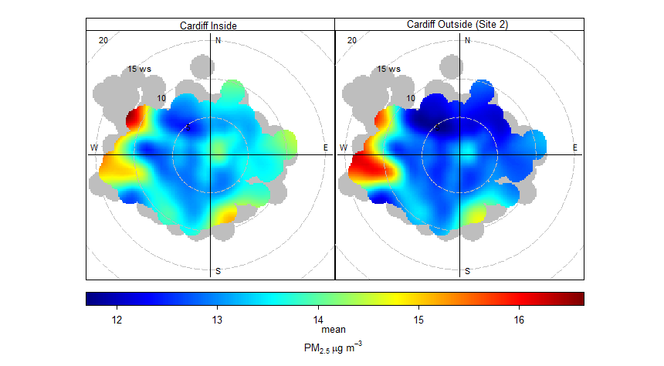
Figure E-6. Polar Plot of adjusted PM_{2.5} (µg/m³) for Cardiff Site 2 sensors (17/05/23 to 05/03/24)

The polar plots for PM₁₀ and PM_{2.5} for Magor are presented in Figure E-7 and Figure E-8. These show a similar trend to the Cardiff locations in that the highest concentrations occur from a south westerly direction at high wind speeds. This occurs for both pollutants, within and outside the 20 mph area, indicating the source is more regional in nature, with the orientation suggesting the Bristol Channel is potentially the source.
These trends do not occur under the same conditions for NO₂ concentrations in Magor, when compared to Figure D-4, the highest concentrations are present under low wind speeds from multiple directions, which is not the case for PM₁₀ and PM_{2.5}.
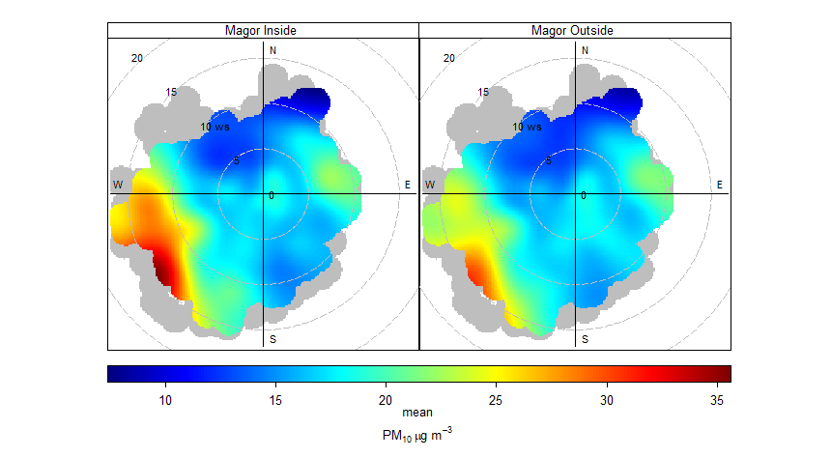
Figure E-7. Polar Plot of adjusted PM₁₀ (µg/m³) for Magor sensors (27/06/22 to 05/04/24)
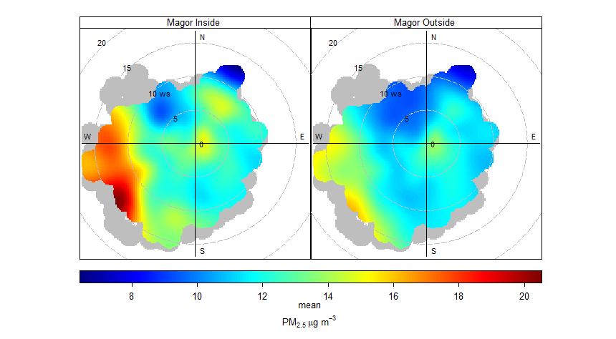
Figure E-8. Polar Plot of adjusted PM_{2.5} (µg/m³) for Magor sensors (27/06/22 to 05/04/24)
The polar plots for PM₁₀ and PM_{2.5} for Abergavenny are presented in Figure E-9 and Figure E-10. These plots are slightly different compared to Magor and Cardiff, which are fairly similar in location by orientation to the Bristol Chanel and therefore sources of particulate pollution. Abergavenny is further inland and at the foot of a valley, so is less impacted by coastal emission sources.
The axis of both Figure E-9 and Figure E-10 has been limited for the maximum concentrations because of elevated concentrations in March 2024. During 7th to 10th March, elevated concentrations were present at both sensors during high speed winds from the east (which are relatively infrequent as shown in Figure D-1). Without limiting these elevated concentrations, the plots become difficult to pick out other defining features and relationships (particularly inside the 20 mph area), as these infrequent conditions dominate the plot. It is unknown what the source of the emissions were, but it is possible this was from a nearby domestic wood burning source which aligns with the direction of the wind.
The polar plots for PM₁₀ and PM_{2.5} for Abergavenny are almost identical in terms of the conditions in which elevated concentrations occur from for both locations within and outside the 20 mph area. The notable difference being higher concentrations of PM₁₀ concentrations relative to PM_{2.5} concentrations at high wind speeds from the southwest. A possible source of emissions from this direction are windblown sediments from the Bannau Brycheiniog National Park (Brecon Beacons), where there are a number of quarries located on the eastern side of the National Park. The sensor outside the 20 mph area is more exposed from this direction, with little development to the southwest, which may explain the larger impact compared to the sensor inside the area.
The main conditions resulting in elevated concentrations at both sites for both pollutants is from the east at various wind speeds. This is likely associated with local sources of particulate emissions associated with the urban area e.g. domestic heating (mainly wood burning) as indicated by the diurnal profile of each pollutant where concentrations are higher in the evening.
In comparison to the polar plot for NO₂ in Figure D-5, the conditions resulting in the greatest concentrations share more similarities than is the case for Cardiff and Magor. Concentrations are greatest from the east, but typically occur at lower wind speeds compared to PM₁₀ and PM_{2.5}.
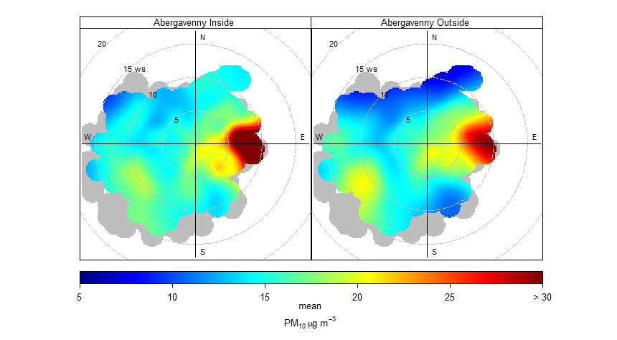
Figure E-9. Polar Plot of adjusted PM₁₀ concentration for Abergavenny sensors (18/03/23 to 10/04/24)

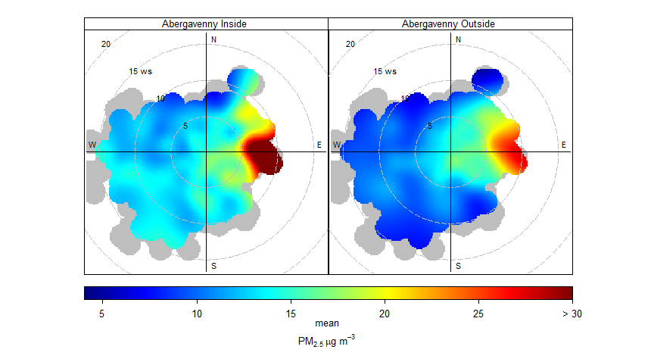
Figure E-10. Polar Plot of adjusted PM_{2.5} concentration for Abergavenny sensors (18/03/23 to 10/04/24)
Comparing the polar plots for each of the study areas against those comparable locations on the Welsh Air Quality Network, there are similarities which demonstrate the regional nature of particulate pollution. Polar plots for PM₁₀ and PM_{2.5} are shown for Cardiff Centre, Cwmbran Crownbridge and Newport St Julians School where data is available for 2022 to 2024 are shown in Figure E-11 and Figure E-12.
These plots typically show highest concentrations occur during high wind speeds from the east, south west and west which are consistent with regional pollutant resuspension.
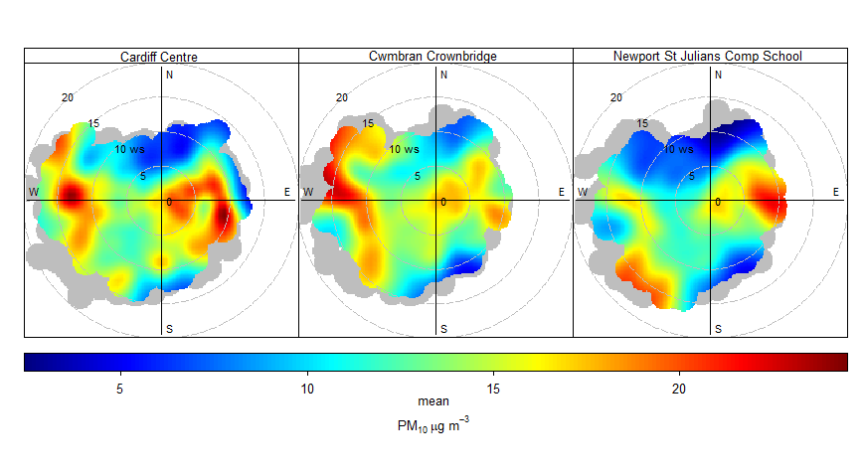
Figure E-11. Polar Plot of PM₁₀ concentration for nearby Welsh AQ Network sites (2022 – 2024)

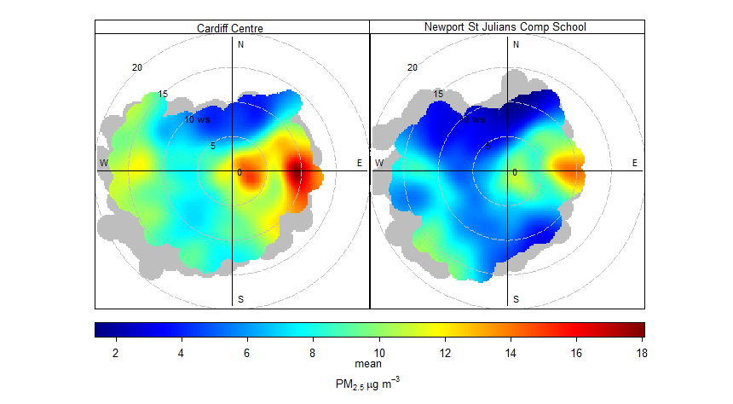
Figure E-12. Polar Plot of PM_{2.5} concentration for nearby Welsh AQ Network sites (2022 – 2024)

Detailed Cardiff Analysis
  - Impact of construction
The construction of the Thornhill Road pedestrian crossing (opposite the crematorium) and associated footpath improvements had a large impact on NO₂ concentrations as shown in Figure 3-1. The concentrations steadily increase from around 24th October before a rapid drop upon conclusion of the works as per the construction programme. The works consisted of traffic management with temporary traffic lights for contraflow traffic.
The construction and traffic management works occurred directly adjacent to the location of the sensor which would have caused periods of queuing and congestion, as well as acceleration as vehicles passed through the traffic lights. In addition to the routine traffic emissions, there would have been additional emissions from heavy machinery associated with the works such as idling HGVs and excavators.
The concentrations at the sensor within the 20 mph area appear to be unaffected by these works as it is located approximately 750m to the south of the pedestrian crossing. The difference between the sensors is presented in Table F-1 below.
This shows that the concentrations outside the 20 mph area were 32.3 µg/m³ greater than those inside the 20 mph area during this period. The daily flow weighted speeds during this period were also low within the area indicating that traffic management impacted speeds further into the 20 mph area. However, concentrations within the area remained consistent across the period.
Whilst the difference over this period is large, it is fairly short lived, being over a duration of 2 months.
Table F-1. Comparison of measured NO₂ concentrations during construction of the pedestrian crossing
NO₂ Concentration (µg/m³) | Inside | Outside | Difference | RMSE | Daily Flow Weighted Average Speed (mph)
During Construction | 15.4 | 47.7 | -32.3 | 3.6 – 3.8 | 24.6
During the construction of the second pedestrian crossing at Templeton Avenue, there is very little difference between the sensor inside the 20 mph area compared to outside the area. This is likely due to the scale of the works being smaller and also without the need for extensive traffic management on Thornhill Road. In addition, the works were undertaken approximately 100m to the north of the sensor, whereas the works undertaken at the crematorium were directly opposite.
  - Impact of raised crossing
The diurnal profile for Cardiff (Site 1) after the construction of the pedestrian crossing (12/01/2023 to 17/05/2023) is shown in Figure F-1. This shows a small but consistent difference in concentrations between the two sensors on an average day of the week across the study period. The profile is characteristic of one impacted by road traffic emissions with much more defined AM and PM peaks in concentrations compared to the pre-construction period shown in Figure 3-4 (which was impacted by the school holidays). The magnitude of the AM peak is typically higher compared to the PM peak in concentrations (maximum hourly concentrations of 41.1 µg/m³ in the AM and 36.2 µg/m³ in the PM for the sensor outside the 20 mph area). Note that comparisons in absolute concentrations cannot be drawn against the pre-construction period because they cover different months, which are subject to different meteorological and traffic conditions. The most suitable comparison is between the two sensors as they are impacted by the same meteorological and traffic conditions.
The off-peak concentrations at background levels are typically slightly higher outside the 20 mph area compared to inside the area. This was also the case during the pre-construction period. In this post-construction period, the daytime concentrations (which are more influenced by road traffic emissions) have shown a change between the sensors whereby the concentrations outside the 20 mph area are greater than the concentrations within the area. The biggest difference in this period is 5.2 µg/m³ at 07:00 where the sensor outside is greater than inside (which is around 13% of the AQO, and outside the range of average measurement error).
The overall difference for the duration of the period is shown in Table F-2. This shows that the sensor outside the 20 mph area is 2.1 µg/m³ greater compared to inside the area. This difference is however within the bounds of the average measurement error of the sensors.
Compared to the pre-construction period presented in Section 3.2.1.1, which indicated that NO₂ concentrations were slightly higher within the 20 mph area than outside, this suggests the crossing has resulted in increased emissions at the location of the sensor outside the 20 mph area.
Increases in emissions can occur when there is a breakdown in flow conditions, as vehicles brake on approach and the accelerate away from the crossing. This could be the reason for the variation in the difference between the sensor outside the 20 mph area relative to inside, pre and post crossing construction, respectively. However, it should be noted that this post construction period consists of only three months of data, which is not considered a large enough sample size to draw firm conclusions. The survey period at the location outside the 20 mph area was cut short so that the potential impact of the crossing did not get misinterpreted as an impact of 20 mph introduction. The sensor was moved to Site 2.
Table F-2. Comparison of measured NO₂ concentrations post-construction of the pedestrian crossing
NO₂ Concentration (µg/m³) | Inside | Outside | Difference | RMSE | Daily Flow Weighted Average Speed (mph)
Post Construction | 27.3 | 29.4 | -2.1 | 3.6 – 3.8 | 28.8
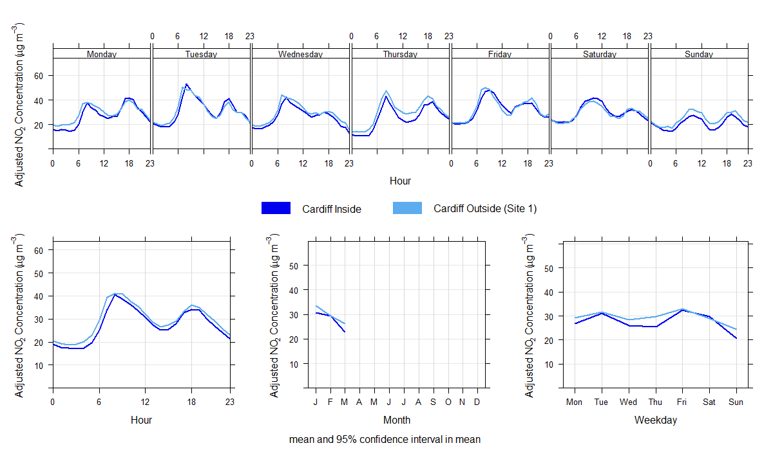
Figure F-1. Average hourly NO₂ Concentrations (µg/m³) for Cardiff (Site 1) (Post-Construction of crossing)

Detailed Magor Analysis
  - Elevated Concentrations During late 2022
As shown in Figure 3-2 the sensor outside the 20 mph area experienced a large increase relative to the sensor within the area during late December 2022 and early January 2023. During this period, it is known there were a number of issues relating to temporary closures of the M48 Severn Bridge. This is thought to have resulted in increased congestion impacting the roundabout to the west of the sensor outside the area.
Typically, this time of year results in lower traffic flows compared to average due to the festive period. Such a reduction in traffic was observed in Magor around this time, as can be seen in Figure C-1 in Appendix C. There is also a reduction in traffic speeds over this period coinciding with motorway closures in the area. Due to the lower than average traffic flows during this period, the difference between the sensors is perhaps larger than would be expected.
The period where the difference is greatest and concentrations peak outside the 20 mph area is on the 4th January, when the M48 Severn Bridge was closed due to high winds. Relative to other times during this period, wind speeds increased and transitioned from a southerly wind toward a westerly wind. Winds then returned to a more southerly direction on the 5th of January when concentrations then reduced. This pattern could suggest:
- greater dispersion of road traffic emissions associated with traffic congestion around the roundabout towards the sensor outside the 20 mph area; or
- potential emissions from a nearby industrial source to the west impacting measured concentrations at the sensor outside the 20 mph area over this period. This is because during strong winds and stable atmospheric conditions (which are more likely to occur in winter months), it is more likely that a plume can become grounded rather than dispersing upwards.
These episodes are typically local and short-lived. Activity data from nearby industrial emission sources are not known, however, and more detailed analysis is beyond the scope of this study, so this cannot be confirmed. It is, however, known that various industrial emission sources are present at an industrial park located to the west of the sensors, beyond the A4810.
The observed difference in concentrations between the sensors is presented in Table G-1, which shows during this short period the sensor outside the 20 mph area monitored concentrations 43.0 µg/m³ (i.e. >500%) greater than the sensor inside the 20 mph area. It should be noted that this difference was relatively short-lived and does not appear to be a result of changes to average daily flow weighted speed, which was recorded at 31.6 mph during the same timeframe within the 20 mph area. However, these speeds may not be representative of those adjacent to the sensor outside the area.

Table G-1. Comparison of measured NO₂ concentrations during 20/12/22 to 09/01/23 in Magor
NO₂ Concentration (µg/m³) | Inside | Outside | Difference | RMSE | Daily Flow Weighted Average Speed (mph)
Traffic Issues | 10.3 | 53.3 | -43.0 | 2.7 – 5.1 | 31.6
  - Conditional Analysis
    - Impact of roundabout
Conditional analysis is the process of isolating measured concentration data attributable to the source of interest to increase the signal to noise ratio. This technique is a popular technique to provide more confidence in trends associated with the relevant target source within complex environments. There is evidence in the Magor polar plots (Figure D-4) that factors other than road traffic emissions may be influencing one monitoring site and not the other, for example, the roundabout to the west of the monitoring site and the influence of trees to the north of the sensor outside the 20 mph area on dispersion. Both of these factors could be impacting the concentrations monitored outside the area and could explain the larger difference between the two monitoring sites.
The target source in this case is the contribution made by the B4245 to both sensors. By using Figure D-4, certain emission sources can be identified under certain conditions based on known orientation to the sensors and also known behaviour of emissions under certain wind speeds. For example, it is known a roundabout is located to the west of the sensor outside the 20 mph area. Therefore excluding winds from the west using conditional analysis would reduce the influence of this potential emission source. By removing data when winds are from the direction of the roundabout, the emission signal of the B4245 is increased. It is also known that at high wind speeds, it is possible high level stack emissions or regional emissions are more likely to contribute towards monitored concentrations.
The target source signal of the B4245 can therefore be increased by isolating those meteorological conditions where winds are:
- From between 40 and 230 degrees; and
- Have a speed less than 5 m/s
These conditions are illustrated with the black arch on the polar plots for NO₂ concentrations in Figure G-1. An average of all of the hours that meet these conditions (with M4/M48 issues removed) are presented alongside the ‘unconditioned’ data in Table G-2.
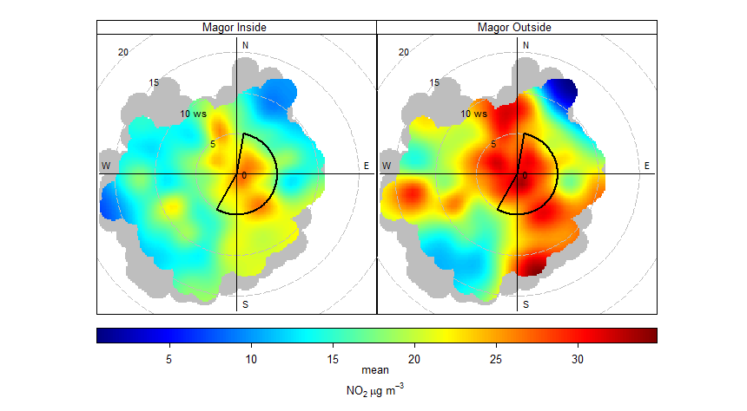
Figure G-1. Polar Plot of adjusted NO₂ (µg/m³) for Magor sensors with conditioned subset marked out
The comparison between conditioned and unconditioned data in Table G-2 shows little change between the difference in concentrations of the sensors inside and outside the 20 mph area (the difference is 0.5 µg/m³ greater in the conditioned data compared to unconditioned). The absolute concentrations are greater at both sensors under the conditioned subset, primarily due to the exclusion of higher wind speeds, whereby emissions are more easily and widely dispersed, resulting in lower concentrations. Note that the number of hours available in the conditioned subset is considerably less compared to the unconditioned data.
The small difference between the two datasets suggests that the proximity of the roundabout to the west of the sensor outside the 20 mph area (as an emission source) is not a primary factor in the large difference between the sensor outside the area compared to inside.
As a result of this test, the reasons for the differences between the sensors can be more confidently attributed to either of the following:
- Greater emissions on the B4245 associated with acceleration away from the roundabout; and/or
- Impact of vegetation as a buffer for dispersion.
Table G-2. Comparison of conditioned vs unconditioned measured NO₂ concentrations in Magor
NO₂ Concentration (µg/m³) | Inside | Outside | Difference | RMSE | Number of hours
Conditioned | 23.0 | 29.1 | -6.1 | 1.0 - 5.1 | 3,991
Unconditioned | 20.2 | 25.8 | -5.6 | 1.0 - 5.1 | 14,923
Data associated with the M4/M48 issues are excluded from this analysis
Conditioned data subsets the measured data where winds are from between 40 to 230 degrees and less than 5 m/s, whereas there are no meteorological restrictions on unconditioned data
    - Impact of vegetation
As noted in Section 3.2, in addition to the proximity of the roundabout to the west adding an additional contribution to the sensor outside the 20 mph area, the dense vegetation around the sensor may also be inhibiting dispersion. This would likely lead to a build up in emissions leading to higher concentrations. One of the ways to test this impact is to look at the differences by season, as the vegetation becomes less dense during the winter months and denser during the summer months. The difference between the sensors during the summer months is likely to be greater as the dense foliage inhibits dispersion, but conversely the difference should be smaller during the winter when leaves fall from the trees.
Table G-3 and Figure G-2 show the seasonal trends in concentrations of NO₂ between the two sensors which does show that typically the difference between the sensors is greater during the spring and summer months indicating that concentrations may be influenced by the greater foliage during these times. However, it should be noted that the dispersion characteristics are not the only difference between the two locations. As stated previously, the sensor outside the 20 mph area may be influenced by other confounding factors such as proximity to the roundabout and possible contributions from nearby industrial sources of pollution. This is shown by a large difference in February, where foliage is less dense, but the difference between the sensors is the second highest of any month. However, the general trend is lower concentrations during the winter months compared to summer.
Table G-3. Seasonal variation in NO₂ concentrations (µg/m³) at Magor
Month | Inside | Outside | Difference
January | 20.8 | 26.5 | -5.7
February | 16.2 | 19.5 | -3.3
March | 13.1 | 18.0 | -4.9
April | 16.2 | 22.5 | -6.3
May | 14.5 | 21.6 | -7.1
June | 19.2 | 27.4 | -8.3
July | 20.7 | 27.8 | -7.1
August | 21.4 | 27.6 | -6.2
September | 22.5 | 28.1 | -5.6
October | 24.3 | 29.5 | -5.2
November | 24.1 | 28.7 | -4.7
December | 25.4 | 30.2 | -4.8
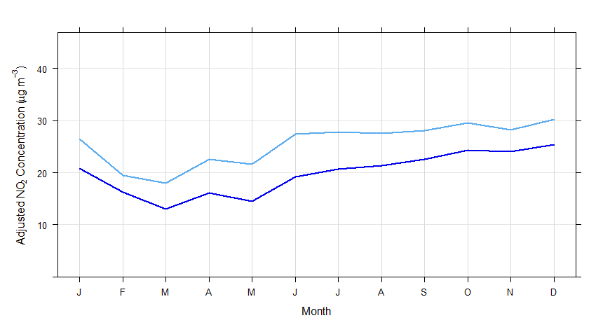
Figure G-2. Average monthly NO₂ concentration at both Magor sensors

Potential Impact of Speed Enforcement
As discussed in Appendix C average flow weighted speeds have remained fairly consistent over the duration of the study period, with some evidence of a recent reduction in speeds. The average speeds are above the signposted limit of 20 mph, even with recent reductions.
Periodic enforcement activities were undertaken during the study period, with the presence of a GoSafe van within the 20 mph area to encourage drivers to reduce speeds closer to the signposted limit. The enforcement activities undertaken in each study location are detailed in Table H-1.
Table H-1. Details of speed enforcement activities
Location | Day | Start | End | Length
Cardiff | Friday | 02/06/2023 12:45 | 02/06/2023 13:00 | 00:15:00
 | Monday | 26/06/2023 09:25 | 26/06/2023 09:40 | 00:15:00
 | Friday | 30/06/2023 12:35 | 30/06/2023 14:20 | 01:45:00
 | Wednesday | 05/07/2023 09:35 | 05/07/2023 11:20 | 01:45:00
 | Wednesday | 19/07/2023 12:30 | 19/07/2023 14:15 | 01:45:00
 | Tuesday | 25/07/2023 11:00 | 25/07/2023 12:45 | 01:45:00
 | Tuesday | 08/08/2023 18:00 | 08/08/2023 19:45 | 01:45:00
 | Friday | 18/08/2023 12:20 | 18/08/2023 14:05 | 01:45:00
Magor | Wednesday | 18/01/2023 10:55 | 18/01/2023 14:00 | 03:05:00
 | Wednesday | 18/01/2023 15:20 | 18/01/2023 18:25 | 03:05:00
 | Thursday | 19/01/2023 07:40 | 19/01/2023 10:45 | 03:05:00
 | Thursday | 19/01/2023 11:10 | 19/01/2023 14:20 | 03:10:00
 | Monday | 11/09/2023 06:55 | 11/09/2023 10:00 | 03:05:00
 | Tuesday | 12/09/2023 06:55 | 12/09/2023 10:00 | 03:05:00
Abergavenny | Monday | 11/09/2023 07:00 | 11/09/2023 10:00 | 03:00:00
 | Tuesday | 12/09/2023 06:55 | 12/09/2023 10:00 | 03:05:00
Whilst the total number of hours of enforcement is small, analysis has been undertaken to compare the monitored concentrations both within and outside the 20 mph area. Concentrations were compared for the hours and days of the week for which enforcement was active.. For example, the measurements during enforcement for Cardiff are compared against the non-enforcement hours of 09:00 to 14:00 and 18:00 to 19:00 on Mondays, Tuesdays, Wednesdays and Fridays to limit confounding factors. Note that absolute concentrations may differ due to seasonality, however percentage difference between the sensors is comparable. The results of the analysis are presented in Table H-2.
Table H-2. Comparison of NO₂ (µg/m³), number of hours and hourly average speeds for enforcement and non-enforcement
 |  | NO₂ Concentration (µg/m³) | NO₂ Concentration (µg/m³) | Number of hours | Number of hours | Hourly Average Speed (mph) | Hourly Average Speed (mph)
 |  | Enforcement | Non-enforcement | Enforcement | Non-enforcement | Enforcement | Non-enforcement
Cardiff | Inside | 24.0 | 22.2 | 15 | 460 | 26.5 | 27.1
 | Outside | 26.6 | 25.1 |  |  | - | -
 | % Dif | -10% | -12% |  |  | - | -
Magor | Inside | 31.6 | 23.6 | 23 | 2,033 | 26.8 | 29.4
 | Outside | 42.9 | 29.8 |  |  | - | -
 | % Dif | -26% | -21% |  |  | - | -
Abergavenny | Inside | 26.4 | 21.2 | 8 | 438 | - | 29.4
 | Outside | 24.5 | 20.0 |  |  | - | 38.0
 | % Dif | +8% | +6% |  |  | - | -
The number of hours are for those hours matching the hours and days of the week in which enforcement activities were undertaken
Averages for NO₂ concentrations and average speeds are for those subset of hours to reduce confounding factors
Table H-2 shows differing results for each area, however it should be noted that the number of hours with enforcement are limited when compared to those for the non-enforcement dataset, so this analysis is for comparison only. No firm conclusions can be drawn from such a small sample size, however the results indicate:
- For Cardiff, a small change in the percentage difference in NO₂ concentrations between the sensor inside vs outside the 20 mph area, with the sensor inside being 10% and 12% lower than outside for enforcement hours and non-enforcement hours, respectively. Speeds over these periods do show a slight reduction from 27.1 mph in the non-enforcement hours to 26.5 mph in the enforcement hours.
- For Magor, a slightly higher percentage difference between the sensor inside vs outside the 20 mph area, with the sensor inside being 26% and 21% lower compared to outside for enforcement hours and non-enforcement hours, respectively. Over the same period, traffic speeds reduce from 29.4 mph in non-enforcement hours, to 26.8 mph during enforcement. This suggests there is some evidence of reduced concentrations inside the 20 mph area compared to outside the area during enforcement.
- For Abergavenny, a small change in the percentage difference between the sensor inside vs outside the 20 mph area, with the sensor inside being 8% and 6% greater compared to outside for enforcement hours and non-enforcement hours, respectively. There were no speed data available during the enforcement activities, so changes in speed are unknown. It should be noted that Abergavenny had the smallest number of enforcement hours compared to Magor and Cardiff.
Whilst the results in Table H-2 do show some differences in NO₂ concentrations during enforcement activities, compared to during non-enforcement hours, these differences are highly uncertain given the very small number of hours available on which to base this analysis. In addition, whilst there is evidence in Cardiff and Magor, that speeds reduced during enforcement activities, the average was still above the signposted limit of 20 mph.

https://www.gov.wales/20mph-task-force-group-report
https://www.gov.wales/20mph-task-force-group-report
Diez et al. 2022. Air pollution measurement errors: is your data fit for purpose? Atmos. Meas. Tech., 15, 4091-4105.
https://airquality.gov.wales/
Carslaw, D. C., and K. Ropkins. 2012. “Openair – An R package for air quality data analysis.” Environmental Modelling & Software 27-28 (0): 52-61.
For the assessment of EU Limit Values, pollutant concentrations need to be measured using a defined ‘reference’ method or one shown to be equivalent to the reference method (‘reference equivalent’). Such monitoring devices are much larger than air quality sensors and therefore much more difficult to install at the roadside. Furthermore, they are substantially more expensive to purchase, install and operate.
The coloured areas mark the defined periods described in Section 3 – Aqua (pre construction of pedestrian crossing), Blue (post construction of pedestrian crossing), Orange (unknown abnormal concentrations) and Grey (construction periods)
Department of Health and Social Care, 2022. Chief Medical Officer’s annual report 2022: air pollution. Available at: https://assets.publishing.service.gov.uk/media/639aeb81e90e0721889bbf2f/chief-medical-officers-annual-report-air-pollution-dec-2022.pdf
https://uk-air.defra.gov.uk/assets/documents/reports/cat09/2006240803_Assessing_the_effectiveness_of_Interventions_on_AQ.pdf
AQMesh air quality sensor for outdoor air quality monitoring. https://www.aqmesh.com/products/
https://www.breathelondon.org/
https://digitalkiosk.ecotech.com/embed/view/AxrpV8UcGdJLTW7j
Defra, 2022. ‘Low-cost’ pollution sensors – understanding the uncertainties. Available at: https://uk-air.defra.gov.uk/research/aqeg/pollution-sensors/understanding-uncertainties.php. Date Accessed: November 2023.
https://www.aqmesh.com/media/1dfhyw0h/standard-operating-procedure-v3-1.pdf
https://www.ncei.noaa.gov/products/land-based-station/integrated-surface-database
Lingard et al., 2013. Statistical evaluation of the input meteorological data used for the UK air quality forecast (UK-AQF): RMP/1902 Defra Air Quality Forecasting. Available at: https://uk- air.defra.gov.uk/assets/documents/reports/cat20/1310100848_Evaluation_of_meteorological_data_for_UK_forecasting.pdf
https://uk-air.defra.gov.uk/news
Malby, A.R., Whyatt, J.D., Timmis, R.J., 2013. Conditional extraction of air-pollutant source signals from air- quality monitoring. Atmospheric Environment, 74, 112-122.

