Safe Working Procedure Pro-Forma
Activity | Ramp Use | Date procedure issued

PPE required, Safety Warnings, or Prohibitions to Note
Add pictogram from safety signage template:

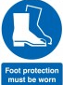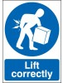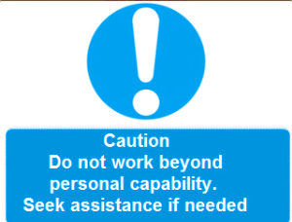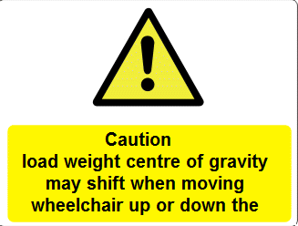

Training & Equipment
Outline skills and training etc. and equipment needed to carry out the task safely

- Manual handling training
- Risk assessment briefing
- PPE issue & briefing
- Portaramp

Safety Guidelines:
Correct procedure which must be followed and precautions to be taken:

General points to Safe lifting :

- Plan your route and assess the environment for hazard, react appropriately
- Lift smoothly avoiding jerking movements
- Bend your knees
- Lift your head first – the back then straightens automatically
- Keep the load close to your body as possible
- Use your leg muscles to lift the load – not your back
- Do not lift beyond personal physical capability
- If you feel excessive strain - STOP - and seek help

Carrying and placing the ramp to position on the platform:

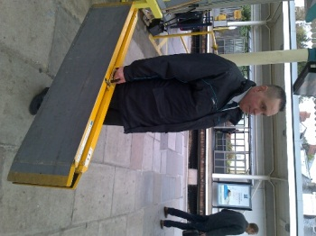

Carry the ramp to your platform position, head up and back straight look ahead and plan your route. Keep your posture upright, head up and back straight. Use the handle to carry the ramp one handed and hold the load close to your body.

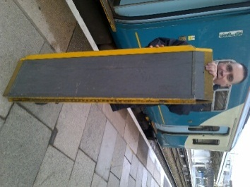

Place/rest the lower part of the ramp on the floor at a ramp’s length distance from train, ensure the correct ends of ramp, marked top/bottom, are in the correct place ready for placement to the train edge. Keeping the ramp in an upright position with the lower part in contact with the floor allows the weight to be supported.

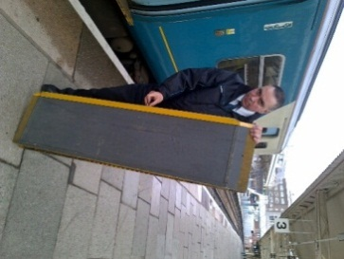

Under a controlled movement, slightly tip the ramp keeping the far corner in contact with the floor to support the weight and allowing you to move it/pivot without lifting.

Keep one hand at the top of the ramp to keep it under control. With the other hand release the clip to allow you to unfold the ramp.

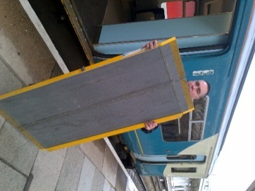

Keeping the ramp under control maintain contact between the bottom of the ramp and the floor, to support the weight and prevent it from folding back on you. Carefully open it up/fold it out.

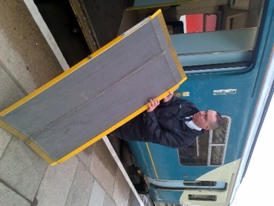

Move to the side of the ramp keeping hold of the ramp with both hands, do not overstretch your arms, keep the weight under control, stand as close to the ramp as possible and slowly begin to lower the ramp into place.

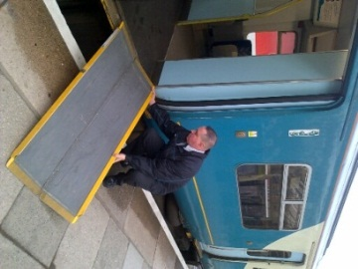
Gently lower the ramp by squatting down at the knees lowering yourself and the ramp
through use of the legs.

Keeping the arms as close to the body as possible, do not overstretch, move the ramp into place.

Always keep your head and back as upright as possible - ensure your comfort and personal limits are not exceeded when doing this do not force your head backwards/upwards etc, do not bend or stoop to lower the ramp.

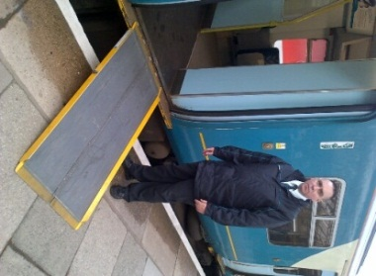

Job done!

Retrieving the ramp from the train

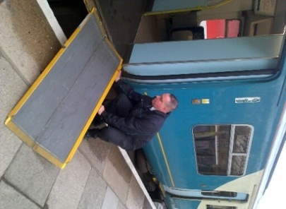

You should mirror your actions in the reverse order to that as is described above, additionally carrying out the following:

When lifting the ramp from train edge ensure that you lift through the legs and do not stoop, use the handle provided to ensure you have a good grip

175/158/150 PRM Mod Ramps

When using ramps with pins, always ensure that the pins are inserted into the lug holes

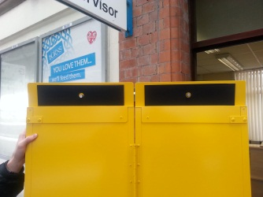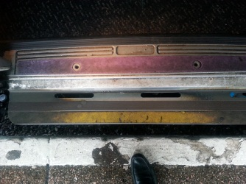

Moving a wheelchair

General safety points

- To prevent risk of injury to workers or customers during this manual task:
- Follow all steps of this Safe Work Procedure (SWP).
- Each time before moving wheelchairs, make sure area and route is clear of obstacles.
- Use forward and backward steps to push wheelchair, allow free flow of wheels.
- Communicate with customer and others involved at every step of this task.
- Do not over-exert or push beyond your own personal capabilities, seek assistance if required.

Instruction Operation
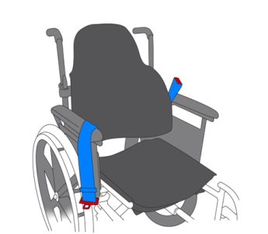
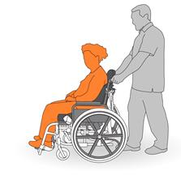

Ask customers to remove any non-medical baggage or excess weight etc. that could cause sudden movement and destabilise the centre of gravity before moving up/down the ramp.
Ask customers if they could tighten any restraints.

Stand close to the wheelchair, so as not to over-reach
Stand in upright position, to maintain natural curve of spine.
Have firm grasp of handles, with arms extended forward slightly.
Take forward, even steps, push from thighs; let the wheels do the work.
Keep a steady, slow pace when walking. Walk with the chair, and do not overreach.

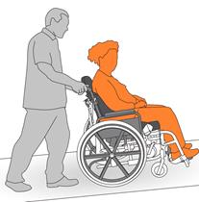
Take a wheelchair up a ramp forward facing
Use the correct ramp size to minimise the incline
Stand close to rear of wheelchair, keep back straight.
Push from thighs and lower body while walking, staying close to wheelchair.

Take a wheelchair down a ramp backwards.
Pushing a wheelchair up a slight incline or ramp.
Use the correct ramp size to minimise the incline
Hold handles firmly, move slowly taking the weight of the chair through the thighs

When stopping a wheelchair momentarily to perform another task, ensure the brakes are applied, do not do this on the ramp!
At end of the movement always ensure that the brakes are applied and the customer is safely and comfortably positioned
Make sure area is safe and free of hazards.
Document any incident and report to supervisor immediately.

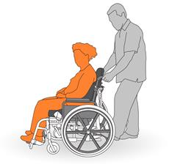

Confirmation
A briefing and practical demonstration has been given and understood
Name of trainer |  | Name of employee
Signed by trainer |  | Signed by employee
Date |  | Date

V3 – 22/09/23
Removal of the ‘Do Not’ section – feedback from Safety

