Walking and wheeling attitudes

Summary:
- Across Wales, XX% of people walk or wheel at least once per week. South East Wales is the region with the highest share (XX%), whereas Mid Wales has the lowest share of individuals making frequent walking or wheeling journeys (XX%).
- South East Wales has the highest journey satisfaction levels (XX%), X percentage points above the national average. Mid Wales has the lowest levels of satisfaction (XX%).
- More females (XX%) than males (XX%) walk or wheel per week. However, males report feeling more satisfied with their overall journey (XX% males, XX% females) and their feeling of safety (XX% males, XX% females).
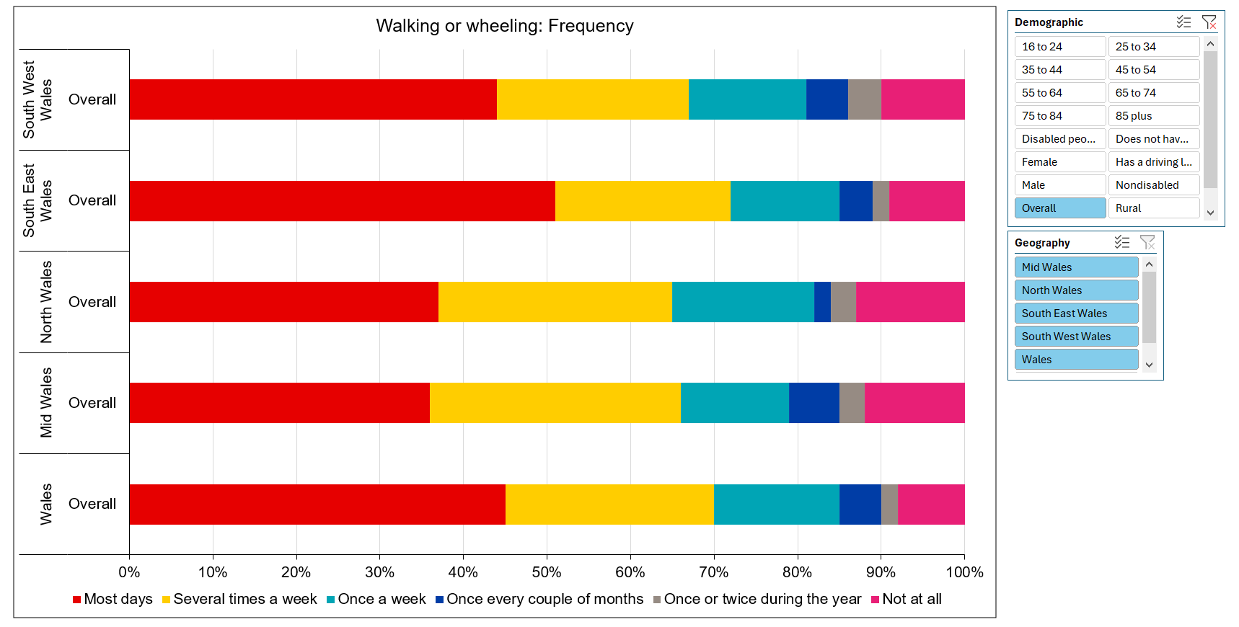
Link to Excel Workbook

