Walking and wheeling attitudes

Overview:
Data on how frequently an individual walks or wheels is available at the national and regional level, and for key demographic groups.

Frequency of use:
Across Wales, XX% of people walk or wheel at least once per week. South East Wales is the region with the highest share (XX%), whereas Mid Wales has the lowest share of individuals making frequent walking or wheeling journeys (XX%). North Wales had the highest share of individuals who did not walk or wheel as transport at all, with XX%.
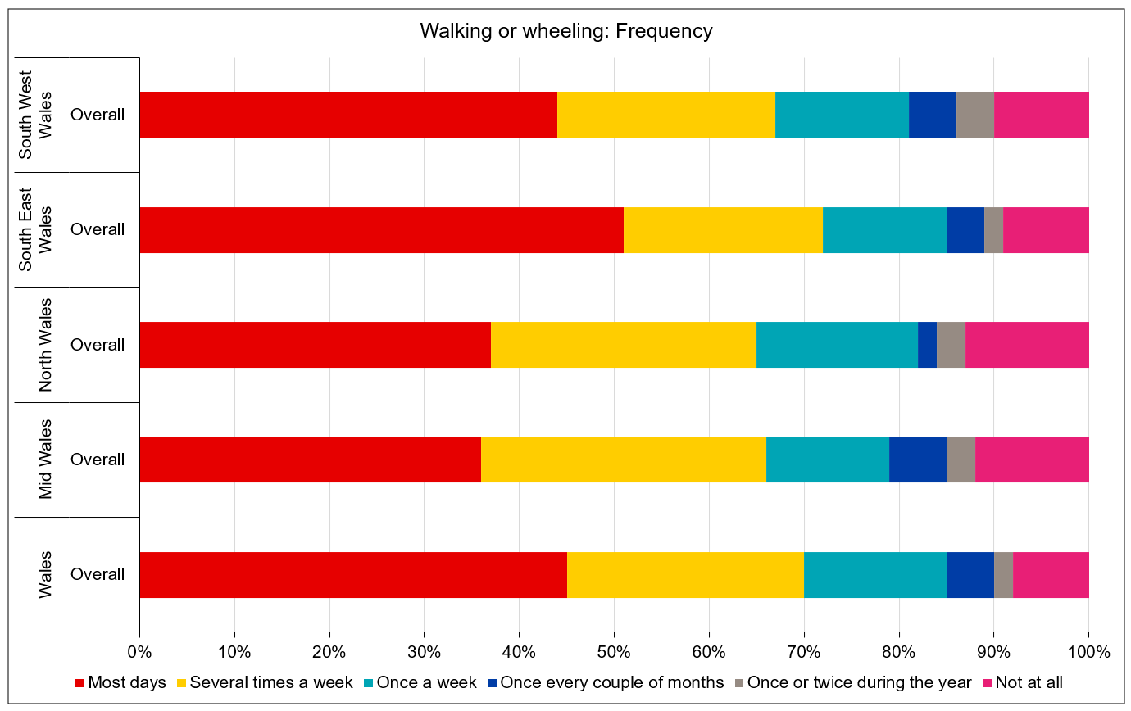

Overall journey satisfaction:
Nationally, XX% of people in Wales are satisfied with their walking or wheeling journeys (XX% Very satisfied, XX% fairly satisfied). Alongside their high walking or wheeling frequency, South East Wales also has the highest levels of satisfaction (XX%). Mid Wales has the highest overall rate of dissatisfaction, at XX%, though South West Wales has the largest share of respondents who are very dissatisfied (XX%).
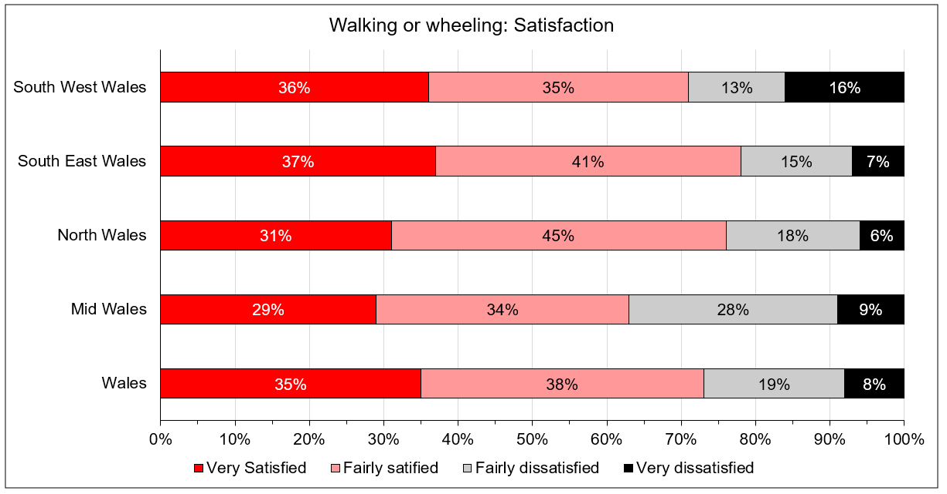
Link to Excel Workbook

