Walking and wheeling attitudes

Introduction:
Any individual is considered a frequent walking or wheeling user if they indicated they walk or wheel at least once per week (selecting either “Most days”, “Once every couple of days”, or “Once per week”). Nationally, these frequent users make XX walking or wheeling journeys per day, compared to XX journeys per day for infrequent users. This gap is widest in Mid Wales, where frequent users made XX walking or wheeling journeys per day, compared to XX journeys per day for infrequent users.
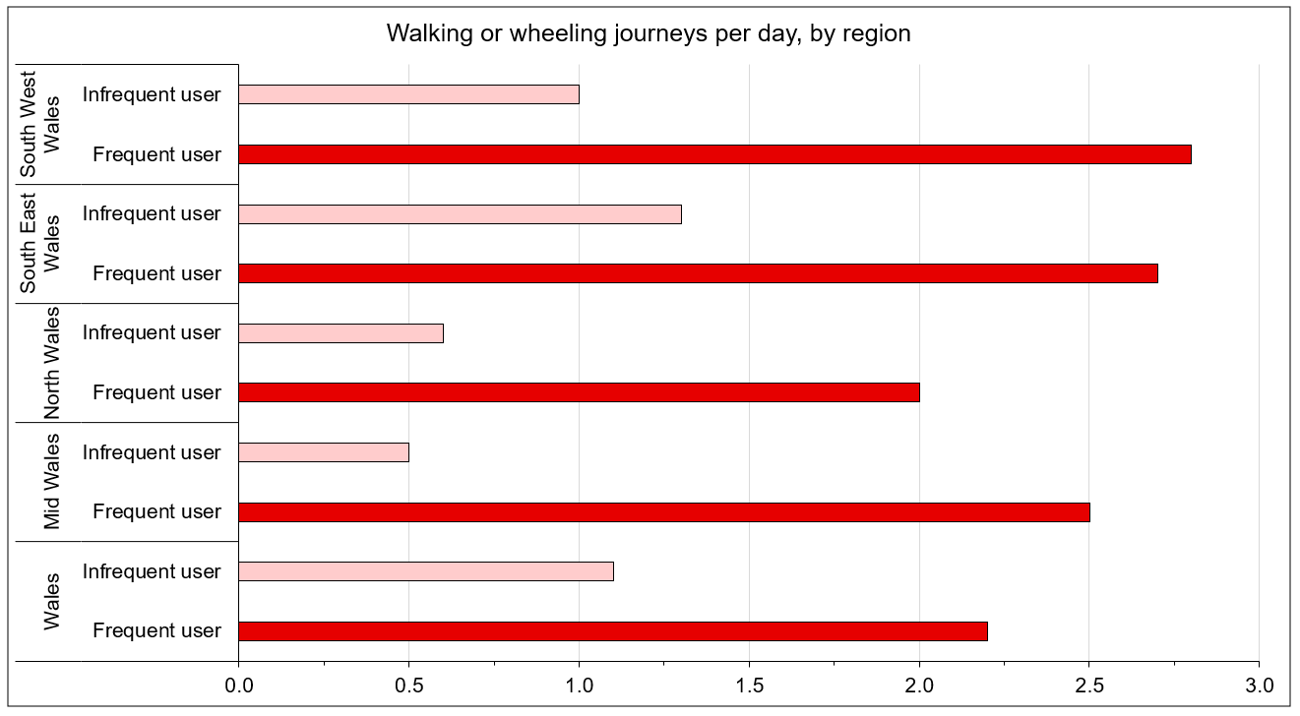
Mode share:
Travel frequency has a corresponding effect on the transport mode share. Nationally, we see XX% of journeys made by walking or wheeling.
There is a difference in mode share and journey satisfaction by rural-urban status. In rural areas, XX% of journeys are made by walking and wheeling, compared to XX% in urban areas. This difference is also visible in journey satisfaction levels, with XX% of people satisfied with their overall journey in rural areas, XX percentage points higher than in urban areas (XX%).

Link to Excel Workbook

