Date issued: 23rd of September 2024

Freedom of Information Request 242/24

You asked us…
Please can you provide copies of training materials produced as part of the recent Penalty Fare zone expansion from September 2024 onwards.
RESPONSE

There are no training materials produced by TfW for Penalty Fares administration. this is because TfW staff are not responsible for the administration or issuance of penalty fares nor any appeals against said penalty fares.

The Penalty Fares process itself is managed by Transport Investigation Limited (https://transportinvestigations.co.uk/), as per an ongoing contractual agreement.

The appeals process is manged by Penalty Services Limited (https://www.penaltyservices.co.uk/), again as per an ongoing contractual agreement.

This is all detailed in our Penalty Fares information online (https://tfw.wales/ways-to-travel/rail/travel-information/penalty-fares).
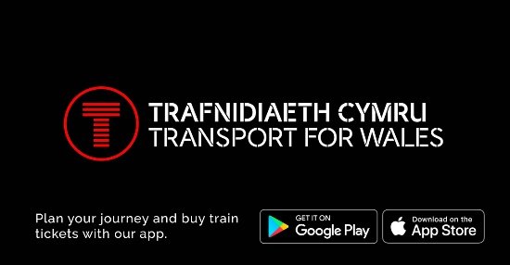 | Penalty Fares | Transport for Wales  Transport for Wales | Buy Cheap Train Tickets and Check Train Times  tfw.wales

We hope this information is of use to you.

Yours sincerely,

Transport for Wales

Appeal Rights
If you are unhappy with the way your request has been handled and wish to make a complaint or request a review of our decision, please write to the Head of Freedom of Information at either Transport for Wales, 3 Llys Cadwyn, Pontypridd, CF37 4TH or freedomofinformation@tfw.wales. Your request must be submitted within 40 working days of receipt of this letter. If you are not content with the outcome of the internal review, you have the right to apply directly to the Information Commissioner for a decision.
The Information Commissioner (ICO) can be contacted at Information Commissioner's Office, Wycliffe House, Water Lane, Wilmslow, Cheshire, SK9 5AF or you can contact the ICO through the 'Make a Complaint' section of their website on this link: https://ico.org.uk/make-a-complaint/
The relevant section to select will be "Official or Public Information".

