**Date issued:** 23rd of October 2024

**Freedom of Information Request 263/24**

**You asked us…**

**Following a number of issues with cancelled and delayed trains in recent times, can TfW confirm how many services travelling to Swansea and further west in Wales have been cancelled over the most recent 12-month period? (October 1, 2023 to September 31, 2024).**

**RESPONSE**

The total cancellations were 654 for the period requested. Breakdown by period in the graph below.

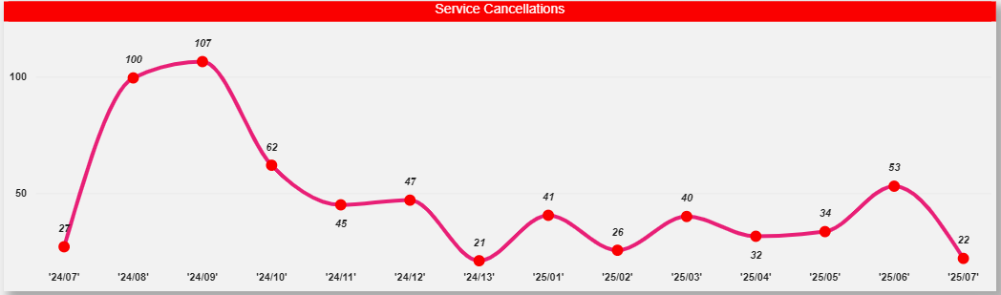

We hope this information is of use to you.

Yours sincerely,

**Transport for Wales**

**Appeal Rights**

If you are unhappy with the way your request has been handled and wish to make a complaint or request a review of our decision, please write to the Head of Freedom of Information at either Transport for Wales, 3 Llys Cadwyn, Pontypridd, CF37 4TH or [freedomofinformation@tfw.wales](mailto:freedomofinformation@tfw.wales). Your request must be submitted within 40 working days of receipt of this letter. If you are not content with the outcome of the internal review, you have the right to apply directly to the Information Commissioner for a decision.

The Information Commissioner (ICO) can be contacted at Information Commissioner's Office, Wycliffe House, Water Lane, Wilmslow, Cheshire, SK9 5AF or you can contact the ICO through the 'Make a Complaint' section of their website on this link: <https://ico.org.uk/make-a-complaint/>

The relevant section to select will be "Official or Public Information".