**Date issued:** 23rd of October 2024

**Freedom of Information Request 275/24**

**You asked us…**

**Can I request fail to stop data for Ty Glas, Birchgrove, Rhiwbina, Whitchurch and Coryton please? Preferably as a percentage.**

**RESPONSE**

Please see below for Fail to stop data.

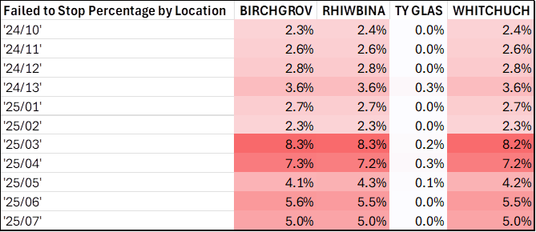

We hope this information is of use to you.

Yours sincerely,

**Transport for Wales**

**Appeal Rights**

If you are unhappy with the way your request has been handled and wish to make a complaint or request a review of our decision, please write to the Head of Freedom of Information at either Transport for Wales, 3 Llys Cadwyn, Pontypridd, CF37 4TH or [freedomofinformation@tfw.wales](mailto:freedomofinformation@tfw.wales). Your request must be submitted within 40 working days of receipt of this letter. If you are not content with the outcome of the internal review, you have the right to apply directly to the Information Commissioner for a decision.

The Information Commissioner (ICO) can be contacted at Information Commissioner's Office, Wycliffe House, Water Lane, Wilmslow, Cheshire, SK9 5AF or you can contact the ICO through the 'Make a Complaint' section of their website on this link: <https://ico.org.uk/make-a-complaint/>

The relevant section to select will be "Official or Public Information".