Date issued: 20th of May 2025

Freedom of Information Request 109/25

You asked us…
I am making a Freedom of Information Request under the Freedom of Information Act 2000 about cancellations and late arrivals of Transport for Wales trains from Swansea to Shrewsbury since January 2025.
RESPONSE

Please see the below stats for the Swansea to Shrewsbury line.

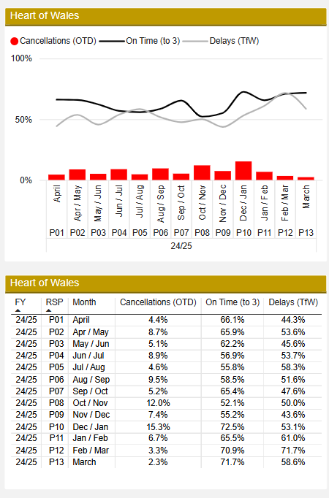

A total of just over 8k delay minutes have been generated on the HOW line between P2510 and P2513. Almost 2/3 of the delay minutes are attributed to TFW with request stops, trainee driver and passenger loading delays as key themes. NR delays focus on point and track failures and account for roughly the remaining 1/3. A total of 59 (weighted) on-the-day cancellations have been recorded, with responsibility almost equally split between TFW and NR. The main drivers of on-the-day cancellations include fleet (faults / failures / shortages) and infrastructure related (points / track / items on the line).

Performance figures demonstrate an improvement on the line post autumn season. Fleet and Control teams have worked hard to try and protect services on the Heart of Wales line, however, there have been some teething issues with the new 153 active travel fleet. Current improvement plans on the line include some vegetation work by NR and some work to protect a specific service departing Canton depot, in order to avoid later train crew related knock-on effects.

Note - The graph does not take into account pre-cancellations which do not form the plan of the day but may impact customer perception / experience.

We hope this information is of use to you.

Yours sincerely,

Transport for Wales

Appeal Rights
If you are unhappy with the way your request has been handled and wish to make a complaint or request a review of our decision, please write to the Head of Freedom of Information at either Transport for Wales, 3 Llys Cadwyn, Pontypridd, CF37 4TH or freedomofinformation@tfw.wales. Your request must be submitted within 40 working days of receipt of this letter. If you are not content with the outcome of the internal review, you have the right to apply directly to the Information Commissioner for a decision.
The Information Commissioner (ICO) can be contacted at Information Commissioner's Office, Wycliffe House, Water Lane, Wilmslow, Cheshire, SK9 5AF or you can contact the ICO through the 'Make a Complaint' section of their website on this link: https://ico.org.uk/make-a-complaint/
The relevant section to select will be "Official or Public Information".

