Date issued: 11th of August 2025

Freedom of Information Request 194/25

You asked us…

How many vehicles does the department have?

Of these, how many are petrol? Diesel? Electric?

RESPONSE

Please see the below train numbers.

Please note,
- currently the 398s are not in service.
- Of the Rolling Stock detailed in the table provided, TfW lease or hire the majority of them, they do not own them. The stock that TfW actually own are:

Class 153 – 17 are leased the remainder TfW own.
Class 230 – 5 Units
MKIV LHCS – 48 coaches (these are unpowered coaches a diesel or electric loco will provide the traction)
Class 67 diesel locomotive – TfW only own 1 loco’.

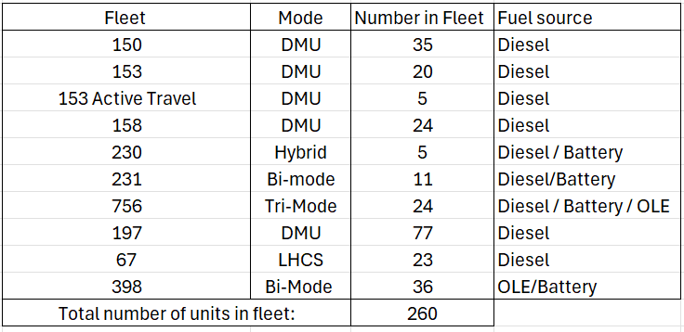

TfW directly owns 12 buses - 10 are diesel and 2 are electric (repowered).

TFW and its subsidiaries currently operate 81 vehicles with a combustible engine as part of our road fleet.

We hope this information is of use to you.

Yours sincerely,

Transport for Wales

Appeal Rights
If you are unhappy with the way your request has been handled and wish to make a complaint or request a review of our decision, please write to the Head of Freedom of Information at either Transport for Wales, 3 Llys Cadwyn, Pontypridd, CF37 4TH or freedomofinformation@tfw.wales. Your request must be submitted within 40 working days of receipt of this letter. If you are not content with the outcome of the internal review, you have the right to apply directly to the Information Commissioner for a decision.
The Information Commissioner (ICO) can be contacted at Information Commissioner's Office, Wycliffe House, Water Lane, Wilmslow, Cheshire, SK9 5AF or you can contact the ICO through the 'Make a Complaint' section of their website on this link: https://ico.org.uk/make-a-complaint/
The relevant section to select will be "Official or Public Information".

