Appendices: South West Wales bus network survey findings
November 2025



Contents

Appendix A: Online material 3
Appendix B: Survey in full 4
Appendix C: Stakeholders contacted 28
Appendix D: Schedule of workshops 33
Appendix E: Sign up information (demographic) 35
Appendix F: Public drop in schedule 36
Appendix G: Campaign / promotional materials 37

Appendix A: Online material

Interactive Map

Descriptive list of routes

South West Bus Public Engagement; Non-technical summary

Downloadable maps

- Pembrokeshire (Hubs - Haverford West, Pembroke, Milford Haven)
- Carmarthenshire (Hub - Carmarthen)
- Llanelli and Ammanford
- Swansea Urban
- Swansea Rural and Gower
- Neath and Port Talbot

FAQs and other information

Bus reform for Wales: our roadmap to franchising | GOV.WALES
Bus franchising | Transport for Wales
Bus Reform: South West Wales
Bus franchising - frequently asked questions | Transport for Wales
FAQs on South West Wales Engagement | Transport for Wales
Contact us | Transport for Wales

Appendix B: Survey in full

South West Wales Public Engagement Survey

About Bus Reform

The Welsh Government and Transport for Wales are working together to introduce Bus Reform. Currently new legislation is being discussed in the Senedd. This change means that decisions about bus services in Wales, including routes, timetables, fares, hours of operation and service quality standards, will be made by the public sector.
South West Wales will be the first region to see Bus Reform in 2027.

About Us
The first step in bus reform has involved Transport for Wales and local authorities in South West Wales jointly developing a proposal for the bus network in South West Wales. We’re calling this our Proposed Base Network and it’s this we want feedback on.

Survey
This survey will aim to capture views, which will help refine our Proposed Base Network. However, there are ‘free text’ opportunities so that information can be provided on anything that matters to people about bus.

Please place an X in the boxes to mark your response to questions.

Please complete this survey and return it to Transport for Wales, 3 Llys Cadwyn, Pontypridd CF37 4TH

----------------------------------------------------------------------------------------------

Section 1: About You

We want to start a conversation about the bus network with as many people in the South West Wales region as possible. It doesn’t matter if you use public transport everyday, or never even consider using public transport, we want to hear from as many people as we can. To help us understand the reach of this engagement, we want to get started by learning a little bit about you.

Section 1a

- How are you responding to this survey?

☐ As an individual

☐ On behalf of an organisation

Which organisation do you represent:

- Please provide your postcode here:

Section 1b

This section is for people responding as individuals. If you represent an organisation please skip to Section 2.

- Are you a current bus user?

☐ Yes

☐ No

If you are a current bus user: | If you are not a current bus user:
- How often do you currently use the bus? [Please select one]  ☐ 5 + days per week  ☐ 3-4 days per week  ☐ 1-2 days per week  ☐ 1-3 days per month  ☐ Less frequently than this  - What is the main reason that you use the bus? [Please select one]  ☐ For work purposes  ☐ To access education  ☐ For leisure purposes  ☐ For care responsibilities  ☐ To access healthcare  ☐ Other [Please specify in the box] | - Why don’t you use the bus? [Please select all that apply]  ☐ It’s too expensive  ☐ There is no suitable service in my community  ☐ Bus services are not reliable  ☐ Bus services are not accessible  ☐ Bus services are not frequent enough  ☐ It’s slower than other options  ☐ It’s inconvenient  ☐ I have safety concerns  ☐ Other [Please specify in the box]

Section 2: About Our Proposed Base Network
We have used the current network as the starting point to develop our Proposed Base Network. This is the network we believe we can deliver within the limits of our current resources (funding, buses and drivers).
Planning our Proposed Base Network using the same level of resources that are in the system today means that we have not been able to propose changes everywhere. So, for some places our Proposed Base Network will be the same as the current network, whereas in other places we have suggested changes.
Proposed Improvements
Where we have made some changes, they are based on:
- Having a simpler network, that is easy to explain, remember and navigate.
- High-frequency core routes that can attract the highest patronage.
- Interchanges between bus services to enable faster journeys to more possible destinations.
- Some more direct services.

Identifying Changes
You will be able to tell where we have proposed changes on some bus routes because the service number will have a lower-case letter in front of it. For example, today’s 150 service in Neath has some changes, and is now called the u51. Whereas the 349 in Pembrokeshire does not change, and is still called the 349 in our Proposed Base Network.
Please note Traws services already have an uppercase ‘T’ in front of the number, for example the T1, T5 and T6. We are not proposing changes to these Traws services here.
You can also find a list of all the services where changes are proposed in Section 3. These are split by area and listed numerically to help you find the services that you are interested in.
If you do have access to a computer / tablet / mobile device please search https://haveyoursay.tfw.wales/bus-reform to find maps and more information about our Proposed Base Network.

Section 3: Service Changes

Please see a list of all the services which are affected by the proposals for your information.

These are split by area and listed numerically to help you find the services that you are interested in. Services which have no proposed pages are not listed here. You do not need to read all of these and can move on to Section 4 and 5, to give feedback on up to six services and/or one general area.

Swansea

a2 Swansea – Caswell Bay/Newton
Based on existing service number: 1, 2
Routes 1 and 2 are now unified under a single number, simplifying the network. Buses will continue to alternate between Newton and Caswell Bay, but will no longer serve Thistleboon or Bracelet Bay.

a4 Singleton – Morriston Hospital
Based on existing service number: 4, 2, 24
Alternate daytime journeys now serve Parc Gwernfadog after Morriston Hospital, enhancing local access.

a6 Swansea - Port Tennant
Based on existing service number: 6
On weekdays, most buses now travel directly to Port Tennant. The service bypasses Grenfell Park, this change will shorten travel time. The complementary a44 service will serve Grenfell Park.

g11 Swansea - Carmarthen
Based on existing service number: X11, 111
This service now travels directly from Fforestfach Tesco to Loughor Bridge, then via Bynea and Llwynhendy to Llanelli.

a11 Swansea - Loughor/Llanelli
Based on existing service number: 111, 16
Alternate buses now loop around Loughor via Borough Road and Brynllwchwr instead of continuing to Llanelli. This change provides better local coverage in Loughor.

a12 Swansea - Townhill
Based on existing service number: 12, 13
Buses now only serve Townhill. They are proposed to go in one direction (anti-clockwise), simplifying the loop.

a13 Swansea - Mayhill
Based on existing service number: 12, 13
Similar to a12, buses now only serve Mayhill in an anti-clockwise direction, simplifying the loop.

a17 Swansea - Gorseinon
Based on existing service number: X13A, 111, 46
A new route operating every other hour. It travels from Swansea via the Rail Station, Gors Avenue, Fforestfach Tesco, and Gorseinon, continuing to Highfield and Llanerch Crescent. It forms part of a half-hourly service along Gors Avenue.

a20 Swansea - Killay/Dunvant
Based on existing service number: 20, 20A, 21, 22
This provides a consistent 15-minute frequency between Swansea - Sketty - Killay, under one bus route. From Killay, buses alternate destinations (e.g., Ridgeway, Derlwyn, Priors Way). Aneurin Way and New Mill Road are now served by a66.

a24 Swansea - Craig Cefn Parc/Glais
Based on existing service number: 24, 35, X6C, 45
Route 24 is now diverted via Hollett Road, replacing service 35. It no longer goes to Morriston Hospital but instead serves Graig Felen, Clydach, and either Craig Cefn Parc or Glais. A school-time journey covers Morriston Comprehensive and Bishop Vaughan schools.

a29 Swansea – Tycoch
Based on existing service number: 29, 39, 22
Unified under one bus service number for all weekday journeys. One bus per hour follows the current 29 route; the other goes via Sketty Cross and takes a loop via Harlech Crescent and Glan-yr-Afon Road. Linked with u4 for through journeys to the Rail Station.

a30 Swansea - Trallwn (Rhydyfelin)
Based on existing service number: 30, 33, 45
Operates as the current 30 from Swansea to Princess of Wales Court (Mansel Road), then via Llansamlet Tesco to Trallwn, operating a loop via Frederick Place and Rhyd-y-Felin.

a31 Swansea - Birchgrove/Morriston Hospital
Based on existing service number: 31, 33, 24, 961
One service number is used for all buses via Winch Wen. Trips terminating at Trallwn no longer serve the Frederick Place loop (see a30). Some trips between Birchgrove and Morriston Cross will serve Herbert Thomas Way instead of Tregof. The Gower College journey from service 961 is now part of this route

a33 Swansea - Cefn Hengoed
Based on existing service number: 45
This new service connects into Cefn Hengoed, with the current 45 service that currently serves Cefn Hengoed forming part of the a30

a34 Swansea - Neath
Based on existing service number: 34
Alternate journeys Mondays to Fridays divert via Birchgrove, to give new links between Birchgrove and Neath. On these days, the service is linked with the a29 to offer through journeys to Sketty and Killay.

a35 Swansea - Llangyfelach
Based on existing service number: 35
Now runs directly along Llangyfelach Road, no longer serving Hollett Road, which is now served by the a24.

a36 Swansea - Morriston
Based on existing service number: 36
Slight extension at Morriston to serve Asda.

a42 Caereithin Cross - Bishop Gore School
Based on existing service number: 43
New number for Bishop Gore School journeys currently on the 43. Early morning journeys currently numbered 42 will be numbered a43 instead.

a43 Singleton - Morriston Hospital
Based on existing service number: 43
Between Singleton and Fforestfach Cross, all journeys operate direct along Cockett Road. No longer runs between Singleton and Bus Station (see a53).

a44 Swansea - Grenfell Park
Based on existing service number: 6
This weekday service complements the a6, ensuring communities in the SA1 area and Grenfell Park are connected.

a46 Gorseinon - Morriston Hospital
Based on existing service number: 46
Now operates only during peak hours. Daytime service replaced by a47 and Gorseinon loop by a17.

a47 Gorseinon - Morriston Hospital
Based on existing service number: 46, 142
New service, from Gorseinon Bus Station via Penllergaer Llewellyn Road, Felindre, Rhydypandy to Morriston Hospital, then a loop via Maes-y-Gwernen or Llangyfelach to Morriston Cross.

a53 Swansea - Weig Fach Lane
Based on existing service number: 53, 43
Revised to start at Weig Fach Lane, then travel via Townhill, Singleton, and Brynmill to the Bus Station. Tircoed will be served by X13A during the day, and service 41 early morning.

a65 Llanrhidian - Scurlage
Based on existing service number: 115
Now runs only between Llanrhidian and Scurlage. Passengers can connect to a66 or a68 for further travel.

a66 Swansea - Llangennith
Based on existing service number: 116, 21
All journeys now operate beyond Llanrhidian to Llangennith and Llanmadoc on a standardised 90 minute frequency. Diverted in Sketty Park via New Mill Road and Aneurin Way.

a67 Llangennith - Bishopton Comp
Based on existing service number: 117
Now operates only as a school journey.

a68 Swansea - Rhossilli
Based on existing service number: 118, 119
All journeys to Rhosilli and Port Eynon now operate via Parkmill. Alternate journeys operate via Oxwich Cross or Horton Car Park. Standardised timetable, with additional journeys at peak holiday times.

a69 Llanrhidian - Killay
Based on existing service number: 119
Revised to run between Llanrhidian and Killay only, with connections to the a66 and a68

Neath Port Talbot

u4 Swansea - Pontardawe/Ystradgynlais
Based on existing service number: X6, X26
This service follows the current X6 route between Swansea and Pontardawe but now uses the Bus Link between Swansea Rail Station and Landore Stadium for faster access. All journeys will run via Capel Road in Clydach. Beyond Pontardawe, the route splits: an hourly service will run to Ystradgynlais, with alternate buses serving Alltwen or a longer route via Gellideg, Cwmgors, Tairgwaith, Brynamman, and Cwmtwrch.

u21 Ystradgynlais - Ystalyfera
Based on existing service number: 121, 62, 64
Revised to include a loop north of Ystradgynlais Interchange serving Pen-y-Bryn. South of the Interchange, all buses now go via Pengorof Surgery and Gurnos to Tesco before completing the loop around Ystalyfera. One journey in each direction also serves Cwmgiedd Crossroads.

u24 Swansea - Ystradgynlais
Based on existing service number: X6, X26
This service follows the current X26 route between Swansea and Pontardawe, via Glais, continuing via Alltwen and Pantteg to Ystradgynlais. This offers faster journeys from the Swansea Valley into Swansea.

u53 Neath - Glyncorrwg
Based on existing service number: 59, 83
Based on the current 59 service, this route is extended beyond Pontrhydyfen to Cymmer, Glyncorrwg, and Abercreggan. It maintains connections at Pontrhydyfen for Port Talbot and at Cymmer for Blaengwynfi and Croeserw/Maesteg.

u54 Caewathan - Pencaerau
Based on existing service number: 4, 204
This combines the current 204 with the Pencaerau end of route 4.

u56 Neath - Longford
Based on existing service number: 4
Now operates solely between Longford and Neath, simplifying the route.

u57 Port Talbot - Neath
Based on existing service number: 202, 82, 9
Follows the current 202 route to Heol Morfa, then continues to Port Talbot via Waterside Health Centre, NPT Hospital, Aquadome, and Lake Road.

u59 Neath - Gnoll Park
Based on existing service number: 153
We are proposing to extend this service into Gnoll Park, however, the feasibility of this is subject to further checks.

u61 Neath - Aberdulais
Based on existing service number: 161, 164
Route is now primarily between Neath and Cilfrew with increased weekday frequency. Some journeys extend to Aberdulais.

u62 Ystradgynlais - Pontneddfechan
Based on existing service number: 62, 161, 162
Extended from Banwen to Glynneath and Pontneddfechan. Connects with X7 for travel to Swansea, Neath, and Cwmgrach Roundabout. No longer serves Pen-y-Bryn (now covered by u21).

u76 Swansea - Coelbren
Based on existing service number: 38, X8, 58
Combines current routes 38 and X8. Operates a one-way loop around Onllwyn, Coelbren, and Banwen.

u82 Port Talbot - Sandfields
Based on existing service number: 9, 82
Based on the current service 9, but now runs directly via Afan Way between the Bus Station and Hospital. Early morning service has been improved.

u83 Swansea - Port Talbot/Blaengwynfi
Based on existing service number: X1, 84, 83
Based on the current 83, now extended to Swansea and Blaengwynfi/Abergwynfi. Continues to serve NPT Hospital (but not Morrisons) and maintains connections to Neath and Glyncorrwg.

u84 Port Talbot - Baglan
Based on existing service number: 202, 84
Circular route between Port Talbot and Baglan. Travels one way via the Hospital and Resource Centre, and the other via Dinas Baglan Road. All buses loop around Baglan in a clockwise direction.

u86 Port Talbot - Velindre
Based on existing service number: 66, X3
New route just serving Abbey Road and Velindre as a circular.

u87 Bridgend - Margam/Pontardawe
Based on existing service number: X1, 87, 256, 56
The current 87 is extended at both ends - from Neath to Pontardawe, and Margam to Bridgend.

u88 Port Talbot - Maesteg
Based on existing service number: X3, 66
Based on the current X3, now diverted via Taibach and Goytre.

Section 4: Your Feedback on Our Proposed Base Network

You have the opportunity to provide feedback both on specific services (up to six) and on a general area of your choosing.

- Would you like to provide feedback on one or more services in our Proposed Base Network?

☐ Yes

☐ No [Please go to question 13, on page 15]

Specific Services

If you would like to provide feedback on one or more services in our Proposed Base Network please complete these questions.

You have the option to provide feedback on up to six routes in this survey. You do not need to complete this for six services if you do not want to.

Service #1
- Please provide the bus route number which you would like to provide feedback on:

- How do you believe this proposed service will impact you? [Please select one]

☐ It will allow me to travel more easily

☐ It won’t make much difference

☐ It won’t make any difference

☐ It will make travel by bus more inconvenient

☐ Unsure

- Do you have a specific need for this service to run more than just during the main daytime hours, such as in the early morning, evenings or Sundays?

☐ Yes

☐ No

- Please explain when and why you would like this service to run:

- Please use this space you have any further comments regarding this service:

Service #2
- Please provide the bus route number which you would like to provide feedback on:

- How do you believe this proposed service will impact you? [Please select one]

☐ It will allow me to travel more easily

☐ It won’t make much difference

☐ It won’t make any difference

☐ It will make travel by bus more inconvenient

☐ Unsure

- Do you have a specific need for this service to run more than just during the main daytime hours, such as in the early morning, evenings or Sundays?

☐ Yes

☐ No

- Please explain when and why you would like this service to run:

- Please use this space you have any further comments regarding this service:

Service #3
8. Please provide the bus route number which you would like to provide feedback on:

- How do you believe this proposed service will impact you? [Please select one]

☐ It will allow me to travel more easily

☐ It won’t make much difference

☐ It won’t make any difference

☐ It will make travel by bus more inconvenient

☐ Unsure

- Do you have a specific need for this service to run more than just during the main daytime hours, such as in the early morning, evenings or Sundays?

☐ Yes

☐ No

- Please explain when and why you would like this service to run:

- Please use this space you have any further comments regarding this service:

Service #4
- Please provide the bus route number which you would like to provide feedback on:

- How do you believe this proposed service will impact you? [Please select one]

☐ It will allow me to travel more easily

☐ It won’t make much difference

☐ It won’t make any difference

☐ It will make travel by bus more inconvenient

☐ Unsure

- Do you have a specific need for this service to run more than just during the main daytime hours, such as in the early morning, evenings or Sundays?

☐ Yes

☐ No

- Please explain when and why you would like this service to run:

- Please use this space you have any further comments regarding this service:

Service #5

- Please provide the bus route number which you would like to provide feedback on:

- How do you believe this proposed service will impact you? [Please select one]

☐ It will allow me to travel more easily

☐ It won’t make much difference

☐ It won’t make any difference

☐ It will make travel by bus more inconvenient

☐ Unsure

- Do you have a specific need for this service to run more than just during the main daytime hours, such as in the early morning, evenings or Sundays?

☐ Yes

☐ No

- Please explain when and why you would like this service to run:

- Please use this space you have any further comments regarding this service:

Service #6
- Please provide the bus route number which you would like to provide feedback on:

- How do you believe this proposed service will impact you? [Please select one]

☐ It will allow me to travel more easily

☐ It won’t make much difference

☐ It won’t make any difference

☐ It will make travel by bus more inconvenient

☐ Unsure

- Do you have a specific need for this service to run more than just during the main daytime hours, such as in the early morning, evenings or Sundays?

☐ Yes

☐ No

- Please explain when and why you would like this service to run:

- Please use this space you have any further comments regarding this service:

Feedback on area
- Do you want to give feedback on a specific area?
☐ Yes

☐ No [Please go to question 17, on page 16]

- Please tell us which area you would like to provide feedback on:

- How do you believe the proposed services in the area you have specified will impact you? [Please select one]
☐ They will allow me to travel more easily

☐ They won’t make much difference

☐ They won’t make any difference

☐ They will make travel by bus more inconvenient

☐ Unsure

- Please use this space I you have any further comments regarding services in the area you have specified:

Section 5: The Approach to Bus Network Design

When we plan bus networks, we are working within a set of constraints. Some examples include, bus driver shortages, availability of buses and funding. Within these constraints, we often face a set of choices to navigate.

We have planned our Proposed Base Network to be delivered with the same resources (funding, buses, drivers) that are in the network today. This means that if we want to make an improvement that requires more resource, we will have to use less resource somewhere else in the network.

Let’s say, we wanted to increase frequency, so a service runs every 20 minutes, rather than every 30 minutes because it would benefit a lot of people. This could mean 2 more buses are needed to run that service. We would then have to choose which is more important, removing 2 buses from somewhere else, or keeping the frequency as it is.

These are not necessarily easy choices. The choices we face mean that we know that our Proposed Base Network will not be perfect for everyone.
That is why we want to ask for your opinion about some of these typical choices first. This will help us refine our Proposed Base Network.

- How strongly do you agree or disagree with the following statements?

Network changes that improve the level of service for the majority of people should be considered, even if that inconveniences some people.

☐ Strongly Agree ☐ Agree ☐ Neither agree nor disagree ☐ Disagree ☐ Strongly Disagree ☐ Unsure

Minimising inconvenience for existing passengers is more important than improving services for the majority of people.
☐ Strongly Agree ☐ Agree ☐ Neither agree nor disagree ☐ Disagree ☐ Strongly Disagree ☐ Unsure

Continues on next page.

I would rather walk further to catch the bus, so that I get to my destination sooner.
☐ Strongly Agree ☐ Agree ☐ Neither agree nor disagree ☐ Disagree ☐ Strongly Disagree ☐ Unsure

I would rather wait longer for a bus to come to the stop nearest to my home, even if that means my journey takes longer.
☐ Strongly Agree ☐ Agree ☐ Neither agree nor disagree ☐ Disagree ☐ Strongly Disagree ☐ Unsure

Complex timetables which enable better connections with train services are more important than simple and consistent timetables (such as bus service that always runs at half past the hour) which people can rely on.
☐ Strongly Agree ☐ Agree ☐ Neither agree nor disagree ☐ Disagree ☐ Strongly Disagree ☐ Unsure

I would be willing to interchange between buses or trains if it means I get to my destination sooner.
☐ Strongly Agree ☐ Agree ☐ Neither agree nor disagree ☐ Disagree ☐ Strongly Disagree ☐ Unsure

Serving Schools

- If a bus journey usually goes via a school, what would you prefer to see happen to that service during the school holidays? [Please select one]

☐ The trip runs at the same times, making the timetable easy to remember, but it waits at the closed school.

☐ The trip starts at the same time, but doesn’t service the school, arriving at the other stops earlier than normal.

☐ The trip starts later, doesn’t serve the school, and arrives at the other stops at the usual time.

☐ I do not have a preference

☐ I don’t know / this is not applicable to me.

- Some routes have an easy-to-remember timetable in the middle of the weekday, but the timetable changes during morning and evening peaks for schools. What should the timetable be like on weekends? [Please select one]

☐The trips to match Mondays to Fridays.

☐The trips to continue on the middle of the day pattern.

☐I do not have a preference.

☐I don’t know / this is not applicable

Section 6: General feedback on our Proposed Base Network

- To what extent do you believe our Proposed Base Network for 2027 will be better for you?
☐Much better

☐Better

☐The same

☐Worse

☐A lot worse

☐Unsure

- To what extent do you believe our Proposed Base Network for 2027 will be better for people you know?
☐Much better

☐Better

☐The same

☐Worse

☐A lot worse

☐Unsure

- To what extent do you believe our Proposed Base Network for 2027 will be better for South West Wales as a whole?
☐Much better

☐Better

☐The same

☐Worse

☐A lot worse

☐Unsure

- Do you have any comments on how we can improve the South West Base Network?

- Is there any other feedback you would like to share

Appendix C: Stakeholders contacted

Stakeholder Group | Including
Bus operators in Wales | Large Municipals  PLCs  Community Transport Proivders  Local Authority Fleet  Learner travel providers  SME Operators  Fflecsi service providers  Trawscymru service providers
Welsh Local Authorities | Transport Officers at all 22 Welsh Local Authorities; as members of our local authority regional working groups.
Elected Representatives | Leaders and cabinet members of:  - Pembrokeshire County Council  - Carmarthenshire County Council  - Swansea Council  - Neath Port Talbot Council  One Voice Wales – the Voice of Town and Community Councils across Wales  Members of the Senedd for:  - Carmarthen West and South Pembrokeshire  - Carmarthen East and Dinefwr  - Llanelli  - Gower  - Swansea West  - Swansea East  - Preseli Pembrokeshire  - Neath  - + 4 South Wales West Regional Members  Members of Parliament for:  - Caerfyrddin  - Swansea West  - Mid and South Pembrokeshire  - Ceredigion Preseli  - Gower  - North and Swansea East  - Llanelli
Community Rail Partnerships/heritage railways | Heart of Wales Line CRP  South West Wales Connected CRP  Talyllyn Railway
Transport User Groups and Associations | RailFuture Cymru  Heart of Wales Line Transport Association  South Pembrokeshire Rail Action Group  North Pembrokeshire Transport Forum  PRTO
Ferry operators | Irish Ferries  Stena Line
Health Boards | Hywel Dda UHB  Swansea Bay UHB
Walking, Wheeling and Cycling | Sustrans  Ramblers Cymru
Voluntary Services | Powys Association of Voluntary Organisations  NPTCVS  Swansea Council for Voluntary Service  Dolen Teifi  DANSA  PACTO
Business / Growth | Swansea BID  Swansea bay Business Club  4 The Region  Swansea Bay City Deal
TfW Advisory Architecture | TfW Bus Reform Industry Panel including:  - Transport Focus  - Bus Users Uk  - Coach & Bus Association Cymru  - Confederation of Passenger Transport  - Community Transport Association Wales  - Association of Transport Coordinating Officers  - Wales Local Government Association  - Local Authorities  - Trade Unions  TfW Advisory Panel  TfW Stakeholder Forums  TfW Access & Inclusion Panel  TfW Have your Say digital network  Transport Liaison Group
EDI Groups/Protected Characteristics | EDI/Access group lists as provided by:  - Pembrokeshire County Council  - Carmarthenshire County Council  - Swansea Council  - Neath Port Talbot Council
Colleges and Universities | Swansea University  University of Wales Trinity St Davies  Neath Port Talbot College  Pembrokeshire College  Coleg Sir Gar  Gower College
National Parks/Environmental | Bannau Brycheiniog National Park  Pembrokeshire Coast National Park  Swansea Environmental Forum
Tourism/Destinations | Visit Pembrokeshire  Tourism Swansea Bay  Visit Wales  Mid Wales Tourism  Around Tenby  National Botanic Garden  Swansea Arena  Liberty Stadium

Appendix D: Schedule of workshops

Date | Group | Topic
10/09/25 | TfW Advisory Panel | ‘Your bus service, your voice’ engagement commitment for the South West
28/08/25 | TfW Access and Inclusion Panel | ‘Your bus service, your voice’ engagement commitment for the South West – how do we engage in an accessible and inclusive way
03/07/25  08/09/25 | TfW Bus reform Industry panel | ‘Your bus service, your voice’ engagement commitment for the South West
Bi-monthly throughout engagement period | TfW/Local Authority regional meeting; West Wales | ‘Your bus service, your voice’ engagement commitment for the South West
Bi-monthly throughout engagement period | TfW/Local Authority regional meeting; South East Wales | ‘Your bus service, your voice’ engagement commitment for the South West
Bi-monthly throughout engagement period | TfW/Local Authority regional meeting; North Wales | ‘Your bus service, your voice’ engagement commitment for the South West
Bi-monthly throughout engagement period | TfW/Local Authority regional meeting; Mid Wales | ‘Your bus service, your voice’ engagement commitment for the South West
17/07/25 | TfW Transport Liaison Group | An update on Bus reform and ‘Your bus service, your voice’ engagement commitment for the South West
09/09/25 | TfW Regional Stakeholder Forum (North) | An update on Bus reform and ‘Your bus service, your voice’ engagement commitment for the South West
06/08/25 | Swansea Bay Travel Planning Forum | Base Network Workshop
11/09/25 | Routes to Education workshop | Base Network Workshop
09/09/25 | Hearing From Diverse Perspectives – Neath Port Talbot | Base Network Workshop
16/09/25 | Hearing From Diverse Perspectives – Swansea | Base Network Workshop
15/09/25 | Hearing From Diverse Perspectives - Carmarthenshire | Base Network Workshop
16/09/25 | Hearing From Diverse Perspectives - Pembrokeshire | Base Network Workshop

Appendix E: Sign up information (demographic)

- Postcode
- Gender
- Age category
- Disability
- Ethnicity
- Sexual Orientation
- Welsh language ability

Appendix F: Public drop in schedule
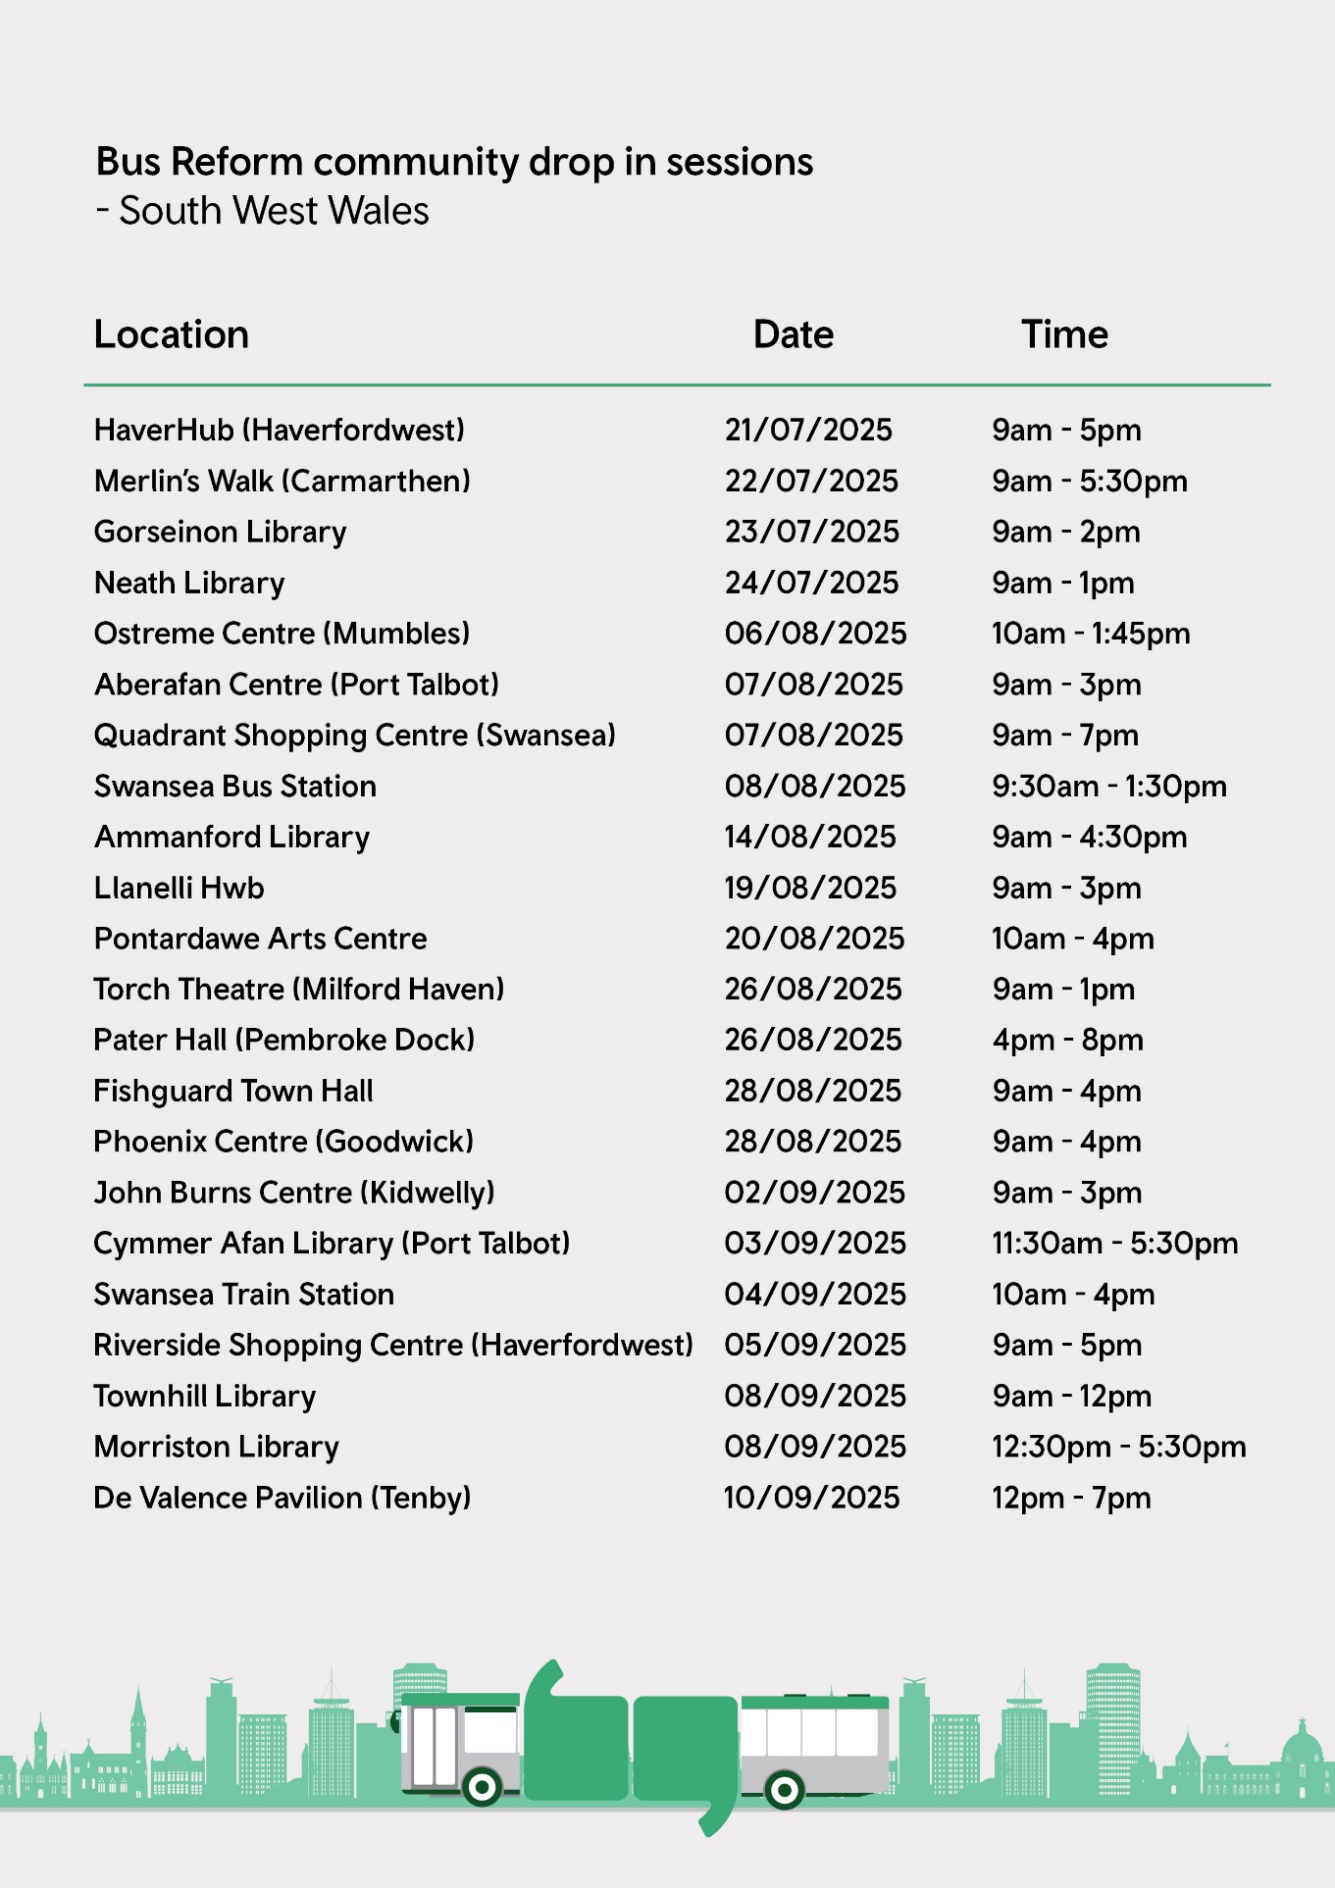

Appendix G: Campaign / promotional materials
Out of home advert example
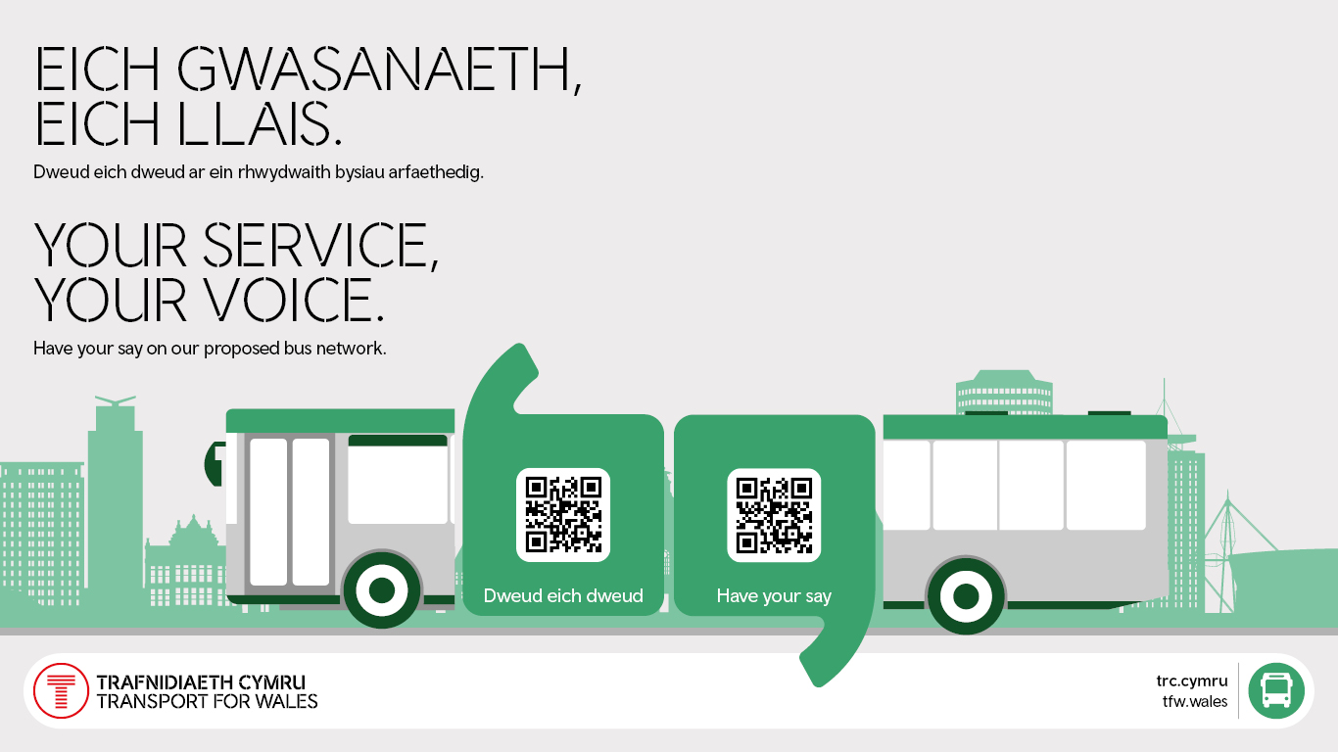

Poster as displayed at stations and bus stops
