Date issued: 3rd of September 2025

Freedom of Information Request 215/25

You asked us…

Please could you provide a breakdown of all parcels of land owned by Transport for Wales.

If possible, please could you also let us know when each piece of land was purchased.

RESPONSE

TfW acquired the Core Valley Lines estate from Network Rail in March 2020. The land comprised in the Core Valley Lines estate is the operational rail estate that runs north through the valleys from Cardiff. Please see the below which illustrates in red, the railtrack and associated land that falls within TfW’s ownership. In addition, TfW has needed to acquire land and property to deliver the transformation and development of the rail estate. The land that TfW has acquired to date is documented in the table below.

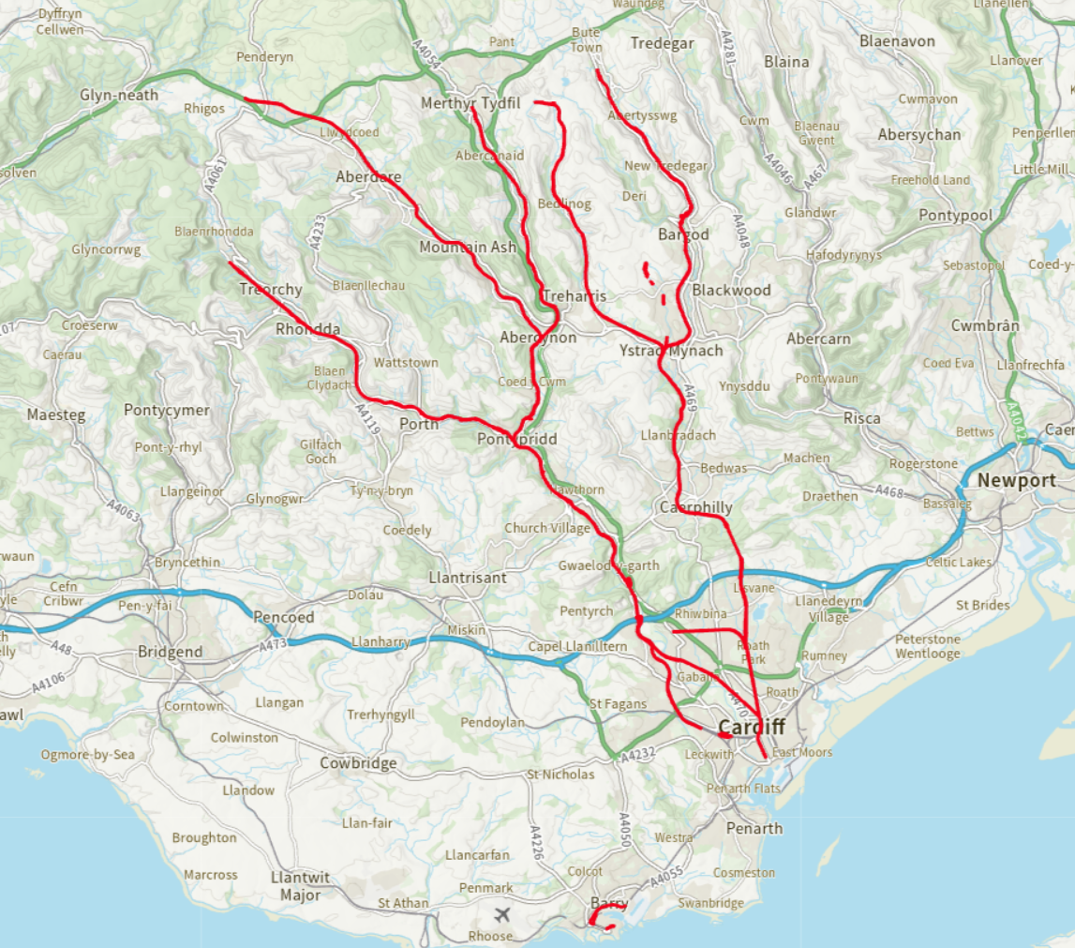

Property | Completion date
Taff’s Well depot site | 05 February 2021
Acquisition of former TAVR Barracks at Pentre to facilitate closure of the level crossing (LX). | 17 June 2021
0.25 acres at Canton Depot for the Canton Traction Power Site (TPS) | 03 August 2021
Gelynis Farmhouse for the construction of the Gelynis Overbridge to close the LX | 27 August 2021
Land at Treforest Ind Est for the Tonteg TPS | 17 December 2021
Barry Rail Depot and station | 14 May 2022
Land to the west side of Taff’s Well depot | 07 July 2022
Land nr Gelynis LX for the construction of the Gelynis Overbridge to close the LX | 21 July 2022
Rhymney Rail Station – additional parking required. | 29 July 2022
Land adjacent to Ynyswen FB | 12 July 2023
Quakers Yard new footbridge scheme | 28 July 2023
Land nr Sardis Rd, Pontypridd for the Ponty TPS | 31 August 2023
Quakers Yard new footbridge scheme | 12 October 2023
Land adjacent to Devils FB | 23 October 2023
Rosewood Bungalow, Polypin | 05 January 2024
Land adjacent to Ynyswen FB | 16 February 2024
Troedyrhiw OLE land acquisition | 09 April 2024
Part of PFI land at Cardiff Bay (Lloyd George Ave verge) to facilitate delivery of Intermediate Station and extension to Cardiff Bay terminus | 01 May 2024
land to the south of Treforest Station | 31 October 2024
Rheola Road OLE Land Acquisition | 11 November 2024
Porth Interchange | 10 January 2025
Land in Llandaff North to facilitate delivery of new footbridge and closure of Barry Wrides LX | 01 May 2025
Ystrad Rhondda OLE Land Acquisition (Brook st Bridge) | 14 May 2025
Holyhead LMD - TfWRL wheel lathe 125yr lease acquisition. | 01 June 2025
Land at Fernhill to facilitate delivery of new footbridge | 19 June 2025

We hope this information is of use to you.

Yours sincerely,

Transport for Wales

Appeal Rights
If you are unhappy with the way your request has been handled and wish to make a complaint or request a review of our decision, please write to the Head of Freedom of Information at either Transport for Wales, 3 Llys Cadwyn, Pontypridd, CF37 4TH or freedomofinformation@tfw.wales. Your request must be submitted within 40 working days of receipt of this letter. If you are not content with the outcome of the internal review, you have the right to apply directly to the Information Commissioner for a decision.
The Information Commissioner (ICO) can be contacted at Information Commissioner's Office, Wycliffe House, Water Lane, Wilmslow, Cheshire, SK9 5AF or you can contact the ICO through the 'Make a Complaint' section of their website on this link: https://ico.org.uk/make-a-complaint/
The relevant section to select will be "Official or Public Information".

