Date issued: 15th of September 2025

Freedom of Information Request 223/25

You asked us…

Under the freedom of information act, please would you inform me about the reliability of the Coryton line service. Specifically, since the introduction of the June 2024 timetable, on how many days has both of the following happened: Every train to Coryton has run and called at every intermediate station on the way up to Coryton between Heath Low Level and Coryton and Every train from Coryton has run and called at every station between Coryton to Heath Low Level. I recognise that Ty Glas station is currently closed, so am not asking for this to be included in the figures.

RESPONSE

We have liaised with our Performance analysts who, unfortunately do not record the level of detail requested. They have provided the performance figures for the route and the number of cancellations recorded each period at each station.

Overall Performance
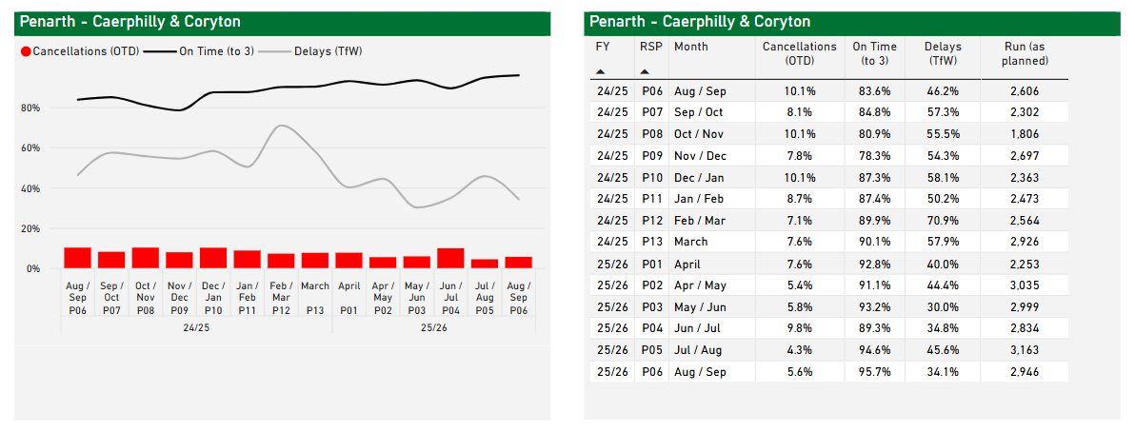

Cancellations by station by period
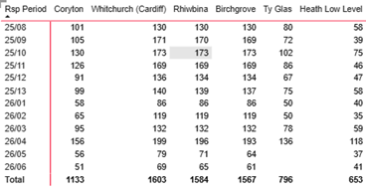

We hope this information is of use to you.

Yours sincerely,

Transport for Wales

Appeal Rights
If you are unhappy with the way your request has been handled and wish to make a complaint or request a review of our decision, please write to the Head of Freedom of Information at either Transport for Wales, 3 Llys Cadwyn, Pontypridd, CF37 4TH or freedomofinformation@tfw.wales. Your request must be submitted within 40 working days of receipt of this letter. If you are not content with the outcome of the internal review, you have the right to apply directly to the Information Commissioner for a decision.
The Information Commissioner (ICO) can be contacted at Information Commissioner's Office, Wycliffe House, Water Lane, Wilmslow, Cheshire, SK9 5AF or you can contact the ICO through the 'Make a Complaint' section of their website on this link: https://ico.org.uk/make-a-complaint/
The relevant section to select will be "Official or Public Information".

