Date issued: 24th of October 2025

Freedom of Information Request 275/25

You asked us…

Can I please ask what measures were taken by TFW to accommodate the 29000 odd Cardiff Half marathon participants that were travelling to and from Cardiff Central, Queen Street and Cathays station
On the 5th October.
Can you please provide details of how many additional services and extra carriages/capacity were put on by TFW between 730am and 945am
into these stations??

RESPONSE

The attached services that say additional are the train services we specifically ran to support the event and LTP is what is pre planned as BAU.

To accommodate the significant increase in both participants and visitors, Transport for Wales implemented a wide range of measures to enhance capacity, manage flows and maintain safety across our network. This was the second consecutive year we have delivered enhanced transport services for the event with our 2025 operation significantly increased from 2024 to meet rising demand.

Planning & delivery measures
- Additional rail and bus services were introduced to help ease congestion and improve flow across key corridors
- Expanded crowd management and security teams were deployed to ensure the safe movement of passengers at our busiest locations
- Transport for Wales management representatives were present at seven key locations before, during and after the event to coordinate activities and support colleagues
- Enhanced communications included social media updates, banners and signage at major stations including Swansea, Newport, Bridgend, Cardiff Central, Cardiff Queen Street, Radyr and Pontypridd, and a dedicated event webpage: https://tfw.wales/places/events/cardiff-half-marathon
- Spectator guides and safety pins were distributed at stations
- A press release and internal communications campaign supported colleague readiness and customer awareness

Operation in numbers
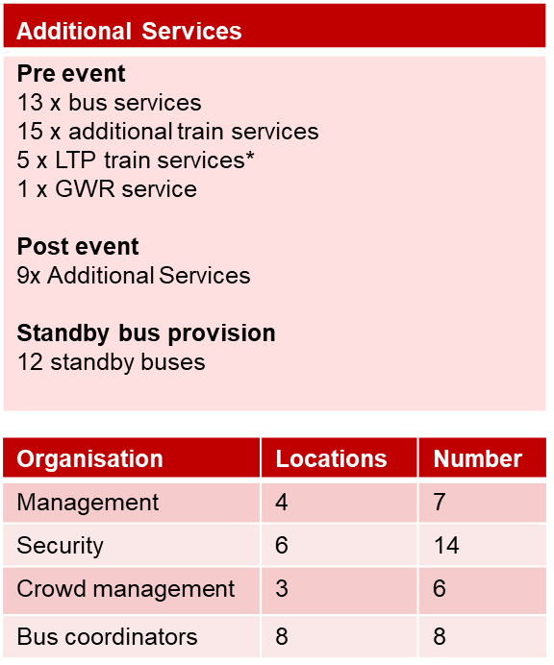

Challenges and learnings
Despite extensive planning, we faced some unavoidable challenges with demand extremely high and reports of high numbers at locations unable to board services. In addition, essential overnight engineering works on the Gloucester, Rhymney, VOG, Maesteg & Ebbw Vales lines prevented earlier morning train services which placed additional pressure on other routes and hubs

Next steps
We are working through all feedback linked to the event, with an internal event review having already taken place and a debrief planned with the event organisers and key partners. We are proud of the collaborative effort that went into supporting this year’s Cardiff Half Marathon and we appreciate the ongoing cooperation from event organisers, local authorities and operational partners. Despite the challenges faced, our teams delivered a strong and safe transport operation under extremely high demand. We remain committed to learning from this year’s experience and working closely with all stakeholders to strengthen our joint approach for the 2026 event and beyond.

We hope this information is of use to you.

Yours sincerely,

Transport for Wales

Appeal Rights
If you are unhappy with the way your request has been handled and wish to make a complaint or request a review of our decision, please write to the Head of Freedom of Information at either Transport for Wales, 3 Llys Cadwyn, Pontypridd, CF37 4TH or freedomofinformation@tfw.wales. Your request must be submitted within 40 working days of receipt of this letter. If you are not content with the outcome of the internal review, you have the right to apply directly to the Information Commissioner for a decision.
The Information Commissioner (ICO) can be contacted at Information Commissioner's Office, Wycliffe House, Water Lane, Wilmslow, Cheshire, SK9 5AF or you can contact the ICO through the 'Make a Complaint' section of their website on this link: https://ico.org.uk/make-a-complaint/
The relevant section to select will be "Official or Public Information".

