Date issued: 24th of November 2025

Freedom of Information Request 294/25

You asked us…

Please could you provide me with the reliability data of the locomotive pulled trains compared with your modern rolling stock.

RESPONSE

The common reliability measure reported by all Train Operating Companies to Rail Delivery Group is Miles Per 701D (Mp701D). Mp701D is explained as “Incidents that occur as a result of the technical failure of on-train equipment are coded to 701D. Mp701D is a measure of the engineering reliability of trains expressed as the average mileage between 701D codified incidents that are associated with a 3 minute (or more) primary delay on one journey and/or result in any cancellation (or part cancellation)” and “In all cases, a 3 Minute Delay is defined as a train incident which results in a delay of 3 or more primary minutes to that train where the root cause is a technical or maintenance-related defect on the train. Any such incident which results in a cancellation or part cancellation is also included”.

This is presented as Moving Annual Average (MAA) and the table below contains the most recently published figures for our locomotive pulled trains (67/Mk 4) compared with our modern rolling stock :
Fleet | Mp701D MAA
197 | 7124
231 | 4578
756 | 2564
67/Mk 4 | 2832

Please see below for a graphical representation of this for the last year:
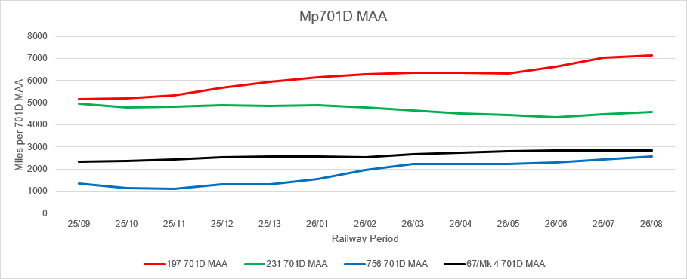

We hope this information is of use to you.

Yours sincerely,

Transport for Wales

Appeal Rights
If you are unhappy with the way your request has been handled and wish to make a complaint or request a review of our decision, please write to the Head of Freedom of Information at either Transport for Wales, 3 Llys Cadwyn, Pontypridd, CF37 4TH or freedomofinformation@tfw.wales. Your request must be submitted within 40 working days of receipt of this letter. If you are not content with the outcome of the internal review, you have the right to apply directly to the Information Commissioner for a decision.
The Information Commissioner (ICO) can be contacted at Information Commissioner's Office, Wycliffe House, Water Lane, Wilmslow, Cheshire, SK9 5AF or you can contact the ICO through the 'Make a Complaint' section of their website on this link: https://ico.org.uk/make-a-complaint/
The relevant section to select will be "Official or Public Information".

