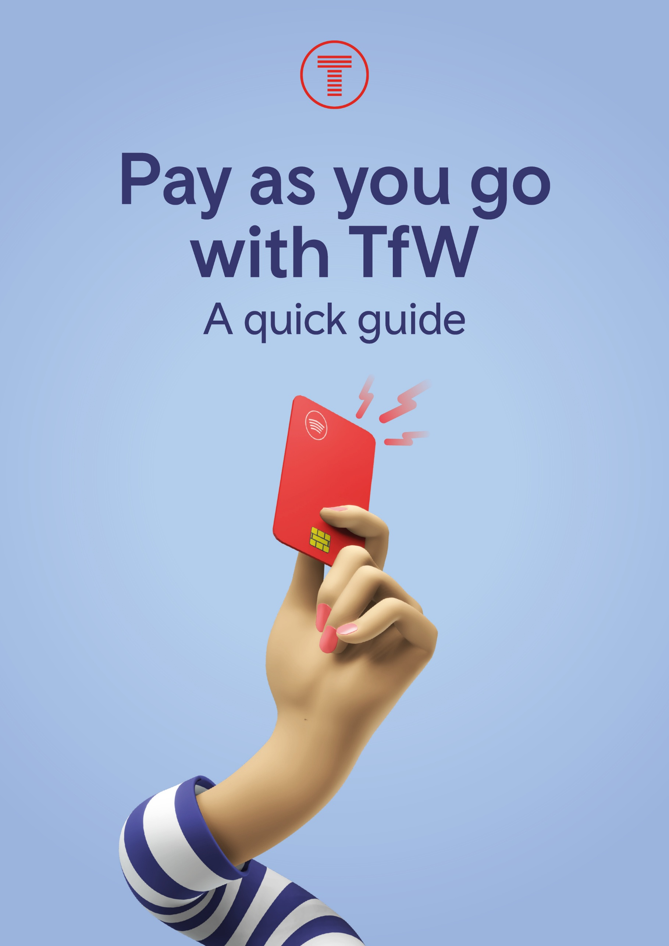

Here you’ll find simple step-by-step guidance on:
- Our pay as you go service
- Tapping in and out
- Using our app to check your journeys
- Daily and weekly fare capping
- Onboard inspections
- Incomplete journeys.
For more detailed information, please visit tfw.wales/help-and-contact/faqs

- What is pay as you go?
It’s simply tapping in at the beginning of each journey and tapping out at your destination using your contactless card or device. No more queuing at the ticket machine and no more fumbling around for paper tickets.
Our daily and weekly price caps mean you’ll never pay more than you need to. We’ll automatically charge you the best value fare for the journey you’ve made.
To learn more about our pay as you go fares and getting the best deal, please visit: tfw.wales/ways-to-travel/rail/ticket-types/pay-as-you-go/fares-and-capping
Use our fare finder to see how much you could save:
tfw.wales/ways-to-travel/rail/ticket-types/pay-as-you-go

- Register for a pay as you go account.
First, visit tfw.wales/payg or download the TfW app.
Step 1 Open the app.
Step 2 Navigate to pay as you go in the footer.
Step 3 Add your contactless card details.
Step 4 Upload and confirm your card details.
You’re ready to travel!
**You don’t need an account to use pay as you go, but you’ll need an account for help with your journeys and payments.

- Tapping in and out.

Tap in
- At the start of your journey, tap your contactless card or smart device at the station ticket barriers or on the yellow validator on the platform.
- Wait for the ticket barrier to open or for the platform validator to beep.

Tap out
- At the end of your journey, tap again on the ticket barrier or yellow platform validator.
Use the same card or device to tap in and tap out. Don't switch between cards, even if they're linked to the same bank account. If you're using your phone or smartwatch, make sure you select the same card from your phone's wallet to tap in and tap out.
Need to change platforms to continue your journey? Please refer to our frequently asked questions.
We’ll calculate your journey at the end of each day and bill it to your account overnight. We’ll always charge you the cheapest possible fare. Your journey tap data will not appear in the TfW app until the next working day.

Why it’s important to tap
- Not tapping in may result in you getting a penalty charge, which costs more.
- Not tapping out may result in you getting an incomplete journey charge, which costs more.

- Using our app to check your journeys.
Once you’ve got a pay as you go account, you can use our app or website to:
- View your journey history and charges.
- Check your daily and weekly fare caps.
- Correct any journeys e.g. adding a missing tap.
- Download your statements.
- View up to 12 months of your journey history.
- Manage your payment methods and account settings.

- Don’t want to register? Use our guest portal.
- This can be accessed on our app or website at tfw.wales/payg.
- Select ‘view your pay as you go journey history’.
- Follow the on-screen instructions to upload your card details and see your travel and payment history.
Remember, you’ll only be able to see seven (consecutive) days of travel and payment history. If you’d like to see more, you’ll need to register for an account.

- Daily and weekly fare capping.
Our daily and weekly price caps mean you’ll never pay more than you need to. We’ll automatically charge you the best value fare for the journey you’ve made.

Daily cap
- You’ll never pay more than the daily maximum fare for unlimited travel in your chosen zones.
- Additional charges may apply for travel beyond a capped zone until the next zonal cap is reached.
- All daily caps reset at the end of each day.

Weekly cap
- After reaching the zonal weekly cap, additional journeys that week are free in that zone.
- Extra charges apply if you travel beyond a zone where a weekly cap applies.
- Weekly caps reset every Monday morning.
If you’ve reached a cap, please continue to tap in and out for all journeys to avoid additional charges.
For more information on fares and capping, please visit: https://tfw.wales/ways-to-travel/rail/ticket-types/pay-as-you-go/fares-and-capping
You can also use our fare finder to see how much you could save:
tfw.wales/ways-to-travel/rail/ticket-types/pay-as-you-go

- Incomplete journeys.
If you don’t tap out, you could get an incomplete journey charge. This won’t leave your account for 48 hours, giving you time to correct the journey.
If you don’t complete the journey within 48 hours, the charge will be made to your bank account.

- How we’ll notify you if you have an incomplete journey.
If you have an account, we’ll:
- Send you a notification on the app.
- Send you a notification by email to your registered account.
We can’t send you a notification if you don’t have an account.

Correcting an incomplete journey
You’ll have until the Wednesday following the previous week’s travel to correct any incomplete journeys.
Example:
A.
You travel on Monday 15 December 2025 and forget to tap in or tap out. You’ll have an opportunity to complete this journey until Wednesday 24 December 2025.
B.
You travel on Saturday 20 December 2025 and forget to tap in or tap out. You’ll have an opportunity to complete this journey up until Wednesday 24 December 2025.
After this time, you’ll not be able to correct a journey as all fares are finalised. We won’t be able to issue any refunds.

- How to complete a journey.
This video shows how you can add a missing tap using the app:
youtube.com/watch?v=Yi5oxpRCr74

Incomplete journey auto fills
Our system may complete a journey on your behalf if journey patterns are clearly identifiable.

- Onboard inspections.
We carry out onboard inspections to check customers have tapped in for their journey.
- Please tell the conductor you’re travelling using pay as you go.
- They’ll ask you to ‘tap’ the inspection device.
Remember to tap the same card or device you used to start your journey. For example, if you tapped in with your phone, you’ll need to tap the inspection device with your phone.
If you don’t do this, you could get a penalty charge, meaning you’ll pay more.
If the conductor tells you your card is one the ‘denial list’, it means it’s invalid for use on our pay as you go service. You’ll then need to buy a physical ticket, which may be more expensive.

- Reasons a payment card or device might not be valid for travel.
- The card has expired.
- There’s an unpaid fare on your account.
- The card has been reported lost or stolen.
You can check if your card or device is valid for travel. If you have an account and use the TfW app, the status of your card will show as either:
Ready for travel – valid Blocked from travel
– not valid
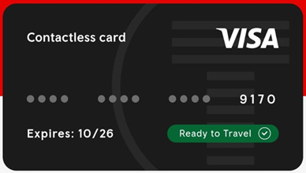
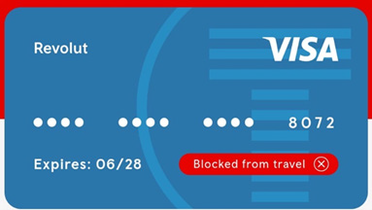

- If something goes wrong.
If you think something isn’t right, start by checking your journey history on our app or website. You’ll often be able to correct problems yourself. If not, we’ll be happy to help. Here’s how to get in touch:
Phone: 03333 211 202
Email: customer.relations@tfw.wales
Live chat: Available via our app and website.
Support hours:
Monday to Friday: 07:00 - 20:00
Saturday: 08:00 - 20:00
Sunday: 11:00 - 20:00
For support by email, live chat or webform, you’ll need to be a registered pay as you go user.

Handy hints and tips
- Always tap in and out at the start and end of each journey to avoid extra charges.
- Use the same card or device to tap in and tap out. Don't switch between cards, even if they're linked to the same bank account. If you're using your phone or smartwatch, make sure you select the same card from your phone's wallet to tap in and tap out.
- Present the same card or device you used to start your journey during a ticket inspection.
- Check the app regularly to view your journey history and price caps you’ve hit.
- Keep your payment details up to date for uninterrupted travel and smooth billing.
You cannot use Amex or Maestro for pay as you go journeys. Due to issues outside our control, physical Chase cards cannot be used, but you can use Chase through your Apple or Google wallets.

