Date issued: 2nd of March 2026

Freedom of Information Request 29/26

You asked us…

Delays
- The number of delayed services year-on-year since 2021. If possible, this should be broken down by route as well as year. If possible, the combined time delayed should also be provided, by route and by year.
- The amount of delay compensation paid out, year-on-year, since 2021. If possible, this should be broken down by route as well as year
- The amount spent on Rail-replacement buses, year-on-year, since 2021. If possible, this should be broken down by route as well as year
- The amount spent on taxis following delays or cancellations, year-on-year since 2021. If possible, this should be broken down by route as well as year.

RESPONSE

Question 1

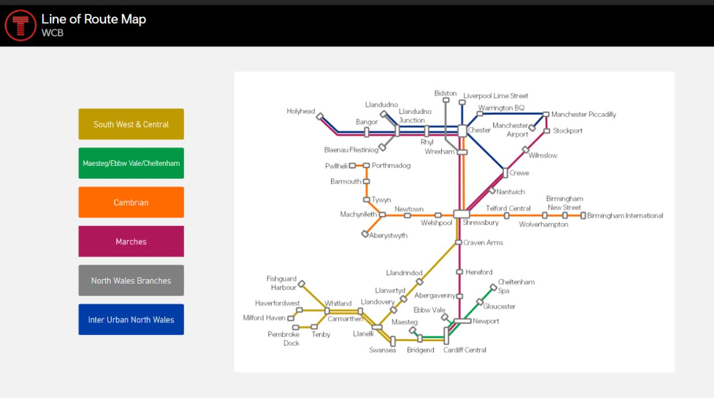

Question 2

Delay Repay Figures are listed as:
20/21 – 50,275
21/22 – 542,611
22/23 – 1,405,638
23/24 – 1,953,704
24/25 – 1,733,033
25/26 – 1,060,391 (Pds1-10)

Question 3

Please see the below spend on busses-

 | 2021 | 2022 | 2023 | 2024 | 2025 | 2026
Pre-Planned Bus | 7,074,223 | 10,647,051 | 17,627,656 | 11,574,138 | 12,402,763 | 885,234
Emergency Bus | 1,449,465 | 3,316,151 | 6,800,772 | 5,008,107 | 5,178,815 | 1,008,544
Total | 8,523,688 | 13,963,202 | 24,428,428 | 16,582,245 | 17,581,578 | 1,893,778

Please be aware that pre-scheduled buses are primarily deployed to accommodate engineering blockades. Emergency buses are assigned reactively in response to incidents such as adverse weather conditions or fleet shortages.
Question 4
Unfortunately, taxi costs for staff and members of the public are not recorded differently. As such, we are unable to provide this figure.
We hope this information is of use to you.

Yours sincerely,

Transport for Wales

Appeal Rights
If you are unhappy with the way your request has been handled and wish to make a complaint or request a review of our decision, please write to the Head of Freedom of Information at either Transport for Wales, 3 Llys Cadwyn, Pontypridd, CF37 4TH or freedomofinformation@tfw.wales. Your request must be submitted within 40 working days of receipt of this letter. If you are not content with the outcome of the internal review, you have the right to apply directly to the Information Commissioner for a decision.
The Information Commissioner (ICO) can be contacted at Information Commissioner's Office, Wycliffe House, Water Lane, Wilmslow, Cheshire, SK9 5AF or you can contact the ICO through the 'Make a Complaint' section of their website on this link: https://ico.org.uk/make-a-complaint/
The relevant section to select will be "Official or Public Information".

