Date issued: 3rd of March 2026

Freedom of Information Request 42/26

You asked us…

When using tap in/out at stations how can I use my concession card on valley line.
RESPONSE

Concessionary cards cannot be used for a discount on rail PAYG.

Details of where concessionary cards can be used on rail are available on our website: Rail concessionary travel | Transport for Wales . The extract for use in the Valleys is pasted below:
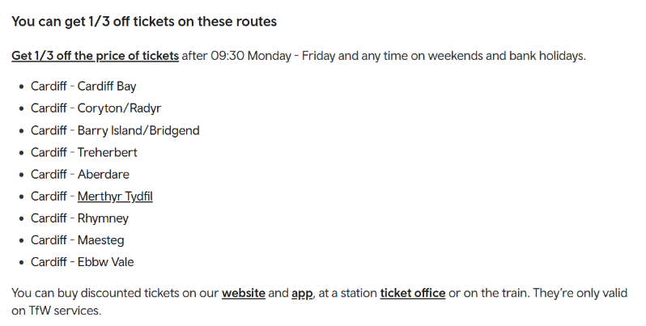

We hope this information is of use to you.

Yours sincerely,

Transport for Wales

Appeal Rights
If you are unhappy with the way your request has been handled and wish to make a complaint or request a review of our decision, please write to the Head of Freedom of Information at either Transport for Wales, 3 Llys Cadwyn, Pontypridd, CF37 4TH or freedomofinformation@tfw.wales. Your request must be submitted within 40 working days of receipt of this letter. If you are not content with the outcome of the internal review, you have the right to apply directly to the Information Commissioner for a decision.
The Information Commissioner (ICO) can be contacted at Information Commissioner's Office, Wycliffe House, Water Lane, Wilmslow, Cheshire, SK9 5AF or you can contact the ICO through the 'Make a Complaint' section of their website on this link: https://ico.org.uk/make-a-complaint/
The relevant section to select will be "Official or Public Information".

