Employee Sustainable Travel Policy
Policy statement [optional]
This policy supports [INSERT ORGANISATION’S] responsibilities towards net zero and supports staff health and wellbeing in relation to organisational travel. This will be achieved through supporting staff with guidance when choosing their mode of transport for business travel, in line with the Sustainable Travel Hierarchy (STH).
This aligns with [INSERT ORGANISATION] strategic priorities [INSERT ORGANISATION’S PRIORITIES].
The Sustainable Travel Hierarchy [mandatory]
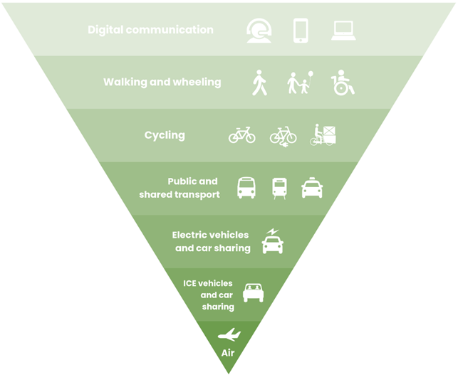

Image: Energy Saving Trust
Purpose [mandatory]
This Employee Sustainable Travel Policy sets out [INSERT ORGANISATION’S NAME] approach to organisational travel, ensuring that staff business travel aligns with [INSERT ORGANISATION’s] & Welsh Government’s carbon reduction and wider sustainability targets (see Relevant Legislation section below).
The purpose of the policy is to put the STH at the heart of decision-making for staff business travel, whilst supporting staff in selecting the most suitable transport option. The hierarchy must be considered for all staff business travel and using a process of elimination from top to bottom, the most appropriate method of transport should be chosen for that individual journey.
Scope [mandatory]
The scope of this policy covers all travel for organisational needs relevant to all employees within [INSERT ORGANISATION’S NAME], including part time workers, [school-based employees] and temporary workers, and mandates the consultation of the STH for business travel. This policy applies to all employees who travel for business purposes i.e., travel whilst undertaking their duties, often taking them from their normal place of work. This policy sets out clear expectations for staff and helps guide decision-making when undertaking business travel. This policy does not apply to staff commuting, although the same principles are encouraged.
To be read in conjunction with [mandatory]
- Policy procedure document.
- Subsistence/Expenses Policy [Optional]
Principles [mandatory]
This policy aligns with the Well-being of Future Generations (Wales) Act and aims to meet three of the seven well-being goals: A More Equal Wales, A Healthier Wales, and A Globally Responsible Wales.
In line with Welsh Government’s vision, this policy details how, wherever possible, travel should be prioritised in line with the STH. The STH provides a way to guide travel decisions for business purposes giving priority to the most sustainable modes of travel. The STH prioritises home working, walking and wheeling, cycling, public transport and ultra-low emissions vehicles over other private motor vehicles (petrol/diesel). As an organisation, we will do this by considering the STH for every journey we take as employees.
When considering which mode of transport you should take, consult the STH and review each level of the hierarchy, and ask is this reasonable? If not, move to the next level, and ask the same question until you reach the appropriate level for your journey, taking into account personal circumstances, logistics (e.g., time/cost/weather). The aim is to make sure that all sustainable options are considered, and private motor vehicles are not the default, when other options are available.
Before making any journey, you must consult the STH to determine whether the journey is necessary and if so, the best method of travel. This means choosing the most sustainable (and reasonably practical) mode of transport for the individual journey and individual’s requirements (e.g., can the meeting be conducted online?). Colleagues are expected to adopt a common-sense approach when making this decision and seek line manager support for guidance where necessary. Organisational travel should be for essential purposes only and for any travel outside of your routine role, you must have your manager’s prior approval.
[INSERT NAME OF ORGANISATION] wishes to ensure employees are reimbursed with approved expenses incurred in the course of their work including travel, meals or overnight accommodation.
You are responsible for the effective use of resources concerning organisational travel, considering organisational need (i.e. is the journey necessary?) and ensuring your claims are reasonable, actual, necessarily incurred and in line with [INSERT ORGANISATION’S] expense policy.
Staff Travel Survey [mandatory]
This policy mandates the completion of an annual staff travel survey for monitoring, measurement and reporting purposes. As an employee, you must commit to undertaking the survey.
Justifying your choice [optional – if your organisation is able to add a justification mechanism]
When submitting expenses, you must state for each journey that you have considered the STH and justify why the chosen mode of transport was the most suitable in relation to the STH. This is to support with the identification of barriers/opportunities for sustainable travel options.
Objectives [mandatory]
- This policy aims to support [INSERT ORGANISATION’S NAME] net zero and decarbonisation goals by encouraging and supporting sustainable travel in line with the STH.
- This policy aims to ensure that no employee will be disadvantaged for the additional time associated with using sustainable modes of transport to travel when undertaking duties.
- This policy aims to support better collection of staff travel data to understand barriers and opportunities for staff travel and inform organisational carbon reporting.
- This policy aims to promote healthy, sustainable choices by raising awareness of sustainable travel opportunities (i.e., bike hire scheme) and providing subsequent resources to make it more accessible to staff.

Supporting documents [mandatory]
This policy supports the delivery of several national pieces of legislation and policies including, but not limited to:
- Well-being of Future Generations (Wales) Act 2015 – The Future Generations Commissioner for Wales
- National transport delivery plan 2022 to 2027 | GOV.WALES
- Net Zero Wales: Carbon budget 2 | GOV.WALES
- Environment (Wales) Act 2016: factsheets | GOV.WALES
- Prosperity for all: a climate conscious Wales | GOV.WALES
- Prosperity for all: a low carbon Wales | GOV.WALES
- Active Travel (Wales) Act 2013 | Law Wales
- About the Charters - Healthy Travel Wales
- Wales' Fourth Carbon Budget - Climate Change Committee
- Llwybr Newydd: the Wales transport strategy 2021 | GOV.WALES
Relevant resources (mandatory)
To support the implementation of the policy, there are a number of resources and initiatives currently available to staff in order to support the consideration of sustainable travel. Please visit the Healthy Travel Charter website for more information.
[The following are optional and examples of what your organisation could include.]
- Decision Tree
- Cycle to Work Scheme
- Discounted Rail Travel Scheme
- EV Salary Sacrifice Scheme
- Bus and Train timetables
- Active travel maps
- Cycle expenses
Accountability
This policy template is the responsibility of [INSERT ORGANISATION’S RESPONSIBILE TEAM].
Created by:
Date Created:
Reviewed By:
Date Reviewed:
Current Version:
Adopted by/date:

Document Control
Version | Date | Author | Notes/Changes

